*The Solar System*

by The Author

Copyright Nature Publications

Revised: 11/15/2017 12:07:00 PM

*The Solar System*

by The Author

***Contents***

No table of contents entries found.

# General Outline

The book is about the solar system. The contents are from wikibooks. Please refer <http://en.wikibooks.org/wiki/Wikijunior_Solar_System> for more information.

The book contains basic information about sun and the 9 planets in the solar system: Mercury, Venus, Earth, Mars, Jupiter, Saturn, Uranus, Neptune and Pluto.

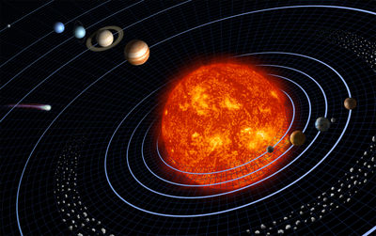

<Document Path="//Document[@Name='Overview']/@Path" />

<Document Path="//Document[@Name='Sun']/@Path" />

<Document Path="//Document[@Name='Mercury']/@Path" />

<Document Path="//Document[@Name='Venus']/@Path" />

<Document Path="//Document[@Name='Earth']/@Path" />

<Document Path="//Document[@Name='Mars']/@Path" />

<Document Path="//Document[@Name='Jupiter']/@Path" />

<Document Path="//Document[@Name='Saturn']/@Path" />

<Document Path="//Document[@Name='Uranus']/@Path" />

<Document Path="//Document[@Name='Neptune']/@Path" />

<Document Path="//Document[@Name='Pluto']/@Path" />