CS443 - Assignment 1

Question #1

Consider the following data. Arrows show the functional dependency.

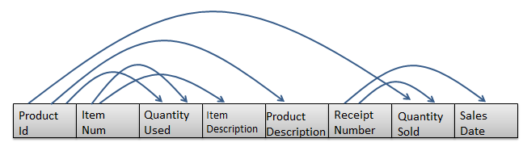

The arrows in this question indicated the determination of two attributes. For example, the arrow that goes ProductID to ProductDescription indicates that ProductID determines the ProductDescription. This in turn means that ProductId can be considered as primary key for ProductDescription.

- Write the tables
Product (ProductID, ProductDescription)
Item (ItemNum, ItemDescription)
Receipt (ReceiptNumber, SalesDate)
Prod_Rec ((ProductID*, ReceiptNumber*), QuantitySold)
Prod_Item ((ProductID*, ItemNumber*), QuantityUsed)

- Place the tables in 3rd normal form (if necessary)
It is in 1st normal form because there is only one instance in every field. It is in 2nd normal form because there are no partial functional dependencies. No derived dependencies because nothing can be calculated nor derived from other attributes, and no transitive dependencies because there are no non-key attributes dependent on another non-key attribute. So, it is already in 3rd normal form.

- Create ERD based on the normalized tables
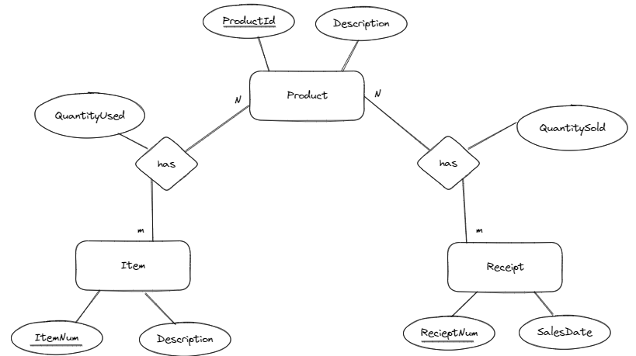

- Write a script to create a database. Your script should create the tables and ensures that all constraints are set properly.
Submitted through the txt file in the zipped folder.

Here is some information to create your tables

Data Item (Column Name) | Type | Restriction
ProductId | Numeric – Integer
ItemNum | Numeric – Integer | Not null
QuantityUsed | Numeric – Integer | >= 0
ItemDescription | Character – Up to 200
ProductDescription | Character – Up to 200
ReceiptNumber | Numeric – Integer | Not null
QuantitySold | Numeric – Integer | > = 0
SalesDate | Date

Question #2

Consider the following ERD

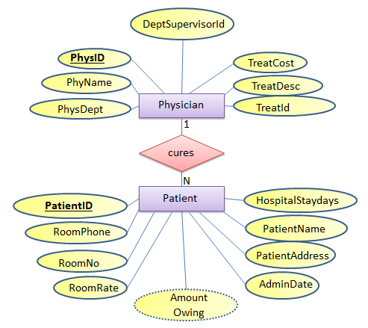

Where
- PatientId: It is the identification number of each patient
- PatientName: It is the name of the patient
- Patientddr: It is the address of the patient
- AdmitDate: It is the date when the patient is admitted to the hospital
- AmounOwing: The amount the patient owes based on his/her sickness after being discharged
- RoomNo: it is the room where the patient is kept in the hospital
- RoomPhone: The phone number in the patient’s room
- HospitalStayDays: Number of days the patient would be in the hospital for treatment.
- RoomRate: The rate charged for every day the patient is in the room

In the second table:
- PhysId: It is the identification number of each physician
- PhyName: It is the name of each physician
- PhysDept: It is the department id where physician works
- DeptSupervisorId: It is the id of the physician who is in change of managing the PhyDept. For example, suppose physician x works in department y. DeptSupervisorId is the id of the physician (not necessarily physician x) who in managing department y.
- TreatId is a number that represents the type of treatment the physician can do
- TreatDesc and TreatCost are Treatment description and treatment cost

    - Each patient is assigned one doctor, but a doctor can have many patients
    - There may be more than one patient in a room but each patient is kept in one room only
    - Each patient is being treated for one sickness only
    - There is only one phone number in each room in the hospital

    - Each doctor can do only do one treatment, but a treatment can be done by many doctors
    - The treatment cost is fixed for each treatment
    - Each doctor works in only one department, but a department can have many doctors
    - Each department has 1 supervisor. This supervisor is just one of the physicians who works in that department
    - A Patient is charged based on the treatment cost and number of days in hospital

Note that not all the rooms in the hospital has patient at a particular time but all patient must be is some rooms. Further, only some of the physicians are supervising the departments in the hospital; however, all departments must be managed by some physicians.

You may make any other assumption you think is necessary but you have to be very specific and realistic. You can add other assumptions but you are not allowed to change the above assumptions

Do the following

- Change the ERD to tables
Physician (PhysID, PhysName, PhysDept, DeptSupervisorId, TreatCost, TreatDesc, TreatId)
Patient (PatientID, PatientName, PatientAddress, AdmitDate, HospitalStayDays, AmountOwing, RoomPhone, RoomNo, RoomRate)

- Place the tables in 3rd normal form (if necessary)
Already in 1st normal form because there are not multiple instances in any field. Already in 2nd normal form because there are no partial functional dependencies. NOT, in 3rd normal form yet because there are transitive dependencies in both tables. TreatId is a non-key attribute that can uniquely identify TreatCost and TreatDesc, which are dependent on TreatId and are also non-key attributes. So, a new table can be made called Treatment that will have TreatId as the primary key, and TreatCost and TreatDesc as the attributes in it. There is another transitive dependency in the Physician table in which DeptSupervisorId is reliant on PhysDept. So, that can become its own table called Department in which Phys Dept is the primary key and DeptSupervisorId is an attribute in the table. In the patient table there is also a transitive dependency in which RoomPhone and RoomRate are dependent on RoomNo which is a non-key attribute. There is also a derived dependency in AmountOwing, which can be calculated by other attributes.

Revised tables:
Physician (PhysID, PhysName, PhysDept*, TreatID*)
Patient (PatientID, PatientName, AdmitDate, HospitalStayDays, PhysID*, RoomNo*)
Treatment (TreatID, TreatCost, TreatDesc)
Department (PhysDept, DeptSupervisorId)
Room (RoomNo, RoomPhone, RoomRate)

- Revise the given ERD based on the normalized tables (if necessary)
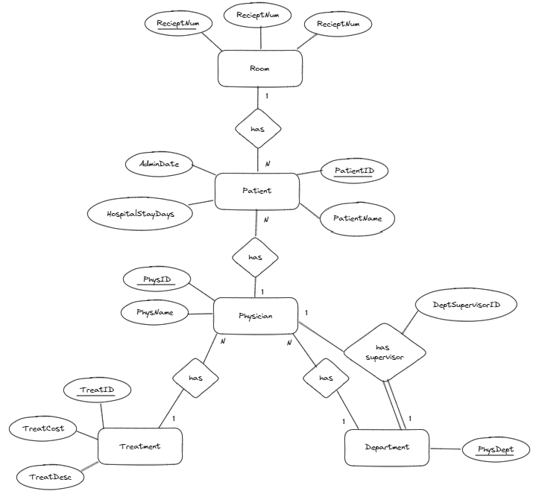

- Write a script to create a database. Your script should create the tables and ensures that all constraints are set properly.
Submitted through the txt file in the zipped folder.

Here is some information to create your tables using SQL. Depending on your normalization process, some of the following fields may not be in your final normalized table.

Data Item (Column Name) | Type | restrictions
PatientID | Numeric – Integer
PhysID | Numeric – Integer
RoomNo | Numeric – Integer | >= 100 and <= 999
AdmitDate | Date
PatientName | Character -- Up to 50 | Not null
PatientAddress | Character -- Up to 200 | Not null
RoomPhone | Character -- Up to 8
HospitalStayDays | Numeric – Integer | >= 0
RoomRate | Numeric – Decimal  10 with 2 decimals | >= 30.00 and < =100.00
AmountOwing | Numeric – Decimal  10 with 2 decimals
PhysName | Character -- Up to 50 | Not null
PhysDept | Numeric – Integer
DeptSupervisorId | Numeric – Integer
TreatId | Numeric – Integer
TreatDesc | Character -- Up to 200
TreatCost | Numeric – Decimal  10 with 2 decimals | >= 50.00

Question #3

Create the tables related to the following ERD. Determine the primary Keys and the foreign keys of each table.

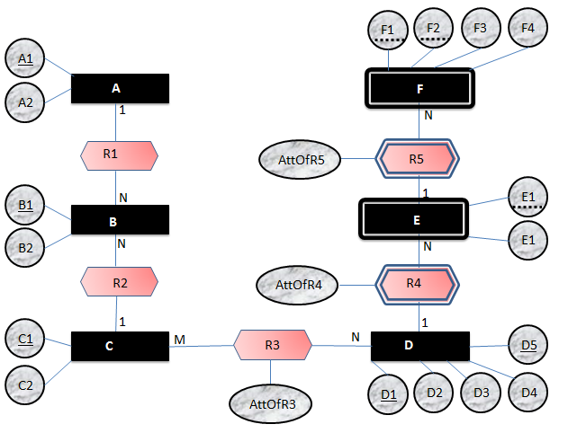
E2

Tables:
A (A1, A2)
B (B1, B2, A1*, C1*)
C (C1, C2)
D ((D1, D5), D2, D3, D4)
F ((F1, F2, (E1, (D1, D5))*), F3, F4, AttOfR5)
E ((E1, (D1, D5)*), E2, AttOfR4)
CD (((D1, D5)*, C1*), AttOfR3)

Question #4

Create ERD based on the following tables. The underlines attributes are primary keys. The links are connection between primary keys and foreign keys

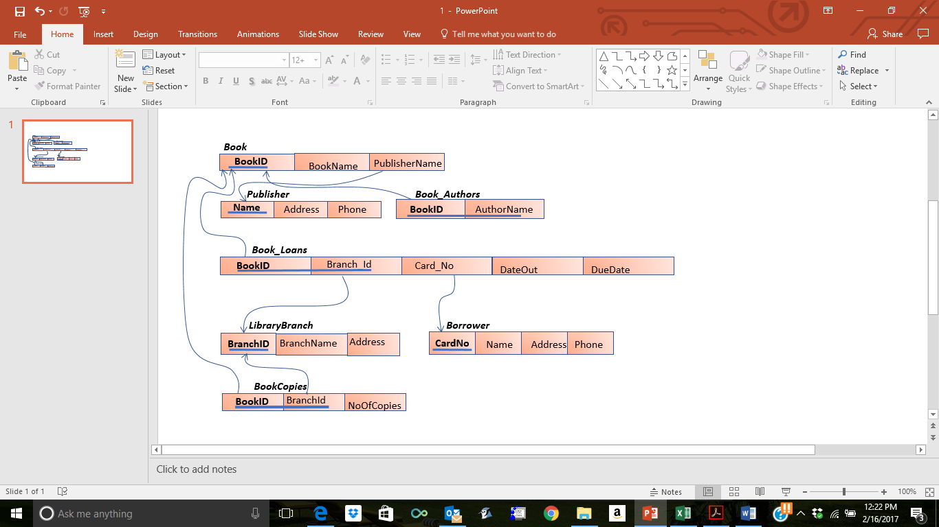
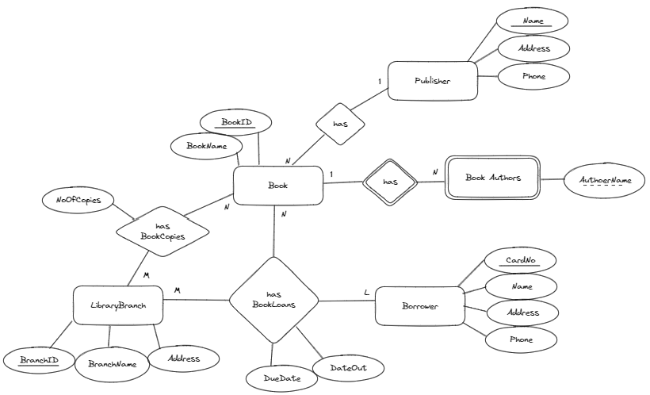
Question #5

Create ERD based on the following tables. The underlines attributes are primary keys. The links are connection between primary keys and foreign keys
