Assignment 2
No Duplicate Rows are allowed in the following questions

- Write a select statement to list all the columns from the Offices table. 'Select *' is not allowed. Return the list in DESC Office order.

Query:
SELECT office, city, region, mgr, target, sales
FROM Offices
ORDER BY office DESC;

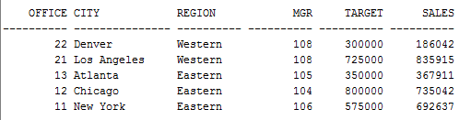

- List the product ID, mfr ID, Name (its description), and dollar value of quantity on hand (price * quantity) of the products whose dollar value is greater than 20000. Return the list in descending order by their dollar value.

Query:
SELECT product_ID, mfr_ID, description, (qty_on_hand * price) AS dollar_val
FROM Products
WHERE (qty_on_hand * price) > 20000
ORDER BY dollar_val DESC;

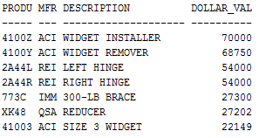

- List the Order Number, Order Date, Customer Number, and Sales Rep Number for orders for part '779C' or '773C'. (Use a compound search condition - OR.)

Query:
SELECT order_num, order_date, cust, rep
FROM Orders
WHERE product = ‘779C’ OR product = ‘773C’;
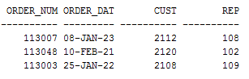

- List the Name and Age of all Sales Reps in the following offices: 11; 13. (Use the set membership test - IN.)

Query:
SELECT name, age
FROM Salesreps
WHERE rep_office IN (11, 13);

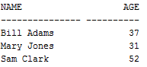
- List the names of all Sales Reps who have the letter 'a' (this is lower case a) as the second character of their name.

Query:
SELECT name
FROM Salesreps
WHERE name LIKE ‘_a%’;

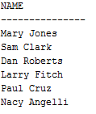

- Return the Sales Rep ID and Name of any Sales Rep not assigned to an office yet.

Query:
SELECT empl_num, name
FROM Salesreps
WHERE rep_office IS NULL;

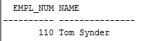

- Show all the sales rep names with last name “Smith” or “Jones”.

Query:
SELECT name
FROM Salesreps
WHERE name LIKE ‘% Smith’ OR name LIKE ‘% Jones’;

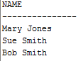

- List different titles in the sales reps table. Only list each title once and unknown titles should be ignored. Duplicate rows are not allowed.

Query:
SELECT DISTINCT title
FROM Salesreps
WHERE title IS NOT NULL;

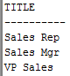

- List the description of the products which are more than 6 character and less than 10 character long. No duplicate row is allowed. You can use the build in function length() to do this. For example, length(name) return the number of characters for attribute called “name”.

Query:
SELECT DISTINCT description
FROM products
WHERE LENGTH(description) > 6 AND 10 > LENGTH(description);

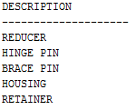

- For all order Amount less than $700, list the order num with the name of the rep who placed the order and the name of the customer who made the order and the name of the rep for that customer

Query:
SELECT order_num, Amount, sr1.name AS orders_name, company, sr2.name AS rep_name
FROM orders, salesreps sr1, salesreps sr2, customers
WHERE Amount < 700
AND rep = sr1.empl_num
AND cust = cust_num
AND cust_rep = sr2.empl_num;
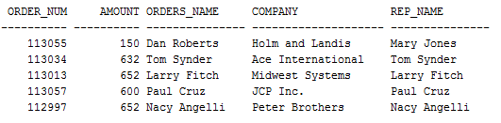

- List the Mfr Id, the Product Id, Company and PRICE of all products bought by customers where customer number is one of (2111,2112,2105,2119) and where the amount of the order < $10,000. Order the results by ascending Company. Duplicate row are not allowed.

Query:
SELECT DISTINCT mfr_id, product_id, company, price
FROM products, customers, orders
WHERE cust = cust_num
AND mfr = mfr_id
AND product_id = product
AND cust_num IN (2111, 2112, 2105, 2119)
AND amount < 10000
ORDER BY company ASC;

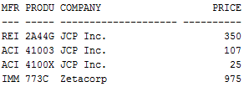

- List all orders number, the name of the rep who took the order , the city where the rep has his/her office. Print the employee whose office is in either Chicago or Denver;

Query:
SELECT order_num, name, city
FROM orders, salesreps, offices
WHERE rep = empl_num
AND rep_office = office
AND city IN ('Chicago', 'Denver');
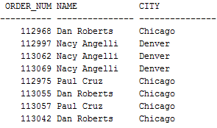

- List all customers (Customer number, Company, and Credit Limit) and orders (Order Number, Amount) where the Amount is within $10,000 of the Credit Limit. Therefore:
- Credit_limit should be greater than zero and
- Amount should be greater than zero and
- Amount should be less than credit_limit and
- Credit_limit – Amount <=$10000
Query:
SELECT cust_num, company, credit_limit, order_num, amount
FROM customers, orders
WHERE cust = cust_num
AND credit_limit > 0
AND amount > 0
AND amount < credit_limit
AND (credit_limit – amount) <= 10000;

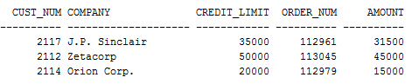

- List all salesreps names and their managers’ names where the salesrep is at least as old as the manager. Duplicate rows are not allowed.

Query:
SELECT DISTINCT employees.name, managers.name AS mgr_name
FROM salesreps employees, salesreps managers
WHERE managers.empl_num = employees.manager
AND employees.age >= managers.age;

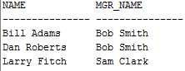

- List all salesreps (Name) and the City they work in where either the sales of the salesrep < Quota or the sales for the office is < Target.

Query:
SELECT name, city
FROM salesreps, offices
WHERE rep_office = office
AND (salesreps.sales < quota OR offices.sales < target);

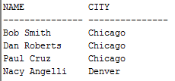

- List the name, ID, and hire date of the salesreps where the following two conditions hold:
- The salesreps sales should be greater than the quota and
- The rep should be either “Sam Clark”, or “Mary Jones.”

Query:
SELECT name, empl_num, hire_date
FROM salesreps
WHERE sales > quota
AND (name = 'Sam Clark' OR name = 'Mary Jones');

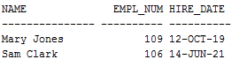

- List all orders (Order Number) over $7,000 showing the company placing the order, the Customer Rep assign to the company, the Office id and the city , and the rep who took the order where such that the Customer Rep’s is not the rep who took the order.
Query:
SELECT order_num, company, cust_rep, office, city, rep
FROM orders, customers, offices, salesreps
WHERE amount > 7000
AND cust = cust_num
AND cust_rep = empl_num
AND rep_office = office
AND rep != cust_rep;

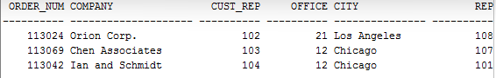

- List all customer reps (their name and their id) and their managers name in which the manager is based in New York. Use appropriate column header.

Query:
SELECT DISTINCT employees.name AS customer_rep, employees.empl_num, managers.name AS manager
FROM customers, salesreps employees, salesreps managers, offices
WHERE cust_rep = employees.empl_num
AND managers.rep_office = office
AND managers.empl_num = employees.manager
AND city = 'New York';

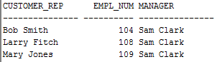

- List all products (ProductId, MFR_Id, and Description), customers (CustNum, Company) who have bought that product, and orders (Order Number, and Order Date) where the order < $700. Sort the rows by the OrderDate. Duplicate rows is not allowed.

Query:
SELECT DISTINCT product_id, mfr_id, description, cust_num, company, order_num, order_date
FROM products, customers, orders
WHERE cust = cust_num
AND product = product_id
AND amount < 700
ORDER BY order_date;

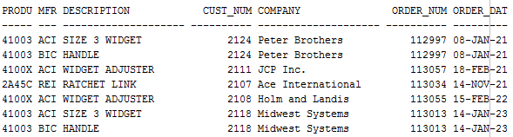

- List the name of the salesreps and the name of their managers only if the manager has taken care of some orders.

Query:
SELECT DISTINCT employees.name, managers.name AS mgr_name
FROM salesreps employees, salesreps managers, orders
WHERE employees.manager = managers.empl_num
AND managers.empl_num = rep;
