CS443 – Lab 2

Question 1:
Consider the following information:

Supplier: SupplierId, SupplierName, SupplierAddress (The address consists of StreetName, AptNo, PostalCode)
Shipment: ShipmentId, ShipmentDate, ShipmentTime
Item: ItemNo, ItemDescription, QuantityOnHand

One supplier can send many shipments; however, a particular shipment is only sent by one supplier. One item can be in many shipments and a shipment can include many items. A supplier can supply many items and a particular item can also be supplied by many suppliers.

- Create your ERD.

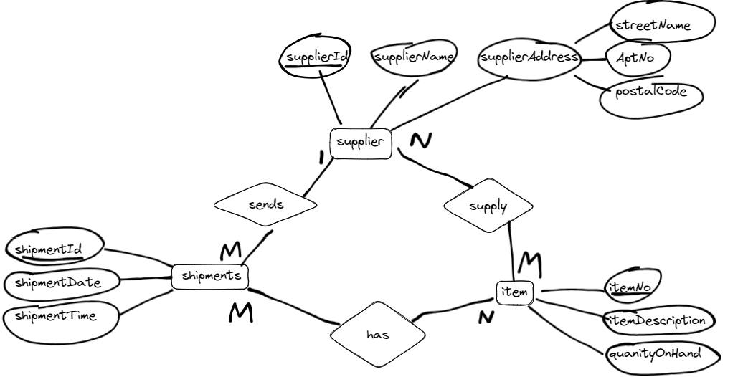

- Create associated tables

Supplier (supplierId, supplierName, streetName, aptNo, postalCode)
Shipments (shipmentId, shipmentDate, shipmentTime, supplierId*)
Item (itemNo, itemDescription, quantityOnHand)
Supply (itemNo*, supplierId*)
Has (itemNo*, shipmentId*)

Question 2:
Provide the tables for the following ERD

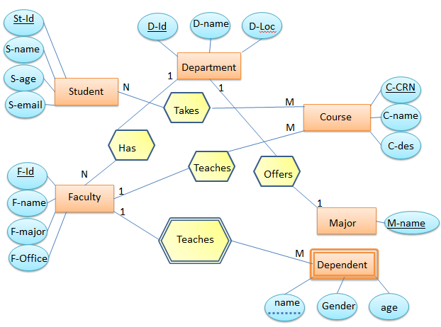

Tables for the ERD above:

Student (St-Id, S-name, S-age, S-email)
Department (D-Id, D-name, D-Loc)
Faculty (F-Id, F-name, F-major, F-Office, D-Id*)
Course (C-CRN, C-name, C-des, F-Id*)
Major (M-name, D-Id*)
Dependent ((F-Id*, name), gender, age)
Takes (C-CRN*, St-Id*)

Question 3:

Provide the tables for the following ERD

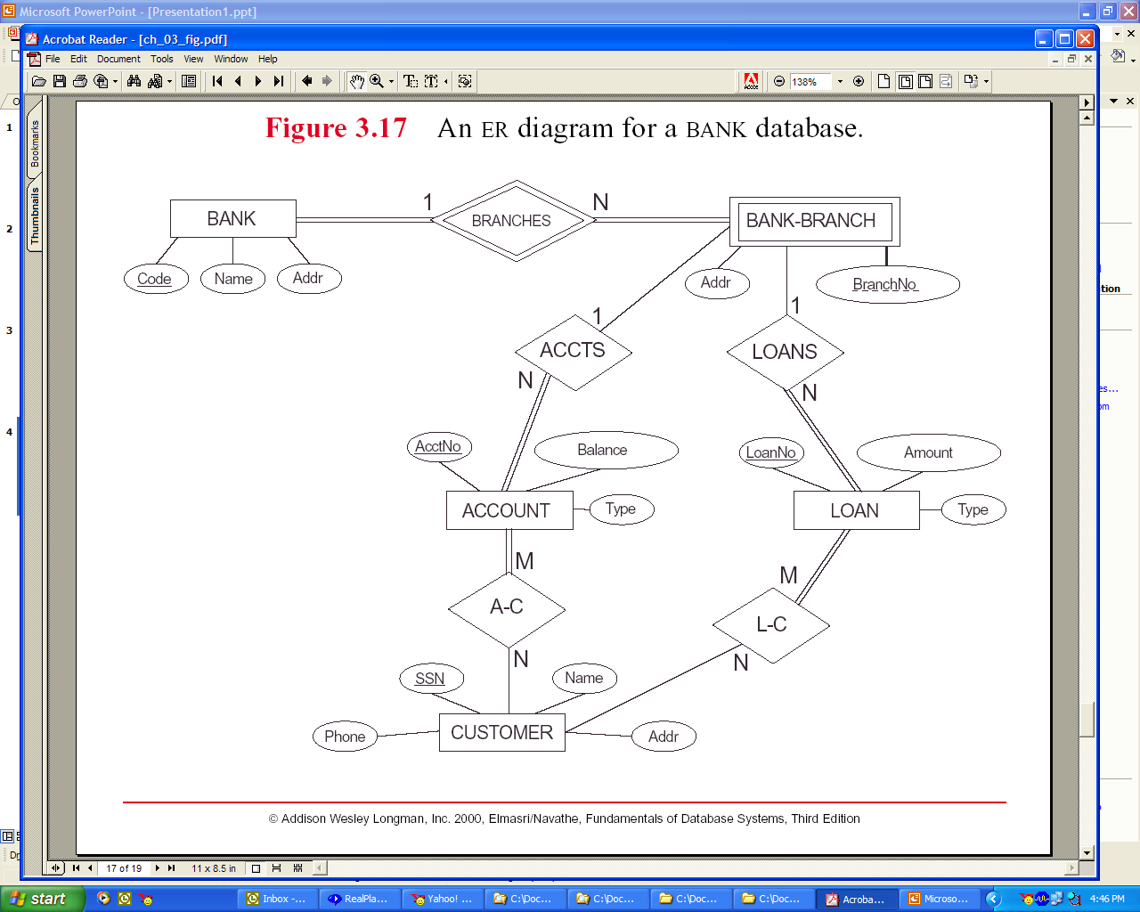

Tables for the ERD above:

Bank (Code, Name, Addr)
Account (AcctNo, Balance, Type, (Code, BranchNo)*)
Customer (SSN, name, phone, addr)
Loan (LoanNo, Amount, Type, (Code, BranchNo)*)
Bank-Branch ((Code*, BranchNo), Addr)
A-C (SSN*, AcctNo*)
L-C (SSN*, LoanNo*)

