CS443 – Lab 5

Question 1:
Use extended hashing technique to insert the employees in which their corresponding binary Empl_IDs are shown below. Assume you can have two employees per block. Show the depth of both global and local directories. The bits should be considered from left to right.

10010, 00001,10000, 00111, 11101, 10100, 11011, 10101, 01111

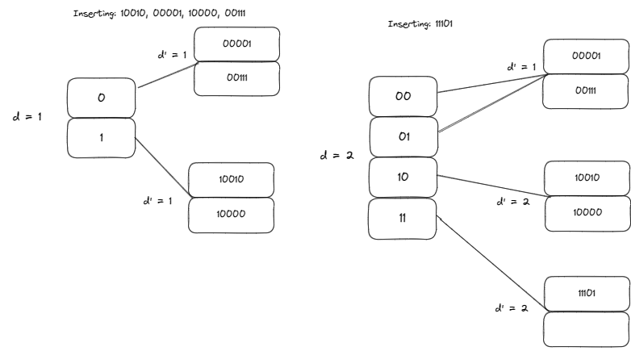
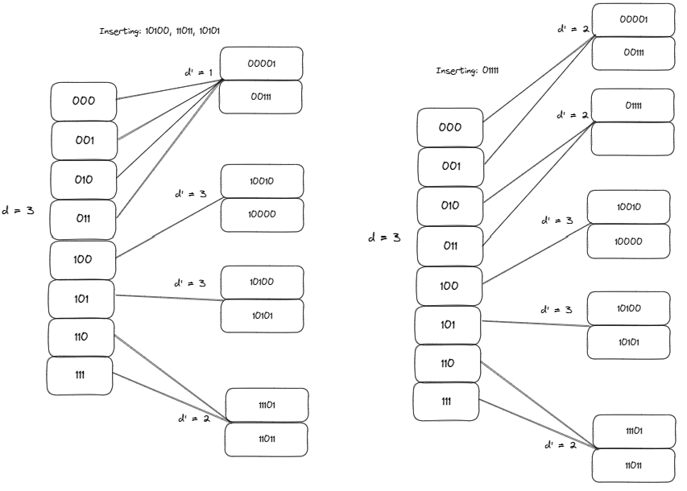

Question 2:
Consider the following records: (Again Digits should be considered from left to right)

00001, 10000, 10100, 00111, 11011, 11101, 10010, 01111, 10101

Load the records into files using Dynamic Hashing Scheme. You can put two records per block. Show the directory at each step, and the global and local depths.

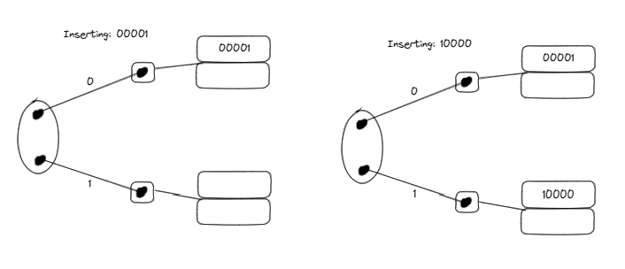
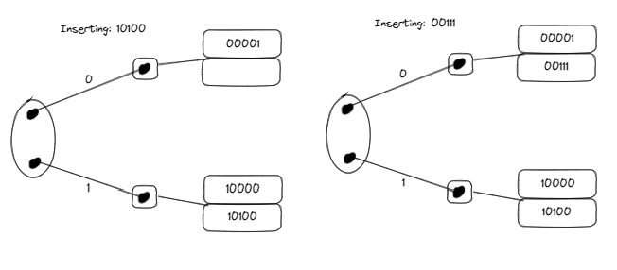
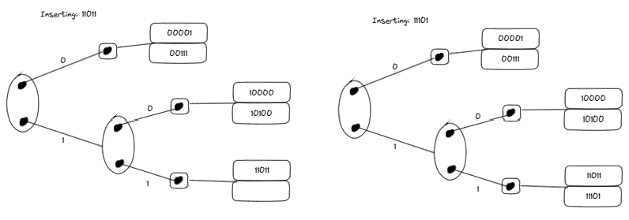
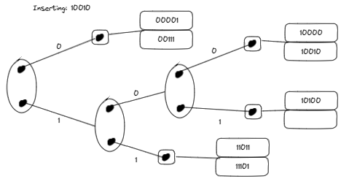
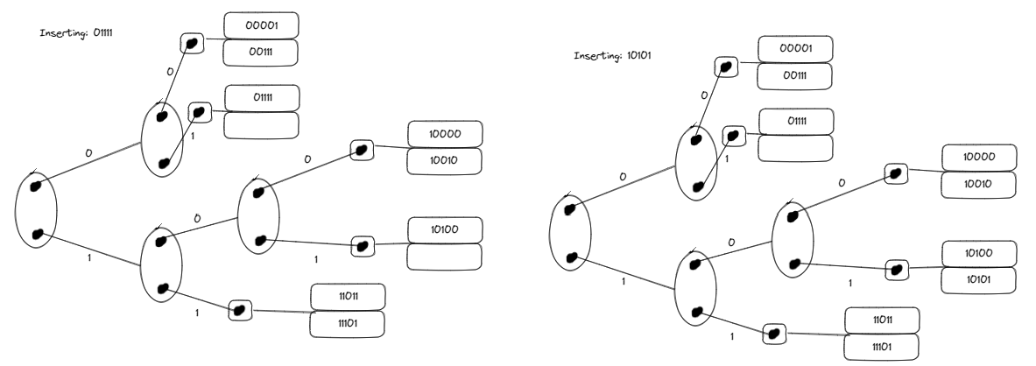

Question 3:
Insert the following into B⁺ tree of order 3. Show your work step by step with proper illustration of pointers as shown in pages 47-54 in multi-way trees lecture

90, 22, 27, 24, 28, 20, 51, 63, 8, 80, 15, 71, 35, 55

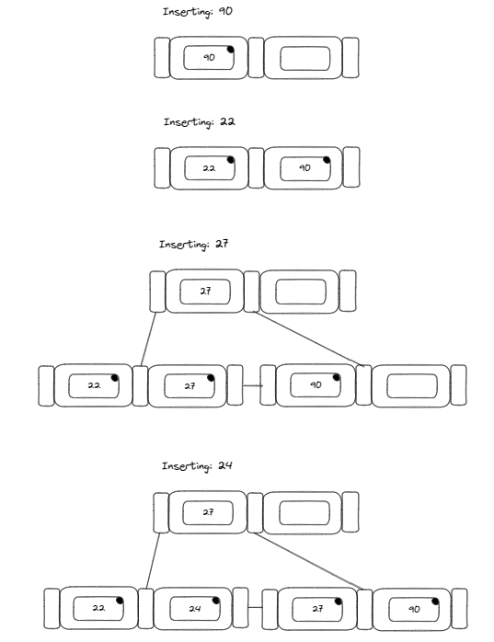
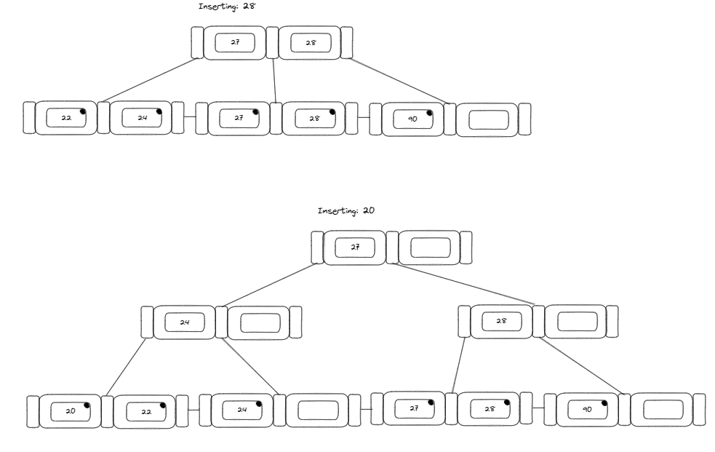
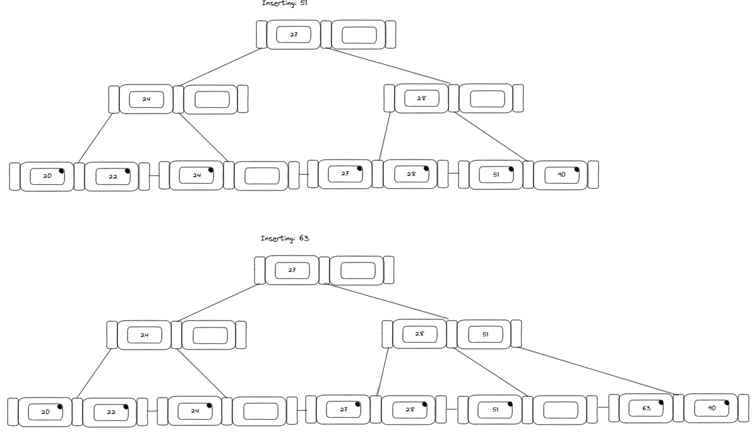
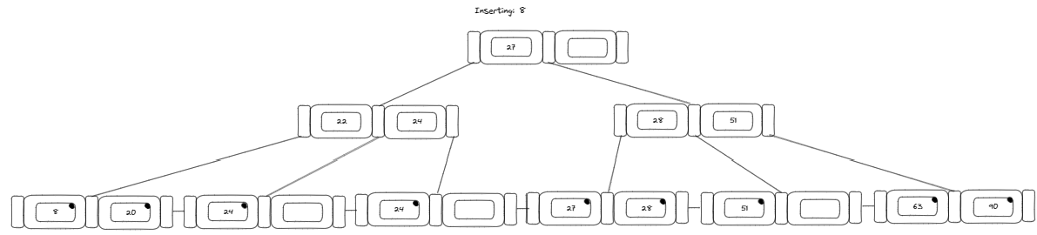
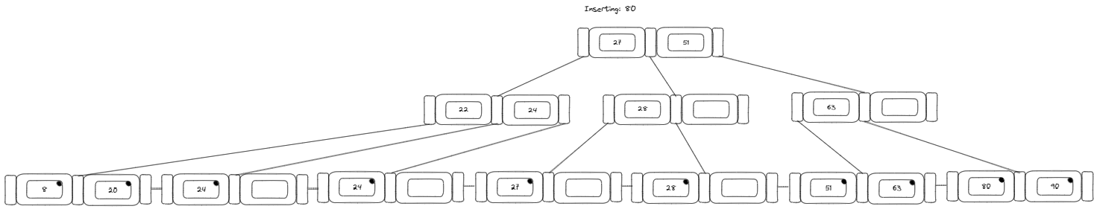
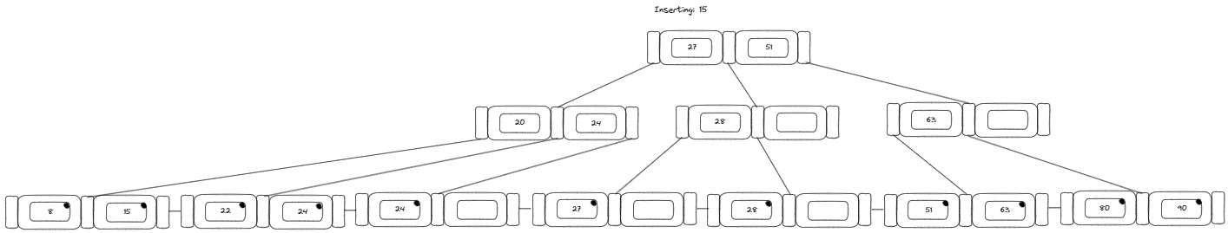
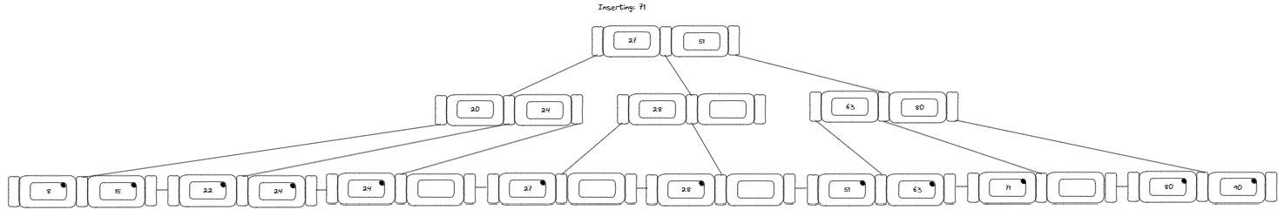
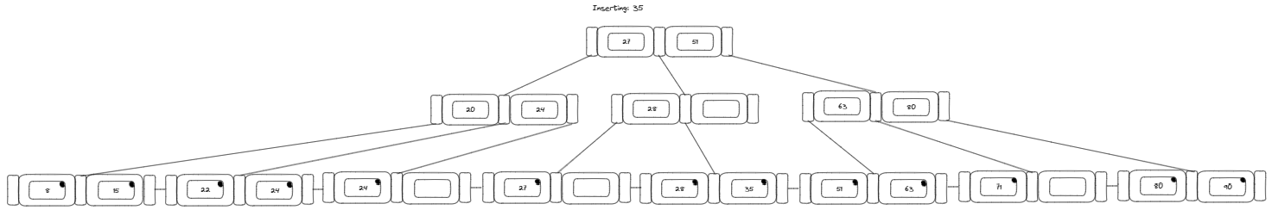
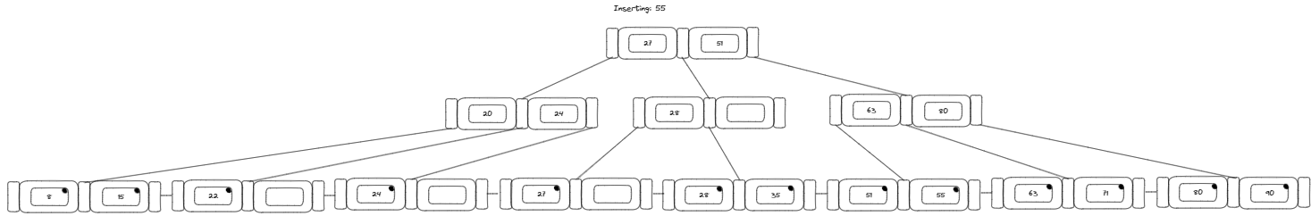

Question 4:

Insert the following into B_ tree of order 3. Show your work step by step with proper illustration of pointers as shown in pages 47-54 in multi-way trees lecture

2, 99, 9, 71, 16, 11, 15, 13, 91, 92, 94

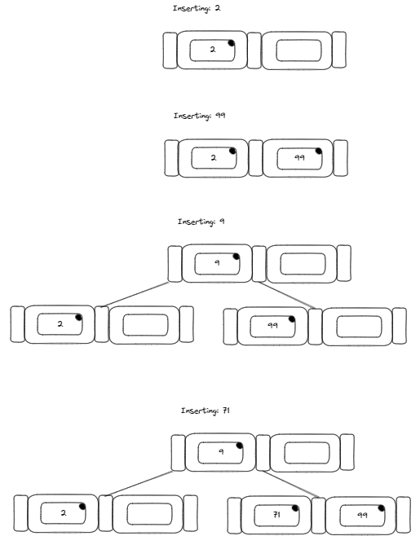
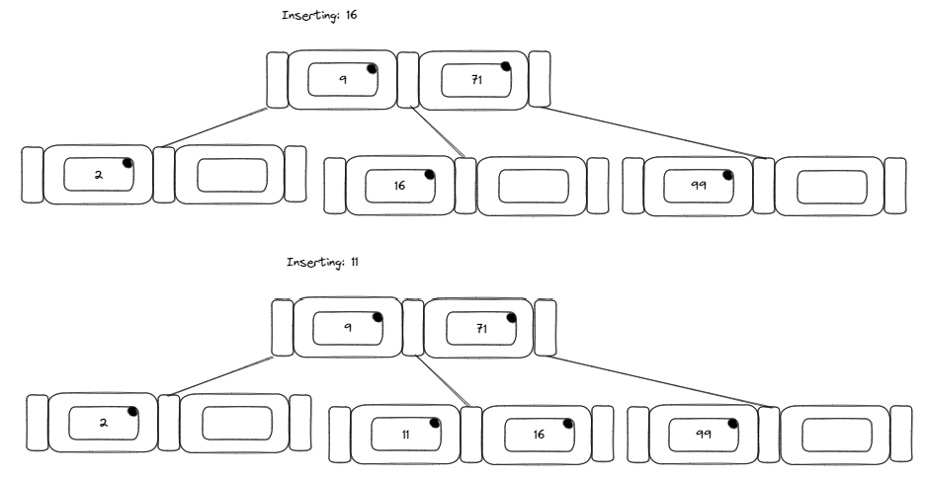
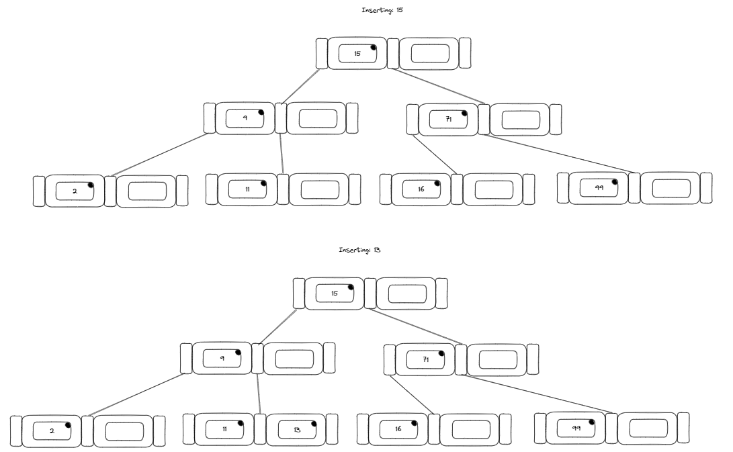
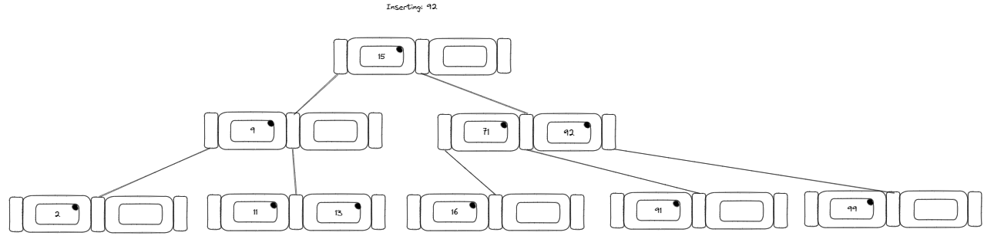
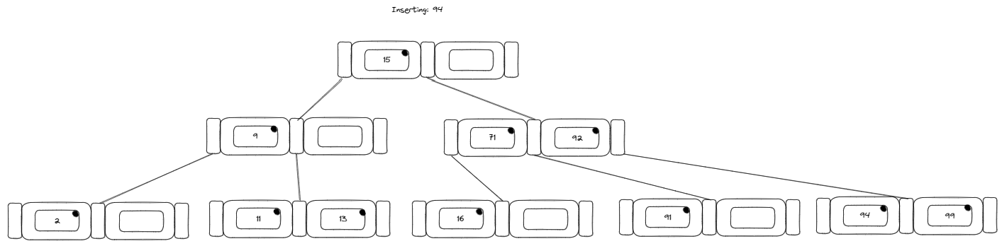

Question 5:

Consider the following B-tree.
a) Redraw the tree after deleting 14.
b) Again, redraw the tree after deleting 15.
c) Again, redraw the tree after deleting 25.

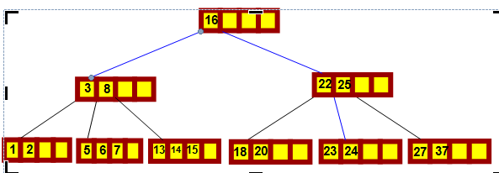

a)
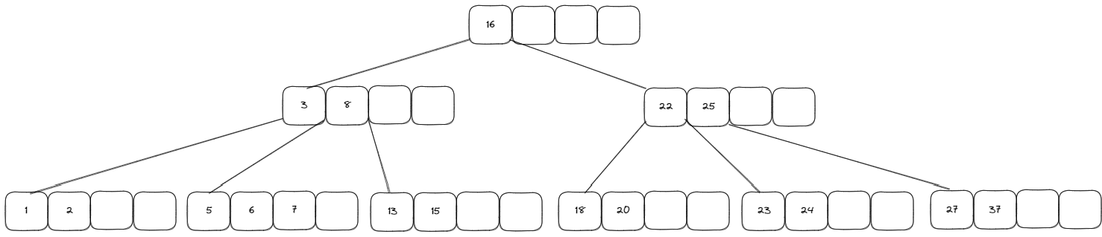
b)
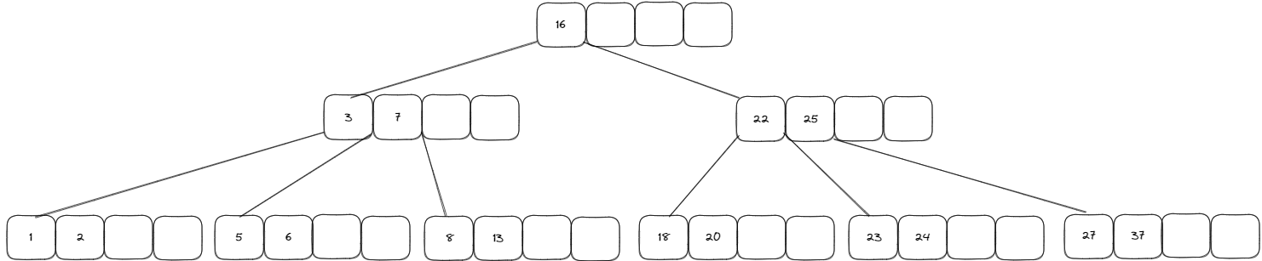

c)
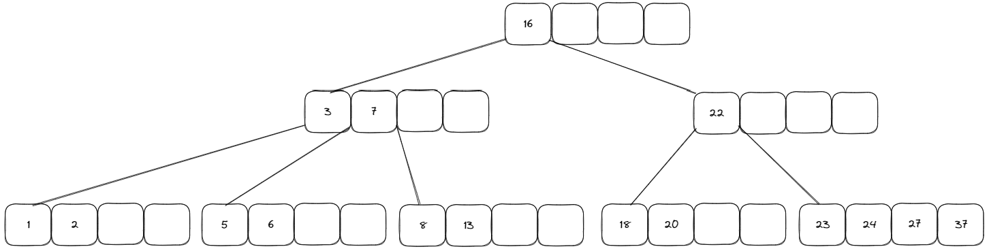

Question 6:
Consider the following B+ tree:

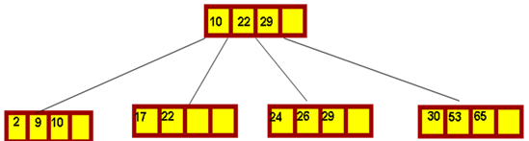

- Delete 29 and redraw the tree after that
- Next delete 10 and redraw the tree after that
- Next delete 26 and redraw the tree after that
- Next delete 24 and redraw the tree after that
- Next delete 9 and redraw the tree after that

a)
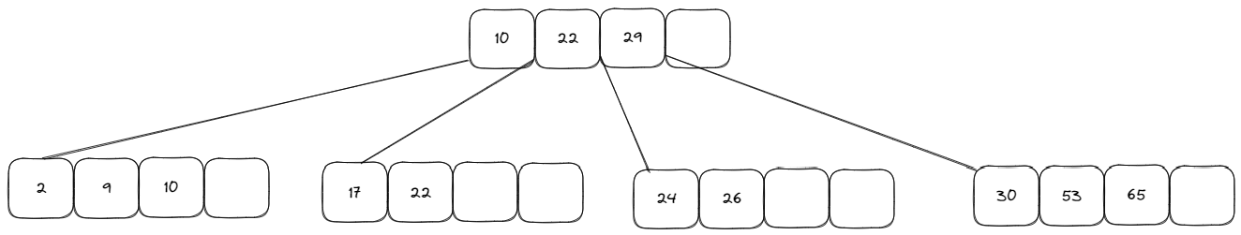

b)
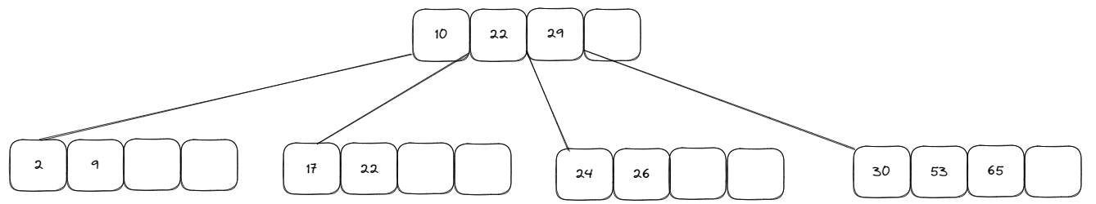

c)
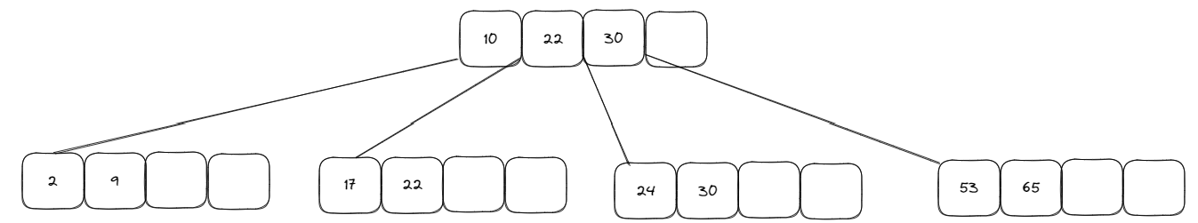

d)
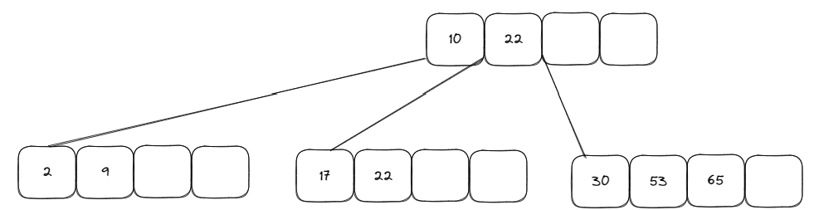

e)
