Lab 6
- Draw the optimization tree for the following query.
SELECT Order_Num, Amount, Company, Name, City
FROM Orders, Customers, Salesreps, Offices
WHERE Cust = Cust_Num
AND Cust_Rep = Empl_Num
AND Rep_Office = Office
AND Amount > 20000

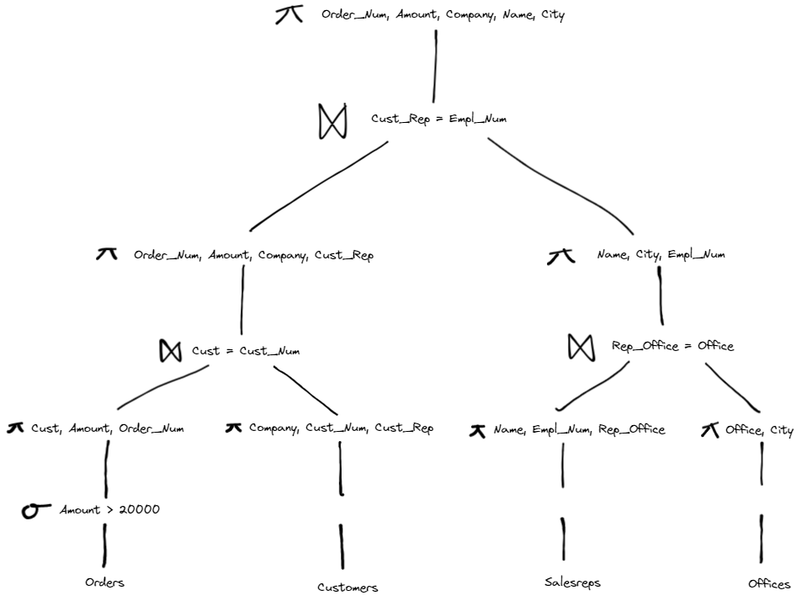

- Draw the optimization tree for the following query.
SELECT cust_num, cust_rep, name, rep_office, city
FROM Customers, Salesreps, Offices
WHERE empl_num = cust_rep, and rep_office = office
AND credit_limit >= 7000
And region = “western”
And office in (12, 13)

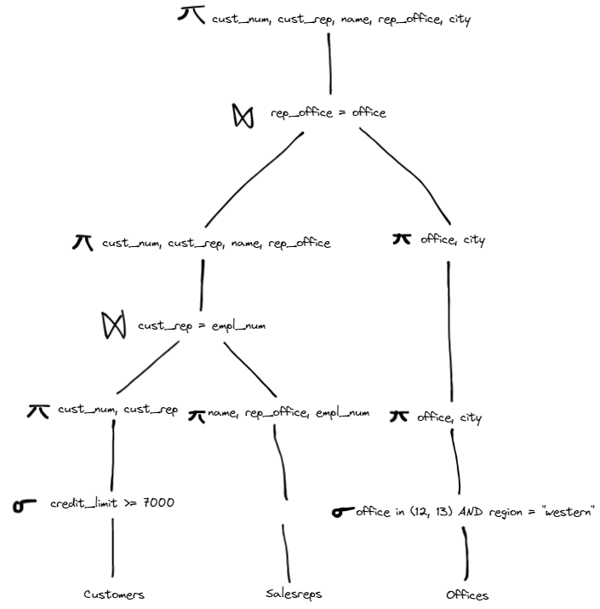
- Some of frequent attacks on the database include: Unauthorized Privilege Escalation, Privilege Abuse, Denial of Service, and Weak authentication. Explain Privilege Abuse and weak Authentication is a few lines. (Slide 2)
Privilege Abuse is when an authorized user views or modifies confidential data, like when an employee accesses confidential salary information on a company. Weak Authentication is when a user’s authentication system is weak and a hacker can easily impersonate a legitimate user.

- One form of Security Injection Attack is called “SQL manipulation”. Suppose we have the following query
SELECT *
FROM users
WHERE username = 'user_input' AND password = 'password_input’;
How can an attacker insert a code in the above query to retrieve the database data without authorization? (Slide 4)
By doing this:
SELECT *
FROM users
WHERE username = ‘’ OR ‘1’ = ‘1’ AND password = ‘’ OR ‘1’ = ‘1’
This condition will equate to True every time because of the ‘1’ = ‘1’ clauses, no matter what the user inputs for the username or password. So, this allows the hacker to login without a valid username or password.

- Rewrite the following query with a php code to prevent the attack (Slide 6)

SELECT *
FROM users
WHERE username = 'user_input' AND password = 'password_input’;
$stmt = $pdo->prepare(“SELECT * FROM users
WHERE username = :username AND password = :password”);
$stmt->execute([‘username’ => $user_input, ‘password’ => $password_input]);

- What are the four types of “Code Injection”? Just name them (no need to explain them).(Slide 7)
- SQL Injection
- Command Injection
- Script Injection
- Buffer Overflow

- Provide examples of “Function Call Injection” where an attacker
  - can find the user id of a database user. Just provide the query. (Slide 14)
SELECT * FROM employees WHERE first_name = ‘’ OR 1=1; SELECT user() --‘;
  - can find the version of database. Just provide the query. (Slide 15)
SELECT * FROM employees WHERE first_name = ‘’ OR 1=1; SELECT version() --‘;
  - can find the currently connected database. (Slide 16)
SELEECT * FROM employees WHERE first_name =’’ OR 1=1; SELECT database() --‘;
  - can drop a table in the database. (Slide 17)
‘ OR 1=1; EXEC xp_cmdshell(‘DROP TABLE employees’) --

- How to prevent the Function call Injection? Give a PHP code with pdoPrepare function that blocks attacker from function call injection. (Slide 19)
One way to prevent a Function call Injection is by using prepared statements or parameterized queries. Here is an example:
$stmt = $pdo->prepare(“SELECT * FROM employees WHERE first_name = :first_name”);
$stmt->execute([‘first_name’ => $user_input]);

- What are the typical risks associated with SQL Injection. Just name them, no need to provide any explanation. (Slides 20, and 21)
Database Fingerprinting, Denial of Service, Bypassing Authentication, Identifying Injectable Parameters, Executing Remote Commands, Performing Privilege Escalation.

- What are the three forms of protections against SQL Injection. Give example queries of each method. (Slide 22, 23, and 26)
- Bind Variables (using parameterized Statements);
PreparedStatement stmtconn_PrepareStatement
(Select * FROM EMPLOYEE
WHERE EMPLOYEE_ID=? AND PASSWORD=?”);
Stmt.setString1.employee_id;
Stmt.setString2.password;
- Filtering Input (Input Validation):
cursor.execute(“SELECT * FROM users WHERE username = ?”, (input_username_escaped,))
- Function Security:
cursor.execute(“SELECT * FROM users WHERE username = ?”, (user_input,))

