**Red: Answer**

**Green: Not sure**

**Blue: Detailed Explanation or Subjective answer**

L1

•Mention four architectural levels of computer systems.

–The assembly language level.

–The instruction set architecture level. 指令集结构层

–The micro architecture level. 微体系结构层

–The digital logic level.

•What does CPU stand for? ALU?

Central Processing Unit，Arithmetic Logical Unit

•What are the components of a computer system?

hardware & software

•Mention 4 different types of computers.

•Mainframe computers (1960s) 大型计算机

•Supercomputers (1970s) 巨型机

•Workstations (1980s) 工作站

•Microcomputers (1980s) 微型计算机

•Personal computers (1980s) PC

•‘Servers’ are facilitated via the availability of ?

–network

–Web

–Cloud

•Define the areas of study for ‘computer systems’.

Computer Hardware:

–input

–processing

–output

–storage

–communications

System software

–communication with hardware

–resource management

–facilitates communication among application programs

•Define ‘Downward Compatibility’.

•Most software written for computers with old hardware can be run on computers with newer hardware

•What is the description language that can be used to design high speed IC hardware?

VHDL——Very-High-Speed Integrated Circuit Hardware Description Language

•What are the advantages of having a hierarchical approach to computer system?

•Functionalities of hardware systems can be brought out by operating systems and thus offered to the user.

•The user’s programs interact with hardware systems through the functionalities provided by operating systems. –Ease of programming. –Protection for the system and for other users. –Fairness and efficiency of using system resources

•What is Moore’s Law?

–The amount of circuitry (number of transistors) which can be placed on a given chip area approximately doubles every two years.

•Functionalities of hardware systems can be brought out by what and thus offered to the user?

operating systems

•What are the advantages of having ‘operating systems’ wrapping around the computer hardware?

The user’s programs interact with hardware systems through the functionalities provided by operating systems.

–Ease of programming.

–Protection for the system and for other users.

–Fairness and efficiency of using system resources

•WIMP stand for? WIMP is available due to the development of ?

•Windowing interfaces –WIMPs.

•A by-product of the microprocessor revolution, which allowed all users to have fast bitmapped graphics on their desks

•What is the focus of scientific computing ?

-computation

•What is the focus of business computing ?

-data

•What is the major characteristic of personal computing?

-interaction

L2

•Using a diagram, illustrate the concept of InputProcess-Output Model

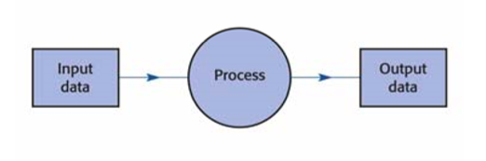

•Which model gives the fundamental structure of the current generation of digital computers?

The Input-Process-Output Model

•Process is controlled by what?

The process is to be controlled by a special, custom-made program.

•Highlight the three components required for the implementation of Input-Process-Output and von Neumann model.

–Hardware.

–Software.

–Data that is being manipulated.

•Name 5 examples of computer hardware.

–CPU, memory, hard disk, keyboard, display screen, …

•Identify the active part within a computer which performs calculations and other operations.

Central Processing Unit (CPU)

•Which part of a computer holds data and programs for access by CPU?

The main memory(primary storage or working storage), or RAM (for random access memory) holds data and programs for access by CPU.

•Give 3 examples of secondary storage.

–Long-term storage.

–Holds programs and data.

–Hard disk, CDs, DVD, etc.

•Give 3 examples of input devices.

keyboard, mouse, scanner, etc.

•Give 3 examples of output devices.

monitor, speaker, printer, etc.

•Define ‘software’.

To make it perform useful tasks, these simple steps are combined in the form of programs, which are collectively known as software.

•Difference between these two models – Input-Process-Output model & von Neumann model?

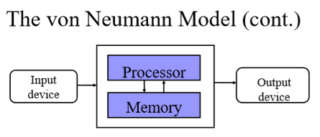

•For a particular machine, the machine instruction set is usually fixed. True or false?

True. Every CPU has its own instruction set (100200 instructions, typically). –For a particular machine, this set is fixed.

•There exists a standard instruction set for industry purpose. True or false?

•Although the instruction sets of different CPUs are similar, there is no standard instruction set.

•High Level Programming Languages (HLLs) are more suitable for programming than the languages of machine instructions. Why?

it may use [natural language](https://en.wikipedia.org/wiki/Natural_language) elements, be easier to use, or may automate (or even hide entirely) significant areas of computing systems (e.g. [memory management](https://en.wikipedia.org/wiki/Memory_management)), making the process of developing a program simpler and more understandable than when using a lower-level language.

•Mention 4 major categories of machine instructions.

•Input-output: IN,OUT (Intel x86 and Pentium, but does not exist in some CPUs),…

•Data transfer and manipulations: MOV, ADD,MUL,AND,OR,…

•Transfer of program control: JMP, JC, …

•Machine control: can halt processing, reset the hardware, INT, HLT…

•Why HLL programs need to be translated before execution?

Machines cannot understand the HLL.

•What is the von Neumann model?



•Both ?and ? are held in computer’s memory (store) and both represented by?

Program and data

•Identify the von Neumann bottleneck.

–CPU is continuously forced to wait for vital data (and instructions) to be transferred to or from memory.

•How could computers distinguish data from instructions since they are both represented by binary codes?

– Data and instructions are stored in memory.

– CPU knows where to fetch program instructions.

– Central Processing Unit (CPU) executes the program instructions.

– Instructions and data have to be in a special coded form in order to be understood by CPU.

•What is the main difference between von Neumann machine and Harvard architecture?

–Separates data from programs.

–Requires different memories and access buses for programs and data.

–The intention is to increase transfer rates, improving throughput.

•Motivate the use of Harvard architecture.

[Digital signal processors](https://en.wikipedia.org/wiki/Digital_signal_processors) (DSPs)

[Microcontrollers](https://en.wikipedia.org/wiki/Microcontrollers)

•What is the additional cost from the usage of Harvard architecture?

•Most desktop CPUs have an internal "instruction cache" feeding the control unit and a completely separate "data cache“. This mimicks which computer architecture?

Harvard Architecture

L3

•Name 4 examples of HLLs.

A: Python; Java; C; C++; Lisp; FoxPro; Prolog

•Translation fills in the semantic gap in computer systems. (True of false?)

A: True

•Name 3 different ways of translation. Identify the crucial role of translation under each.

A: Compilers: translating HLL instructions into machine code before the code can be run on the machine;

Assemblers: translating mnemonic form of machine instructions into their binary codes;

Interpreters: translating HLL instructions into machine code on-the-fly

•When compile-time errors occur, what do we do?

A: Check the HLL source file

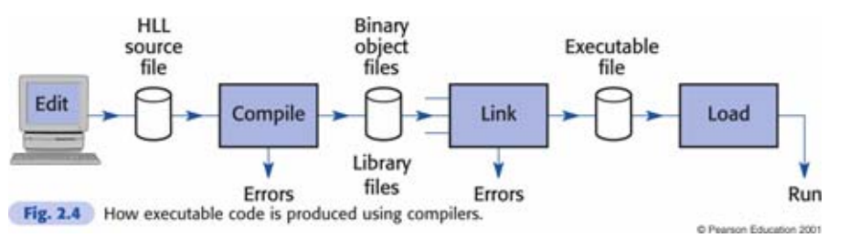

•What are the purposes of linking?

A: Resolving external references

•‘Loading’ is carried out before ‘linking’ after a program is compiled. (True or false?)

A: False

•Program modules can be compiled separately. (True or false?)

A: True

•A compiler can translate a module into binary codes, but it cannot resolve those references to other modules. This occurs when …?

A: The linker does not work

•Library files are usable if linked into your program code. (True or false?)

A: True

•Interpreters typically convert program code into what?

A: Tokens

•What is the output of program compilation?

A: Assembly language

•Name 2 scenarios where interpreters are more useful than compilers.

A: Interpreters are more suitable for rapid prototyping:

Interpreters are more accurate in terms of error reporting;

Interpretation can provide uniform execution environment across several diverse computers

•Interpreters are sometimes called as virtual machine because … ?

A: Interpreters are somewhat similar to the computer hardware (CPU)

•Mention 3 approaches to code sharing.

A:

Source-level subroutines and macro libraries.

Pre-translated re-locatable binary libraries.

Dynamic libraries and dynamic linking.

•Name 2 disadvantages (or issues) of macro libraries.

A: The code owner

The code maintainer

•Libraries can be linked into your program code, but not altered. (True or false?)

A: True

•What are the disadvantages of program execution with pre-translated program library?

A: Each program is to have a private copy of the subroutines, wasting valuable memory space, and swapping time, in a multitasking system.

•There exists a de-facto standard of dynamic libraries and dynamic linking.(True or false?)

A: True (ActiveX standard)

L4

•Define ‘bit’.

A: A bit is the most basic unit of information possible: it contains the information necessary to distinguish two alternatives

•Decimal notation is more compact than binary. (T or F).

A: False

•Binary is more “convenient” for computers due to ? two-state, ON/OFF technology employed.

•Every number can be used as a base. (T or F).

A: True

•Hexadecimal notation uses ? as a base. 16

•Octal notation uses ? as a base. 8

•Why do we use hexadecimal,or base 16, number notation?

A: Convenient shorthand for binary numbers.

Every hexadecimal digit exactly represents 4 binary bits.

•How many bits are required to encode ASCII? 7 bits

L5

Q: The most widely used binary code with non–IBM mainframes and virtually all microcomputers, is •a. EBCDIC •b. DOS •c. ASCII •d. LAN

•Q. Which of the following coding schemes is not yet commonly used? •a. Unicode •b. EBCDIC •c. ASCII •d. All of the above are common coding schemes.

•Q. A drawback to ASCII is that it

•a. cannot handle all the characters of some languages other than English and European languages. •b. uses only 4 bits to form each character.

•c. is slower than EBCDIC.

•d. None of the above is correct.

•ASCII is divided into two classes of codes?

–Printing characters. –Control characters.

•What is the most widely-used standard for floating-point computation?

IEEE 754 standard.

•Two things happen when you declare variables in a program. What are they?

–You are telling the compiler to reserve the correct amount of memory space to hold the variable. –You are also telling the compiler what encoding/decoding/representation scheme to be used.

L6

•What is the most important development during the past 40 years evolution of OS?

Only the introduction of windowing interfaces really distinguishes

•OS needs to provide fair & protected access to system resources, why?

•Explain ‘multi-tasking’.

•Windows: Programs can run simultaneously, if they are not too resource consuming. (Same with Unix and Linux.)

•Mention 3 functions that need to be provided when an OS is to support ‘multitasking’.

–Program to allocate memory and other resources to each program. (memory manager)

–Program to allocate CPU time to each program (scheduler: more details later on).

–Program to maintain integrity of each program. (security kernel)

•Explain ‘multi-user’.

Multi-user [software](https://en.wikipedia.org/wiki/Software) is software that allows access by multiple [users](https://en.wikipedia.org/wiki/User_(computing)) of a [computer](https://en.wikipedia.org/wiki/Computer). [Time-sharing](https://en.wikipedia.org/wiki/Time-sharing) systems are multi-user systems.

•How does operating system provides access to network facilities?

(via networking API, e.g. socket interface)

•Telecommuting or online shopping are enabled through the introduction of ?

Connectivity

L7

• Name 2 typical applications run by coprocessors.

– math

– graphics

• Name 3 different types of bus in a computer system.

address, data and control buses

• List two reasons behind bus bottleneck.

A bus can only transfer one item of data at a time, like a railway line.

• Highlight the 2 major components of a CPU.

1.ALU: Arithmetic and Logic Unit.

2.Control unit.

• What tasks are performed during a machine cycle.

• Fetch the instruction from memory. This step brings the instruction into the instruction register, a circuit that holds the instruction so that it can be decoded and executed

• Decode the instruction

• [Read the effective address from memory if the

instruction has an indirect address]

• Execute the instruction

• [Store the results]

• Computers & printers are usually connected via what type of ports?

Parallel port (IEEE 1284)

• RISC refers to

• a. RAM that supports fewer instructions than do CISC chips.

• b. instructions that support fewer codes than do CISC chips.

• c. processors that support fewer instructions than do CISC chips.

• d. coding schemes that are used as a back–up to CISC.

• Q: The computer's main processor follows its instructions to manipulate data into information.

• a. hardware

• b. CPU

• c. software

• d. Unicode

• Q: This type of hardware consists of devices that translate data into a form the computer can process.

• a. application

• b. input

• c. system

• d. None of the above is correct.

• Q. Name 4 registers that are always used during each instruction execution.

**L8**

• The ‘execute’ phase is the same for different types of instructions. (T or F?)

F The execute phase depends on the type of instruction.

• The assembler program takes as input a program written in assembly language, and translate

instructions into ? form.

Translate instructions into their binary machine-code form.

• Assembler associates labels with ?

Associates labels with memory addresses.

• A CPU may execute only instructions loaded in the main memory (T or F ?).

T

• Access time is the same for all the RAM cells (T or F ?).

T Access time is the same for all the stored items.

• Q. What is the meaning of

MOV EBX, [EBX] ?

Get the value into EBX using EBX as the memory pointer.

What is the side effect of this instruction?

buzhidao

• Q. JNZ L2 means ?

If the result is not zero, then jump to L2.

• When will there be compile time error for

the above instruction?

L2 doesn’t exist.

• Is this valid assembly code?

• MOV maxval, loc1

No

**L9**

• Name 3 use cases of the Flag register in Pentium.

1) EFLAG: The Flag register holds the CPU status flags.

2) The status flags are separate bits in EFLAG where information on important arising conditions such as overflow or carry bits, is recorded.

3) A way of communication between one instruction and the subsequent instructions.

• The Flag register can be used to pass information between one instruction and the subsequent instructions. (T or F?)

T (上题 3) )

• Which register is used to store the result of subtraction from this instruction? CMP AL, BL

Z flag

• Under inline assembly, what mechanism is used to pass arguments to printf routine ?

To pass arguments to **printf** we use a **stack**.

• Q. Inline assembler can be used to call a C library function within an assembly segment in a C program (True or False).

T

• Q. Status flags are set (or cleared) before an instruction is being executed. (True or

False)

T

• Q. D Flag is used to set the direction of looping.

F It is to set the direction of accessing string arrays.

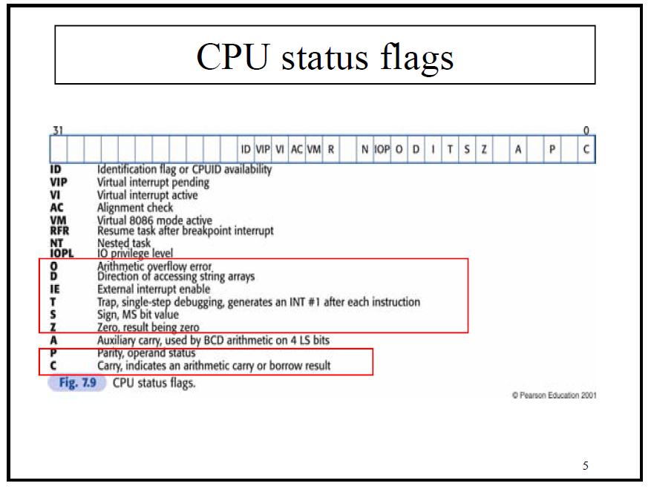

**L10**

• Q. The Pentium instruction set has a fixed width for all instructions to speed up instruction decoding.

T

Pentium instructions can be from 1 to 15 bytes

long, depending on:

– The operation required.

– The addressing modes employed.

• Q. Which sample program is more efficient? (slide 12 vs slide 14)

14

• What are those 3 major components covered by every instruction?

– The action or operation of the instruction.

– The operands involved (where to find the information to operate with).

– Where the result is to go.

• Machine instructions are encoded with what to contain information about the operation required?

Machine instructions are encoded with **distinct bit fields in the prefix** to contain information

• Which of the following is the fastest to execute?

– mov eax, b

– mov a, ebx

– mov eax, ebx This one.

• Q. The following instruction will involve the calculation of ‘effective address’.

(T or F)

• mov eax,table[esi] T

• Q. After the execution of the following instruction, eax will contain the content of

message1 inside. (T or F)

• lea eax, message1 F Address only.

**L11**

• Q. To pass two parameters to *printf* in inline assembly code, the first parameter should be pushed onto the stack first. (True or false)

F

• Q. When calling *printf* in inline assembly, the parameters passed to it will be popped

off stack by *printf*. (True or false)

F

• Q. When calling *scanf* in inline assembly, the address of the variable to receive input needs to be pushed onto the stack. (True or false)

T

• Q. What is the conversion specifier to be used when printing a string under *printf*?

%s

• Q. If three integer parameters were pushed onto stack when calling ‘scanf’ in inline

assembly, how would you adjust the value of register ‘esp’ when returning from

‘scanf’?

12

• Q. The execution of

**cmp eax,ebx**

will check upon the setting of zero flag.

(T or F)

T

**L12**

• Q. Conditional jumps in assembly can be used to implement HLL constructs like

while, for and switch. (T or F)

T

• Q. ‘loop’ instruction in assembly has a branching effect based upon the value of

decremented ECX register. (T or F)

T

• Q. Explain what ‘LOOPNE label’ does.

The loop upon two conditions

• Q. Explain what the following instructions do.

CMP EAX, EBX

LOOPNE label

If eax and ebx are same or 200 times already, then the program continue. Else it goes to next.

**L13**

• Q. A subroutine can be called at various moments from different places in the main program. (T or F)

T

• Q. A subroutine can be called by itself. (T or F)

T

• Q. How many return addresses can you store using a stack?

As many as you want

• Q. How many nested calls can you make within a program?

As many as you want

• Q. How does the computer know when to return from a subroutine?

One needs to store a return address for every call of the subroutine.

• Q. What happens when a ‘CALL …’ instruction is executed?

– Records the current value of EIP (Instruction Pointer) as the return address.

– Places the required subroutine address into EIP (instruction Pointer) , so the next instruction to execute is the first instruction of the subroutine.

• Q. What happens when a ‘RET’ instruction is executed?

– Pop the last address stored in the stack and put it into EIP

**L14**

• Q. When is value parameter good for?

In the cases that additional information required by a subroutine is the values of variables.

• Q. When is reference parameter good for?

It needs the address of the variables as an additional information.

• Q. Why multiple stack frames can coexist at the same time?

Because of the nested calls several stack frames may be present at the same time.

• Q. What type of data are stored under a stack frame?

– Parameters of the subroutine.

– Return addresses.

– Local variables.

**L15**

• Q. A recursive procedure will typically provide an exiting condition. (T or F)

T

• Q. A recursive procedure will typically have a divide-and-conquer step. (T or F)

T

• Q. What is the side-effect of the procedure multiply’?

– Stack modified (2 pops)

– eax original contents replaced with the product

• Q. A recursive procedure can always be reimplemented using iteration without recursion. (T or F)

F

**L16**

• Q. What are the pros & cons of BCD? Binary-coded decimal

P: BCD is less economical than binary representation

Translation between BCD and character form is easier

C: Calculations in BCD are more difficult

BCD is used for some business applications. ( Binary representation is more common)

• Q. Is it possible to have a 3’s complement scheme?

Yes

• Q. Can overflow still occur under 2’s complement addition?No

• Q. What are the pros & cons of 2’s complement?