**Problem Session Week 11 Thursday 3 May**

# Question 1



1

Continue the backtracking search for a solution to the four-queens problem, which was given in this week's lecture, to find the second solution to the problem. Explain how the board’s symmetry can be used to find the second solution to the four-queens problem.

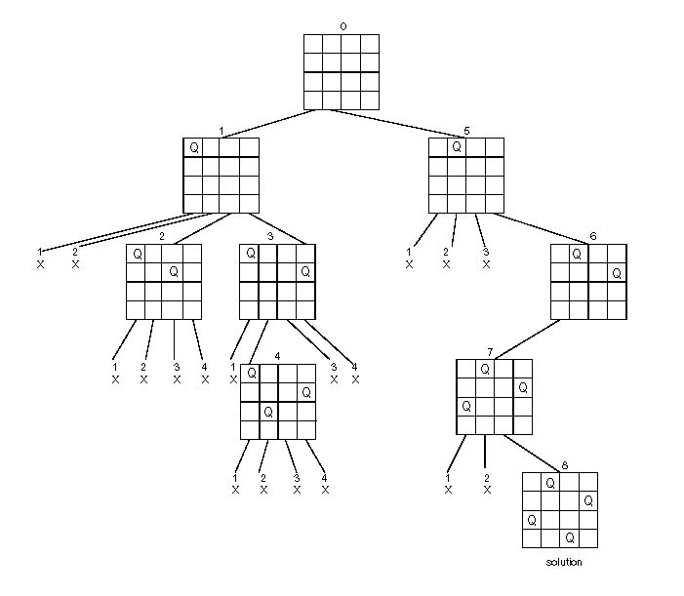

**Answer:** Since the board is symmetric, if the first queen is at 1st row and 4th column, that is the same situation as node 1. Similarly, if the first queen is at 1st row and 3rd column, that is the same situation as node 2. Therefore, the second solution is an axisymmetric shape of the first solution, which is shown below.

|  |  |  |  |
| --- | --- | --- | --- |
|  |  | Q |  |
| Q |  |  |  |
|  |  |  | Q |
|  | Q |  |  |

# Question 2

Apply backtracking to the problem of finding a Hamiltonian circuit in the following graph (starting from vertex *a*)



a

b

c

d

e

f

g

**Answer:**



# Question 3

Solve the same instance of the assignment problem as the on solved in the section by the best-first branch-and-bound algorithm with the bounding function based on matrix columns rather than rows.

|  |  |  |  |  |
| --- | --- | --- | --- | --- |
|  | Job1 | Job2 | Job3 | Job4 |
| Person a | 9 | 2 | 7 | 8 |
| Person b | 6 | 4 | 3 | 7 |
| Person c | 5 | 8 | 1 | 8 |
| Person d | 7 | 6 | 9 | 4 |

**Answer:**

Lb=5+2+1+4=12.

At first, the lower bound is 12.



Thus, the node 14 is the best solution. The lower bound is 13.

# Question 4

Apply the branch-and-bound algorithm to solve the travelling salesman problem for the following graph.

1



2

a

b

5

8

7

3

c

d

**Answer:**

distance matrix:

|  |  |  |  |  |
| --- | --- | --- | --- | --- |
|  | a | b | c | d |
| a | 0 | 2 | 5 | 7 |
| b | 2 | 0 | 8 | 3 |
| c | 5 | 8 | 0 | 1 |
| d | 7 | 3 | 1 | 0 |

Lb = [(2+5)+(2+3)+(1+5)+(1+3)]/2=11.

