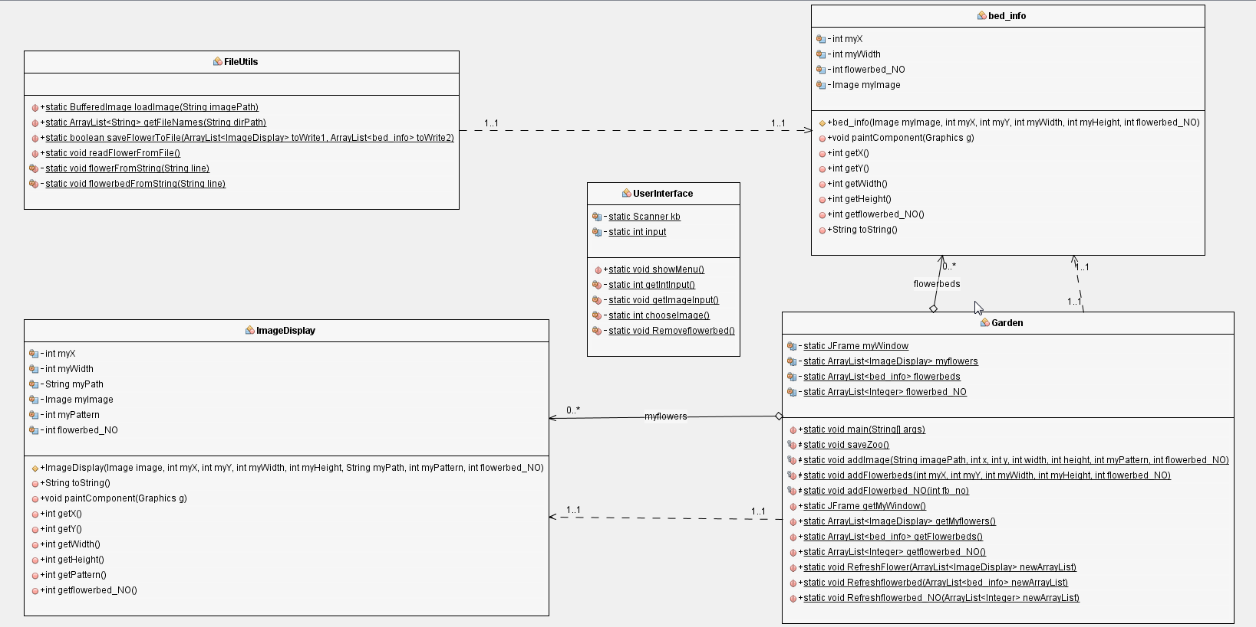

1. Garden Class

Garden class is the main class. It includes the main method which is responsible for controlling the whole program. It also consists of public methods to let other class get the value of the private variables such as ‘myWindow’, the ArrayList ‘myflowers’, ArrayList ‘flowerbeds’ and ArrayList ‘flowerbeds_NO’. Other public methods such as ‘RefreshFlower’, ‘Refreshflowerbed’ and ‘Refreshflowerbed_NO’ which are responsible for refreshing the data in the ArrayLists when a flowerbed is removed.

2. UserInterface Class

UserInterface Class’ s function is to interact with users to get the input and ensure all the input is valid. After all the data has been scanned in, objects will be created and added to the window.

3. FileUtils Class

This class is used for saving and reading the objects’ information in the text file.

4. ImageDisplay Class

ImageDisplay Class extents Jpanel which is used for creating a new ‘ImageDisplay’ object in other class. It contains a constructor to record all the flowers information and public ‘get’ methods which serve other class to get key values of flowers. It should be mentioned that the ‘paintComponent’ method in this class judges which pattern the user choses and offers corresponding painting method. For example, if the user chose ‘vertical’ strip pattern. Assuming that the image of flower is at the position (x, y), then x will be set as a constant value and y will be added for each loop. Meanwhile, flowers will be added on the window for each (x, y). Similarly, if y is set as constant value and x increases for each loop, this can be applied to ‘horizontal’ strip pattern.

5. bed_info Class

bed_info Class extents Jpanel which is used for creating a new ‘bed_info’ object in other class. It contains a constructor to record all the flowerbeds information and public ‘get’ methods which serve other class to get key values of flowerbeds. And the ‘paintComponent’ method in this class is responsible for adding the background image in the flowerbeds.