CSE102 Algorithmic Foundations
Problem Session 2
(11:00 – 13:00, 4th April, 2018, Wednesday/Week 6)
________________________________________________________________________

Question 1

Consider the following graph G.
a
b
c
d

e
f
g
h

  - Give the adjacency matrix and adjacency list of the graph G.

 | a | b | c | d | e | f | g | h
a | 0 | 1 | 0 | 0 | 1 | 0 | 0 | 0
b | 1 | 0 | 1 | 0 | 0 | 1 | 0 | 0
c | 0 | 1 | 0 | 1 | 0 | 0 | 1 | 0
d | 0 | 0 | 1 | 0 | 0 | 0 | 0 | 0
e | 1 | 0 | 0 | 0 | 0 | 1 | 0 | 0
f | 0 | 1 | 0 | 0 | 1 | 0 | 1 | 0
g | 0 | 0 | 1 | 0 | 0 | 1 | 0 | 1
h | 0 | 0 | 0 | 0 | 0 | 0 | 1 | 0

A b e
B a c f
C b d g
D c
E a f
F b e g
G c f h
H g

- Give the incidence matrix and incidence list of the graph G.
 | a | b | c | d | e | f | g | h
e1 | 1 | 1 | 0 | 0 | 0 | 0 | 0 | 0
e2 | 0 | 1 | 1 | 0 | 0 | 0 | 0 | 0
e3 | 0 | 0 | 1 | 1 | 0 | 0 | 0 | 0
e4 | 1 | 0 | 0 | 0 | 1 | 0 | 0 | 0
e5 | 0 | 1 | 0 | 0 | 0 | 1 | 0 | 0
e6 | 0 | 0 | 1 | 0 | 0 | 0 | 1 | 0
e7 | 0 | 0 | 0 | 0 | 1 | 1 | 0 | 0
e8 | 0 | 0 | 0 | 0 | 0 | 1 | 1 | 0
e9 | 0 | 0 | 0 | 0 | 0 | 0 | 1 | 1

e1 | a | b
e2 | b | c
e3 | c | d
e4 | a | e
e5 | b | f
e6 | c | g
e7 | e | f
e8 | f | g
e9 | g | h

- Starting at the vertex a and resolving ties by the vertex alphabetical order traverse the graph by breadth-first-search (BFS) and construct the corresponding BFS tree.

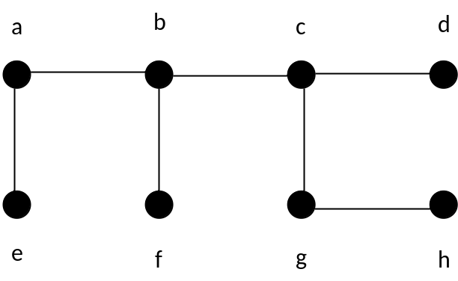

- Starting at the vertex a and resolving ties by the vertex alphabetical order traverse the graph by depth-first-search (DFS) and construct the corresponding DFS tree.

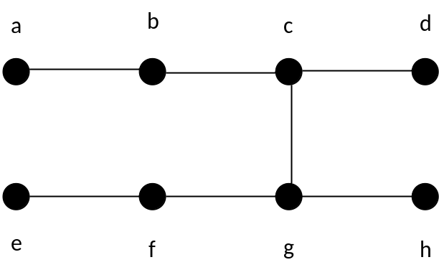

Question 2

Consider the following recursive function

f(n)=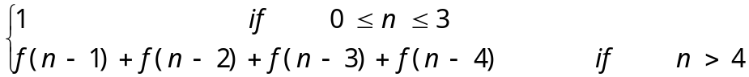

- Write a recursive (top-down) algorithm to compute it.
If 0<=n<=3
Return 1

Else
Return f(n-1)+ f(n-2)+ f(n-3)+ f(n-4)

- What is the complexity of your algorithm (in big-O notation)?
O(n⁴)

- Design and write the pseudo code of a faster nonrecursive (bottom-up) algorithm using the concept of dynamic programming.

Array a
a[0],a[1],a[2],a[3]=1
If 0<=n<=3
Return 1

For(int i=4;i<=n;i++){
A[i]=A[i-1]+ A[i-2]+ A[i-3]+ A[i-4]
}
Return A[n]

- What is the time complexity of the faster algorithm (in big-O notation)?
O(n)

Question 3

Consider the following graph G. The label of an edge is the cost of the edge.
1
6
4
7
10
10
3
1
a
b
c
d
e
f
g
h
2
5
7
8

- Using the Prim's algorithm given below, draw a minimum spanning tree (MST) of the graph Also write down the change of the priority queue step by step and the order in which the vertices are selected. Is the MST drawn unique? (i.e., is it the one and only MST for the graph?)

MST-Prim-Algorithm(G, w, root)
// Given a weighted graph G=(V,E) and a root vertex
for each u in V do
begin
key[u] = ∞
π[u] = NIL
end
key(root) = 0
V_{T} = ∅
while V - V_{T} ≠ ∅ do
begin
choose the vertex u in V - V_{T} with minimum key(u)
V_{T} = V_{T} ∪ { u }
for every vertex v in V - V_{T} that is a neighbour of u do
if w(u,v) < d(v) then // w(u,v) is the weight of edge (u,v)
d(v) = w(u,v)
π[v] = u
end

Vertex order | a(0,-) | b(-,∞) | c(-,∞) | d(-,∞) | e(-,∞) | f(-,∞) | g(-,∞) | h(-,∞)
a(0,-) |  | b(a,4) | c(-,∞) | d(-,∞) | e(a,1) | f(-,∞) | g(-,∞) | h(-,∞)
e(a,1) |  | b(a,4) | c(-,∞) | d(-,∞) |  | f(e,2) | g(-,∞) | h(-,∞)
f(e,2) |  | b(f,3) | c(f,10) | d(-,∞) |  |  | g(f,5) | h(-,∞)
b(f,3) |  |  | c(b,6) | d(-,∞) |  |  | g(f,5) | h(-,∞)
g(f,5) |  |  | c(g,1) | d(g,10) |  |  |  | h(g,7)
c(g,1) |  |  |  | d(c,7) |  |  |  | h(g,7)
d(c,7) |  |  |  |  |  |  |  | h(g,7)
h(g,7)

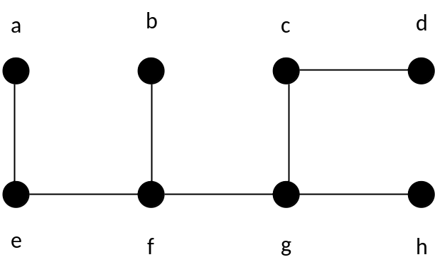

- Using Kruskal’s algorithm, draw a minimum spanning tree (MST) of the graph G. Write down the order in which the edges are selected. Is the MST drawn unique? (i.e., is it the one and only MST for the graph?)
(a, e) | 1
(c, g) | 1
(e, f) | 2
(b, f) | 3
(a, b) | 4
(f, g) | 5
(b, c) | 6
(c, d) | 7
(g, h) | 7
(d, h) | 8
(c, f) | 10
(d, g) | 10

- Referring to the same graph above, find the shortest paths from the vertex a to all other vertices in the graph G using Dijkstra’s algorithm given below. Show the changes of the priority queue step by step and give the order in which edges are selected.

Dijkstra-Algoritm(G, w, root)
// Given a weighted graph G=(V,E) and a source vertex s
for each u in V do
begin
d(v) = ∞
p(v) = null
end
d(s) = 0
V_{T} = ∅
while V - V_{T} ≠ ∅ do // there is still some vertex left
begin
choose the vertex u in V - V_{T} with minimum d(u)
V_{T} = V_{T} ∪ { u }
for every vertex v in V - V_{T} that is a neighbour of u do
if d(u) + w(u,v) < d(v) then //w(u,v) is the weight of edge (u,v)
d(v) = d(u) + w(u,v)
p(v) = u
end

N.B. There may be more than one solution. You only need to give one of the solutions.

Vertex order | a(0,-) | b(-,∞) | c(-,∞) | d(-,∞) | e(-,∞) | f(-,∞) | g(-,∞) | h(-,∞)
a(0,-) |  | b(a,4) | c(-,∞) | d(-,∞) | e(a,1) | f(-,∞) | g(-,∞) | h(-,∞)
e(a,1) |  | b(a,4) | c(-,∞) | d(-,∞) |  | f(a,3) | g(-,∞) | h(-,∞)
f(a,3) |  | b(a,4) | c(f,13) | d(-,∞) |  |  | g(f,8) | h(-,∞)
b(a,4) |  |  | c(b,10) | d(-,∞) |  |  | g(f,8) | h(-,∞)
g(f,8) |  |  | c(g,9) | d(g,18) |  |  |  | h(g,15)
c(g,9) |  |  |  | d(c,16) |  |  |  | h(g,15)
h(g,15) |  |  |  | d(c,16)
d(c,16)

