COMP201 - Assignment 2

Name: Jin, Minhao

University Username: sgmjin2

Student ID: 201447766

**Task 1 (20%) You are to create 4 separate lists, each with added details if required.**

**1a) List all candidate classes, their candidate attributes, and their candidate operations.**

|  |  |  |
| --- | --- | --- |
| Candidate class | Candidate attributes | Candidate operations |
| Garage |  | Perform inspection task  Perform repair task  Perform maintenance task |
| Inspection task | MOT test  General diagnostic test |  |
| Repair task | Body repair  Engine repair  Window replacement |  |
| Maintenance task | air conditioning top-up  body resprays  tyre change |  |
| Person | name |  |
| Customer | name  telephone  vehicle | Park vehicle  Walk  Discuss need |
| Staff | name |  |
| Receptionist | name | Open tickets  Get ‘signed off’ ticket  Call customer  Set ticket status to ‘waiting’ |
| Mechanic | name | Get ‘waiting’ ticket  Set ticket status to ‘in progress’  Set ticket status to ‘check’  Perform work  Update price |
| Manager | name | Get ‘check’ ticket  Set ticket status to ‘signed off’  Perform task  Update price  Check work |
| Ticket | Customer  Vehicle  Work  deadline  price  status |  |
| Vehicle | Cars  Vans  buses |  |
| Bill |  |  |
| Shop |  |  |

**1b) List all potential inheritance relationships.**

|  |
| --- |
| Person |
| -name: String |
|  |

|  |
| --- |
| Customer |
| ^-name: String  -telephone: String  -vehicle: String [] |
| +get_telephone(): String  +get_vehicles():String [] |

|  |
| --- |
| Staff |
| ^-name: String  -garage: Garage |
| +update_status(): void  +get_next_ticket(): Ticket |

|  |
| --- |
| Receptionist |
| ^-name: String  ^-garage: Garage |
| ^+update_status():void  ^+get_next_ticket(): Ticket  +openTicket(Ticket new_ticket): void  +call_customer(): void |

|  |
| --- |
| Mechanic |
| ^-name: String  ^-garage: Garage |
| ^+update_status(): void  ^+get_next_ticket(): Ticket  +perform_task(): void  +update_price(): void |

|  |
| --- |
| Manager |
| ^-name: String  ^-garage: Garage |
| ^+update_status(): void  ^+update_price(): void  ^+perform_task(): void  ^+get_next_ticket(): Ticket  +check_work(): void |

**1c) List those candidate classes that are to be eliminated, and give justification as to why.**

Candidate classes that needs to be eliminated: ‘Work’ and ‘Vehicle’.

Reason: Class ‘Work’ and ‘Vehicle’ only has only one string attribute which defines their types. Additionally, they have few interactions with the other classes. Thus, it is meaningless to keep these two classes and they can be directly replaced by some strings in further coding.

|  |  |
| --- | --- |
| Candidate classes that needs to be eliminated | reason |
| Inspection task | It is unnecessary to have these 3 classes because the task is defined on the ticket with the attribute ‘work’. ‘work’ is a string value which can specify the specific work type mechanics should perform. |
| Repair task |
| Maintenance task |
| Vehicle | This class can also be replaced by attribute ‘vehicle’ in class ‘customer’ which should be a string array to record what types of vehicles the customer has. |
| Bill | ‘Bill’ is synonymous with the attribute ‘price’ in class ‘ticket’ |
| Shop | ‘Shop’ is synonymous with the class ‘garage’ |

**1d) Give the final list of candidate classes, along with their attributes and their candidate operations.**

**You should ensure minimal data duplication (e.g. if a customer has multiple cars in for repair).**

|  |  |  |
| --- | --- | --- |
| Candidate class | Candidate attributes | Candidate operations |
| Garage | -People: Vector<Staff>  -Tickets: Vector<Ticket> | +perform_inspection_task(): void  +perform_repair_task(): void  +perform_maintenance_task(): void  +view_waiting_tickets():Ticket  +view_check_tickets(): Ticket  +view_signoff_tickets(): Ticket |
| Person | -name: String | +get_name(): String |
| Customer | -name: String  -telephone: String  -vehicle: String [] | +get_telephone(): String  +get_vehicles():String [] |
| Staff | -name: String  -garage: Garage | +update_status(): void  +get_next_ticket(): Ticket (abstract method) |
| Receptionist | -name: String  -garage: Garage | +update_status(): void  +openTicket(Ticket new_ticket): void  +get_next_ticket(): Ticket  +call_customer(): void |
| Mechanic | -name: String  -garage: Garage | +update_status(): void  +perform_task(): void  +update_price(): void |
| Manager | -name: String  -garage: Garage | +update_status(): void  +perform_task(): void  +update_price(): void  +check_work(): boolean |
| Ticket | -customer: Customer  -vehicle: String  -work: String  -deadline: Date  -price: double  -status: String | +get_status(): String  +get_price(): double  +set_status(): void  +set_price(): void |

**Task 2 (20%) Produce CRC Cards for each class. For each CRC Card, comment on whether the**

**class is “Good" or “Bad", and give justification for your reasoning. If it is “Bad" then you should**

**state how it may be improved, but do not implement this improvement.**

|  |  |
| --- | --- |
| Garage | |
| Responsibilities | Collaborators |
| 1.Record staff members and tickets.  2.Provide methods for staff to view tickets. | Ticket  Staff |
| Comment: Good  Cohesion: ‘Garage’ has the attributes staff members and tickets and it also provides the method to inspect these attributes.  Coupling: ‘Garage’ has the relation with 2 class: ‘ticket’ and ‘Staff’.  Thus, it is strong-cohesion and loose coupling. | |

|  |  |
| --- | --- |
| Person | |
| Responsibilities | Collaborators |
| 1.Provide his/her name |  |
| Comment: Good  Cohesion: ‘Person’ has the attribute ‘name’ and the method to inspect this attribute.  Coupling: ‘Person’ has no relation with any other classes.  Thus, it is strong -cohesion and loose coupling. | |

|  |  |
| --- | --- |
| Customer | |
| Responsibilities | Collaborators |
| 1.Provide his/her personal phone number  2.Provide his/her vehicle information | Person |
| Comment: Good  Cohesion: ‘Customer’ has the attribute ‘telephone’ and ‘vehicles’ and it also provides methods to inspect the attributes.  Coupling: ‘Customer’ has the relation with only 1 class ‘person’.  Thus, it is strong-cohesion and loose coupling. | |

|  |  |
| --- | --- |
| Staff | |
| Responsibilities | Collaborators |
| 1.Access the data of Garage  2.Update ticket status | Person  Garage |
| Comment: Good  Cohesion: ‘Staff’ has the attribute ‘garage’ and it also provides methods to inspect the attribute.  Coupling: ‘Staff’ has the relation with 2 classes ‘person’ and ‘Garage’.  Thus, it is strong-cohesion and loose coupling. | |

|  |  |
| --- | --- |
| Receptionist | |
| Responsibilities | Collaborators |
| 1.Open tickets for customer  2.View ‘signoff’ tickets  3.Call customers | Garage  Staff  Ticket  Customer |
| Comment: Bad  Cohesion: ‘Staff’ has the attribute ‘garage’, but its responsibilities are not focused.  Coupling: ‘Staff’ has the relation with 4 classes ‘Garage’, ‘Staff’, ‘Ticket’ and ‘Customer’.  Thus, it is weak-cohesion and strong coupling. | |

|  |  |
| --- | --- |
| Mechanic | |
| Responsibilities | Collaborators |
| 1.View ‘waiting’ tickets  2.Perform the work required  3.Update cost on the ticket | Garage  Staff  Ticket |
| Comment: bad  Cohesion: The responsibilities of ‘Mechanic’ are grouped because they perform similar functions  Coupling: ‘Staff’ has the relation with 3 classes ‘Garage’, ‘Staff’ and ‘Ticket’.  Thus, it is weak-cohesion and strong coupling. | |

|  |  |
| --- | --- |
| Manager | |
| Responsibilities | Collaborators |
| 1.View ‘check’ tickets  2.Perform the work required as a mechanic when short-staffed  3.Update cost on the ticket  4.Check whether the work has been carried out  to a good standard | Garage  Mechanic  Ticket |
| Comment: bad  Cohesion: The responsibilities of ‘Manager’ are grouped because they perform similar functions  Coupling: ‘Manager’ has the relation with 3 classes ‘Garage’, ‘Staff’ and ‘Ticket’.  Thus, it is weak-cohesion and strong coupling. | |

|  |  |
| --- | --- |
| Ticket | |
| Responsibilities | Collaborators |
| 1.Record all the information links the customer, their vehicle, the work required, the deadline, and the quoted price. |  |
| Comment: Good  Cohesion: ‘Ticket’ has the attributes and corresponding methods to inspect the attributes.  Coupling: ‘Ticket’ has no relation with any other classes.  Thus, it is strong-cohesion and loose coupling. | |

**Task 3 (20%) Produce a UML Class Diagram showing the classes, attributes, operations, and**

**associations of the system (use answers from Task 1 to guide you). You should be sure to use the**

**correct type of association, navigability, and multiplicity.**

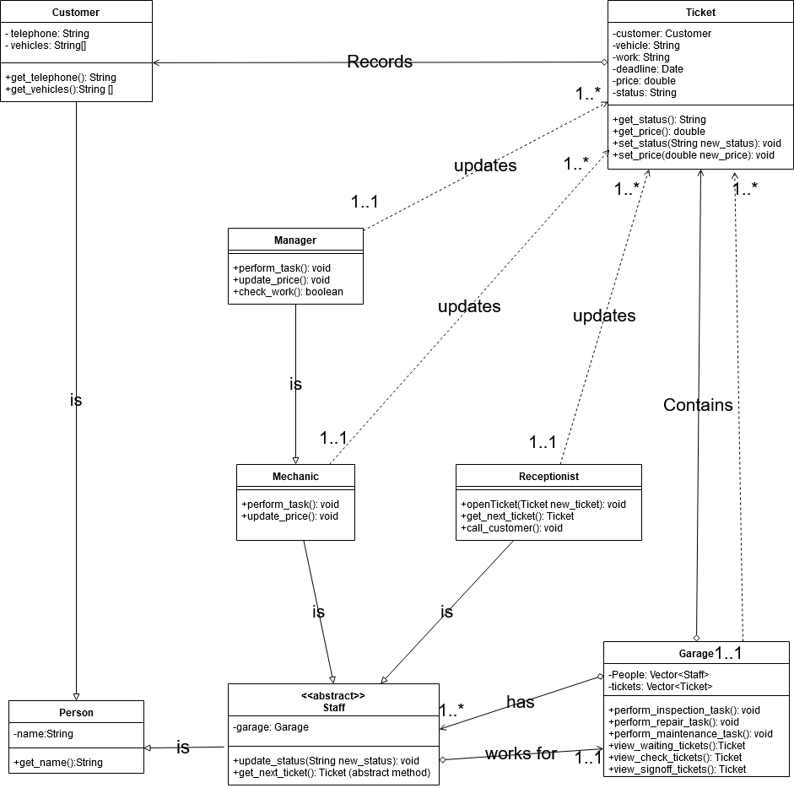

**Task 5 (20%) Produce a UML activity diagram capturing the workflow of the garage.**

