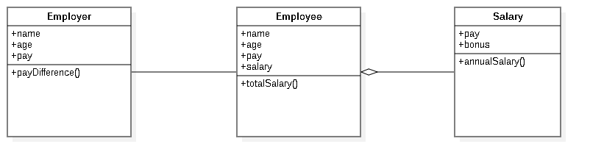

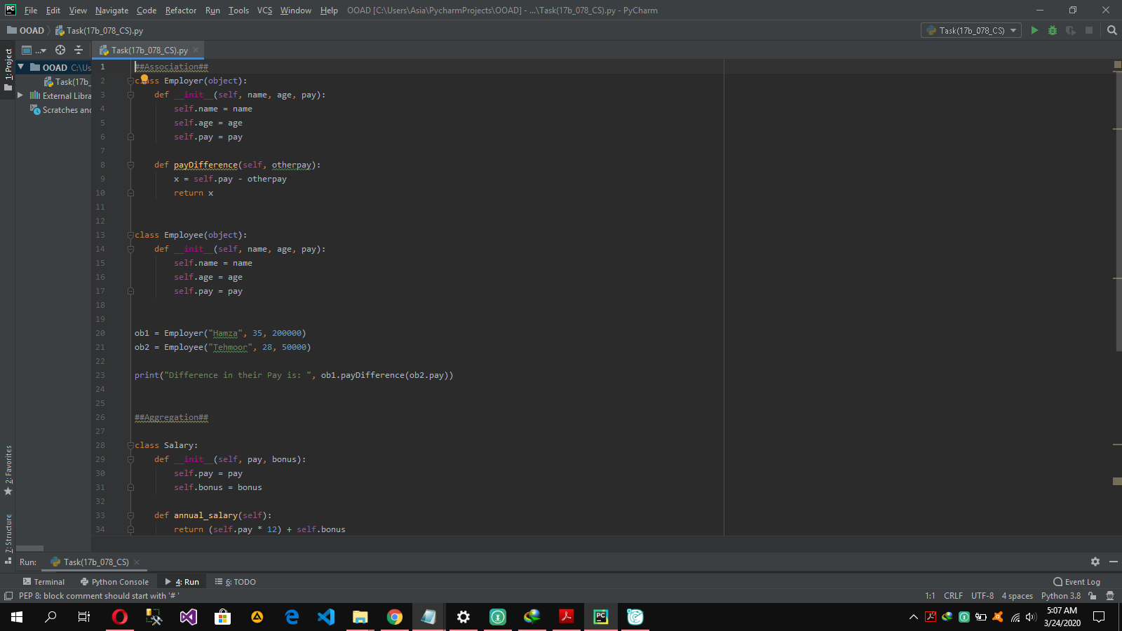

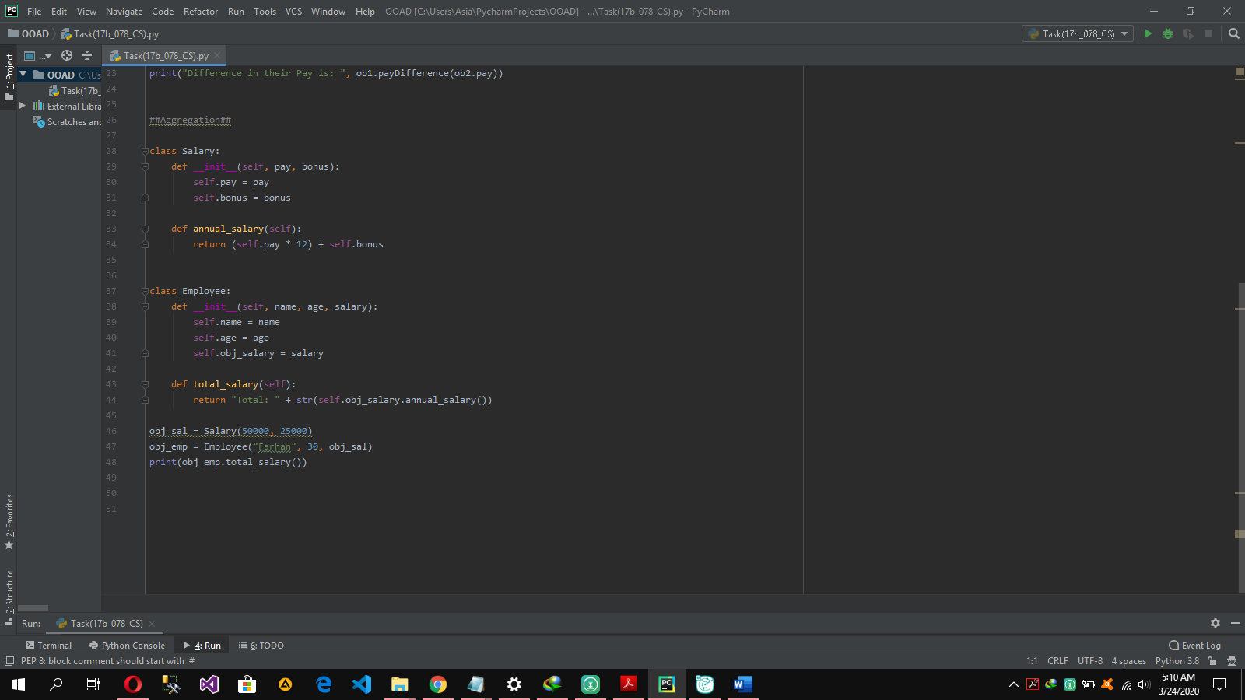

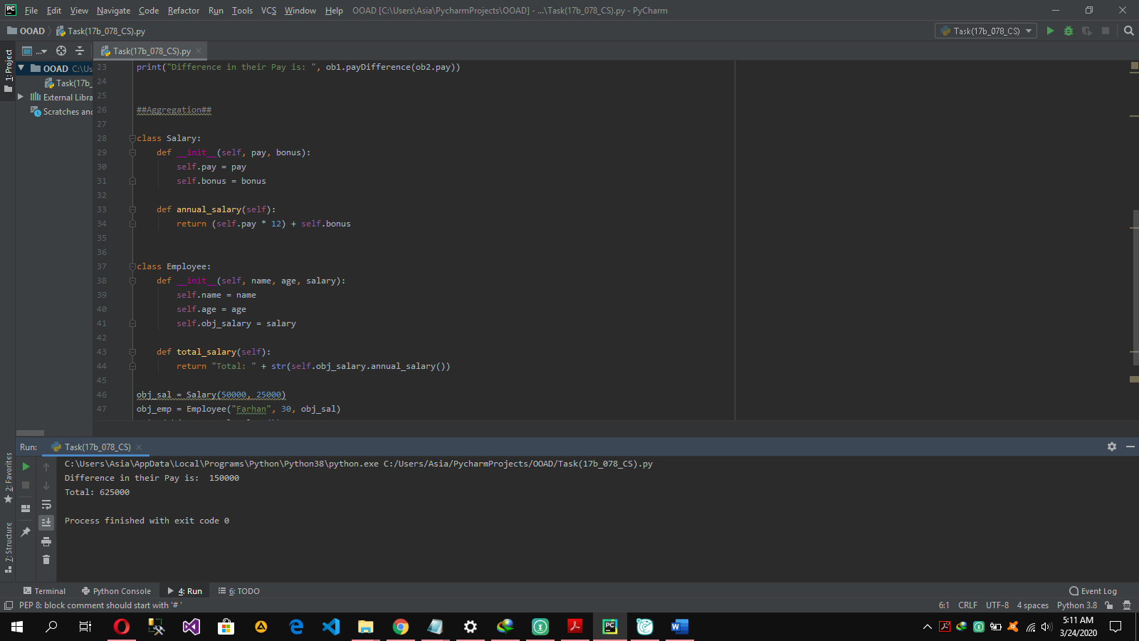

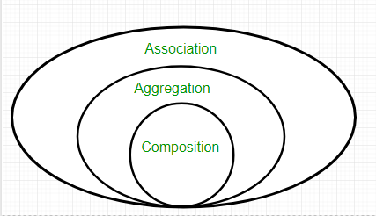

**Association** is relation between two separate classes which establishes through their Objects. Association can be one-to-one, one-to-many, many-to-one, many-to-many. Composition and Aggregation are the two forms of association.

***In the light of above example:***

In above example two separate classes Employer and Employee are associated through their Objects. Employer can have many employees so, it is a one-to-many relationship.

**Aggregation** implies a relationship where the child **can exist independently** of the parent. It represents a **Has-A** relationship. It is a **unidirectional association** i.e. a one-way relationship.

***In the light of above example:***

As Employee class and Salary Class can exist independently so aggregation is used here

***When do we use Aggregation ??***Code reuse is best achieved by aggregation. When Classes can exist independently

**Composition** is a restricted form of Aggregation in which two entities are highly dependent on each other.

It represents part-of relationship. In composition, both the entities are dependent on each other. When there is a composition between two entities, the composed object cannot exist without the other entity.

In the light of above example:

Composition is not used in the above example