Malcom Chiaji

SCT212-0063/2021

Lab2

a)

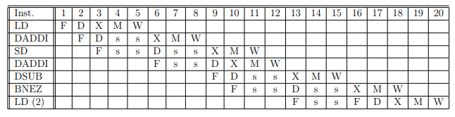

**No Forwarding, Branch Flush**

* **Dependencies:**
  + DADDI R1 waits for LD R1 (WB).
  + SD waits for DADDI R1 (WB).
  + DSUB waits for DADDI R2 (WB).
  + BNEZ waits for DSUB (WB).
* **Loop iterations:** 99 (396/4).
* **Cycles per iteration:** 15 (first 98 iterations) + 18 (last iteration).
* **Total cycles:** (98 × 15) + 18 = 1488.

**b)**

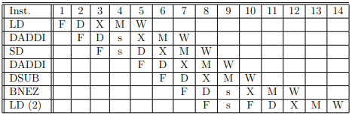

* s: Stall (interlocking). Forwarding reduces stalls
* BNEZ waits for DSUB’s EX stage (forwarded).
* **Total cycles:** (98 × 9) + 12 = 894.

c)

**Optimizations:**

1. Move DADDI R2 to load delay slot.
2. Move DSUB after DADDI R2.
3. Move SD to branch delay slot (adjust offset: SD -4(R2), R1).

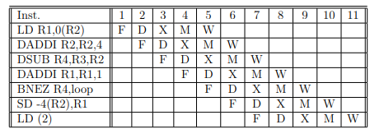

* No stalls for DADDI R1 (separated by 2 cycles from LD).
* BNEZ resolves without waiting (forwarded from DSUB).
* **Total cycles:** (98 × 6) + 10 = 598.