Web Development 2

CMS Project Proposal
By Malcolm White

Organization name:
JobWatch Group
Organization Description:
JobWatch is a non-profit organization run by students, for students, to help one another in their post-secondary job search. This organization previously operated out of a small breakout room at the Red River College campus, and through weekly meetings, shared information about job postings, internship opportunities, and co-op openings in the IT field. Increased interest in JobWatch has prompted the founders to ditch the in-person meetings and build a web application in the form of a CMS (content management system) that can provide the same service, with increased accessibility. Continued growth over the past 3 quarters, as well as donations from former students and faculty members has provided JobWatch with the funds to make this possible. JobWatch projects that this application will serve between 200-300 users.
Users, roles, and features:
Although JobWatch began as a group of BIT (Business Information Technology) students, the increased interest they have received has prompted them to offer their services in all fields of study. The CMS will operate in similar fashion to the in-person meetings.
There will be three categories of users:
Admins will oversee discussion and have the ability to edit/delete listings as they see fit. Admins will also have access to a user control panel, where they can view member details. Admins will have the ability to ban users.
Moderators will have the ability to edit/remove listings and will be responsible for updating the status of job postings.
Users will be able to contribute discussion items/information on job listings but will not have administrative access unless granted permission. JobWatch will feature a ‘Favourite’ system that will allow users to keep track of the job postings they are interested in on their dashboard. Users will be able to search the job listing database for jobs that align with keywords, and use a drop down menu to refine their search results.
Database Schema
The proposed database schema is simple: it will consist of a users table, a roles table, a jobs table, and a comments table.
Users will be able to sign up through the index page, and they will provide an email, create a username, and be assigned a basic user role. The users table will handle user information. The roles table will handle the role information associated with the user, which will be displayed on their listings.
Job listings will feature a user id (the original poster), a title, description, listing url, date, location and one of 4 statuses: New (posted within the last 3 days), active (between 3-14 days old), old (15-60 days old) and closed. The jobs table will be the main area of focus for this website, and a fully functional job feed will be listed on the index page.
Comments on job postings will display content, a user id, and a date. Each row in the comments table will be associated with one (and only one) job listing.
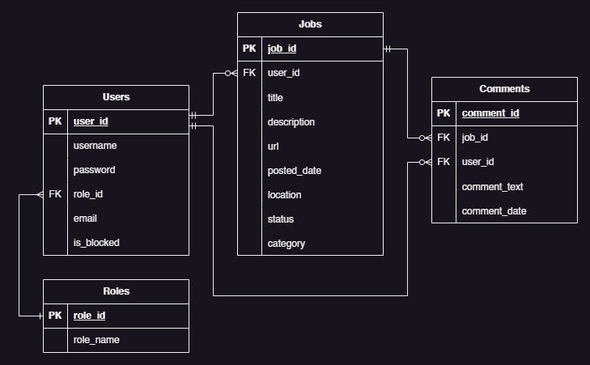

This proposal outlines a comprehensive plan to build a user-friendly and efficient job listing platform to students at the college. By implementing role-based access with password encryption, it ensures a secure, well-moderated environment that is tailored not only to those in the IT field, but also other fields of study at the college. The dating system will provide the users with information about which listings may be worth applying for. scalability will also be considered when building the website, in the event that the service continues to grow. Clean and concise design choices will be made when developing the UI/UX of the website. All form entries and fields will be sanitized and validated. CAPTCHA verification will be used.
If you believe that my vision for this product is appropriate, and you wish to proceed with the development process, contact me at my email address below.
Sincerely,

Malcolm White
mwhite2@rrc.ca

