Using GARCH to Forecast Electricity Prices

By: Jose Maldonado

## Spanish Data

## Spanish data was obtain from www.omel.es  
## Once the file is read we converted into a time series and multiplied by 10 to also conver it to Euros.  
spanishjune = read.csv("SpanishDataJune.csv", stringsAsFactors = FALSE, header = TRUE)  
spanishjunets = ts(spanishjune[,-1] * 10, frequency = 24)  
spanishoctober = read.csv("SpanishDataOctober.csv", stringsAsFactors = FALSE, header = TRUE)  
octoberts = ts(spanishoctober[,-1] * 10, frequency = 24)  
autoplot(spanishjunets)

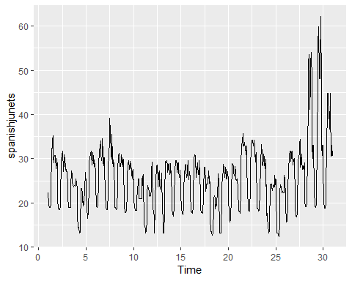

autoplot(octoberts)

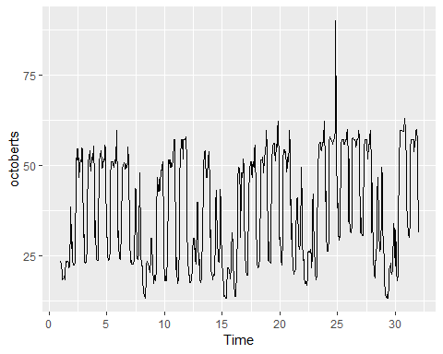

## California Data

## Data was obtain from http://www.energyonline.com/Data/GenericData.aspx?DataId=20&amp;CAISO___Average_Price  
## Taking the price from every five minutes we found the average price per hour and used those values for our hourly price.  
calimay = read.csv("CaliDataMay.csv", stringsAsFactors = FALSE, header = TRUE)  
calimayts = ts(calimay[,-1], frequency = 24)  
calijune = read.csv("CaliDataJune.csv", stringsAsFactors = FALSE, header = TRUE)  
caliunets = ts(calijune[,-1], frequency = 24)  
autoplot(calimayts)

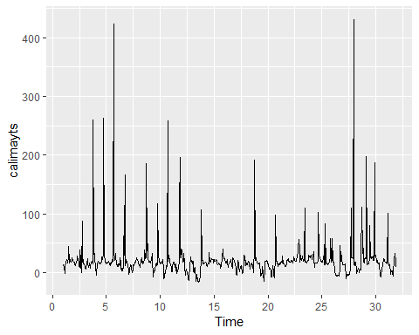

autoplot(caliunets)

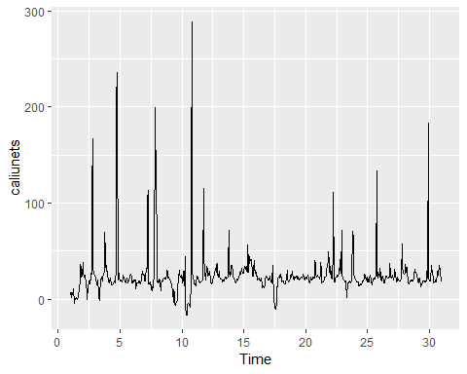

## ARIMA (for comparing)

## ARIMA(1,0,0)(2,1,2) [24] was chosen as the best model, we can see from the residuals and the test and train set that ARIMA cannot handle the volatility of the data well.  
## Using ARIMA to forecast takes alot of computing power aswell, when compared to GARCH ARIMA does poorly.  
arimasjune = auto.arima(spanishjunets, seasonal = TRUE, stepwise = FALSE, lambda = "auto")  
autoplot(forecast(arimasjune), h = 24)

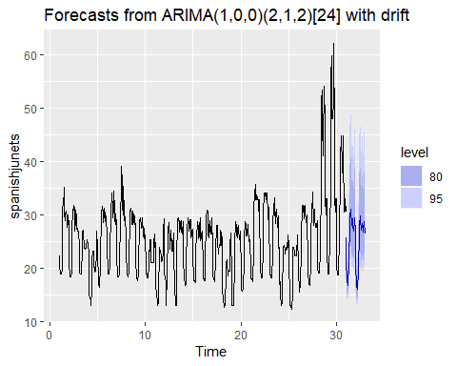

arimasjune

## Series: spanishjunets   
## ARIMA(1,0,0)(2,1,2)[24] with drift   
## Box Cox transformation: lambda= -0.7716549   
##   
## Coefficients:  
## ar1 sar1 sar2 sma1 sma2 drift  
## 0.8819 0.7199 -0.2846 -1.4968 0.5601 0  
## s.e. 0.0181 0.1003 0.0451 0.0973 0.0980 0  
##   
## sigma^2 estimated as 4.574e-05: log likelihood=2469.42  
## AIC=-4924.84 AICc=-4924.67 BIC=-4893.02

checkresiduals(arimasjune)

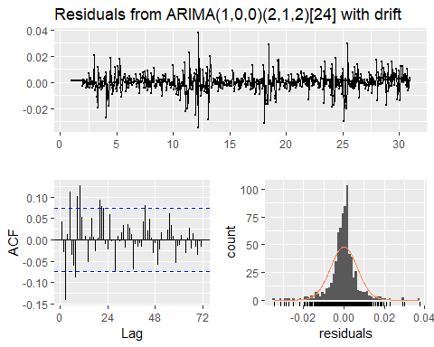

##   
## Ljung-Box test  
##   
## data: Residuals from ARIMA(1,0,0)(2,1,2)[24] with drift  
## Q* = 99.641, df = 42, p-value = 1.378e-06  
##   
## Model df: 6. Total lags used: 48

train = subset(spanishjunets, end = 575)  
test = subset(spanishjunets, start = 576)  
sjunetrain = Arima(train, order = c(1,0,0), seasonal = c(2,1,2), lambda = "auto")  
sjunetrain %>% forecast(h = 145) %>% autoplot() + autolayer(test)

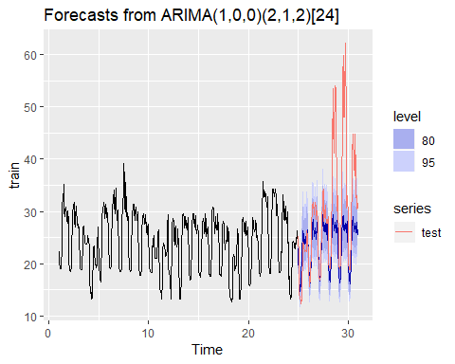

## GARCH Spanish Data for June

## A model is first made from ugarchspec, GARCH (1,3) seems to be best for most of the data sets along with ARMA (1,1).  
sjune1 = ugarchspec(variance.model = list(garchOrder = c(1,3)),mean.model = list(armaOrder = c(1,1)), distribution.model = "norm")  
## ugarchfit gives us the information we need as far as parameters, and we are able to use the different test and the information criteria to compare different models to pick the best GARCH model for the data. From this GARCH (1,3) was chosen.  
sjunegarch1 = ugarchfit(spec = sjune1, data = spanishjunets)  
sjunegarch1

##   
## *---------------------------------*  
## * GARCH Model Fit *  
## *---------------------------------*  
##   
## Conditional Variance Dynamics   
## -----------------------------------  
## GARCH Model : sGARCH(1,3)  
## Mean Model : ARFIMA(1,0,1)  
## Distribution : norm   
##   
## Optimal Parameters  
## ------------------------------------  
## Estimate Std. Error t value Pr(>|t|)  
## mu 24.399086 0.810591 30.100383 0.000000  
## ar1 0.865916 0.020118 43.041536 0.000000  
## ma1 0.383728 0.032477 11.815280 0.000000  
## omega 0.158723 0.091207 1.740241 0.081817  
## alpha1 0.069848 0.018750 3.725283 0.000195  
## beta1 0.594340 0.161816 3.672928 0.000240  
## beta2 0.000000 0.308164 0.000001 0.999999  
## beta3 0.313229 0.193305 1.620389 0.105149  
##   
## Robust Standard Errors:  
## Estimate Std. Error t value Pr(>|t|)  
## mu 24.399086 0.824864 29.579520 0.000000  
## ar1 0.865916 0.014532 59.588340 0.000000  
## ma1 0.383728 0.034771 11.035940 0.000000  
## omega 0.158723 0.086853 1.827478 0.067628  
## alpha1 0.069848 0.017978 3.885188 0.000102  
## beta1 0.594340 0.120587 4.928722 0.000001  
## beta2 0.000000 0.249207 0.000001 0.999999  
## beta3 0.313229 0.205989 1.520611 0.128358  
##   
## LogLikelihood : -1639.182   
##   
## Information Criteria  
## ------------------------------------  
##   
## Akaike 4.5755  
## Bayes 4.6264  
## Shibata 4.5753  
## Hannan-Quinn 4.5951  
##   
## Weighted Ljung-Box Test on Standardized Residuals  
## ------------------------------------  
## statistic p-value  
## Lag[1] 3.822 0.05057  
## Lag[2*(p+q)+(p+q)-1][5] 28.387 0.00000  
## Lag[4*(p+q)+(p+q)-1][9] 45.433 0.00000  
## d.o.f=2  
## H0 : No serial correlation  
##   
## Weighted Ljung-Box Test on Standardized Squared Residuals  
## ------------------------------------  
## statistic p-value  
## Lag[1] 0.1042 0.74681  
## Lag[2*(p+q)+(p+q)-1][11] 8.4933 0.17829  
## Lag[4*(p+q)+(p+q)-1][19] 16.5124 0.05509  
## d.o.f=4  
##   
## Weighted ARCH LM Tests  
## ------------------------------------  
## Statistic Shape Scale P-Value  
## ARCH Lag[5] 0.06469 0.500 2.000 0.79923  
## ARCH Lag[7] 1.43427 1.473 1.746 0.63968  
## ARCH Lag[9] 8.81186 2.402 1.619 0.04771  
##   
## Nyblom stability test  
## ------------------------------------  
## Joint Statistic: 3.0525  
## Individual Statistics:   
## mu 0.04634  
## ar1 0.03223  
## ma1 0.24105  
## omega 0.19693  
## alpha1 0.61180  
## beta1 0.39822  
## beta2 0.39670  
## beta3 0.38289  
##   
## Asymptotic Critical Values (10% 5% 1%)  
## Joint Statistic: 1.89 2.11 2.59  
## Individual Statistic: 0.35 0.47 0.75  
##   
## Sign Bias Test  
## ------------------------------------  
## t-value prob sig  
## Sign Bias 0.1408 0.8881   
## Negative Sign Bias 0.1441 0.8855   
## Positive Sign Bias 1.2553 0.2098   
## Joint Effect 2.2021 0.5315   
##   
##   
## Adjusted Pearson Goodness-of-Fit Test:  
## ------------------------------------  
## group statistic p-value(g-1)  
## 1 20 127.3 4.652e-18  
## 2 30 141.4 9.693e-17  
## 3 40 153.7 1.545e-15  
## 4 50 179.9 7.753e-17  
##   
##   
## Elapsed time : 0.65014

## ugarchboot lets us forecast.  
sjunepredict = ugarchboot(sjunegarch1, n.ahead = 24, method = c("Partial","Full")[1])  
plot(sjunepredict, which = 2)

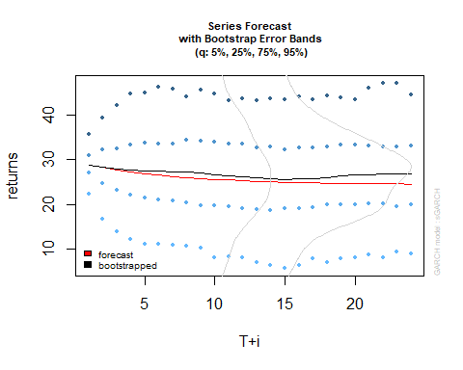

sjunepredict

##   
## *-----------------------------------*  
## * GARCH Bootstrap Forecast *  
## *-----------------------------------*  
## Model : sGARCH  
## n.ahead : 24  
## Bootstrap method: partial  
## Date (T[0]): 1971-12-21 19:00:00  
##   
## Series (summary):  
## min q.25 mean q.75 max forecast[analytic]  
## t+1 9.8339 27.106 28.868 30.996 42.785 28.872  
## t+2 5.0531 24.746 28.415 32.109 53.667 28.272  
## t+3 -12.7248 23.118 27.803 32.487 58.865 27.753  
## t+4 -14.8661 22.145 27.633 33.176 69.519 27.303  
## t+5 -10.0237 21.408 27.565 33.780 72.977 26.914  
## t+6 -14.0289 20.996 27.400 33.451 87.012 26.577  
## t+7 -13.5051 20.905 27.304 33.440 85.580 26.285  
## t+8 -7.2520 20.374 27.165 34.368 84.621 26.032  
## t+9 -11.4537 19.792 27.067 34.120 77.849 25.813  
## t+10 -17.4965 19.838 26.639 33.872 72.941 25.623  
## .....................  
##   
## Sigma (summary):  
## min q0.25 mean q0.75 max forecast[analytic]  
## t+1 4.3588 4.3588 4.3588 4.3588 4.3588 4.3588  
## t+2 4.2598 4.2656 4.4015 4.3878 6.5926 4.4128  
## t+3 4.1431 4.1800 4.3864 4.3982 6.4773 4.3948  
## t+4 4.0422 4.0970 4.3391 4.4334 7.1648 4.3518  
## t+5 3.9542 4.0433 4.3367 4.4408 8.8717 4.3401  
## t+6 3.8591 3.9886 4.3247 4.4681 7.7979 4.3266  
## t+7 3.7713 3.9310 4.3015 4.4863 8.0550 4.3039  
## t+8 3.6883 3.8983 4.2592 4.4723 7.9618 4.2851  
## t+9 3.6129 3.8479 4.2362 4.4576 7.7697 4.2683  
## t+10 3.5252 3.8102 4.2428 4.4464 7.8007 4.2499  
## .....................

## ugarchroll is used as a train and test set to see how it handles forecasting.  
sjuneroll = ugarchroll(sjune1, spanishjunets,n.start = 576, refit.every = 24, refit.window = "moving", solver = "hybrid", calculate.VaR = TRUE, VaR.alpha = 0.05, keep.coef = TRUE)  
sjuneroll

##   
## *-------------------------------------*  
## * GARCH Roll *  
## *-------------------------------------*  
## No.Refits : 6  
## Refit Horizon : 24  
## No.Forecasts : 144  
## GARCH Model : sGARCH(1,3)  
## Distribution : norm   
##   
## Forecast Density:  
## Mu Sigma Skew Shape Shape(GIG) Realized  
## 1971-07-31 20:00:00 24.1654 1.8385 0 0 0 25.24  
## 1971-08-01 20:00:00 25.5513 1.8689 0 0 0 21.58  
## 1971-08-02 20:00:00 20.3059 2.7922 0 0 0 14.56  
## 1971-08-03 20:00:00 13.3601 3.6635 0 0 0 13.17  
## 1971-08-04 20:00:00 14.3131 2.1169 0 0 0 13.17  
## 1971-08-05 20:00:00 13.9375 1.9188 0 0 0 13.17  
##   
## ..........................  
## Mu Sigma Skew Shape Shape(GIG) Realized  
## 1971-12-16 19:00:00 46.0773 5.1700 0 0 0 37.12  
## 1971-12-17 19:00:00 31.9978 5.4017 0 0 0 34.82  
## 1971-12-18 19:00:00 34.5120 4.8873 0 0 0 30.53  
## 1971-12-19 19:00:00 28.2021 4.8798 0 0 0 30.75  
## 1971-12-20 19:00:00 30.8884 4.8631 0 0 0 33.04  
## 1971-12-21 19:00:00 32.7168 4.6751 0 0 0 30.53  
##   
## Elapsed: 2.678228 secs

plot(sjuneroll, which = 3, VaR.alpha = 0.05)

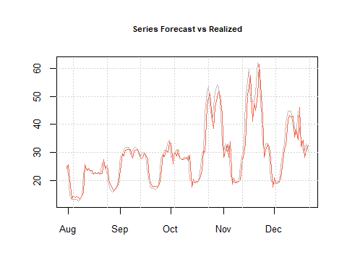

# as.data.frame() is used to look into the variable, letting us see all values. Remove "#" to run it and see the real values vs the forecasted values. By taking higher values and dividing by the smallest value subtracting that from 1 and multiplying we are able to see our error.  
as.data.frame(sjuneroll)

## Mu Sigma Skew Shape Shape(GIG) Realized  
## 1971-07-31 20:00:00 24.16544 1.838472 0 0 0 25.24  
## 1971-08-01 20:00:00 25.55129 1.868851 0 0 0 21.58  
## 1971-08-02 20:00:00 20.30587 2.792209 0 0 0 14.56  
## 1971-08-03 20:00:00 13.36013 3.663457 0 0 0 13.17  
## 1971-08-04 20:00:00 14.31311 2.116900 0 0 0 13.17  
## 1971-08-05 20:00:00 13.93750 1.918762 0 0 0 13.17  
## 1971-08-06 20:00:00 14.08554 1.834719 0 0 0 13.10  
## 1971-08-07 20:00:00 13.93731 1.853911 0 0 0 12.37  
## 1971-08-08 20:00:00 13.05847 1.970300 0 0 0 13.17  
## 1971-08-09 20:00:00 14.43201 1.795349 0 0 0 14.46  
## 1971-08-10 20:00:00 15.54690 1.770157 0 0 0 22.59  
## 1971-08-11 20:00:00 25.54584 4.204469 0 0 0 24.04  
## 1971-08-12 20:00:00 23.46650 2.386274 0 0 0 24.04  
## 1971-08-13 20:00:00 24.28606 1.885157 0 0 0 23.66  
## 1971-08-14 20:00:00 23.47514 1.814275 0 0 0 23.38  
## 1971-08-15 20:00:00 23.43526 1.773370 0 0 0 22.33  
## 1971-08-16 20:00:00 22.10285 1.865853 0 0 0 22.47  
## 1971-08-17 20:00:00 22.80777 1.790708 0 0 0 22.50  
## 1971-08-18 20:00:00 22.56844 1.777312 0 0 0 22.56  
## 1971-08-19 20:00:00 22.73981 1.767709 0 0 0 22.36  
## 1971-08-20 20:00:00 22.41548 1.778381 0 0 0 22.32  
## 1971-08-21 20:00:00 22.49195 1.768601 0 0 0 26.23  
## 1971-08-22 20:00:00 27.48199 2.687182 0 0 0 25.36  
## 1971-08-23 20:00:00 24.39816 2.231329 0 0 0 25.24  
## 1971-08-24 20:00:00 25.29501 2.100880 0 0 0 21.64  
## 1971-08-25 20:00:00 20.61169 2.100955 0 0 0 18.51  
## 1971-08-26 20:00:00 18.44555 2.101030 0 0 0 16.88  
## 1971-08-27 20:00:00 17.22118 2.101105 0 0 0 15.67  
## 1971-08-28 20:00:00 16.17683 2.101180 0 0 0 15.90  
## 1971-08-29 20:00:00 16.82628 2.101255 0 0 0 16.91  
## 1971-08-30 20:00:00 17.82956 2.101330 0 0 0 18.42  
## 1971-08-31 20:00:00 19.31809 2.101405 0 0 0 22.21  
## 1971-09-01 20:00:00 23.41778 2.101480 0 0 0 28.31  
## 1971-09-02 20:00:00 29.41457 2.101555 0 0 0 29.56  
## 1971-09-03 20:00:00 28.82258 2.101630 0 0 0 30.95  
## 1971-09-04 20:00:00 30.72796 2.101704 0 0 0 31.76  
## 1971-09-05 20:00:00 31.04368 2.101779 0 0 0 31.76  
## 1971-09-06 20:00:00 30.93220 2.101854 0 0 0 31.76  
## 1971-09-07 20:00:00 30.97157 2.101929 0 0 0 29.34  
## 1971-09-08 20:00:00 28.00431 2.102003 0 0 0 30.54  
## 1971-09-09 20:00:00 30.51653 2.102078 0 0 0 31.43  
## 1971-09-10 20:00:00 30.71561 2.102153 0 0 0 31.76  
## 1971-09-11 20:00:00 31.04805 2.102227 0 0 0 30.95  
## 1971-09-12 20:00:00 29.94214 2.102302 0 0 0 28.84  
## 1971-09-13 20:00:00 27.75761 2.102376 0 0 0 28.54  
## 1971-09-14 20:00:00 28.16286 2.102451 0 0 0 29.91  
## 1971-09-15 20:00:00 29.69170 2.102525 0 0 0 30.03  
## 1971-09-16 20:00:00 29.29831 2.102600 0 0 0 28.31  
## 1971-09-17 20:00:00 27.45196 2.070898 0 0 0 22.44  
## 1971-09-18 20:00:00 20.97017 2.070898 0 0 0 19.14  
## 1971-09-19 20:00:00 19.21894 2.070898 0 0 0 17.17  
## 1971-09-20 20:00:00 17.42803 2.070898 0 0 0 17.02  
## 1971-09-21 20:00:00 17.87503 2.070898 0 0 0 17.02  
## 1971-09-22 20:00:00 17.71771 2.070898 0 0 0 16.82  
## 1971-09-23 20:00:00 17.52869 2.070898 0 0 0 17.55  
## 1971-09-24 20:00:00 18.48724 2.070898 0 0 0 20.30  
## 1971-09-25 20:00:00 21.51026 2.070898 0 0 0 27.65  
## 1971-09-26 20:00:00 29.42768 2.070898 0 0 0 29.14  
## 1971-09-27 20:00:00 28.46191 2.070898 0 0 0 30.70  
## 1971-09-28 20:00:00 30.70805 2.070898 0 0 0 30.83  
## 1971-09-29 20:00:00 30.07639 2.070898 0 0 0 33.56  
## 1971-09-30 20:00:00 33.63463 2.070898 0 0 0 34.32  
## 1971-10-01 20:00:00 33.31102 2.070898 0 0 0 28.13  
## 1971-10-02 20:00:00 25.86103 2.070898 0 0 0 29.31  
## 1971-10-03 20:00:00 29.92490 2.070898 0 0 0 29.50  
## 1971-10-04 20:00:00 28.72682 2.070898 0 0 0 31.11  
## 1971-10-05 20:00:00 31.11582 2.070898 0 0 0 29.31  
## 1971-10-06 20:00:00 28.07552 2.070898 0 0 0 27.97  
## 1971-10-07 20:00:00 27.50811 2.070898 0 0 0 27.65  
## 1971-10-08 20:00:00 27.31678 2.070898 0 0 0 27.78  
## 1971-10-09 20:00:00 27.54297 2.070898 0 0 0 28.42  
## 1971-10-10 20:00:00 28.24542 2.070898 0 0 0 27.65  
## 1971-10-11 20:00:00 26.99529 2.088090 0 0 0 29.00  
## 1971-10-12 20:00:00 29.05366 2.088089 0 0 0 20.09  
## 1971-10-13 20:00:00 17.47891 2.088089 0 0 0 19.23  
## 1971-10-14 20:00:00 20.47750 2.088089 0 0 0 19.21  
## 1971-10-15 20:00:00 19.40488 2.088089 0 0 0 19.11  
## 1971-10-16 20:00:00 19.65802 2.088089 0 0 0 19.11  
## 1971-10-17 20:00:00 19.56952 2.088089 0 0 0 19.93  
## 1971-10-18 20:00:00 20.59948 2.088089 0 0 0 22.63  
## 1971-10-19 20:00:00 23.52887 2.088089 0 0 0 29.29  
## 1971-10-20 20:00:00 30.61877 2.088089 0 0 0 30.67  
## 1971-10-21 20:00:00 29.82153 2.088089 0 0 0 44.15  
## 1971-10-22 20:00:00 46.52310 2.088089 0 0 0 51.54  
## 1971-10-23 20:00:00 49.68785 2.088088 0 0 0 53.53  
## 1971-10-24 20:00:00 51.00595 2.088088 0 0 0 46.60  
## 1971-10-25 20:00:00 42.10225 2.088088 0 0 0 41.11  
## 1971-10-26 20:00:00 38.52629 2.088088 0 0 0 46.60  
## 1971-10-27 20:00:00 46.46493 2.088088 0 0 0 51.54  
## 1971-10-28 20:00:00 49.70819 2.088088 0 0 0 54.09  
## 1971-10-29 20:00:00 51.68110 2.088088 0 0 0 53.53  
## 1971-10-30 20:00:00 50.30914 2.088088 0 0 0 47.84  
## 1971-10-31 19:00:00 43.85655 2.088088 0 0 0 33.06  
## 1971-11-01 19:00:00 28.10560 2.088088 0 0 0 30.11  
## 1971-11-02 19:00:00 30.01784 2.088087 0 0 0 33.06  
## 1971-11-03 19:00:00 32.94338 2.088088 0 0 0 30.06  
## 1971-11-04 19:00:00 28.15476 4.105483 0 0 0 33.06  
## 1971-11-05 19:00:00 33.79475 4.163461 0 0 0 22.66  
## 1971-11-06 19:00:00 18.55411 5.023183 0 0 0 19.54  
## 1971-11-07 19:00:00 20.57499 4.423773 0 0 0 19.07  
## 1971-11-08 19:00:00 19.19860 4.084283 0 0 0 19.02  
## 1971-11-09 19:00:00 19.67181 4.159782 0 0 0 19.18  
## 1971-11-10 19:00:00 19.68824 3.991950 0 0 0 19.57  
## 1971-11-11 19:00:00 20.17102 3.778032 0 0 0 25.36  
## 1971-11-12 19:00:00 27.24537 3.976864 0 0 0 29.51  
## 1971-11-13 19:00:00 29.69612 3.796187 0 0 0 33.06  
## 1971-11-14 19:00:00 33.19459 3.694035 0 0 0 48.08  
## 1971-11-15 19:00:00 50.67180 5.609223 0 0 0 55.61  
## 1971-11-16 19:00:00 53.31148 4.925573 0 0 0 59.80  
## 1971-11-17 19:00:00 57.53913 4.639553 0 0 0 48.08  
## 1971-11-18 19:00:00 41.19275 5.427567 0 0 0 48.08  
## 1971-11-19 19:00:00 47.55755 5.301696 0 0 0 48.08  
## 1971-11-20 19:00:00 45.07928 4.747161 0 0 0 51.54  
## 1971-11-21 19:00:00 50.38408 5.037049 0 0 0 62.20  
## 1971-11-22 19:00:00 61.68926 5.899670 0 0 0 59.80  
## 1971-11-23 19:00:00 54.27707 5.180953 0 0 0 48.08  
## 1971-11-24 19:00:00 42.46290 5.121681 0 0 0 33.06  
## 1971-11-25 19:00:00 28.22358 5.744924 0 0 0 30.65  
## 1971-11-26 19:00:00 30.74512 5.230155 0 0 0 33.06  
## 1971-11-27 19:00:00 32.78614 4.897554 0 0 0 33.06  
## 1971-11-28 19:00:00 32.00961 5.578718 0 0 0 29.06  
## 1971-11-29 19:00:00 27.32584 5.478183 0 0 0 19.82  
## 1971-11-30 19:00:00 17.59561 5.704481 0 0 0 19.47  
## 1971-12-01 19:00:00 20.87863 5.409745 0 0 0 18.85  
## 1971-12-02 19:00:00 18.85066 5.196357 0 0 0 18.87  
## 1971-12-03 19:00:00 19.65079 5.098298 0 0 0 18.84  
## 1971-12-04 19:00:00 19.30753 4.948615 0 0 0 19.76  
## 1971-12-05 19:00:00 20.58582 4.783176 0 0 0 25.30  
## 1971-12-06 19:00:00 27.00457 4.852583 0 0 0 30.53  
## 1971-12-07 19:00:00 31.07186 4.759896 0 0 0 33.04  
## 1971-12-08 19:00:00 32.64665 4.571039 0 0 0 40.76  
## 1971-12-09 19:00:00 41.67013 5.047392 0 0 0 44.85  
## 1971-12-10 19:00:00 43.32038 4.805954 0 0 0 44.85  
## 1971-12-11 19:00:00 42.68957 4.522591 0 0 0 44.85  
## 1971-12-12 19:00:00 42.93070 4.513731 0 0 0 38.96  
## 1971-12-13 19:00:00 35.49475 4.540455 0 0 0 38.96  
## 1971-12-14 19:00:00 38.33716 4.434814 0 0 0 36.72  
## 1971-12-15 19:00:00 34.45777 4.270711 0 0 0 44.85  
## 1971-12-16 19:00:00 46.07732 5.170032 0 0 0 37.12  
## 1971-12-17 19:00:00 31.99780 5.401667 0 0 0 34.82  
## 1971-12-18 19:00:00 34.51204 4.887256 0 0 0 30.53  
## 1971-12-19 19:00:00 28.20211 4.879772 0 0 0 30.75  
## 1971-12-20 19:00:00 30.88840 4.863125 0 0 0 33.04  
## 1971-12-21 19:00:00 32.71678 4.675142 0 0 0 30.53

## GARCH Spanish Data for October

## Same methond as above was used. We used ugarchfit to see which GARCH model would work best, from that we also obtained our parameters.  
october1 = ugarchspec(variance.model = list(garchOrder = c(1,3)),mean.model = list(armaOrder = c(1,1)), distribution.model = "norm")  
octobergarch1 = ugarchfit(spec = october1, data = octoberts)  
octobergarch1

##   
## *---------------------------------*  
## * GARCH Model Fit *  
## *---------------------------------*  
##   
## Conditional Variance Dynamics   
## -----------------------------------  
## GARCH Model : sGARCH(1,3)  
## Mean Model : ARFIMA(1,0,1)  
## Distribution : norm   
##   
## Optimal Parameters  
## ------------------------------------  
## Estimate Std. Error t value Pr(>|t|)  
## mu 33.04992 2.610505 12.6604 0.000000  
## ar1 0.90011 0.017699 50.8576 0.000000  
## ma1 0.34979 0.030961 11.2977 0.000000  
## omega 6.43145 1.822403 3.5291 0.000417  
## alpha1 0.10949 0.021207 5.1631 0.000000  
## beta1 0.00000 0.048524 0.0000 1.000000  
## beta2 0.00000 0.026763 0.0000 1.000000  
## beta3 0.71184 0.050619 14.0628 0.000000  
##   
## Robust Standard Errors:  
## Estimate Std. Error t value Pr(>|t|)  
## mu 33.04992 3.226512 10.2432 0.00000  
## ar1 0.90011 0.015689 57.3715 0.00000  
## ma1 0.34979 0.055247 6.3313 0.00000  
## omega 6.43145 5.000471 1.2862 0.19838  
## alpha1 0.10949 0.048260 2.2688 0.02328  
## beta1 0.00000 0.121874 0.0000 1.00000  
## beta2 0.00000 0.059946 0.0000 1.00000  
## beta3 0.71184 0.085066 8.3681 0.00000  
##   
## LogLikelihood : -2366.766   
##   
## Information Criteria  
## ------------------------------------  
##   
## Akaike 6.3752  
## Bayes 6.4248  
## Shibata 6.3750  
## Hannan-Quinn 6.3943  
##   
## Weighted Ljung-Box Test on Standardized Residuals  
## ------------------------------------  
## statistic p-value  
## Lag[1] 0.08946 7.649e-01  
## Lag[2*(p+q)+(p+q)-1][5] 13.82411 0.000e+00  
## Lag[4*(p+q)+(p+q)-1][9] 30.84159 2.764e-14  
## d.o.f=2  
## H0 : No serial correlation  
##   
## Weighted Ljung-Box Test on Standardized Squared Residuals  
## ------------------------------------  
## statistic p-value  
## Lag[1] 2.115 1.458e-01  
## Lag[2*(p+q)+(p+q)-1][11] 20.876 3.387e-04  
## Lag[4*(p+q)+(p+q)-1][19] 41.721 1.277e-07  
## d.o.f=4  
##   
## Weighted ARCH LM Tests  
## ------------------------------------  
## Statistic Shape Scale P-Value  
## ARCH Lag[5] 4.454 0.500 2.000 3.482e-02  
## ARCH Lag[7] 5.872 1.473 1.746 7.800e-02  
## ARCH Lag[9] 22.533 2.402 1.619 3.214e-05  
##   
## Nyblom stability test  
## ------------------------------------  
## Joint Statistic: 2.2896  
## Individual Statistics:   
## mu 0.19313  
## ar1 0.03628  
## ma1 0.54241  
## omega 0.16088  
## alpha1 0.42935  
## beta1 0.17136  
## beta2 0.20706  
## beta3 0.19199  
##   
## Asymptotic Critical Values (10% 5% 1%)  
## Joint Statistic: 1.89 2.11 2.59  
## Individual Statistic: 0.35 0.47 0.75  
##   
## Sign Bias Test  
## ------------------------------------  
## t-value prob sig  
## Sign Bias 0.8068 0.42005   
## Negative Sign Bias 1.5228 0.12823   
## Positive Sign Bias 2.1183 0.03448 **  
## Joint Effect 8.5852 0.03535 **  
##   
##   
## Adjusted Pearson Goodness-of-Fit Test:  
## ------------------------------------  
## group statistic p-value(g-1)  
## 1 20 248.7 5.556e-42  
## 2 30 277.9 1.871e-42  
## 3 40 316.0 4.664e-45  
## 4 50 330.0 2.657e-43  
##   
##   
## Elapsed time : 0.2485249

octoberpredict = ugarchboot(octobergarch1, n.ahead = 24, method = c("Partial","Full")[1])  
plot(octoberpredict, which = 3)

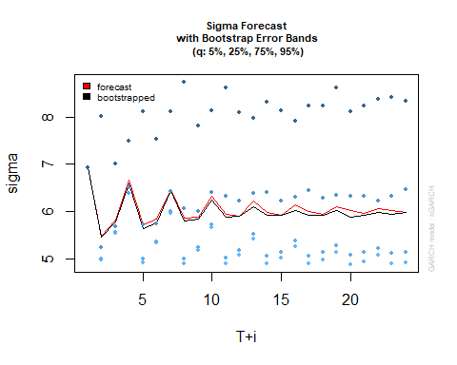

octoberpredict

##   
## *-----------------------------------*  
## * GARCH Bootstrap Forecast *  
## *-----------------------------------*  
## Model : sGARCH  
## n.ahead : 24  
## Bootstrap method: partial  
## Date (T[0]): 1972-01-15 19:00:00  
##   
## Series (summary):  
## min q.25 mean q.75 max forecast[analytic]  
## t+1 4.739 24.096 26.761 29.197 58.585 26.310  
## t+2 -12.682 23.272 27.717 31.693 86.369 26.983  
## t+3 -27.304 22.993 28.590 33.884 89.607 27.589  
## t+4 -27.262 22.443 29.654 36.168 104.062 28.134  
## t+5 -26.465 23.065 30.696 37.523 107.917 28.625  
## t+6 -23.986 22.101 31.102 38.921 117.375 29.067  
## t+7 -20.736 22.809 32.428 41.209 112.846 29.465  
## t+8 -28.941 23.281 33.315 43.235 106.912 29.823  
## t+9 -20.763 22.523 33.418 43.023 109.495 30.146  
## t+10 -18.797 22.986 33.729 43.201 109.577 30.436  
## .....................  
##   
## Sigma (summary):  
## min q0.25 mean q0.75 max forecast[analytic]  
## t+1 6.9326 6.9326 6.9326 6.9326 6.9326 6.9326  
## t+2 4.9790 4.9964 5.4662 5.2330 11.7833 5.4820  
## t+3 5.5404 5.5495 5.7808 5.6817 10.7331 5.8298  
## t+4 6.3752 6.3829 6.5936 6.4999 10.7234 6.6607  
## t+5 4.9084 4.9842 5.6407 5.7158 11.3029 5.7168  
## t+6 5.3188 5.3588 5.7644 5.7360 10.6828 5.8483  
## t+7 5.9472 5.9964 6.4365 6.4206 15.2918 6.4620  
## t+8 4.8563 4.9860 5.7909 6.0626 13.6405 5.8539  
## t+9 5.1580 5.2389 5.8306 5.9929 11.7950 5.8762  
## t+10 5.6242 5.7286 6.2487 6.4031 13.1492 6.3195  
## .....................

octoberroll = ugarchroll(october1, octoberts,n.start = 504, refit.every = 24, refit.window = "moving", solver = "hybrid", calculate.VaR = TRUE, VaR.alpha = 0.05, keep.coef = TRUE)  
octoberroll

##   
## *-------------------------------------*  
## * GARCH Roll *  
## *-------------------------------------*  
## No.Refits : 11  
## Refit Horizon : 24  
## No.Forecasts : 241  
## GARCH Model : sGARCH(1,3)  
## Distribution : norm   
##   
## Forecast Density:  
## Mu Sigma Skew Shape Shape(GIG) Realized  
## 1971-05-20 20:00:00 28.4407 6.0475 0 0 0 23.60  
## 1971-05-21 20:00:00 23.1751 5.9464 0 0 0 24.41  
## 1971-05-22 20:00:00 26.0479 5.8911 0 0 0 23.76  
## 1971-05-23 20:00:00 24.2248 5.9906 0 0 0 19.22  
## 1971-05-24 20:00:00 19.2953 5.9542 0 0 0 17.38  
## 1971-05-25 20:00:00 18.7915 5.8899 0 0 0 17.38  
##   
## ..........................  
## Mu Sigma Skew Shape Shape(GIG) Realized  
## 1972-01-10 19:00:00 55.8900 4.9366 0 0 0 59.84  
## 1972-01-11 19:00:00 58.6681 5.1725 0 0 0 59.86  
## 1972-01-12 19:00:00 57.7779 6.0491 0 0 0 59.78  
## 1972-01-13 19:00:00 57.9711 4.8771 0 0 0 57.13  
## 1972-01-14 19:00:00 54.5929 4.9901 0 0 0 49.43  
## 1972-01-15 19:00:00 46.1770 6.0134 0 0 0 31.29  
##   
## Elapsed: 2.857209 secs

plot(octoberroll, which = 3, VaR.alpha = 0.05)

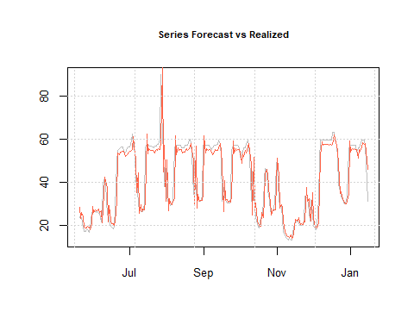

#as.data.frame(octoberroll)

### GARCH Cali Data for May

## Same method as before was used.  
## ARMA (1,3) was picked so it could handle the spikes at the end of the month better.  
may1 = ugarchspec(variance.model = list(garchOrder = c(1,3)),mean.model = list(armaOrder = c(1,3)), distribution.model = "norm")  
maygarch1 = ugarchfit(spec = may1, data = calimayts)  
maygarch1

##   
## *---------------------------------*  
## * GARCH Model Fit *  
## *---------------------------------*  
##   
## Conditional Variance Dynamics   
## -----------------------------------  
## GARCH Model : sGARCH(1,3)  
## Mean Model : ARFIMA(1,0,3)  
## Distribution : norm   
##   
## Optimal Parameters  
## ------------------------------------  
## Estimate Std. Error t value Pr(>|t|)  
## mu 20.300609 1.510411 1.3440e+01 0e+00  
## ar1 -1.000000 0.000910 -1.0995e+03 0e+00  
## ma1 1.196870 0.000086 1.3930e+04 0e+00  
## ma2 0.271151 0.000047 5.7119e+03 0e+00  
## ma3 0.075420 0.000128 5.9090e+02 0e+00  
## omega 34.811176 7.381005 4.7163e+00 2e-06  
## alpha1 0.013773 0.001005 1.3705e+01 0e+00  
## beta1 0.000000 0.005805 2.0000e-06 1e+00  
## beta2 0.000000 0.003877 1.0000e-06 1e+00  
## beta3 0.955391 0.004701 2.0322e+02 0e+00  
##   
## Robust Standard Errors:  
## Estimate Std. Error t value Pr(>|t|)  
## mu 20.300609 1.641392 1.2368e+01 0.00000  
## ar1 -1.000000 0.000702 -1.4253e+03 0.00000  
## ma1 1.196870 0.000419 2.8535e+03 0.00000  
## ma2 0.271151 0.000273 9.9465e+02 0.00000  
## ma3 0.075420 0.000329 2.2928e+02 0.00000  
## omega 34.811176 30.585055 1.1382e+00 0.25505  
## alpha1 0.013773 0.002573 5.3527e+00 0.00000  
## beta1 0.000000 0.010136 1.0000e-06 1.00000  
## beta2 0.000000 0.015873 0.0000e+00 1.00000  
## beta3 0.955391 0.013660 6.9939e+01 0.00000  
##   
## LogLikelihood : -3646.241   
##   
## Information Criteria  
## ------------------------------------  
##   
## Akaike 9.8551  
## Bayes 9.9172  
## Shibata 9.8547  
## Hannan-Quinn 9.8790  
##   
## Weighted Ljung-Box Test on Standardized Residuals  
## ------------------------------------  
## statistic p-value  
## Lag[1] 0.09323 0.7601  
## Lag[2*(p+q)+(p+q)-1][11] 4.05792 0.9999  
## Lag[4*(p+q)+(p+q)-1][19] 6.55008 0.9425  
## d.o.f=4  
## H0 : No serial correlation  
##   
## Weighted Ljung-Box Test on Standardized Squared Residuals  
## ------------------------------------  
## statistic p-value  
## Lag[1] 0.0172 0.8957  
## Lag[2*(p+q)+(p+q)-1][11] 0.5477 0.9997  
## Lag[4*(p+q)+(p+q)-1][19] 0.9328 1.0000  
## d.o.f=4  
##   
## Weighted ARCH LM Tests  
## ------------------------------------  
## Statistic Shape Scale P-Value  
## ARCH Lag[5] 0.1068 0.500 2.000 0.7438  
## ARCH Lag[7] 0.3983 1.473 1.746 0.9239  
## ARCH Lag[9] 0.5050 2.402 1.619 0.9836  
##   
## Nyblom stability test  
## ------------------------------------  
## Joint Statistic: 6.2133  
## Individual Statistics:   
## mu 0.16813  
## ar1 0.14202  
## ma1 0.11992  
## ma2 0.11924  
## ma3 0.11780  
## omega 0.10907  
## alpha1 0.06759  
## beta1 0.16187  
## beta2 0.16975  
## beta3 0.10737  
##   
## Asymptotic Critical Values (10% 5% 1%)  
## Joint Statistic: 2.29 2.54 3.05  
## Individual Statistic: 0.35 0.47 0.75  
##   
## Sign Bias Test  
## ------------------------------------  
## t-value prob sig  
## Sign Bias 2.3417 0.01946 **  
## Negative Sign Bias 0.2045 0.83805   
## Positive Sign Bias 0.4921 0.62277   
## Joint Effect 7.7826 0.05073 *  
##   
##   
## Adjusted Pearson Goodness-of-Fit Test:  
## ------------------------------------  
## group statistic p-value(g-1)  
## 1 20 1328 3.858e-270  
## 2 30 1376 1.416e-271  
## 3 40 1386 1.174e-265  
## 4 50 1412 1.739e-263  
##   
##   
## Elapsed time : 0.439162

maypredict = ugarchboot(maygarch1, n.ahead = 24, method = c("Partial","Full")[1])  
plot(maypredict, which = 2)

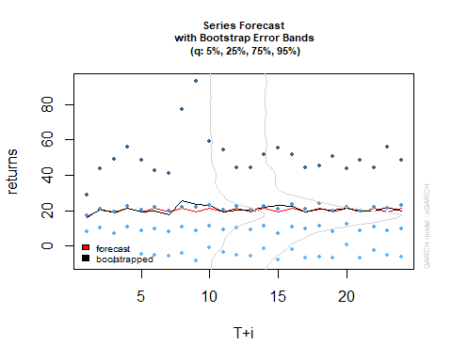

maypredict

##   
## *-----------------------------------*  
## * GARCH Bootstrap Forecast *  
## *-----------------------------------*  
## Model : sGARCH  
## n.ahead : 24  
## Bootstrap method: partial  
## Date (T[0]): 1972-01-12 19:00:00  
##   
## Series (summary):  
## min q.25 mean q.75 max forecast[analytic]  
## t+1 -32.050 7.9056 15.979 17.223 319.51 16.506  
## t+2 -28.265 10.4719 21.043 20.827 465.28 20.533  
## t+3 -37.177 6.8260 18.499 19.225 528.99 19.115  
## t+4 -28.328 10.6804 21.179 22.716 322.69 21.487  
## t+5 -17.115 8.6238 19.419 20.575 457.83 19.115  
## t+6 -34.617 9.5577 19.684 22.177 324.00 21.487  
## t+7 -30.084 7.9652 17.873 19.847 322.07 19.115  
## t+8 -28.258 11.0322 25.596 21.942 483.27 21.487  
## t+9 -20.852 8.6241 23.552 22.009 367.96 19.115  
## t+10 -27.401 11.5119 22.926 23.217 284.36 21.487  
## .....................  
##   
## Sigma (summary):  
## min q0.25 mean q0.75 max forecast[analytic]  
## t+1 32.560 32.560 32.560 32.560 32.560 32.560  
## t+2 32.466 32.467 32.636 32.497 48.151 32.690  
## t+3 37.628 37.629 37.841 37.656 64.205 37.823  
## t+4 32.368 32.369 32.601 32.420 68.510 32.670  
## t+5 32.277 32.285 32.581 32.370 47.876 32.718  
## t+6 37.249 37.256 37.628 37.325 63.817 37.634  
## t+7 32.183 32.193 32.595 32.294 67.252 32.773  
## t+8 32.096 32.114 32.551 32.232 47.801 32.746  
## t+9 36.884 36.900 37.630 37.016 65.925 37.453  
## t+10 32.006 32.029 32.743 32.208 66.000 32.868  
## .....................

mayroll = ugarchroll(may1, calimayts,n.start = 456, refit.every = 24, refit.window = "moving", solver = "hybrid", calculate.VaR = TRUE, VaR.alpha = 0.05, keep.coef = TRUE)  
mayroll

##   
## *-------------------------------------*  
## * GARCH Roll *  
## *-------------------------------------*  
## No.Refits : 12  
## Refit Horizon : 24  
## No.Forecasts : 286  
## GARCH Model : sGARCH(1,3)  
## Distribution : norm   
##   
## Forecast Density:  
## Mu Sigma Skew Shape Shape(GIG) Realized  
## 1971-04-02 19:00:00 17.5142 21.2365 0 0 0 14.5673  
## 1971-04-03 19:00:00 17.3253 22.5581 0 0 0 13.4311  
## 1971-04-04 19:00:00 16.9555 17.8483 0 0 0 6.2853  
## 1971-04-05 19:00:00 15.5587 21.0608 0 0 0 5.2689  
## 1971-04-06 19:00:00 14.9702 22.3662 0 0 0 7.6583  
## 1971-04-07 19:00:00 15.0919 17.6927 0 0 0 6.0291  
##   
## ..........................  
## Mu Sigma Skew Shape Shape(GIG) Realized  
## 1972-01-07 19:00:00 11.4977 20.4265 0 0 0 15.1083  
## 1972-01-08 19:00:00 16.2476 19.2209 0 0 0 26.6633  
## 1972-01-09 19:00:00 22.5012 19.2077 0 0 0 28.4107  
## 1972-01-10 19:00:00 23.0994 17.5437 0 0 0 31.8784  
## 1972-01-11 19:00:00 25.0441 17.6297 0 0 0 19.6008  
## 1972-01-12 19:00:00 15.2957 16.4423 0 0 0 9.1116  
##   
## Elapsed: 4.622566 secs

plot(mayroll, which = 3, VaR.alpha = 0.05)

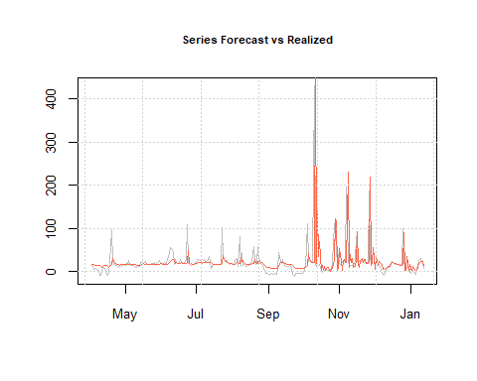

#as.data.frame(mayroll)

## Garch Cali Data for June

cajune1 = ugarchspec(variance.model = list(garchOrder = c(1,3)),mean.model = list(armaOrder = c(1,1)), distribution.model = "norm")  
cajunegarch1 = ugarchfit(spec = cajune1, data = caliunets)  
cajunegarch1

##   
## *---------------------------------*  
## * GARCH Model Fit *  
## *---------------------------------*  
##   
## Conditional Variance Dynamics   
## -----------------------------------  
## GARCH Model : sGARCH(1,3)  
## Mean Model : ARFIMA(1,0,1)  
## Distribution : norm   
##   
## Optimal Parameters  
## ------------------------------------  
## Estimate Std. Error t value Pr(>|t|)  
## mu 22.166407 1.548077 14.318674 0.000000  
## ar1 0.577611 0.049006 11.786442 0.000000  
## ma1 0.027515 0.103974 0.264637 0.791289  
## omega 220.738998 15.074479 14.643226 0.000000  
## alpha1 0.528987 0.136298 3.881091 0.000104  
## beta1 0.031151 0.036883 0.844584 0.398343  
## beta2 0.000000 0.027006 0.000001 0.999999  
## beta3 0.000000 0.014412 0.000000 1.000000  
##   
## Robust Standard Errors:  
## Estimate Std. Error t value Pr(>|t|)  
## mu 22.166407 2.481281 8.933451 0.000000  
## ar1 0.577611 0.095646 6.039077 0.000000  
## ma1 0.027515 0.133892 0.205506 0.837177  
## omega 220.738998 77.199934 2.859316 0.004246  
## alpha1 0.528987 0.225200 2.348962 0.018826  
## beta1 0.031151 0.068829 0.452578 0.650853  
## beta2 0.000000 0.027646 0.000001 0.999999  
## beta3 0.000000 0.019928 0.000000 1.000000  
##   
## LogLikelihood : -3038.6   
##   
## Information Criteria  
## ------------------------------------  
##   
## Akaike 8.4628  
## Bayes 8.5137  
## Shibata 8.4625  
## Hannan-Quinn 8.4824  
##   
## Weighted Ljung-Box Test on Standardized Residuals  
## ------------------------------------  
## statistic p-value  
## Lag[1] 1.420 0.2333  
## Lag[2*(p+q)+(p+q)-1][5] 2.823 0.5848  
## Lag[4*(p+q)+(p+q)-1][9] 3.636 0.7730  
## d.o.f=2  
## H0 : No serial correlation  
##   
## Weighted Ljung-Box Test on Standardized Squared Residuals  
## ------------------------------------  
## statistic p-value  
## Lag[1] 0.0003741 0.9846  
## Lag[2*(p+q)+(p+q)-1][11] 0.3653563 0.9999  
## Lag[4*(p+q)+(p+q)-1][19] 0.9588712 1.0000  
## d.o.f=4  
##   
## Weighted ARCH LM Tests  
## ------------------------------------  
## Statistic Shape Scale P-Value  
## ARCH Lag[5] 0.05869 0.500 2.000 0.8086  
## ARCH Lag[7] 0.20399 1.473 1.746 0.9697  
## ARCH Lag[9] 0.32192 2.402 1.619 0.9940  
##   
## Nyblom stability test  
## ------------------------------------  
## Joint Statistic: 7.789  
## Individual Statistics:   
## mu 0.67830  
## ar1 0.04570  
## ma1 0.05709  
## omega 0.18131  
## alpha1 0.29577  
## beta1 0.27546  
## beta2 0.20204  
## beta3 1.07935  
##   
## Asymptotic Critical Values (10% 5% 1%)  
## Joint Statistic: 1.89 2.11 2.59  
## Individual Statistic: 0.35 0.47 0.75  
##   
## Sign Bias Test  
## ------------------------------------  
## t-value prob sig  
## Sign Bias 1.7285 0.08434 *  
## Negative Sign Bias 0.1373 0.89081   
## Positive Sign Bias 0.1640 0.86979   
## Joint Effect 3.4323 0.32964   
##   
##   
## Adjusted Pearson Goodness-of-Fit Test:  
## ------------------------------------  
## group statistic p-value(g-1)  
## 1 20 1546 5.704e-317  
## 2 30 1538 4.462e-306  
## 3 40 1602 3.057e-311  
## 4 50 1594 7.940e-302  
##   
##   
## Elapsed time : 0.3172221

cajunepredict = ugarchboot(cajunegarch1, n.ahead = 24, method = c("Partial","Full")[1])  
plot(cajunepredict, which = 2)

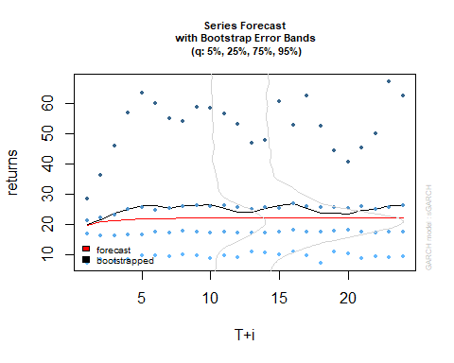

cajunepredict

##   
## *-----------------------------------*  
## * GARCH Bootstrap Forecast *  
## *-----------------------------------*  
## Model : sGARCH  
## n.ahead : 24  
## Bootstrap method: partial  
## Date (T[0]): 1971-12-21 19:00:00  
##   
## Series (summary):  
## min q.25 mean q.75 max forecast[analytic]  
## t+1 -7.6812 17.095 19.961 21.213 184.08 19.894  
## t+2 -20.2839 16.459 21.546 22.223 201.60 20.854  
## t+3 -3.6150 16.387 23.862 23.297 384.89 21.408  
## t+4 -21.2571 16.675 25.038 24.890 210.87 21.729  
## t+5 -12.7576 16.595 26.325 25.743 503.85 21.914  
## t+6 -19.3488 17.537 26.385 24.677 684.87 22.020  
## t+7 -3.7251 17.351 25.445 25.427 419.73 22.082  
## t+8 -4.1479 17.729 26.229 25.954 445.68 22.118  
## t+9 -16.4335 17.563 26.210 26.382 291.89 22.138  
## t+10 -16.3934 17.278 26.551 25.848 209.27 22.150  
## .....................  
##   
## Sigma (summary):  
## min q0.25 mean q0.75 max forecast[analytic]  
## t+1 15.400 15.400 15.400 15.400 15.40 15.400  
## t+2 15.104 15.121 16.391 15.461 120.37 18.804  
## t+3 15.095 15.123 16.797 15.540 132.08 20.464  
## t+4 15.094 15.119 17.555 15.502 232.77 21.338  
## t+5 15.094 15.129 17.617 15.706 132.21 21.812  
## t+6 15.095 15.133 17.927 15.726 332.41 22.074  
## t+7 15.094 15.126 17.399 15.488 277.19 22.218  
## t+8 15.095 15.127 16.796 15.552 138.83 22.299  
## t+9 15.094 15.121 17.251 15.550 225.15 22.344  
## t+10 15.094 15.125 17.264 15.651 134.18 22.370  
## .....................

cajuneroll = ugarchroll(cajune1, caliunets,n.start = 576, refit.every = 24, refit.window = "moving", solver = "hybrid", calculate.VaR = TRUE, VaR.alpha = 0.05, keep.coef = TRUE)  
cajuneroll

##   
## *-------------------------------------*  
## * GARCH Roll *  
## *-------------------------------------*  
## No.Refits : 6  
## Refit Horizon : 24  
## No.Forecasts : 144  
## GARCH Model : sGARCH(1,3)  
## Distribution : norm   
##   
## Forecast Density:  
## Mu Sigma Skew Shape Shape(GIG) Realized  
## 1971-07-31 20:00:00 19.8703 10.4829 0 0 0 23.4016  
## 1971-08-01 20:00:00 23.4104 10.4544 0 0 0 20.1120  
## 1971-08-02 20:00:00 21.3603 10.0843 0 0 0 17.7246  
## 1971-08-03 20:00:00 19.7808 10.0820 0 0 0 17.5720  
## 1971-08-04 20:00:00 19.6511 9.9538 0 0 0 22.2091  
## 1971-08-05 20:00:00 22.6375 9.6800 0 0 0 24.8039  
##   
## ..........................  
## Mu Sigma Skew Shape Shape(GIG) Realized  
## 1971-12-16 19:00:00 25.6665 18.5225 0 0 0 25.5284  
## 1971-12-17 19:00:00 25.5164 17.9177 0 0 0 35.5764  
## 1971-12-18 19:00:00 31.7204 17.5499 0 0 0 29.9795  
## 1971-12-19 19:00:00 29.5393 17.2486 0 0 0 23.8085  
## 1971-12-20 19:00:00 25.2557 16.8149 0 0 0 22.9671  
## 1971-12-21 19:00:00 23.8414 16.4062 0 0 0 18.4327  
##   
## Elapsed: 2.956129 secs

plot(cajuneroll, which = 3, VaR.alpha = 0.05)

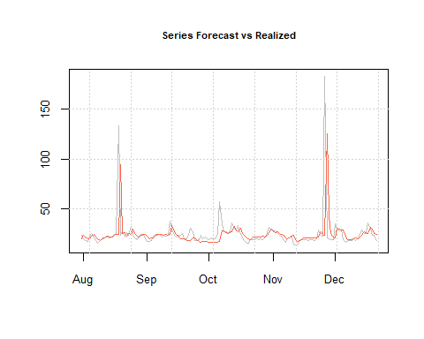

#as.data.frame(cajuneroll)