Add a new computer backup
  - Acronis Cyber Protect Cloud + Maldoori RMM
Document: WI-BACKUP-001 • Version 1.0 • 10 October 2026

Purpose
Enroll a client’s Windows computer for backup, verify recovery, and link its Acronis record to Maldoori.

Before you start
- Operator access to the Acronis customer console and Maldoori.
- Client authorization, Windows administrator access, and a working internet connection.
- An approved storage destination, backup schedule, retention policy, and secure recovery-password storage.
- The correct Customer → Company → Computer assignment in Maldoori.

Quick workflow
1. Choose the customer in Acronis
2. Install and register the backup agent
3. Assign and check the backup plan
4. Run and verify the first backup
5. Test restoring one file
6. Link the computer in Maldoori

Send to the client
“Please open the Acronis installation link we sent on the computer being protected. Run the installer as administrator and follow the registration instructions. This enables ongoing backup and recovery. Keep the computer online for its first backup. Contact SkyBase IT Solutions if you are unsure which customer account to select.”
Pictures in this guide are navigation illustrations. Use the wording closest to the controls shown in your Acronis account.

Step 1 — Choose the customer in Acronis
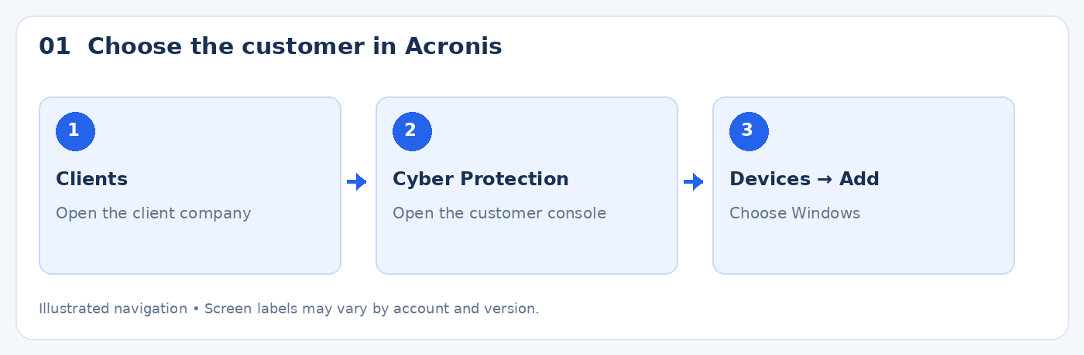
- Sign in to the Acronis management portal with your operator account.
- Open Clients and select the business that owns the new computer. Create a Customer record only if this is a new client business.
- Open Cyber Protection or Manage service for that customer.
- Go to Devices → Add and select Windows.

Check: The selected customer is the business that owns the computer.

Step 2 — Install and register the backup agent
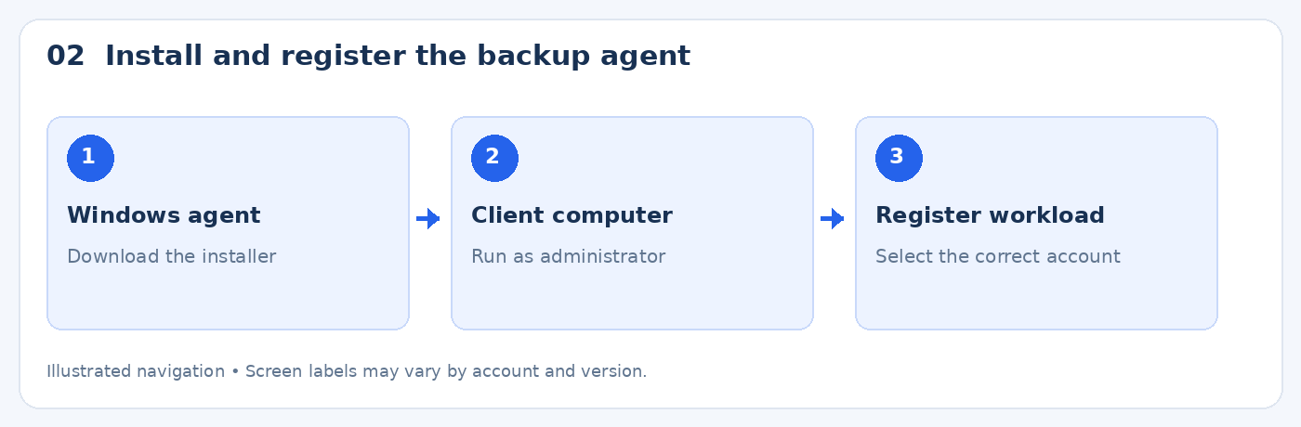
- Use the installer or registration link offered by the customer console. Send it privately to the authorized client.
- On the client computer, run the Acronis installer as administrator and complete installation.
- If a registration code appears, follow its registration link, validate the code, and select the account belonging to the correct customer.
- Review the computer name and customer before registering. If no suitable plan exists, register first and assign the plan in the next step.
- Confirm the computer appears in the customer console. Keep the existing MeshCentral agent installed; the Acronis agent performs backup.

Check: The new computer appears under the intended Acronis customer.

Step 3 — Assign and check the backup plan
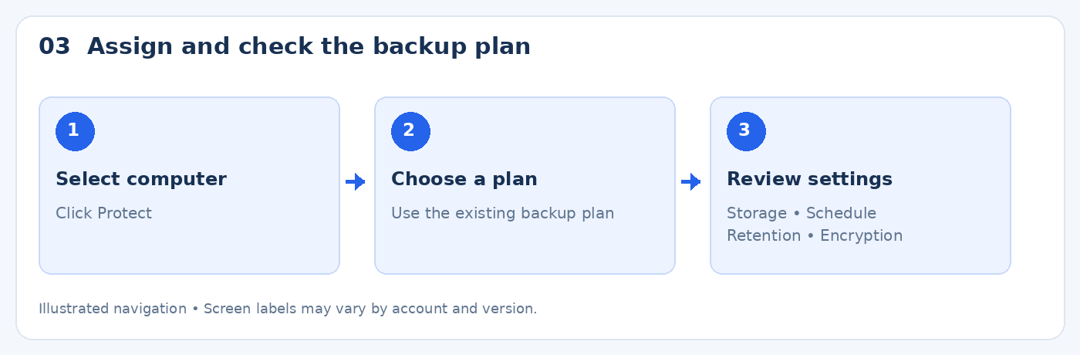
- Select the new computer and click Protect.
- Apply an existing approved backup plan for this customer, or create one if necessary.
- Choose Entire machine / Entire workload for full-computer protection. An entire-machine backup can also support individual file recovery.
- Confirm the destination is the intended Acronis cloud storage and the schedule runs while the computer is usually online.
- Set retention according to the agreed customer policy. Review storage allowance and charges before extending protection to more computers.
- Enable backup encryption where supported and store the recovery password securely in your password manager. Do not put it in this document or client messages.
- Save and apply the plan.

Check: The plan is applied to the correct computer with the intended destination and settings.

Step 4 — Run and verify the first backup
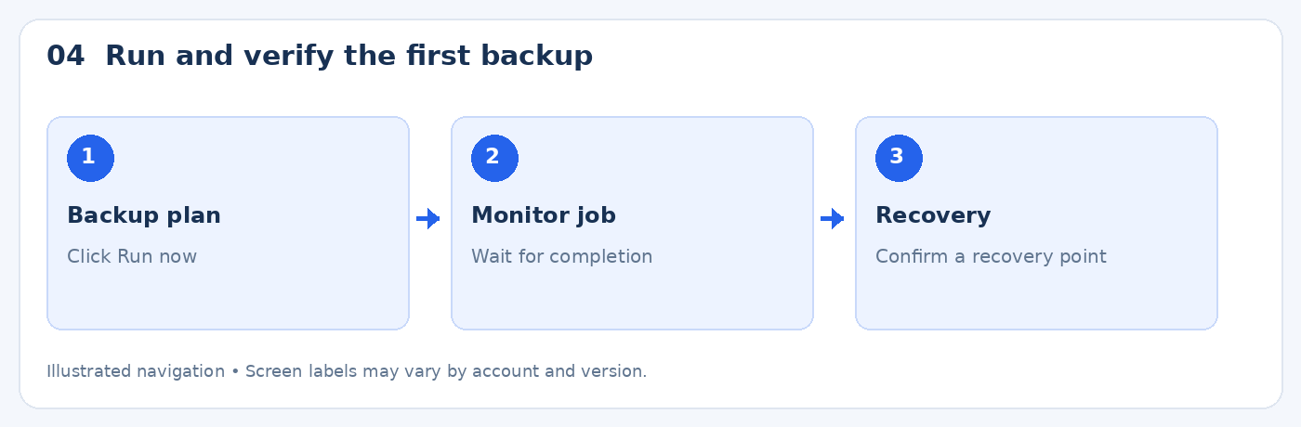
- In the Acronis protection or backup view, click Run now for the assigned plan.
- Keep the computer powered on and connected to the internet. The first full backup may take longer than later backups.
- Check the resulting task for successful completion. Overall device status OK alone does not prove that a backup succeeded.
- Open Recovery and confirm a recovery point is available. Check its date, backup type, and contents.
- If a task fails, review the error and resolve it before reporting the computer as protected.

Check: A successful backup task and an available recovery point are both verified.

Step 5 — Test restoring one file
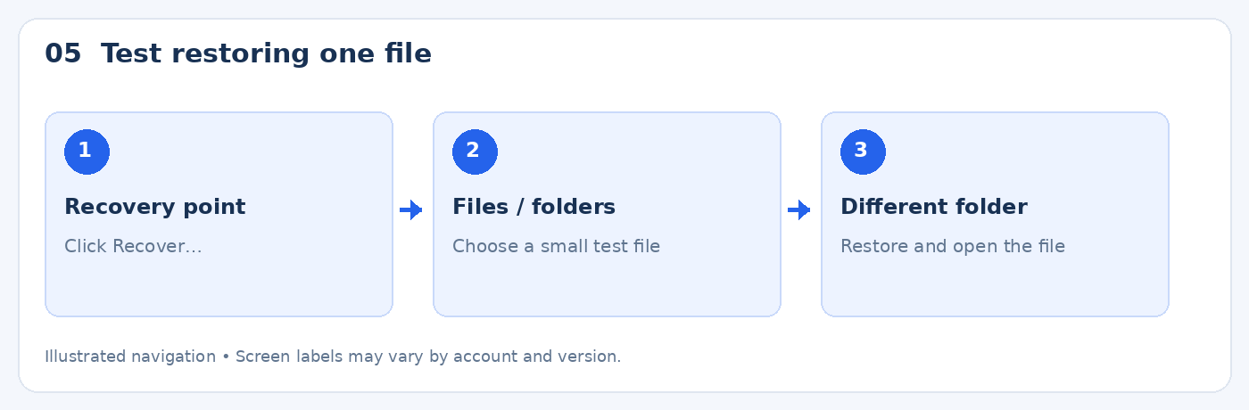
- Select the new recovery point and click Recover….
- Choose Files / folders if offered and select one small, non-sensitive test file.
- Restore the file to a different folder so the test does not overwrite the original.
- Open the restored file and confirm its contents are correct.
- Record the test date, recovery-point date, and outcome. Avoid whole-disk recovery for this file test because it can overwrite the running computer.

Check: The restored file opens correctly in the separate destination.

Step 6 — Link the computer in Maldoori
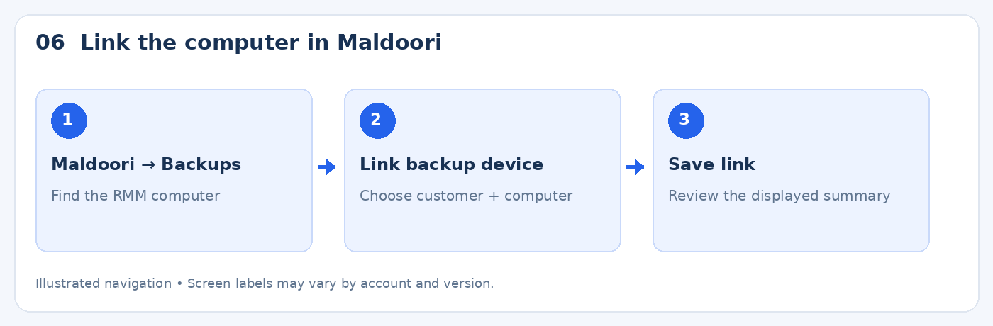
- Confirm the computer is already enrolled in Maldoori through its MeshCentral agent.
- Open Maldoori → Backups and find the computer card. Use search or the company filter if needed.
- Click Link backup device. Choose the matching Acronis resource under the correct customer, then save.
- Check both the customer and computer names. Do not match by computer name alone when multiple customers have similar names.
- Review the latest matched backup task and its last successful task time. If Maldoori shows Not verified, check Acronis directly; it may not have returned a unique device reference.
- Use Manage in Acronis to run backups, change schedules, or restore data. Direct backup execution, schedule editing, and recovery in Maldoori are not implemented in the current release.

Check: The RMM computer is linked to the correct Acronis customer/resource and the restore test is recorded.

Completion record
Item | Record
Customer / company | ____________________________
Computer name | ____________________________
Acronis resource | ____________________________
Plan and schedule | ____________________________
First backup / recovery point | ____________________________
Restore test date and outcome | ____________________________
Operator | ____________________________

