Patch Management
Simple Work Instruction
Current workflow: find a needed update → add it → test → notify the company → install manually → verify. SkyBase currently manages the catalog, plans, and notices; automatic discovery, installation, and verification are not connected.

1. Find a needed update
1. On the computer, open Settings → Windows Update → Check for updates.
2. Choose an available security update. Copy its real name and KB number. Do not choose it from Update history: that list contains already-installed updates.
3. Review the vendor’s known issues and restart instructions. Check that the update applies to each target computer. Optional preview, driver, and major feature updates need separate review.
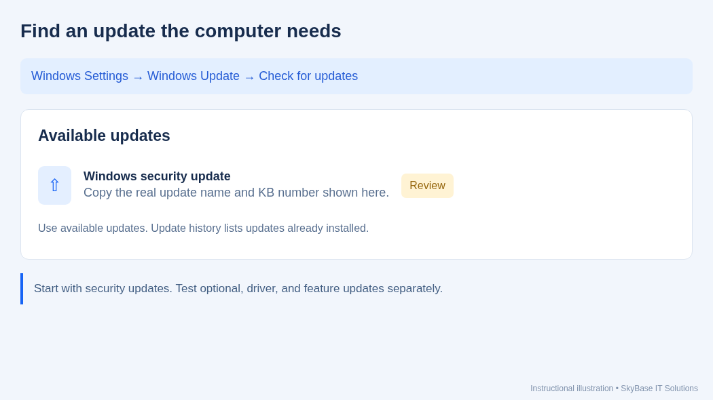
Instructional illustration: where to find available Windows updates.

2. Add the patch in SkyBase
1. Open Patch Management → Add Patch. Enter the actual Patch Name and the vendor’s KB/reference in Patch ID.
2. Enter the description, Type, Severity, and Vendor. Use the vendor’s release date and size if known; otherwise leave these optional fields blank.
3. Tick Requires Reboot only when the update instructions require it. This setting controls the user notice; it does not restart the computer. Click Add Patch. Use Edit to change these details later.
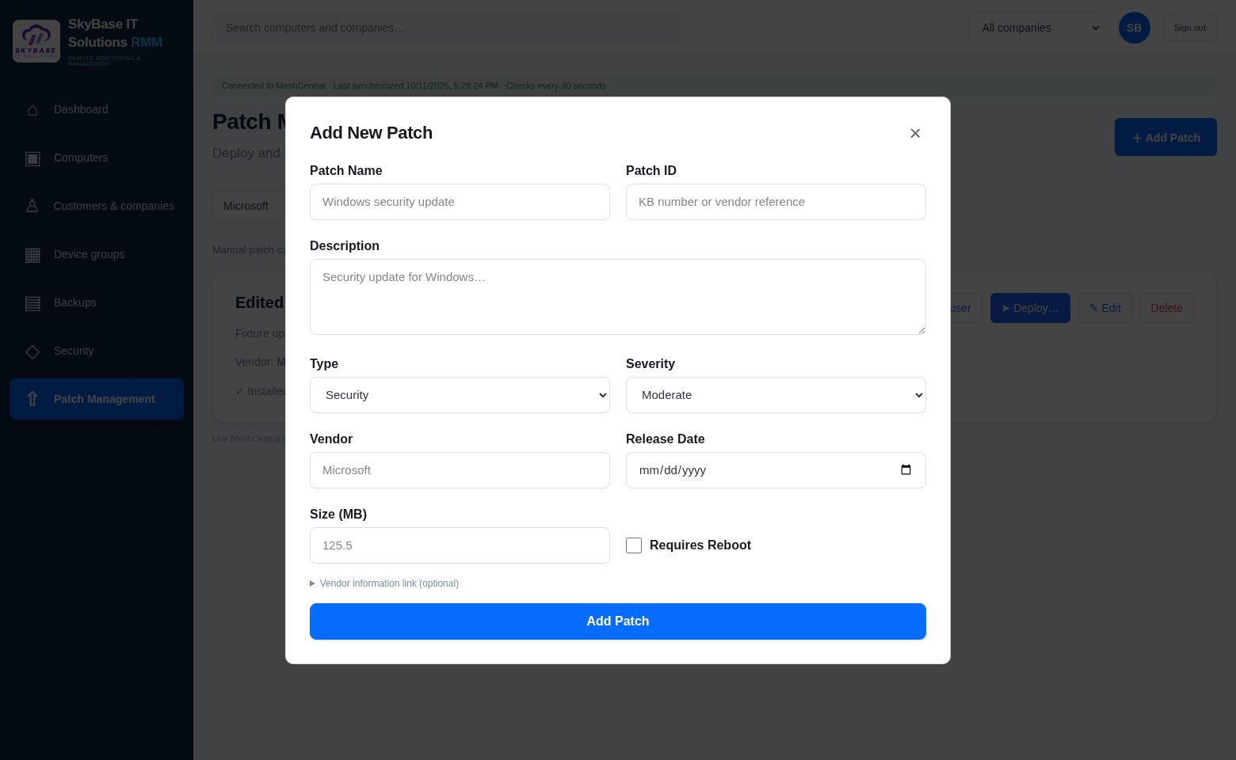
SkyBase Add New Patch dialog. Example interface; copy your real update details.

3. Test on one computer
1. Confirm a recent backup and a working recovery method before changing the computer.
2. Choose one non-critical computer with the relevant Windows version and applications. Connect through SkyBase and install its applicable update manually through Windows Update or the vendor’s supported tool.
3. Restart if required. Check sign-in, business applications, and remote access. If there is a problem, investigate before proceeding to other computers.
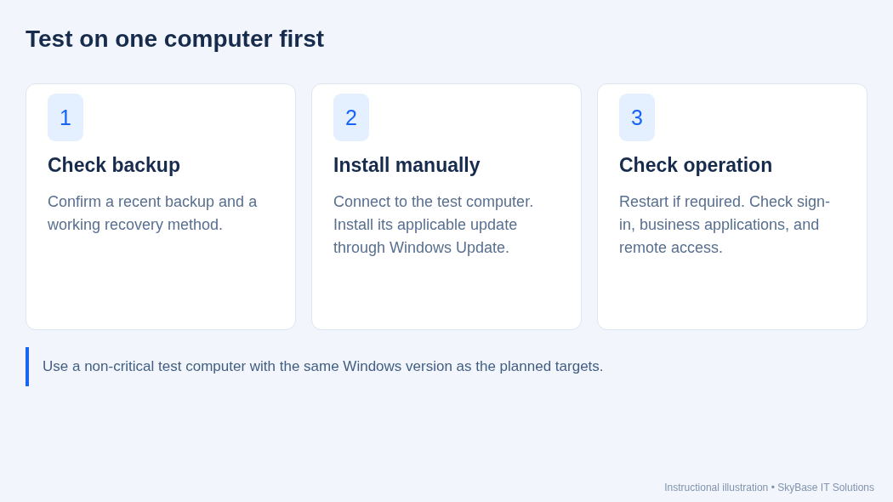
Instructional illustration: backup, test installation, and functional checks.

4. Plan the company rollout and notify users
1. On the patch card, click Deploy… and select the correct company.
2. Enter the maintenance window with its time zone, such as “Tomorrow, 6–7 PM Central.” Do not put restart instructions in this field; those come from Requires Reboot.
3. Click Save plan & notify company. SkyBase plans the company’s Windows targets and sends advance notices to active signed-in users on online Windows computers. This action does not install the update.
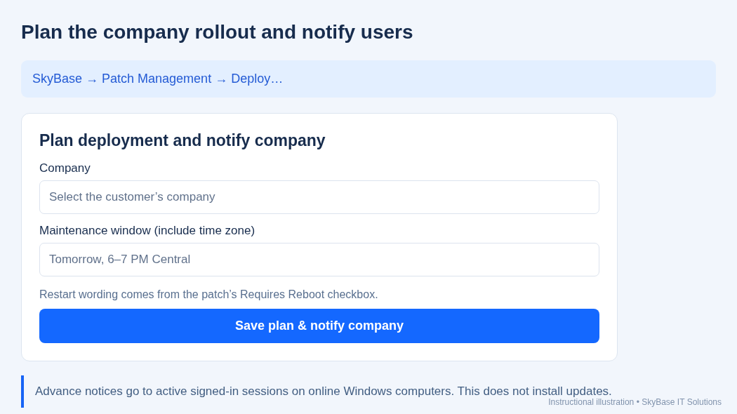
Instructional illustration of the company deployment form.

5. Review notices and install during maintenance
1. Read Company notification results. Accepted means Windows accepted the message, not that the user read it. Offline means no notice was sent or queued for later.
2. For failed, partial, or uncertain results, check the user session and Mesh Agent permissions. Check delivery before resending. View notices reopens the latest company results.
3. During the maintenance window, connect to each applicable target and install the update through Windows Update or the vendor’s supported tool. Arrange any required restart with the user. SkyBase does not do these steps automatically yet.
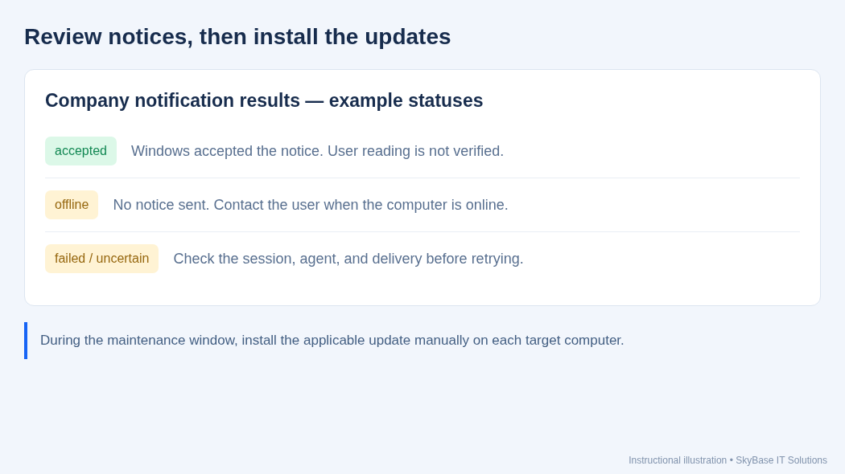
Instructional illustration: understand results before proceeding.

6. Verify and record completion
1. On every target, open Settings → Windows Update → Update history and confirm that the exact KB shows successfully installed. For third-party software, check its installed version against the vendor’s fixed version.
2. Complete any required restart. Confirm that business applications and remote access still work. Record the computer, patch, result, and date in your service notes.
3. SkyBase currently shows Installed: Not verified even after a manual installation. Planned counts rollout targets only. Delete removes the catalog entry and plans; it does not uninstall an update.
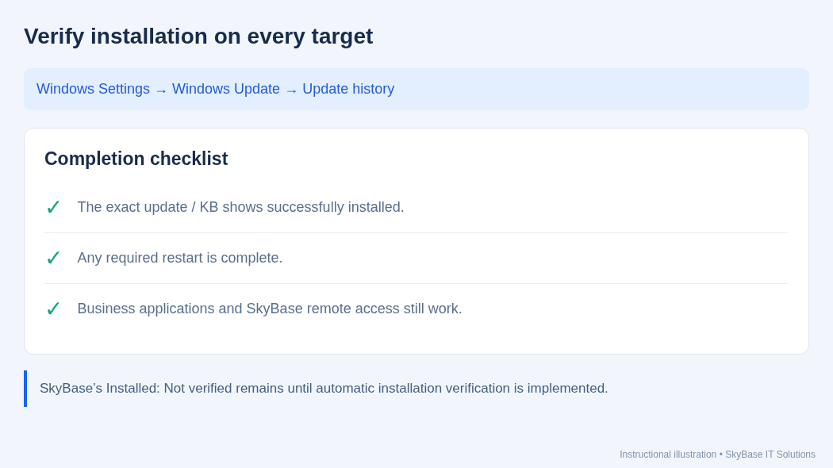
Instructional illustration: installation verification checklist.

