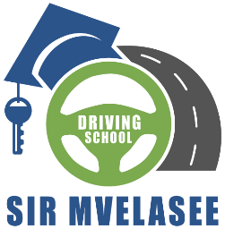

|  |  |  |  |  |  |
| --- | --- | --- | --- | --- | --- |
| SIR MVELASEE DRIVING SCHOOL | |  | | | **INVOICE** |
|  | |  | | |  |
| 29 Tom Jones Avenue | | **INVOICE #** | | | **DATE** |
| Benoni, 1501  Phone: +27 67 115 5624 and +27 76 736 5691 | | 001 | | | 25/04/2024 |
|  | |  | | |  |
| **BILL TO** |
| Kwenzokuhle Linda Mkhize |
| Palfinger South Africa |
| 284B Dekema Road |
| Germiston 1428 |
| 011 608 3670 |
|  |
| **DESCRIPTION** | | |  | **AMOUNT** | |
| 1. **CODE 08 DRIVING COURSE:** | | |  |  | |
| 1. Learners License | | |  | R 2000.00 | |
| 1. Driving Lessons | | |  | R 4500.00 | |
| **TOTAL – FULL COURSE** | | |  | **R 6500.00** | |
|  | | |  |  | |
| 1. **CODE 10 DRIVING COURSE:** | | |  |  | |
| 1. Learners License | | |  | R 2000.00 | |
| 1. Driving Lessons | | |  | R 4500.00 | |
| **TOTAL – FULL COURSE** | | |  | **R 6500.00** | |
| 1. **CODE 14 DRIVING COURSE:** | | | |  | |
| 1. Learners License | | | | R 2000.00 | |
| 1. Driving Lessons | | | | R 7500.00 | |
| **TOTAL – FULL COURSE** | | | | **R 9500.00** | |
| **Payment Information:** | | |  |  | |
| **Account number:** 1323588173 | | |  |  | |
| **Bank name:** Capitec | | |  |  | |
| **Name:** Mr S Mthembu | | |  |  | |
| *Thank you for your business!* | | | | | |