Guide for Locating Ocean Bottom Seismometers

Background
The Endeavour Tomography Study, also known as ETOMO Study, involved dropping ocean bottom seismometers, OBSs, to the seafloor and then firing air guns over the OBSs. The locations that the OBSs were dropped were recorded, but since the OBSs drift in the ocean before sinking to the bottom, the exact locations for each OBS is unknown. To determine the exact locations, first the travel times of the water wave created by the air guns must be found.
The wave created by the air guns travels through the water column and then continues through the ground. The OBSs record these waves. Before the seismic data of the crust can be modeled, the exact location of the OBSs on the seafloor must be determined. By creating an estimated arrival time for the water wave to reach the OBS, a window around the water wave can be created, enabling a person to pick the actual arrival time. Several codes were created to relocate each OBS.

Procedure
Directory: OBS_&_Event_Locations/Water_Wave_Arrival_Picking_Codes
The matlab code Water_Wave.m automatically predicts the water wave arrival times, runs an AR picking algorithm, and allows arrival times to be checked or manually picked (Figure 1). Water_Wave.m works as follows:
- Read file of the drop locations for OBSs (latitude, longitude, depth)
- Identify Shot Numbers that are within 8 or 12km of each OBS location.
- Choose which OBS to create arrival times for.
- Predict water wave arrival time (tw).
- Create a data window around tw (seismic data, vertical, hydrophone)
- Filter the seismic data at high frequency 30 - 80 Hz.
- Run Auto Regressive Picker.
- Manually pick and or verify AR pick.

For the selected OBS, a loop runs through steps 4 through 8 for each shot. The results from running Water_Wave.m are saved in OBS_&_Event_Locations/Water_Wave_Picks. A fixed error of 8ms was chosen for all the picks.

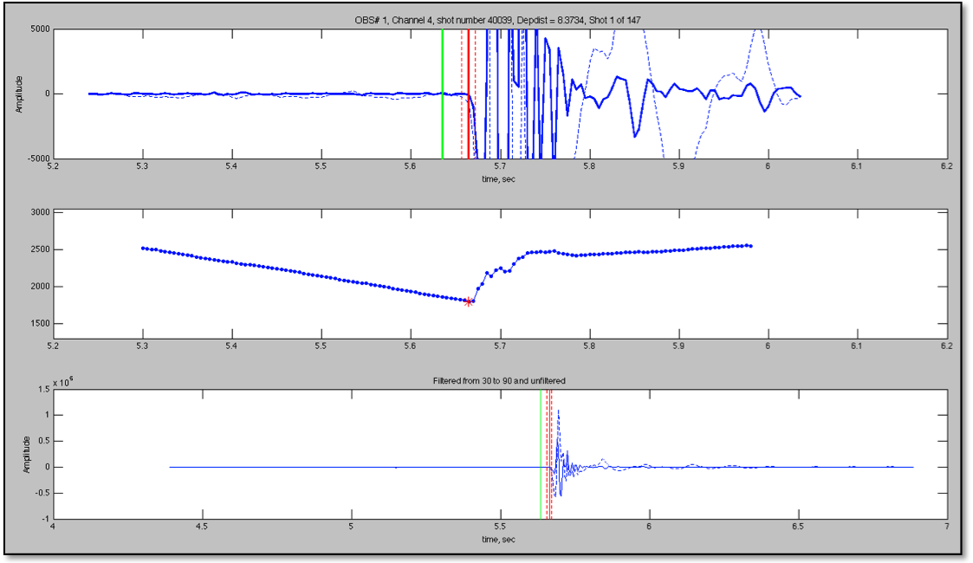
Figure 1 – OBS #1, Shot Number 40037, Channel 4 (hydrophone). The first box is the filtered (bold blue) and unfiltered (dotted blue) zoomed in around the predicted arrival time. The green line is the predicted arrival time. The red line is the actual picked arrival time. This can be moved to pick the best time. The red dotted line is the given standard deviation window. The second box is the auto regressive picking window. The third box shows the entire wave.

Run Inversion for relocating OBSs and shots
Directory: OBS_&_Event_Locations/OBS_&_Event_Relocation_Inversion/Inversion_Code
For the inversion, the water wave arrival times, obs drop locations, and event locations need to be formatted into Stingray matlab structures. The codes create_srStations.m, create_srEvents.m, and create_tlArrivals.m are used to generate input structures for Stingray. The codes can be found in the directory folder Create_Stingray_Structures. The output files are srStation.mat, srEvents.mat, and tlArrivals.mat.
The matlab file run_obsloc_etomo.m runs the inversion (obsloc.m) for the stingray structures. The run_obsloc_etomo.m file is used to set different parameters that can be changed to attain different results. For example, the OBSs and Events can be relocated for x, y, & z and x & y, respectively, or the OBSs can be relocated in x & y while keeping the Events fixed. Obsloc.m creates a structure with the new locations for the events or stations. The structure is saved as an Obsloc_structure file in the directory OBS_&_Event_Locations/OBS_&_Event_Relocation_Inversion/Obsloc_Structures.
Directory: OBS_&_Event_Locations/OBS_&_Event_Relocation_Inversion/Check_Inversion
The directory folder Check_Inversion contains different matlab codes that can check the accuracy of the structure created from run_obsloc_etomo.m file. The codes are listed below.
- outlier_checker.m – checks shots greater than a given error. For example, 5 milli seconds misfit (predicted travel time – picked travel time).
- Residual_Plotter.m – creates residual plots for the structures. The misfits for individual lines and OBSs can be examined.
- sounding_velocity_check.m – compares the located OBSs and shots to the sounding velocities. Can be used to examine the travel time tables.
- statistics.m – shows accuracy of relocated OBSs and shots.
- structure_comparison.m – compares results of different inversions to one another. For example, Obsloc_structure_stations_xy_events_xy compared to Obsloc_structure_stations_xyz_events_xy.

Relocated OBSs/Stations and Shots/Events
Directory: OBS_&_Event_Locations/OBS_&_Event_Relocation_Inversion/Obsloc_Structures
Some OBSs and shots are not included in the inversion due to missing information and shots being out of the 8 or 12 km range. The file add_all_Events_Stations.m will add the missing information to the final obsloc structure. The Events and OBSs that were/were not relocated are identified by the field .tf_relocate (1 for relocated, 0 for not relocated).
The file add_all_Events_Stations.m also calculates the errors for the station and event locations in the x, y, and z fields. The errors were estimated from the median of the difference between inversions that relocated stations (xy) and events (xy) compared to one that relocated stations (xyz) & events (yx). These files compared are Obsloc_structure_stations_xy_events_xy and Obsloc_structure_stations_xyz_events_xy. The estimated errors for the stations and events are listed below.
- Events x – 4.2m
- Events y – 4.4m
- Stations x – 4m
- Stations y – 3m
- Stations z – 33.7m.
Add_all_Events_Stations.m will save the final Stingray structures srStation_Etomo_relocated, srEvent_Etomo_relocated, Obsloc_structure. The final files are saved in the Obsloc_Structures directory folder.
The inversion for relocating stations in xyz and events in xy yielded the smallest amount of error as can been seen in figure 2. Due to the OBSs being drawn approximately 33.7m off of the sea floor, we decided to use the inversion for relocating stations in xy and events in xy, which leaves the stations fixed to the bathymetry map in the z direction. The amount of error can been seen in figure 3.
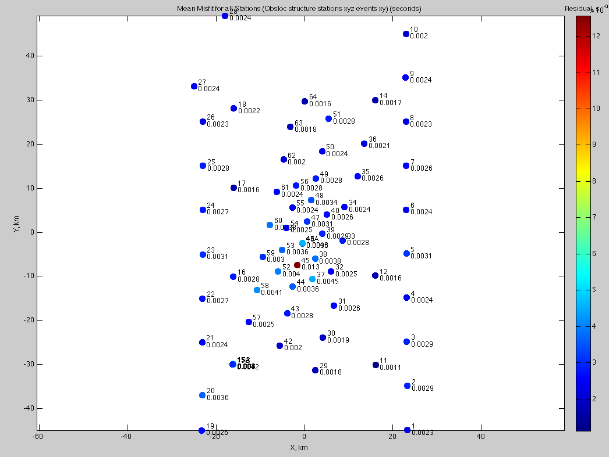
Figure 2 Mean Misfit Map for all Stations (Obsloc structure stations xyz and events xy).
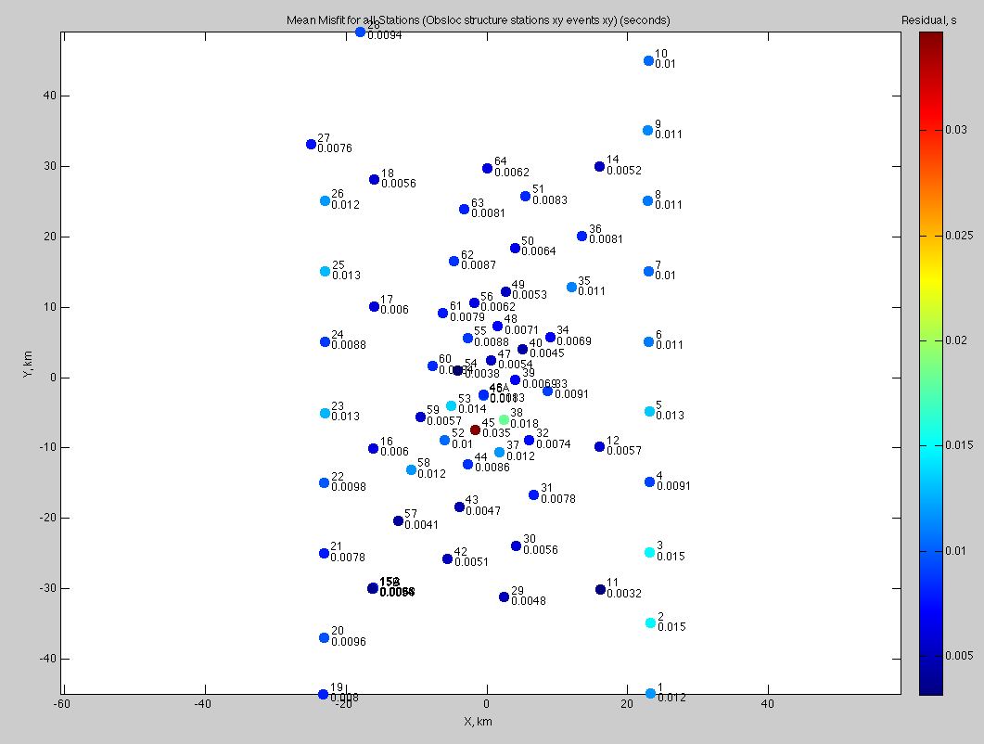
Figure 3 Mean Misfit Map for all Stations (Obsloc structure stations xy and events xy).

Figures 4 shows the relocated stations and events for Obsloc_structure_stations_xy_events_xy and Obsloc_structure_stations_xyz_events_xy compared to the original locations. There are two zoomed in areas showing the distance between lines. The lower right box shows how the outer lines are being drawn inwards towards the center of the map. This movement of events being drawn inward on the map occurs on all four sets of outer lines. There is a bias on the inversion file that pulls the outer lines inward
Figure 4 Map of relocated stations and events. The diamonds are the stations, and the dots are the events. Red represents the initial locations. Blue shows the relocated stations in xy and events in xy. Green shows the relocated stations in xyz and events in xy.

