1. edge result:

1. results:

Inverted the y-axis for match the image coordinates.

plt.gca().invert_yaxis()

1. results:

Least square fitting code part:

plt.plot(x, m*x + c, color='blue')

1. The angle is-: -44.38702510610573 degrees

Code:

A = np.vstack([x, np.ones(len(x))]).T

m, c = np.linalg.lstsq(A, y, rcond=None)[0]

angleinradians = np.arctan(m)

angleindegrees = np.degrees(angleinradians)

1. No,

* Slope-intercept parametrization fails for vertical lines.
* Minimizes vertical distances, we cannot fit vertical/near vertical lines
* Solution is not equivariant with respect to rotation.

1. results:

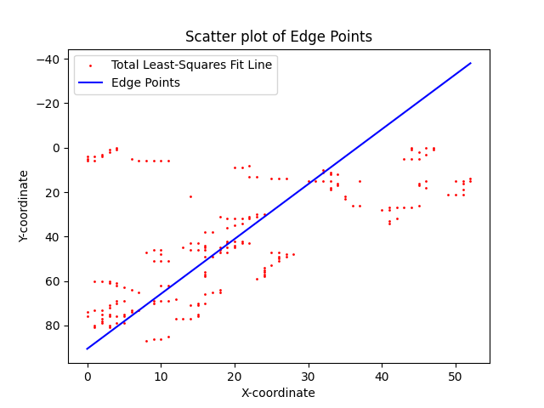

1. Estimated angle of the crop field: -67.97343481367824 degrees