**Instructions on how to run the flutter TODO application:**

In the project root directory, you will find a folder called Secrets that contains all the necessary files to run the application.  
  
- config.dart

- firebase_options.dart

- google-services.json

The first two files should be in the /lib directory.

config.dart will contain the open weather API key, with this format:

const String API_KEY = 'f7b6ca690a87adef1f0030f5ba218026';

you can use the provided key, or you can use your own API key.

Google-services.json should be under /android/app directory

You might have an issue when trying to sign in with google, if so, you should change directory to /android (“ cd .\android\ ”)

Then run this command: ./gradlew signingReport

Copy your SHA1 key and add it to the app in firebase, go to the project setting in firebase, then add a fingerprint SHA1, then restart your app and emulator, google sign in should work fine.

I already gave you Editor access to the firebase app on these emails: 🡪 next page

yangs@vaniercollege.qc.ca // [songyang.dev@gmail.com](mailto:songyang.dev@gmail.com)

Project name: TodoApp

Project ID: todoapp-37904

Project number: 1080514577533

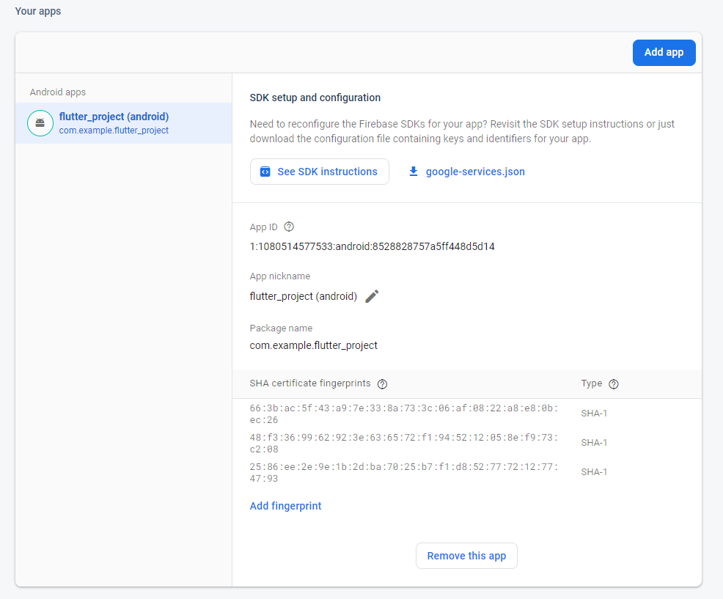Please note that you have to download google.services.json file again after adding the fingerprint with your SHA1 key.



google-services.json should be under /android/app directory.