 | Tunisian republic Ministry of Higher Education and Scientific Research  Directorate General of Technological Studies of Charguia  IT Department | 

END OF STUDY PROJECT REPORT

Presented with a view to obtaining the
LICENSE IN COMPUTER TECHNOLOGY

Specialty: Embedded systems and Mobile

Car Racing Simulation Cockpit
Developed by:
MALEK ISMAIL
EMIR ZOUABI

Produced within AJST (FabLab Solidaires)
Professional supervisor: MR BEN ROMDHANE KARIM
Professional supervisor: MR MILADI WALID
Training Period: 02/06/2023 – 05/27/2023

Academic Year : 2022-2023

Tunisian republic Ministry of Higher Education and Scientific Research

Directorate General of Technological Studies of Charguia

IT Department

END OF STUDY PROJECT REPORT

Presented with a view to obtaining the
LICENSE IN COMPUTER TECHNOLOGY

Specialty: Embedded systems and Mobile

Car Racing Simulation Cockpit

Developed by:
MALEK ISMAIL
EMIR ZOUABI

Produced within AJST (FabLab Solidaires)
Professional and academic supervisor: MR BEN ROMDHANE KARIM
Date:
Signature:

In the presence of the jury:

Dedications

We address this work to all those who have always overcome our fears of failure and who have always been there to lift us up, instill values ​​for free and to teach us how a real human being should be.
We are blessed to be able to call you, our parents.

To our grandparents who gave us a splendid model of hard work and perseverance.

Mom, Dad, your dedication, and sacrifices will forever remain a line of conduct. I am so indebted.
We devote the last words in memory of Emir’s father Mr. Zouabi Abed El Kader who passed away too soon, I hope you appreciate this humble gesture of gratitude from us, asking God for the salvation of your soul.

Malek & Emir

Acknowledgments

We would like to thank the entire FabLabs team for helping us to accomplish this project during these four months.
We would like also to thank the professional manager within the FabLabs Mr. Miladi Walid, for his warm and kind benevolence. We thank him for listening to us and for the trust he placed in us which allowed us to achieve our objectives in our end-of-studies project and to obtain our Diplomas in embedded systems and mobile.
We are blessed to warmly thank MR BEN ROMDHANE KARIM for his supervision within FabLab and also within the faculty and appreciate his support, his suggestions and his recommendations.

We appreciate Mr. Abed El Wehd's motivation and kind words for his excellent service and attention to our needs.
This training allowed us to deepen our various techniques to produce a personalized “fruit”, to deepen our acquisitions and to improve our technical knowledge.
Special thanks to all for the degree of patience and encouragement to reach our goal.

Contents
General introduction 1
Chapter 1: Presentation of the project framework 2
I. Introduction 2
II. Presentation of the host organization 2
1. Host organization 2
2. Areas of activity 3
a. Workshops 3
b. Training 3
c. Animation 3
3. Organizational chart 4
III. Presentation of the project 4
1. Project framework 4
2. Competition study 4
3. Study of the existing 5
4. Proposed solution 6
IV. Conclusion 6
Chapter 2: Project’s Adopted Methodology 7
I. Introduction 7
II. Working and Planification Methodology 7
1. Definition of the Agile methodology 7
2. Comparison of the Agile Methodology 7
3. The choice of the Scrum Methodology 9
a. Scrum Roles 9
b. Scrum Artefacts 10
c. Scrum formal inspection 11
III. Scrum Agile Methodology 12
1. Product backlog 12
IV. Conclusion 12
Chapter 3: Specification and conception 13
I. Introduction 13
II. Specification of needs 13
1. Functional requirements 13
2. Non-Functional requirements 14
III. System Architecture 15
IV. Conception 17
1. UML Language Presentation 17
2. General use case Diagram 17
a. Actors identification 17
b. Use case Diagram 17
c. Use case identification 17
3. Sequence Diagram 20
a. “Ability to control the wheel” Sequence diagram 20
b. "Rear Brake Engagement" Sequence Diagram 21
4. Transition Diagram 23
a. -“Processing Gear Level Changing” Transition State Diagram 23
b. “Treatment of the Handbrake Mechanism” Transition State Diagram 24
V. Conclusion 24
Chapter 4: Development 25
I. Introduction 25
II. Development environment 25
1. Hardware environment 25
a. Computers 25
b. 3D Printers 26
2. Software environment 28
a. SolidWorks 28
b. CubePro 28
c. AI Wave 2016 Wheel Config 29
d. Xloader 30
e. Ultimaker Cura 30
f. Repetier Host 31
g. Unity 31
III. Study of the material 32
1. Pedal 32
a. Springs 32
b. Potentiometer / Potmeter 33
2. Shifter 34
a. Limit Switch 34
3. Steering wheel 36
a. The Direct Current (DC) Motor 36
b. Power Supply 39
c. BTS7960 Motor Driver 40
d. Rotary Encoder 43
e. Arduino Leonardo 45
4. Handbrake 47
IV. Material realization 48
1. Shifter 48
2. Steering Wheel 49
3. Handbrake 50
4. Pedals 50
V. Software Realization 51
1. 3D Conception 51
a. Printing 51
b. Assembly parts 51
VI. Conclusion 58
General Conclusion 59
References 60
Appendix 1: Arduino firmware installation 63
Appendix 2: Configuration 64

List of tables

Table 1 : Agile Methods Pros and Cons 8
Table 2: Product backlog 12
Table 3: Use case identification 18
Table 4 : Microcontroller deployment 46

List of figures
Figure 1:FabLab Logo 3
Figure 2 : Organization chart 4
Figure 3: Logitech G29 5
Figure 4 : The Product Increments 11
Figure 5:System Architecture Diagram 16
Figure 6 : Use case Diagram 19
Figure 7: Control Steering Wheel Sequence Diagram 20
Figure 8 : Rear brake engagement Sequence Diagram 21
Figure 9 : Manage Gear Changes with Acceleration Control Sequence Diagram 22
Figure 10 : Processing Gear Level Changing Transition State Diagram 23
Figure 11: Handling the Handbrake Mechanism Transition State Diagram 24
Figure 12: Filament 26
Figure 13: Cube Pro Printer 26
Figure 14 : Delta Printer 27
Figure 15 : SolidWorks Logo 28
Figure 16 : CubePro Logo 29
Figure 17: Wheel Config Logo 29
Figure 18 : WheelConfig Home page 29
Figure 19 : Xloader 30
Figure 20 : UltraMaker Cura 30
Figure 21 : Repetier Logo 31
Figure 22: Unity Platform 32
Figure 23 : Springs 32
Figure 24 : Potentiometer 33
Figure 25 : Potentiometer Construction 34
Figure 26 : Limit Switch 35
Figure 27 : Limit Switch Schematic 35
Figure 28 : Limit Switch mechanism 36
Figure 29 : DC Motor Construction Parts 39
Figure 30 : Power Supply 40
Figure 31 : Motor Driver Module 42
Figure 32: Rotary Encoder Pinout 44
Figure 33 : Arduino Leonardo 47
Figure 34 : Shifter (Gearbox) Circuit Diagram 48
Figure 35 : Steering Wheel Circuit Diagram 49
Figure 36 : Handbrake Circuit Diagram 50
Figure 37 : Pedals Circuit Diagram 50
Figure 38 : Pedals part 51
Figure 39 : Board 52
Figure 40 : Pedals 52
Figure 41 : Shifter parts 53
Figure 42 : Shifter 54
Figure 43: Final shifter wiring 54
Figure 44 : Handbrake parts 55
Figure 45: Handbrake wiring 56
Figure 46 : Handbrake 56
Figure 47 : Steering wheel parts 57
Figure 48 : Steering wheel 57
Figure 49: steering wheel wiring 58
Figure 50: Xloader 63
Figure 51 : AI Wave configuration 64

General introduction

Depriving ourselves of technology and innovation is a crime, because the global challenge is enormous. Day after day, this cutting-edge technology develops to adapt to our daily activities such as driving vehicles, having fun in games, taking control of everything.
That's why to miss out on today's increasingly widespread games is also to miss out on technology.
And as the saying goes: "Now that almost everyone has access to a computer, could we move from the rat race to the mouse race?" This project is a mix of technology, racing, learning to drive and fun as we call it our Car Racing Simulator Cockpit.
It's the subject of our final year project. We'll start by presenting the project framework and the scope of the course, work on the most important modules, present the project, the comparison study and the existing product as well as the proposed solution in the first chapter, and continue until it covers the methodology, we used in the second chapter.
This report takes you on a tour of the modules we've been working on since the start of our training. The system architecture is also detailed and the requirements in the third chapter.
The next chapter also describes the hardware and software environment and its realization.
To this end, we carry out a theoretical study to provide a clear understanding of the context of our project.
We'll show you how each component is printed and wired, and finish with the video game we are trying to accomplish it .
Our report will be divided into chapters to cover the methodology adopted for our project and the solution we used, going through the details of each sprint to finally unveil our project.

Chapter 1: Presentation of the project framework

- Introduction
In this chapter, we illustrate the general framework of the project. We first present the host organization. Secondly, we expose our existing, the study of competition and our proposed solution.
- Presentation of the host organization

- Host organization
Solitaires FabLab AJST "Association of Youth and Science of Tunisia”, sponsored by Orange. It is a manufacturing laboratory and a production center located around the world, specifically in at least 24 European countries and in Africa. This center is open for almost all ages with the aim of developing and learning experience in teamwork.
It specializes in the production and research in advanced digital manufacturing technologies, and their applications in the fields of design, architecture, physical computing, and sustainability, for intervention in physical and digital reality. It enhances the desire to learn among the youth through these educational programs by presenting a new, motivating, and innovative way of learning.
The Fablab is an open network of a creative community which allows people from all walks of life to entertain and exchange their knowledge by offering them a digital fabrication. This center is equipped with 3D printers, high precision cutting tools, CNC milling machines, PCB production, Laser cutting/engraving, C.I production and vinyl cutting precision and milling machine.

The logo colors represent by the business and economic model by the green color, social impact and sustainability by the blue color and the research and education by its red/orange color. (1)

Figure 1:FabLab Logo

- Areas of activity
The manufacturing laboratory offers: (2) (3)
- Workshops
The workshops allow the modeling of the projects and the harmony within group
members, these workshops located in Fablab allow digital innovation.
- Training
These trainings aim at discovering new knowledge, learning, educating, and bringing
together all learners regardless of their age, gender, and different interests.
- Animation
This laboratory grants animations to allow the inventors of the projects to expose
their work, to make the conference, the exhibition of the competitions and to
discover the materials.

- Organizational chart
Here is the Fablab diagram:
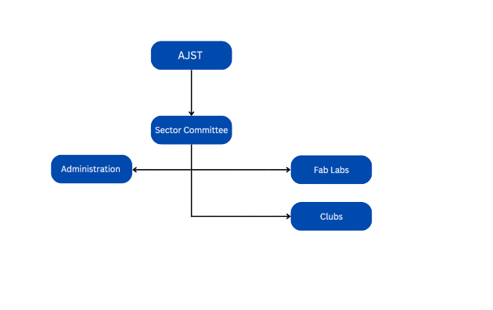
Figure 2 : Organization chart
- Presentation of the project
- Project framework

The objective of this project is to realize a car driving simulator cockpit that allows to educate the user how to accelerate, brake and change gear comfortably with the feeling of a real car.
The non-linear brake pedal mimics the performance of a pressure-sensitive braking system for a more responsive and precise braking feel.
- Competition study

Nowadays, and exactly in the Tunisian market, the user does not have the possibility to choose what s/he will use for her/his simulation trip, and this is due to the limitation of the product in Tunisia in which there are only three brands competing in the market area.
One of the famous brands is Logitech with many models and one of which is called G29 having a lot of functionalities:

- Wheel: (3)
Rotate: 900 degrees
Hall effect steering sensor Two-motor force feedback
Overheating protection

- Pedals: (3)
Non-linear brake pedal
Patented carpet adhesion system
Textured heel grip
Self-calibration

- Gearbox: (4)
Six gears with reverse to depress.
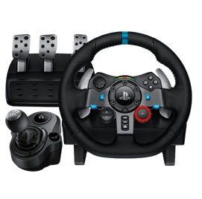
Figure 3: Logitech G29

- Study of the existing
This cockpit is designed for an ideal driving experience, we offer real racing car seats. We understand that after a long day of work, you want to relax with a great racing game or to learn the basics of driving.
To do this, you want to be comfortable in every way.
Our racing simulation cockpits will allow you to play for hours without aches and pains.
The seat recliners and you can easily slide it forward or backward for adjustment purposes.
You can experience all the hustle and bustle of racing as if you were there and you can also learn about driving during your trip.

- Proposed solution
The idea was proposed to make a Cockpit of car racing simulator.
Due to the several criticisms from simulator racing cockpit users, we have decided to build our project with a few different features. Among the necessary differences that will improve the user’s experience is turning the steering wheel with a rotation angle of 900°, which means double and a half turn in both directions making the driver feel the sensation of driving a real car.
Force feedback, which is a steering wheel lock, this technology creates a vibration and mimics gravity while driving.
It offers a fast and easy experience thanks to the USB 3.0 connection.
It is equipped with a non-linear brake pedal, which means that with this pedal, the user will feel the driving session with a lot of comfort, a good pressure sensitive braking system as well as a very realistic physical sensation.
It is compatible with most racing simulation games (e.g., Assetto Corsa, Euro Truck Simulator) and you can also configure your controls in-game.
Many racing simulator users miss the immersive handbrake feel during gameplay, which is not present in most cockpits, so it was important to add this to meet their needs.
Finally, we integrated the gear shifter, which allows the user to shift the car in a manual transmission, with 6 different speeds and a reverse mode.

- Conclusion

Throughout this chapter, we have presented the host organization and the project framework. However, we have studied products similar to our project, with the intention of learning and analyzing all the points that will help us understand the context of our project.
In the following chapter, we present the methodology adopted for the project.

Chapter 2: Project’s Adopted Methodology
- Introduction
The aim of this chapter is to present our work and planning methodology. We begin with the forward planning we have undertaken in order to organize the process of our work throughout this project.
We also explain the story mapping and the product backlog presenting the user stories.
- Working and Planification Methodology
Due to the revolution in project management, the adoption of a development methodology is important to ensure an acceptable level of quality and to avoid missed deadlines.
- Definition of the Agile methodology
The Agile methodology have become a reference in project management, particularly in the field of software development. It offers many advantages such as its flexibility.
It allows to adjust to changes in priorities or needs during the project even late in development.
Indeed, these methods focus on collaboration and customer satisfaction.
This allows for greater responsiveness and efficiency in the delivery of projects, to collaborate daily between customers and developers.
It does make the job more efficient due to all those advantages.
- Comparison of the Agile Methodology
As we have said the Agile Methodology has been one of the important parts to make the project more efficient.
There are many different methods so we will try to identify the differences between some of the top known agile development methods such as: (5)
- Scrum
- Scrumban
- Kanban
- Extreme programming (XP)
- Feature-Driven Development (FDD)

Method | Advantages | Disadvantages
Scrum | - Motivation to finish the sprint.  - All team members have the access to project progress.  - The focus on quality.  - Easy to reorganize. | - Losing the track of the project  - Not clear defining each role.  - No big picture of the project.
Scrumban | - Good for splitting projects into small chunks.  - Everyone from the team has a view of progress.  - Easier to spot bottlenecks. | - Poor in documenting and pitfalls.  - Not working in remote teams.  - If issues are not documented rightly, possibility for repeating the same issues.
Kanban | - View of progress status (completed, in progress, in testing).  - Possibility of limiting tasks  - Easy to track the duration of the tasks.  - Continuous deliveries | - Easy to misinterpret the information about the task.  - No time frame.  - Possible delays in every phase
XP | - Simple codes, easy to improve.  - The whole cycle of XP is visible.  - Constant testing makes the process more agile.  - Uplifting the talent of teams. | - More attention to code and less to design.  - Not working in remote working teams.  - If issues are not documented rightly, possibility for repeating the same issues.
FDD | - Clear picture of project scope  - User-cetric approach  - Works good with long projects and large teams.  - Decreased need for meetings. | - Doesn’t work good with small projects.  - Dependence on lead developers.  - No written documentation to the clients.
Table 1 : Agile Methods Pros and Cons
- The choice of the Scrum Methodology
The Scrum Agile framework is one of the best-known agile methods in the IT fields.
Scrum uses an iterative and incremental approach and structure the project into sprints for a short period of time, most of the time the sprints last from two to four weeks.
Scrum teams are based on defined roles (Product Owner, Scrum Master, developer team) and these roles ensure that the work is collaborative and well-organised.
For our final project, we decided to adopt the Scrum agile method because of its many characteristics and advantages that correspond to the project we are carrying out.
- Scrum Roles
Scrum defines three roles which are: (6)
The Product Owner usually keeps in touch with the Product Managers and other stakeholders outside the team, S/He is responsible for the product of the project team and may have the following responsibilities:
- Managing the product backlog by prioritizing work
- Defining the product vision for the team
- Communicating with external stakeholders (customer, product manager) and translating their needs to the teams.
- Ensuring that the team is focused on the product needs by communicating and reviewing their progress.
The Scrum Master is responsible for ensuring that the Scrum team works as efficiently as possible in accordance with the Scrum values.
S/He ensures that the team follows the plan, leads meetings and solves problems that the team may face.
S/He is both a leader and a behind-the-scenes support, so we cannot define her/his tasks as they differ from organization to organization, from team to team, but the scrum master may have the following responsibilities:
- Leading the daily scrum meetings (also known as daily stand-ups).
- Leading sprint planning meetings.
- Managing obstacles that the team may face.
The development team consists of professionals who perform all the practical tasks. This means that the development team members may be software engineers, designers, writers, data analysts or any other role needed to achieve the sprint goals.
They usually work together to define the objectives and plans for achieving the sprint goals.
Most of the time members of the development team do not have the same partial responsibilities because they do not have the same profile.
For example, you may have a front-end engineer or a UX designer who can update your website but others such as a writer cannot, and vice versa.
However, the development team may have common tasks:
- Assisting with sprint planning and goal setting.
- Contributing to expertise in programming, designing and product improvement.
- Using data to find best practise in development.
- Scrum Artefacts
Scrum is accompanied by the creation of three essential artefacts which are the three pillars of the project: (7)
The Product Backlog:
This is a list containing all the information requested from the customer, the user.
The items on this list are organized by the product owner according to their priority.
From most important to least important.
This phase answers these two questions:
Why this project is conducted and what the main purposes of this project are.
The Sprint Log:
This artefact will contain all the user stories and bugs to be fixed that were agreed during the sprint planning.
Each user story can be divided into different tasks during the development phase. All sprints have a start date and an end date. A sprint lasts three to four weeks.
The sprint backlog contains at least the following three categories (to do, in progress, completed).

The Product Increments:
This is the most important artefact for the agile culture. During each sprint, the development team completes a product increment.
The sum of the product increments allows progress towards the product goals. (8)
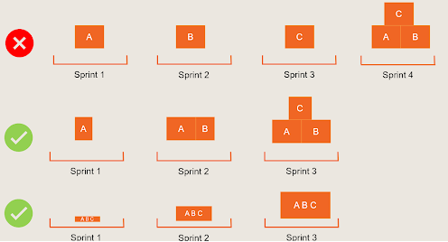
Figure 4 : The Product Increments
- Scrum formal inspection
Scrum offers four formal opportunities for inspection and adaptation:
Sprint planning:
Carried out by the entire Scrum team, this is a supervised meeting that is triggered at the beginning of each sprint. They review the product backlog; the team determines the overall objective of the sprint and prioritizes the items to be worked on.
Daily Scrum:
Once everything is settled and the team begins working on the sprint, team members meet in the same location each day for about 15 minutes to share a brief update on their individual progress and discuss what they plan to do in the coming day.
Sprint Review:
After completing the sprint, the team should meet to review how it went. This is a very important part of the scrum inspection. Developers share feedback on their tasks and a demo of the product can be shown to highlight new features. The product owner validates the work of the sprint and updates the backlog for the next cycle.
Sprint Retrospective:
When it comes to adapting to Scrum, the sprint retrospective is a key event. Here team members reflect on how to improve their overall process. They identify the obstacles they have encountered previously and discuss how to adapt and overcome these problems in futures sprints.
- Scrum Agile Methodology
- Product backlog
The agile product backlog in Scrum is a prioritized list of features containing a brief description of all desired functionality in the product, as in the following table.
Sprints | ID | User story | Period
0 | 0 | Definition of project objective. | 3 Weeks
0 | 1 | Set up all necessary circuit diagrams and purchase components. | 3 Weeks
0 | 2 | Installation of all printing and design software. | 3 Weeks
0 | 3 | Learn to design and print in 3D. | 3 Weeks
1 | 4 | Create a pedal prototype. | 3 Weeks
1 | 5 | Print our pedal prototype and test it. | 3 Weeks
1 | 6 | Repair parts and redesign. | 3 Weeks
1 | 7 | Write final report. | 3 Weeks
2 | 8 | Create gearbox prototype. | 3 Weeks
2 | 9 | Complete 3D printing of all pedal parts. | 3 Weeks
2 | 10 | 3D print gearbox parts. | 3 Weeks
2 | 11 | Write final report. | 3 Weeks
2 | 12 | Print missing pedal parts. | 3 Weeks
3 | 13 | 3D print gearbox parts. | 4 Weeks
3 | 14 | Write final report. | 4 Weeks
3 | 15 | Wire and test pedal. | 4 Weeks
3 | 16 | Create and print steering. | 4 Weeks
3 | 17 | Create handbrake parts. | 4 Weeks
3 | 18 | Print handbrake parts. | 4 Weeks
4 | 19 | Wire and test gearbox. | 3 Weeks
4 | 20 | Wire handbrake. | 3 Weeks
4 | 21 | Wire steering wheel. | 3 Weeks
4 | 22 | Develop racing game. | 3 Weeks
4 | 23 | Test entire system. | 3 Weeks
4 | 24 | Write final report. | 3 Weeks
Table 2: Product backlog
- Conclusion

Finally, in this chapter, we have identified the work and planning the agile methodology, comparing the methodology and methods and the choice we have chosen to work with, including its roles and the product backlog, and comparing the stages of our work in the prints.

Chapter 3: Specification and conception

- Introduction
This chapter aims to present the proposed conceptual solution.
In other words, this chapter we shall focus on the presentation of the hardware architecture such as the synoptic diagram of our work in a detailed design, we are also specifying our needs and displaying the necessary diagrams.
- Specification of needs
In this section, we reveal the functional and non-functional requirements of our project, with the intention of describing the use case and behavior of our system.
- Functional requirements
The functional requirements of our system, i.e. those that must meet the functionality requirements of the future system. Functional requirements are features. They are used to generate use cases.
And on our case the main Actor is:
- User: This is the person who will use the entire system, Operating the vehicle, providing input, and controlling the car’s movement.
Controlling the vehicle
- Brake
- Clutch
- Accelerate
Controlling the steering wheel
- 900-degree rotation
- Force Feedback
Changing the gear level (Gearbox or Shifter)
Controlling vehicle immobilization (Handbrake)

- Non-Functional requirements
The non-functional requirements of our system, also known as quality criteria, which describe requirements that are not directly related to the use of the system. This will give us a brief overview of how our system will behave during the runtime phase.
Since we're talking about the behaviour of our system, we need to keep an eye on:

- performance: the user needs to feel that his system isn't laggy when he's using it, because this will affect his gameplay and that will be very bad, because the most important thing is that the user needs to feel the real sensation of driving. which means that our system has a precise, real-time response to the movements made by the driver.
- Manufacturing quality: We've built our system mainly from PLA filament, which makes it strong and durable. It must be able to withstand intensive, prolonged use without deteriorating rapidly.
- User comfort: The steering wheel is adjustable for maximum comfort, enabling the user to enjoy long periods of use without feeling tired.
- Compatibility: our cockpit will be compatible with almost every simulator of car racing game. it must work correctly with all major operating systems and the latest game versions.
- Responsiveness: The steering wheel must be responsive to the user's actions, offering a feeling of instant, fluid control.
- Noise and vibration: The cockpit will be quieter because we use a single motor, not forgetting the cooling fans.
- Easy to install and configure: The cockpit is easy to install thanks to USB 3.0 and easy-to-configure due to the software.
- Support technology: we provide our system with a documentation package that explains in brief how to use the cockpit.
- Precision: our cockpit should measure the user inputs movements and respond with a high precision with the right feedback.

- System Architecture
Our project consists of 3 connected parts:

The pedals ‘part, the gearbox part and the steering wheel and the engine part.
These parts have a purpose to brake, accelerate and drive the video game car like a real-life driving.
As shown in the synoptic diagram, each part differs in its role in establishing perfect conduct.
The first part which is the part of the pedals is distinguished by 3 potentiometers for each pedal: acceleration pedal, brake and clutch.
The second part of the gearbox consists of 7 speeds (1-6) and a reverse gear such as the gearbox of a normal car.
Last by not least, the steering wheel part which consists of a rotary encoder which is used for determining the turnover ratio of a rotating shaft and a potentiometer. And with the help of engine, we will establish the force feedback when driving for the real feeling of racing.
And finally, all parts are going to be connected to Arduino Leonardo as a microcontroller that’s going to run the whole system.

Here is the block diagram below:
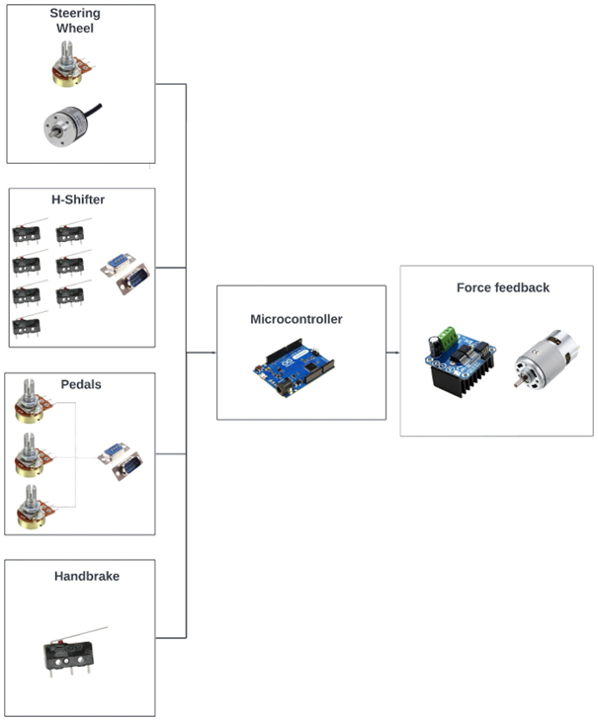
Figure 5:System Architecture Diagram

- Conception
- UML Language Presentation
The Unified Modeling Language (UML) is a pictogram-based graphical modeling language, designed as a standardized method of visualizing problems, with the aim of simplifying their use in software development and object-oriented design.
UML is a set of integrated diagrams used to model the problem encountered, the concept of the project or subject and how to simulate it. It is used by software developers for a clear visual representation of the objects, states and processes of a program or software system.
UML diagrams can be created using diagramming software such as Lucid Chart, MicrosftVisio, Visual Paradim ...
- General use case Diagram
The use case diagram is a type of UML diagram used in the development process and programming environments.
It is used to present the functional structure of a system, to simplify concepts such as how to interact, interactions, the relationship between the actor and the system, and to capture system requirements.
- Actors identification
This type of diagram not only explains the system in terms of interactions and roles...
it forms a methodology for better understanding by summarizing the objectives and modeling the components of a system, while the actors are those who model the information of the system's users; moreover, they are modeled in symbol form and linked by specific connectors.
- Use case Diagram
The purpose of this diagram is to provide a clear and simplified illustration of the interaction between the user and the system.

- Use case identification
The use case diagram presents the product cycle between the actor who is the user of a process, how he is involved in the system, and the system planned for the simulator in our project.
It is therefore a model of several activities.

During our needs analysis, we identified the user, the actions he will perform and the secondary actors he will help to model this vision into reality. So, here's the table that models our work in general, then we're going to present each action by its developed diagram.

Main Actors | General Use Case | Secondary Actors
The User (The Driver) | Press the Pedal | - Adjustable variable resistor
The User (The Driver) | Change Speed Level | - Contact sensor
The User (The Driver) | Control Steering Wheel Operation | - Direct current motor  - Motor driver  - Potentiometer  - Electro mechanical device
The User (The Driver) | Control vehicle immobilization | - Contact sensor
Table 3: Use case identification

We begin by presenting our general use case diagram, which shows the overall functional aspect of our project as follows:

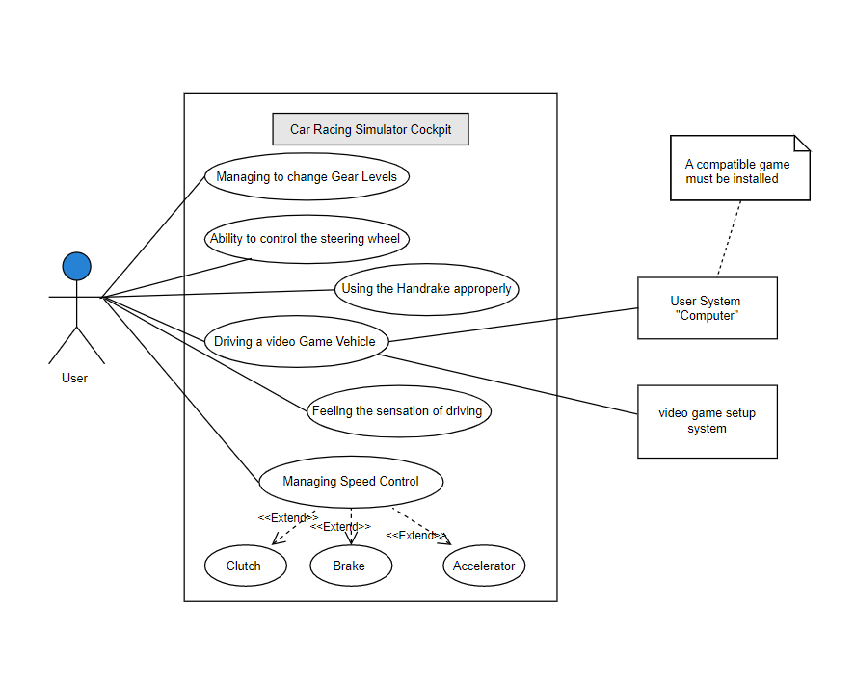
Figure 6 : Use case Diagram

- Sequence Diagram
A sequence diagram shows the chronological order of a sequence of functions.
This type of diagram visualizes the interaction between actors and the system.
Actions are presented and linked by arrows, starting with the beginning of the action and ending with the last action in the lifeline.
This is an in-depth presentation of the sequence of events and actions, with the aim of clarifying the project scenario.
- “Ability to control the wheel” Sequence diagram
This illustrated sequence diagram shows the interaction between the steering wheel when the operator is driving and with each rotation of the steering wheel, thanks to the electro mechanical device which is the rotary encoder that converts the angle of rotation of the steering wheel into an electrical signal that is sent to the microcontroller in order to apply force feedback.
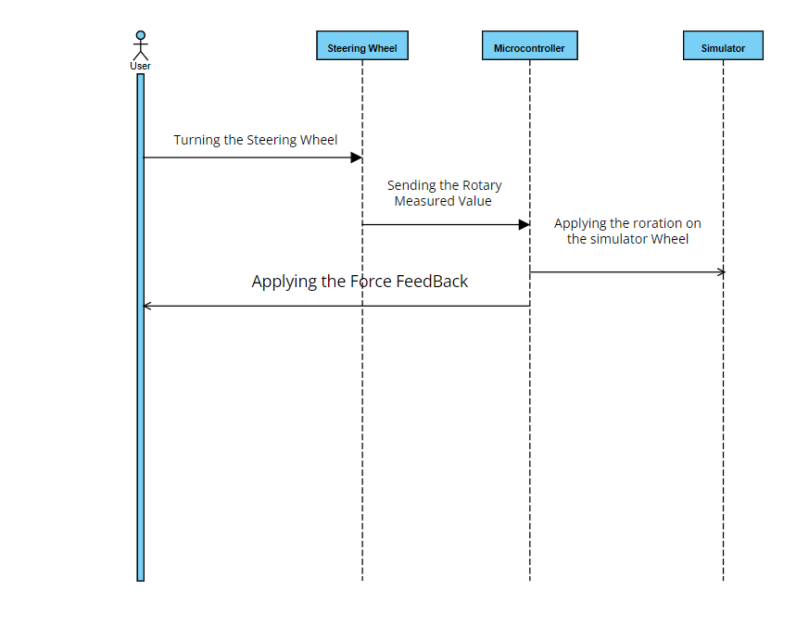
Figure 7: Control Steering Wheel Sequence Diagram

- "Rear Brake Engagement" Sequence Diagram
The diagram below shows how handbrake works, thanks to the built-in limit switch, when we pull up the brake lever, this sensor senses the presence or absence of objects and sends a data signal to the microcontroller.

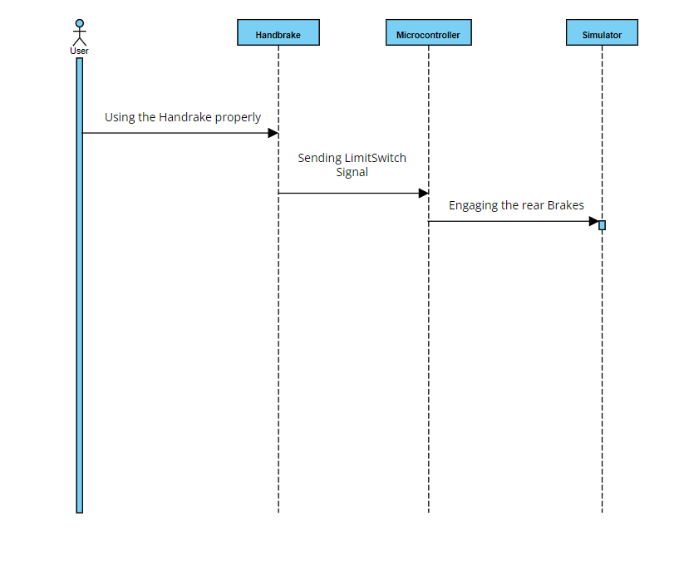
Figure 8 : Rear brake engagement Sequence Diagram

- “Manage Gear Changes with Acceleration Control” Sequence Diagram
This sequence diagram will show the operating mode for each pedal stroke, starting with the 1st level to start driving and moving down to change gear.
The relation between the pedal and the gearbox at the same time, and the transmission of the signal to the microcontroller via the limit switch signal.
Shifting gears to accelerate or slow down the car when driving a game car.

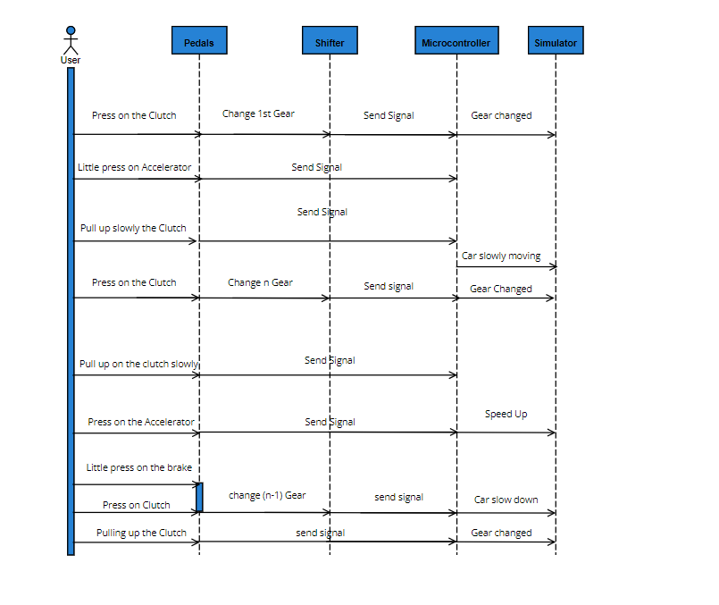
Figure 9 : Manage Gear Changes with Acceleration Control Sequence Diagram

- Transition Diagram
This diagram shows the transitions between different objects to specify the reactions of a part of the system to discrete events.
It shows the events with their triggers and the transition of the object to a new state.
State is the abstraction of a moment in the life of an entity that is brought to satisfy a certain condition, and transition refers to the change of state until a specific condition is met.
This diagram therefore describes the dynamic behavior of an entity as it transmits its behavior under certain conditions to another state under other conditions.
- -“Processing Gear Level Changing” Transition State Diagram
We present in this illustrated diagram the change of the gearbox state by having constraints such as gear change fault or false pressure on the clutch.
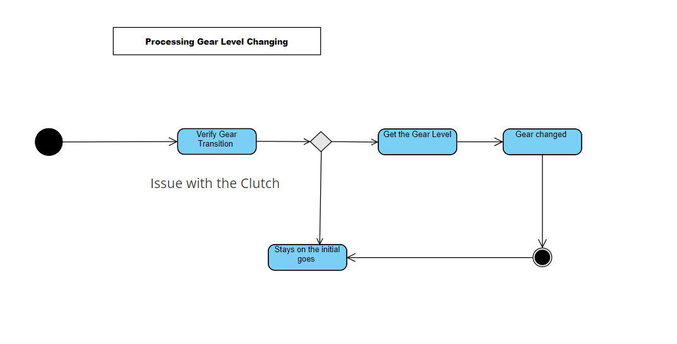
Figure 10 : Processing Gear Level Changing Transition State Diagram

- “Treatment of the Handbrake Mechanism” Transition State Diagram
In the diagram below we present the handbrake function mechanism, whenever we pull up the handle of the handbrake the moving car having a specific state it changes its state or if it is already parked the car can be moved slowly. The car state is changing.
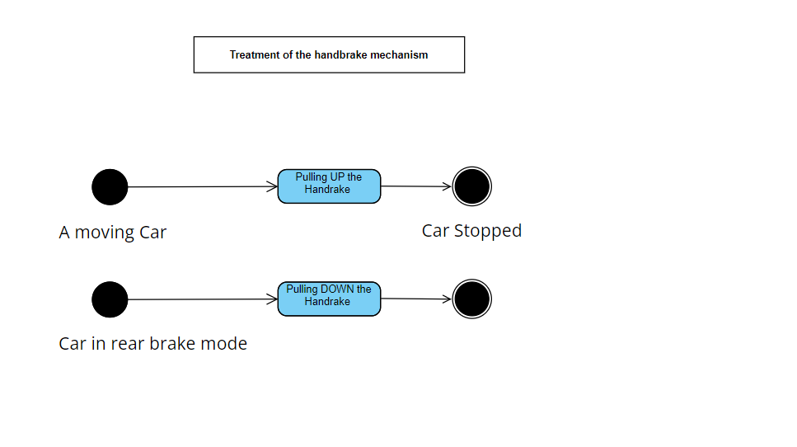
Figure 11: Handling the Handbrake Mechanism Transition State Diagram

- Conclusion
In this chapter, we outline the functional and non-functional requirements, revealing a detailed view of the system architecture to help organize the project, as well as a clearer presentation using diagrams.

Chapter 4: Development

- Introduction
In this chapter we will set up our proposed solution.
First, we will present the hardware environment as well as the software then the detailed realization of this solution.
- Development environment
This chapter describes the hardware and the software parts.
- Hardware environment
We started with the 3D design of our components using computers including design software and for printing we converted the designs into STL extensions and finally printed each component with the 3D printer.
So, for the material realization we used these tools:
The computers, 3D printer and the components.
- Computers
We used the computers for the design, the print …
Here is the difference between the two computers:
1st Computer:
- Processor: Intel(R) Core (TM) i7-10750H CPU @ 2.60GHz 2.59 GHz
- Ram Memory: 16 GO
- Graphic Card: RTX 2060
- Pc storage: 550GO SSD
- Operating System: Windows 10
2nd Computer:
- Processor: Intel(R) Core (TM) i5-9300H CPU @ 2.40GHz 2.40 GHz
- Ram Memory: 16 GO
- Graphic Card: GTX 1650
- Pc storage: 550GO SSD
- Operating System: Windows 10

- 3D Printers
- Cube pro Printer:
The Cube pro is a printer with an area 285mm x 270mm x 230mm.
its supported filament is the PLA, ABS, infinity rinse away support materials and NYLON.
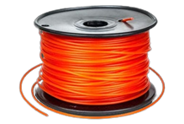
Figure 12: Filament
This is an assembly type 3D printer. The nozzle temperature is 210°C. Its power mechanism is a direct drive mechanism with a power supply of 100-240V, 50/60hz.It supports STL file type by converting it to. gcode file using its specific CubePro software with a maximum temperature of 536°F / 280°C. (9)
It uses plastic jet technology for printing. It is supported by an all-over acrylic enclosure with glass panels for making the printing easy.
It offers a climate chamber in order to make the environment stable and safe for the users. It has a USB, flash drive and WIFI connectivity and that’s the option we used for sending our designs. The PLA filament is more suitable and gives the best result, so we used it instead of the ABS. (10) (11)
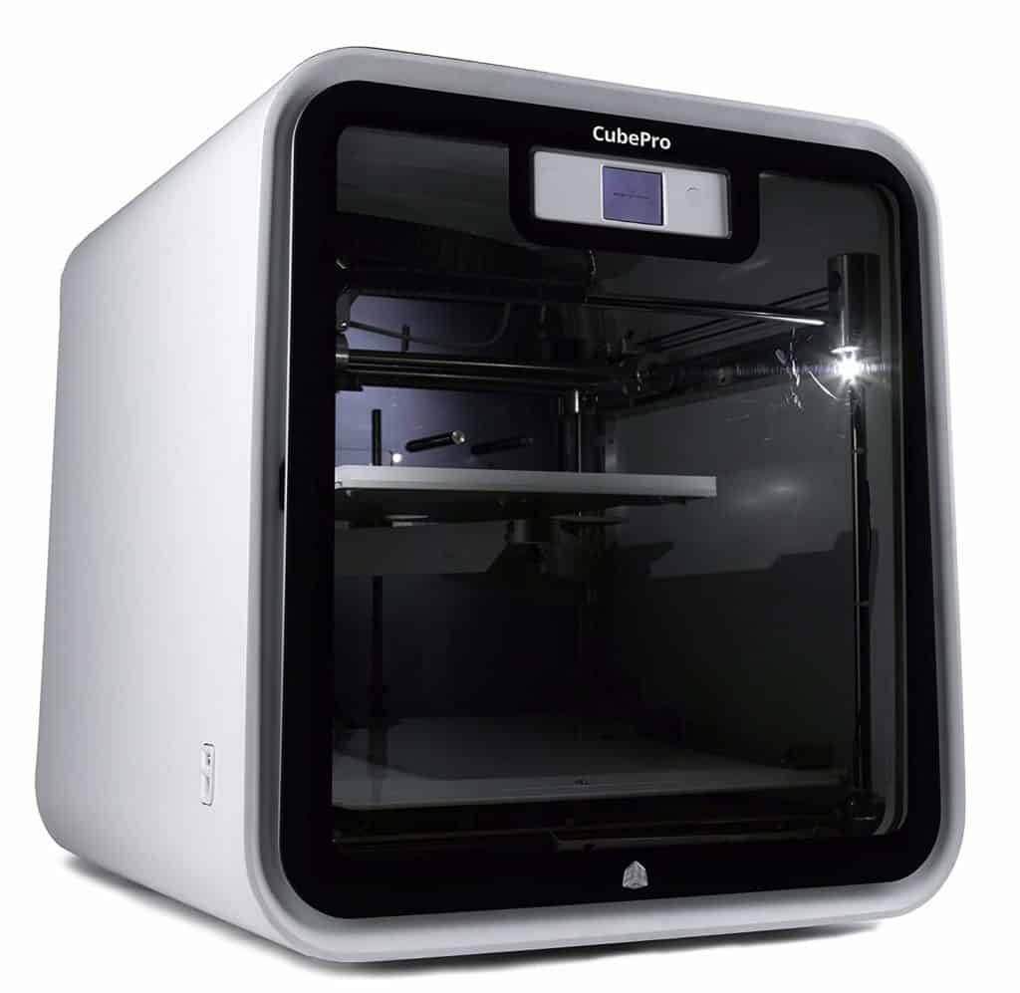
Figure 13: Cube Pro Printer

- Delta printer
The delta 3d printer uses FDM (Fused Deposition Modeling) technology. FDM technology is an additive manufacturing method patented by Stratasys for rapid prototyping. This process is also known as FFF (Fused Filament Fabrication) 3D printing. FDM technology is also known as the cheapest printing solution. It is also reliable, accurate and easy to use, making it the ideal technology for professionals, schools and individuals, and the most widely used 3D printing technology today. (12)
Delta printers are so named because they move using a triangular coordinate system.
The extrusion head of a delta printer is suspended in the air using three arms separated by
equal angles. These arms move up and down using steeper motors, extending and retracting, to control the position of the extruder and soften the plastic until it can be reliably extruded from a heated nozzle and deposited in precisely dictated tool paths: All the arms work together to achieve a single motion. This means that delta printers need different programming to translate the XYZ coordinates into their triangular motion to extrude each layer. (13) (14)
The main attraction of delta printers is that they are faster than Cartesian type machines because they require fewer movements to print the same object.
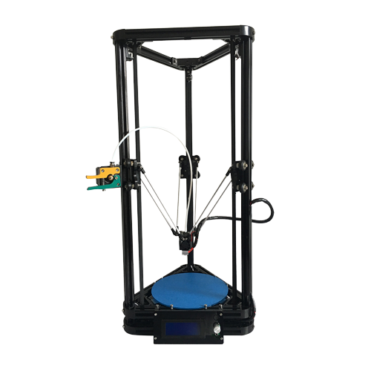
Figure 14 : Delta Printer

- Software environment
For the soft realization we used at first the software SolidWorks for the 3D design.
- SolidWorks
Solid works is a 3D DESIGN application with the help of this software, it is possible to make detailed plans in the field of mechanics, manufacturing and industry, it allows the realization of the parts in three dimensions, to design them, to make assemblies and thus to print in the chosen material.
It only runs on the Windows 10-11 64bit operating systems with 16 GB memory or more, a 2GB VRam graphics card with the help of a 3.3 GHZ processor or higher clock speed.
And for printing using the 3D printer we needed the software Cube Pro which allowed us to do the printing. (15)

Figure 15 : SolidWorks Logo

- CubePro
The CubePro is a 3D printing software, of Shareware in the category Miscellaneous developed by 3D Systems, which allows us to orient and repair our STL file.
The printer we used is equipped with a compatible software called CubePro, which includes a compilation conversion software.
This software helps us convert our 3D model into layer slices so that it can be printed.
With this software, we can rotate our model and see all parts of it.

One of the features of CubePro is that it includes STL file verification.
We send our STL file with the Wi-Fi connection of this software to the printer.
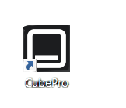
Figure 16 : CubePro Logo

- AI Wave 2016 Wheel Config
The wheel config is a configuration software that offers the user the possibility to configure the inputs of the microcontroller after downloading the wheel config hex Firmware file.
FFB configuration software. Sim Steering V1.1 configuration software.
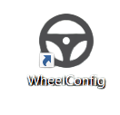
Figure 17: Wheel Config Logo
Here is the software Homepage:

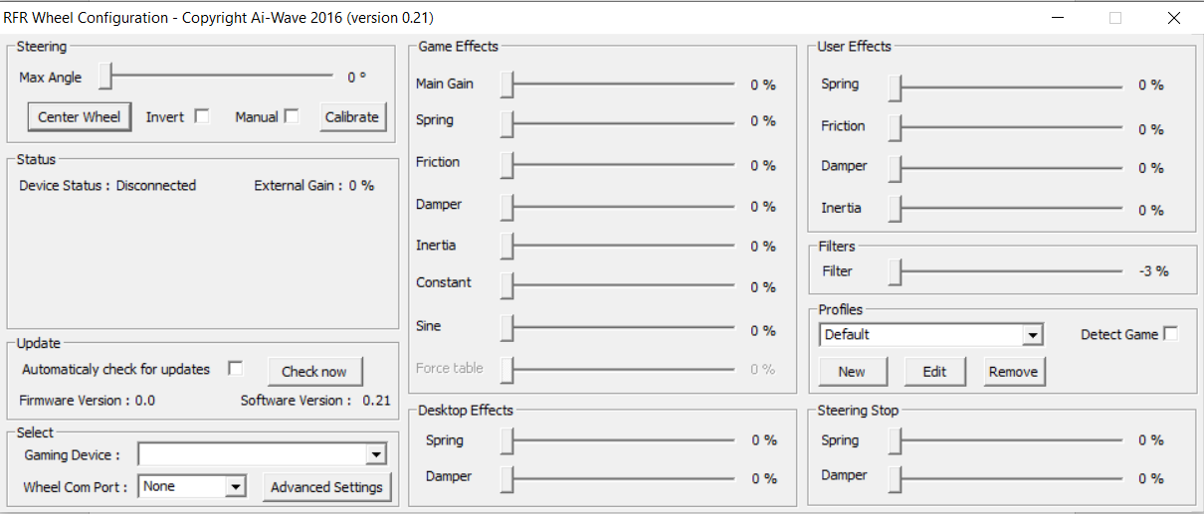
Figure 18 : WheelConfig Home page

- Xloader
The Xloader offers the possibility to download a compiled Arduino sketch, the hex file to the microcontroller directly without needing the Arduino IDE software.

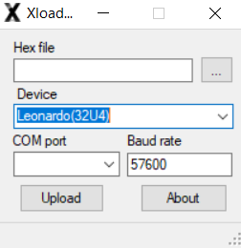
Figure 19 : Xloader

- Ultimaker Cura
Ultimaker Cura is a free software, open source cutting solution for 3D printing, it uses Python, C++, QML programming languages compatible on operating systems such as Microsoft Windows, macOS and Linux.
It is also compatible with file formats such as STL, OBJ, X3D and 3MF.
Cura is used for architectural or interior design projects and printing ... (16)


Figure 20 : UltraMaker Cura

- Repetier Host

Repetier-Host is a 3D printing application developed, slicer program, manual control and printing process, easy to control the print, import models and print them.
It converts the STL file into a ./gcode using one of three prominent slicing engines: Cura, Slic3r, or PrusaSlicer.
It has a lot of features like Slicing engines, Velocity painting, Manual control, multi-extruder support... (17)
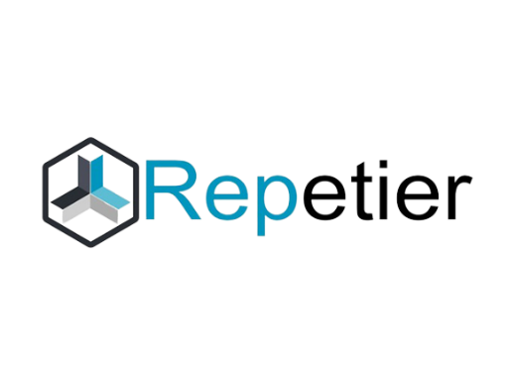
Figure 21 : Repetier Logo
For the 3D printing we have to open our Cura software and export the STL file that we will print and configure the necessary parameters then we will slice it in a file format . /gcode file and since we can't print it because of the bug in Cura software, we close Cura to avoid confusion and we open the Repetier-Host software, we open the /.gcode file that was generated by Cura and we connect our pc to the printer with a USB cable and finally our printing will start.

- Unity

Our cockpit is adapted to all the racing games available on the market, but in addition to our final year project, we are currently working on our own racing game to complement our cockpit. So, we used Unity to make this video game.

Unity is a cross-platform game engine used by video game developers.
It enables them to create and operate their own game environment and helps them develop a real-time 3D gaming platform.
In Unity, developers use game services to help them develop and run their own games.
It's the best-known platform thanks to its prototyping speed.

To develop with Unity, we need to use the C# language.


Figure 22: Unity Platform

- Study of the material
- Pedal
The compression springs at different levels each harder than the other.
The brake having the hardest spring compression, the accelerator having the softest one and the clutch having an average compression, and each relates to a potentiometer.

- Springs
It is a cylindrical spring that increases the resistance to axial pressure.
It is an elastic coil made of spring steel. The spring effect allows it to absorb force or provide resistance. A compression spring can be used as a force absorber for the driver's foot or as a force generator. (18)
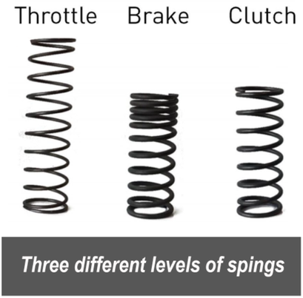
Figure 23 : Springs
For more Details in our case, we have used those springs.
Spring 1 : De : 10,05L0 : 52Di : 7,88d : 1,14
Spring 2: Di: 7,63d: 1,86l0: 50,52De: 11,19
Spring 3: L0: 52,27Di: 9,45d: 1,03De: 11,61

- Potentiometer / Potmeter
Its a three-terminal-mechanically driven rotating analog device.
Its a manually adjustable variable resistor.
It has two fixed connection points which are connected to both ends of the resistive element. (19)
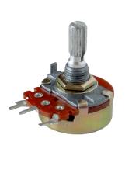
Figure 24 : Potentiometer

These two ports are responsible for establishing an electrical resistance.
On the other hand, the middle port is connected to a sliding contact called wiper attached with a rotary knob when we turn it, it will run across the resistive element for a good electrical contact.
The value of the middle port connected to the right port is equal to the left port connected to the middle port using the multimer.
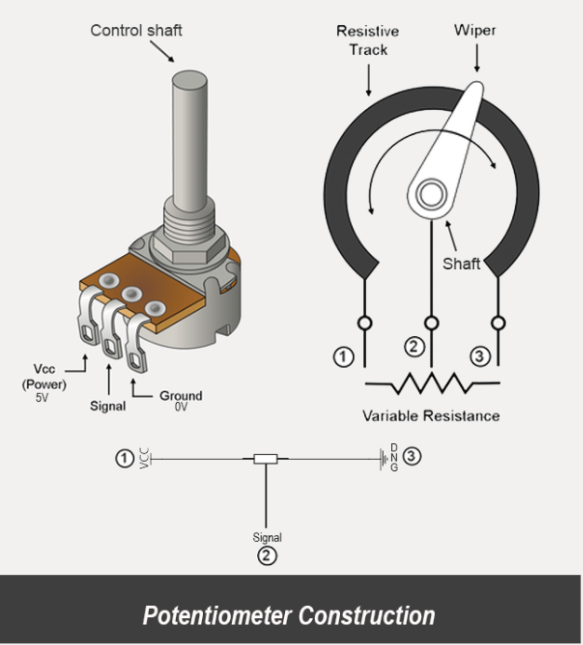
Figure 25 : Potentiometer Construction
- Shifter
We need 7 limit switches.
- Limit Switch
It is an object presence detector that offers high precision and provides an electrical signal.
It is a sensing device used in the physical contact applications.
It consists of a basic switch in a metal or resin case. (20)
The strong outer case protects the inside of the switch from external forces, moisture, oil, dust and dirt that’s why it can be used in locations that demand mechanical strength and environmental resistance. (21)
Micro limit switches with a lever actuator activate when an object depresses the top-mounted lever that is used to activate a plunger. (22)
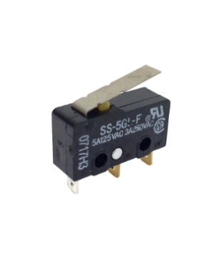
Figure 26 : Limit Switch
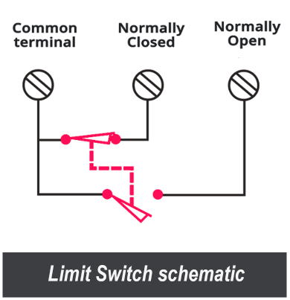
Figure 27 : Limit Switch Schematic
C pin: is the common pin used in both normally open mode and normally closed mode.
NO pin: is normally open pin used in the normally open mode.
NC pin: is normally closed mode used in the normally closed mode.
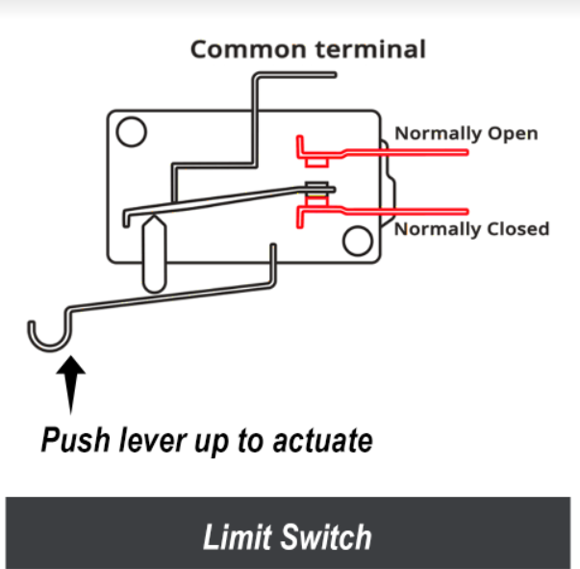
Figure 28 : Limit Switch mechanism

- Steering wheel
- The Direct Current (DC) Motor
A DC motor is a class of rotary electrical motors that convert or transform the direct current electrical energy into a mechanical one.
It relies on the forces produced by induced magnetic fields due to flowing current in the coil.
It takes the electrical power through direct current and convert this energy into mechanical rotation.
When this electromechanical machine is powered, it automatically creates a magnetic field that is powered by direct current in its stator.
This field starts to attract and repels magnets on the rotor which makes the rotation of the rotor and for keeping this rotation continually rotating, the commutator that is attached to brushes connected to the power source supply current to the motors wire windings.
The DC motor types in general have some internal mechanisms, either electromechanical or electronic, to periodically change the direction of current in part of the motor. They were from the first motors which widely used powered from existing direct current lighting power distribution system.
Its speed can be controlled over a wide range using either a variable supply voltage or by changing the strength of current in its field windings. The universal motor, a lightweight brushed motor used for portable power tools and appliances can operate on direct current and alternating current.
Since DC motors are everywhere and used for a wide variety of applications, each one is different from the other by the connection between the field winding and the armature that it can be parallel or series or both.

One of the important things in our project is the high precision of controlling the speed, that’s why we chose the DC motor for its huge ability. Its difference is in the way the rotor is powered because it can be brushed means that the current is applied to the rotor by brushes or brushless which means the rotor has a permanent magnet.
The advent of power electronics has made replacement of DC motors with AC motors possible in many applications.
Working of a brushed electric motor with a two-pole rotor (armature) and permanent magnet stator.
It has two magnets the "N" and the "S” designing the polarities on the inside axis faces of the magnets whereas the outside faces have opposite polarities.
The + and - signs show where the DC current is applied to the commutator which supplies current to the armature coils.
Regardless of our need, this is an 895 DC Motor with a High Torque High Power Generator Ball Motor DC 12-24V Low Speed.
A brushed DC electric motor generating torque from DC power supply by using an internal mechanical commutation. Stationary permanent magnets form the stator field.
Torque is produced by the principle that any current-carrying conductor placed within an external magnetic field experiences a force, known as Lorentz force which means the force experienced by a charged particle in an electromagnetic field. This is the main manifestation of electromagnetic interaction.
In a motor, the magnitude of this Lorentz force and thus the output torque, is a function for rotor angle, leading to a phenomenon known as torque ripple which refers to a periodic increase or decrease in output torque as the motor shaft rotates. Its a percentage of a value measured as the difference between the maximum and the minimum torque over one complete revolution.
Since this is a two-pole motor, the commutator consists of a split ring, so that the current reverses each half turn (180 degrees).

For instance, the smallest DC motor are used for games, tools, appliances, devices and kids toys and the largest one are used in propulsion of electric vehicles, elevator, cutting electric tools, electric toothbrushes and hoists, and in drives for steel rolling mills. We chose the DC motor because it lets us start, stop or reverse it whenever we want.
On the other hand, we can control our equipment as we want thanks to the DC motor.
In our case, we have chosen the DC motor 895 thanks to these options:
- its long shaft
- it has also double side bearing
- special Gear protection lock
- much high speed than 775 Motor with a little grind shaft for proper holding
- a very powerful magnet
- High speed Motor
Comparing this type to the others the only inconvenient is the noise that our motor does.
In global, there is not a big difference between the DC795 and the DC895 in terms of RPM but the DC895 has a bigger hood. Hence, it produces more power.
The DC895 has 6000RPM for 12V with a 42kg.cm Torque and 12000RPM for 24V and with an 8kg.cm Torque.
The voltage and the RPM of the motor are the important two things that we must consider in our work.
The voltage that may be 12V or 24V and the RPM, the Rotation Per Minute of engine which is the maximum speed at which the engine rotates.
This speed is relative to the frequency of the supply voltage but also to the maximum power.
It is expressed in number of revolutions per minute (rpm).
F: is the frequency
p: the number of pole pairs of the electric motor.
When we divide F by p, we obtain a speed in revolutions per second (rps). This rps is in seconds that’s why we multiply it by 60 in order to obtain it in minutes.
- RPM = (F x 60) /p
Therefore, we obtain the result in revolutions per minute (RPM). (23)
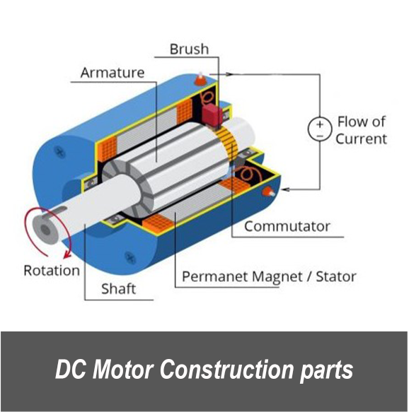
Figure 29 : DC Motor Construction Parts
- Power Supply
In order to ensure that the transfer of AC, DC or other signals from this device is stable, it is necessary to generate an electric current for the good functioning of our equipment.
This system guarantees that our equipment will not be destroyed by providing a power supply that meets the need. (24)
The power supplies differ according to the power which is characterized by the multiplication of the voltage by the current.
- P(W)=U(V)*I(A)
This component is divided into two parts:
1st part: Primary part of 3 pins with the voltage of the mains plug of 230V.
2nd part: Secondary part of 6 pins having the voltage that we will choose to deliver to our object.
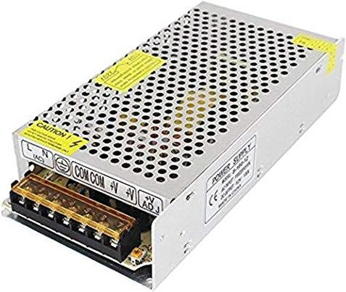
Figure 30 : Power Supply
- BTS7960 Motor Driver

This product is a fully integrated high current half bridge for DC motor control applications, PN high current half bridge.
It consists of a peak current and heat sink, two main chips (bts 7960b) listed as automatic applications, two half-bridges, a p-channel high side mosfet and an n-channel low side mosfet. Together, they make up the H-bridge driver which allows a DC motor to be driven and to move forward or backward thanks to the logic level signals sent which are managed by the 74 hc 244 buffer chip, B- a batterie - , B+ a batterie + , M+ Motor output + , M- Motor output - , the microcontroller , Control logic (voltage regulator) these control input pins control the motor driver, a large capacitor when the inductive load changes, adjusts and eliminates spikes and power supply, reverse polarity protection and two motor leads.
In order to drive our DC895 motor which needs a lot of current, this motor driver will chain this function. (25)
It is composed of 2 half H-bridge BTS7960 allowing to support a current up to 43A under a voltage between 5.5V and 27V.
The control signals are isolated by a 74HC244, and this allows to drive it in 3,3V or 5V.
Double H-bridge driver BTS7960 with high current (43 A).
It is useful for the 4 wheels transfer case, electric windows, windshield wipers ...

5V MCU isolation, effective protection of microcontroller.
The motor driver allows PWM motor input at the highest frequency in both directions, 25 kHz inverted.
Two flows through overheat the error signal output.
Power supply for the isolation chip 5V (this can be shared with the microcontroller).
- Supply voltage: 5.5V to 27V.
- Input voltage: 6V-27V
- Maximum current: 43A
- 16mohm path resistance 25°.
- Path resistance of typ. 16 mΩ@ 25°C
- Low quiescent current of typ. 7 µA @ 25°C
- Current limiting in switched mode for reduced power reduction of power dissipation in
case of overcurrent
- Status flag diagnostics with current sensing current sensing capability
- Overtemperature shutdown with lockout behavior
- PWM capability up to 25KHz combined with active freewheel driver circuit with logic level inputs.
- Overvoltage and undervoltage shutdown
- Driver circuit with logic level inputs
- Adjustable slew rate to optimize EMI
- Input level: 3.3V-5V
- Operating frequency (KHZ): 25
- Control mode: PWM or horizontal
- 5V power supply isolation chip
- Capable of reversing the motor forward, two PWM input frequency up to 25KHZ
- two heat flows through one error signal output
43A high current with 5V SCM isolation, effective protection of single-chip dual-bridge microcomputer BTS7960 H-drive bridge with strong driving and braking effectively isolating the microcontroller and motor driver.
H-drive with thermal overcurrent protection
- PWM capability up to 25 kHz with active freewheel (26) (PWM means Pulse Width Modulation, the principle of PWM is to reduce the average power output of a digital output
(0 or 1) by modulating the signal pulses.)
The PWM method involves varying the duty cycle at a fixed frequency to adjust the voltage or current to the desired target value. The fact that the switching frequency is a fixed parameter is one of the main advantages of the PWM technique for slicing the current. (27)
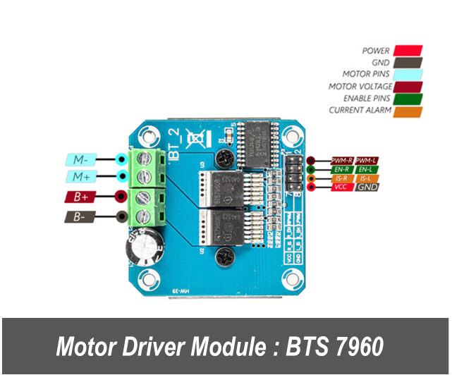
Figure 31 : Motor Driver Module

Pins
RPWM: Forward level or PWM signal input
LPWM: Reverse level or PWM signal input
R_EN: Forward drive enable input.
L_EN: Reverse drive enable input.
R_IS: Forward drive current alarm output.
L_IS: Reverse drive current alarm output.
VCC: 5V power supply
GND: Ground

- Rotary Encoder
Rotary encoder, shaft encoder, NPN open collector output, 1000 ppr, which can control the speed of the conveyor belt as well as the direction of movement.
It is a type of position sensor that measures angular motion used to provide feedback, because when we apply power to the motor, it works, but without knowing the speed, rotation or position.
The rotary encoder measures speed, rotation, or position.
The rotary encoder has several technologies: magnetic, optical, inductive, capacitive and laser.
It is useful to detect and measure angular position, speed, length, acceleration, position and actual speed of a desired object, which it converts into an electrical signal sent to the computer.
It is an electromechanical transducer that uses optical detection technology to provide the most accurate results with high resolution.
It can measure the speed and acceleration of the desired objects, which is useful for intelligent control of any displacement and any fixed length in the motor feedback.
It has a Performance of 400 pulses per revolution and a Maximum mechanical speed of
5000 R / min.
It collects data and provides feedback based on the rotation of the desired object.
It has a power supply of 5V to 24V with a frequency of 30KHZ.
Output: AB 2phase rectangular orthogonal output pulse circuit, output for open collector type NPN. It gives 4000 transitions by rotation between outputs A and B.
The rotary encoder is of two types: the absolute type, whose output indicates the current position of the shaft, making it an angular transducer, and the incremental type, whose output provides information on the shaft movement.
Shaft motion, which is usually processed elsewhere as information such as position, velocity, and distance, is useful for reporting position changes.
It has 4 wires:
VCC: red wire
GND: black wire
A: white wire B
B: green wire
It works by observing changes in the magnetic field created by a magnet attached to the motor shaft. When the motor is running, the encoder outputs are triggered periodically.
The rotary encoder is used for more versatile, more specific, and larger movements, up to 360°, than the potentiometer.
The absolute encoder has a coded disc, a decoder which makes it more complex than the incremental encoder which is called a quadrature encoder or relative encoder but it has an angular position that can be read without power, which means that there is no loss of counter even if the power is off, so every time the shaft turns a pattern code is generated to determine the exact position.
The absolute rotary position is calculated by converting the binary position value into an angular value it is composed of a gear transmission, a main disk giving the position up to 360° and a disk for counting the revolutions. An internal gearbox is connected to the drive shaft, so that the measured value is composed of the angular position and the number of revolutions it translates the rotation into a series of pulses which indicate the shaft movement and its direction.
Thus, to achieve high accuracy, a steering wheel angle of 900°, we used the absolute type to measure the precise position and the incremental type to provide force feedback by measuring relative position changes and steering wheel rotation speed during play. (28)
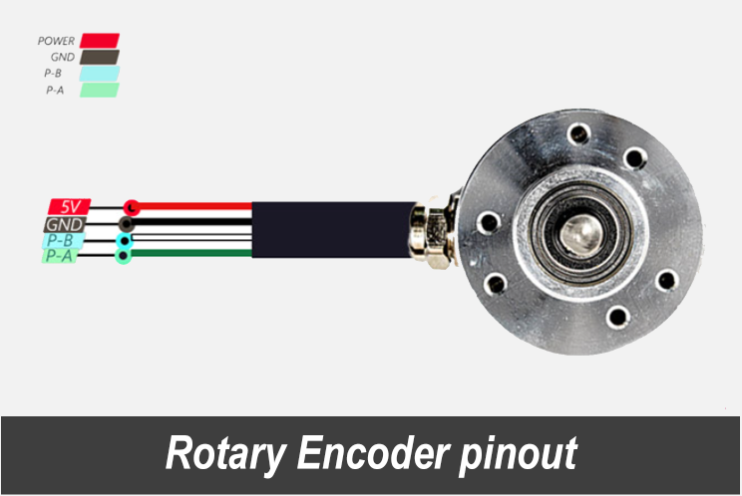
Figure 32: Rotary Encoder Pinout

- Arduino Leonardo

The Arduino Leonardo is a microcontroller board based on the Atmel ATmega32u4.
By executing powerful instructions in a single clock cycle, the device achieves throughputs close to one MIPS per MHz, which optimizes power consumption relative to processing speed.
This card has a power supply socket, an ICSP connector and a reset button.
This board is an evolution of the Arduino UNO, it has a barrel connector, an external power supply that allows the user to consume more energy if needed, compatible with a 9V battery.
The ATmega32u4 MCU has an integrated USB communication, so there is no need to add another processor, this type of connection is a plus so it will let the micro presented as a mouse or a keyboard on the computer.
This allows the Leonardo to appear to a connected computer as an HID, such as a mouse or keyboard, in addition to a virtual serial/COM port (CDC).
The Leonardo board contains everything needed for the microcontroller.
Simply connect it to a computer with a USB cable or power it with an AC-to-DC adapter or battery to get started.
This card is clocked at 16 MHz, which allows the USB port to be managed by a single processor. This allows for greater flexibility in communication with the computer.

However, there are many different cards that can be used for ruling down the project.
We cite the Arduino Leonardo, the Raspberry Pi and the STM32.

Board | Arduino Leonardo | Raspberry Pi | STM32
Microcontroller | ATmega32u4 | - | -
USB connector | Micro USB (USB-B) | USB Type-A, Micro USB, and USB Type-C | Micro USB, USB type-C
Pins | 20 digital input/output pins  7 PWM pins | 8 digitals | Up 20 pins
Power | Input voltage 7-12V | Power over Ethernet (PoE)–enabled | 2.0 to 3.6V
Clock speed | 16 MHz | 700MHZ | 72MHZ
Memory | 2.5KB SRAM, 32KB FLASH, 1KB EEPROM | FLASH MEMORY Micro SD Card | RAM 20KB  FLASH 64KB-128KB
Operating voltage | 5V | 5V
Processor | ATmega32u4 | ARM | ARM Cortex-M processor cores
GPIO | - | Standard 40-pin GPIO header | 36 pins
SD Card support | - | Yes | Yes
Operating system | Windows, Linux, Max | Linux distributions | RTOS
Price | 60DT | 160DT | 90DT
CPU type | AVR Architecture | 64-bit Microprocessor | ARM Cortex M3
Integrated development environment | Arduino Software IDE | SCRATCH, Python, IDLE, Linux... | STM CUBE IDE
Networking | Only by using external modules or shields | Ethernet – WIFI – Bluetooth | ETHERNET – WIFI – BLEUTOTH – USB -CAN
Table 4 : Microcontroller deployment
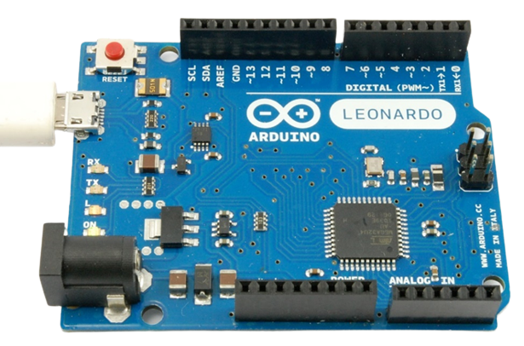
Figure 33 : Arduino Leonardo

The two boards Arduino Leonardo and Arduino Uno have the same dimensions and the same number of pins and are arranged in the same way, the same power supply and the same frequency provided by the frequency generator.
However, they have a micro controller ATmega328 for the UNO and ATmega32u4 for the Arduino Leonardo and different communications because the USB is integrated only in the Leonardo.
In the case of the ATmega328, there is no built-in USB communication, so a virtual COM port is assigned for communication while Leonardo has a plate that is recognized by the computer as if it were a USB device such as a mouse or keyboard. This allows the use of both mouse and keyboard functions.
In addition, the Arduino UNO is characterized by only 6 channels, while the Arduino Leonardo has 12 channels with the number of PWM that is more important.
That’s why we used the Arduino Leonardo in our project. (29) (30)

- Handbrake
It is a mechanism that helps the driver control his car by stopping it when it is parked.
This component is used to prevent the car from rolling away.
For the handbrake, we will use a limit switch.

- Material realization
In this section, we detail the wiring of each component as shown in the following four figures, using Fritzing software for circuit design.
- Shifter
This photo shows the Shifter Circuit diagram.
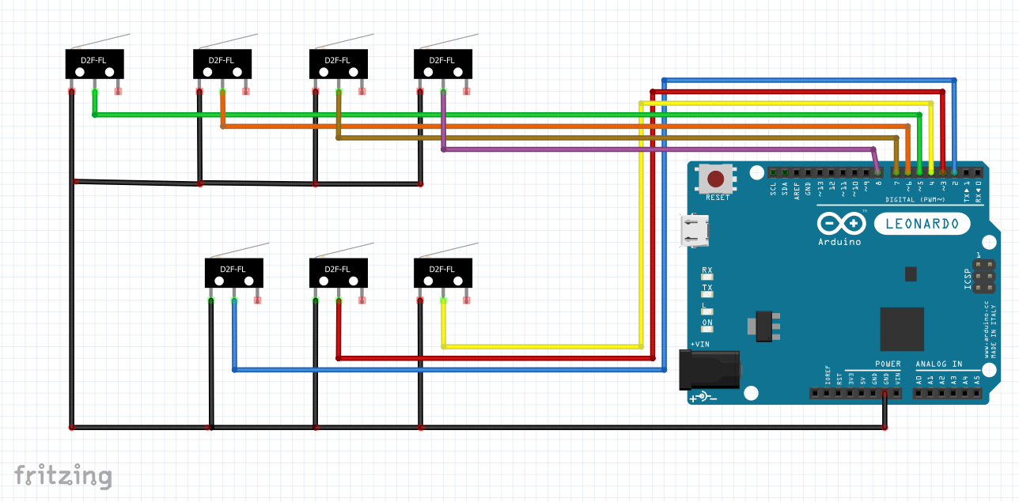
Figure 34 : Shifter (Gearbox) Circuit Diagram

Black: com (GND)
Blue: D2 To NO (Normally Open)
Red: D3 To NO (Normally Open)
Yellow: D4 To NO (Normally Open)
Green: D5 To NO (Normally Open)
Orange: D6 To NO (Normally Open)
Brown: D7 To NO (Normally Open)
Purple: D8 To NO (Normally Open)

- Steering Wheel
This photo shows the pedal Circuit diagram.

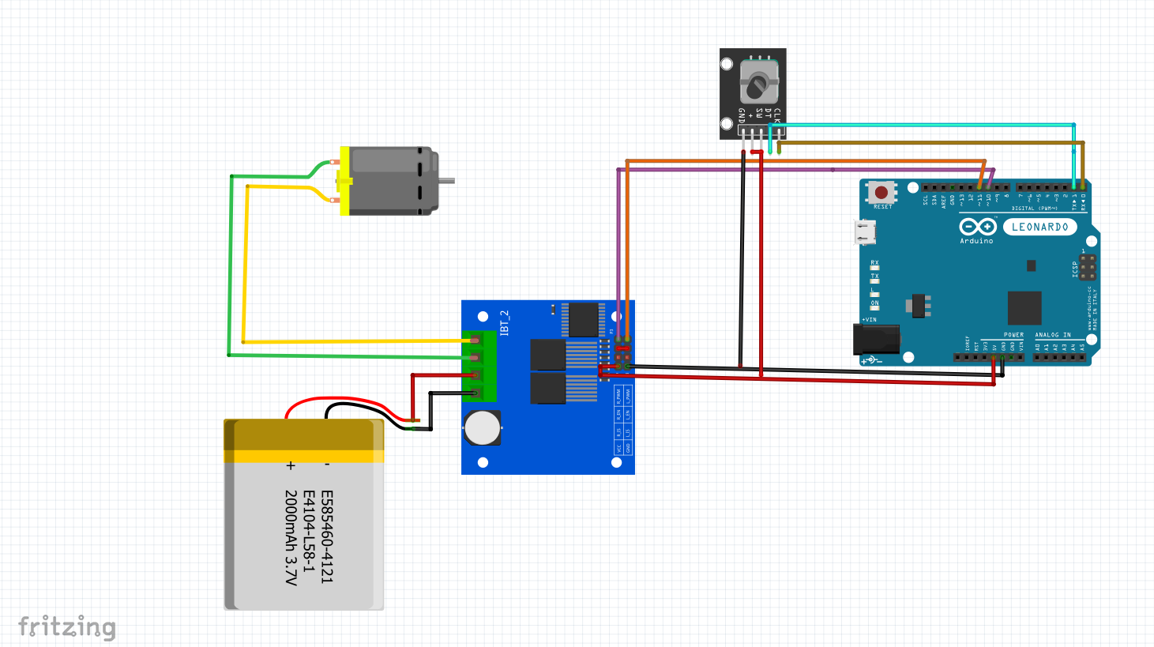
Figure 35 : Steering Wheel Circuit Diagram

RED: VCC
BLACK: GND
Cyan: TX to DT
Brown: RX to CLK
Orange: L_PWM to D11
Purple: R_PWM to D10
Green: VCC
Yellow: GND

- Handbrake
This photo shows the Handbrake Circuit diagram.
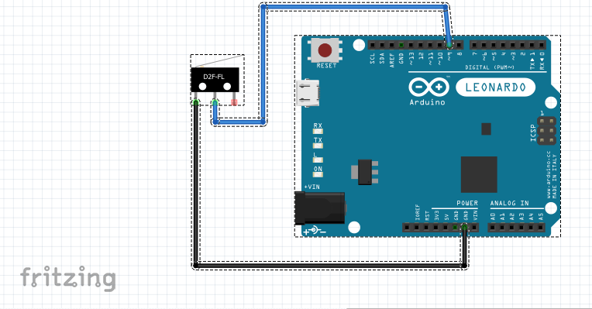

Figure 36 : Handbrake Circuit Diagram
Black: GND
Blue: D9 to NO (Normally open)
- Pedals
This photo shows the pedal Circuit diagram.
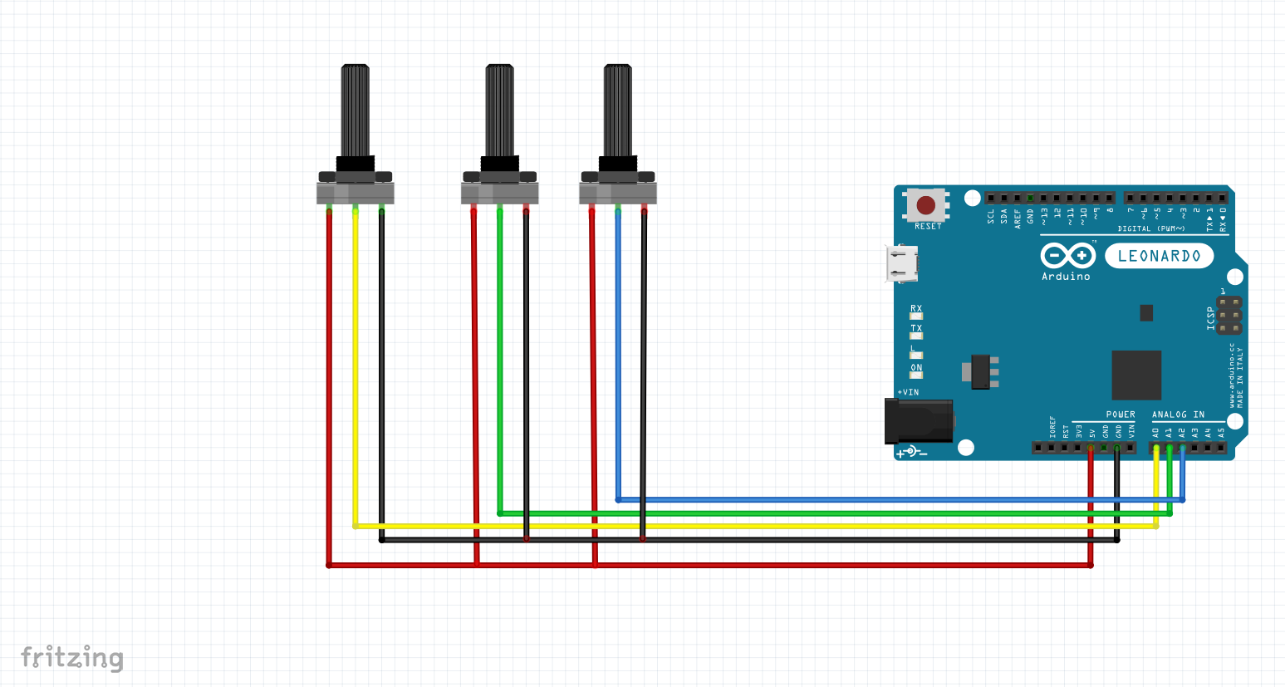
Figure 37 : Pedals Circuit Diagram
Black : GND
Red : VCC
Yellow: Output to A0
Green: Output to A1
Blue : Output to A2
- Software Realization
- 3D Conception
- Printing

The process of printing our parts in 3D includes the following steps:
First, we create our 3D model of the part using 3D modeling software, solid Works in our case.
Second, we prepare our model for 3D printing by checking it for errors or problems that could affect the printing process.
Third, we convert the solid part into an STL "Standard Triangle Language" file (this is a file created by 3D systems with the Stereolithography Type Format known for 3D printing and rapid prototyping).
Fourth, we upload the STL file to the slicing software (Cube Pro, Cura) and set parameters such as layer resolution, print speed, print strength, print pattern, curb and support material, and fill density.
Finally, we send the model to the 3D printer via USB cable, SD card or Wi-Fi, depending on our printer.
- Assembly parts

- Pedals:
As we will see here all the parts that we did printed to create our pedals:

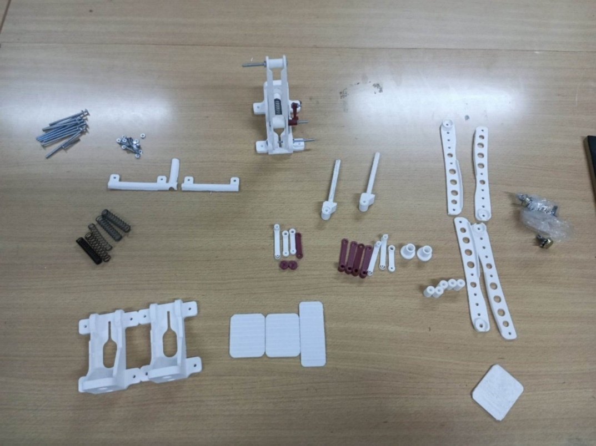
Figure 38 : Pedals part
We have used this board to attach the pedals:

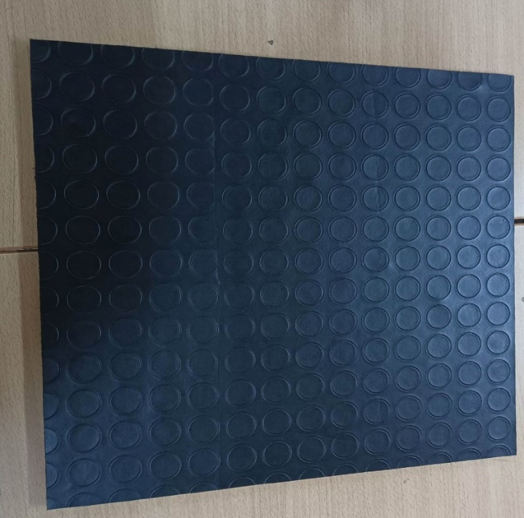
Figure 39 : Board

We began by installing the components for each pedal, then wiring each pedal and configuring the potentiometer to adjust the voltage divider and its wiring.
We tested each pedal using WheelConfig software to ensure that it was in good working order, given that each pedal is different from the other, of course we connected it to the microcontroller, and finally we detached the pins to a DB9 RS232 connector.
And this is our final prototype:
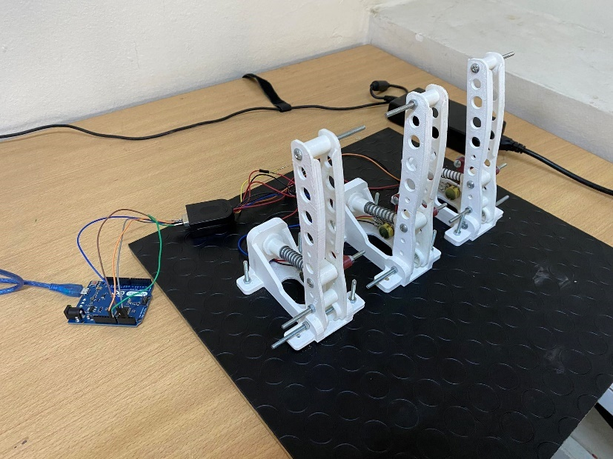
Figure 40 : Pedals

- Shifter:
Here are all the parts printed for the shifter:
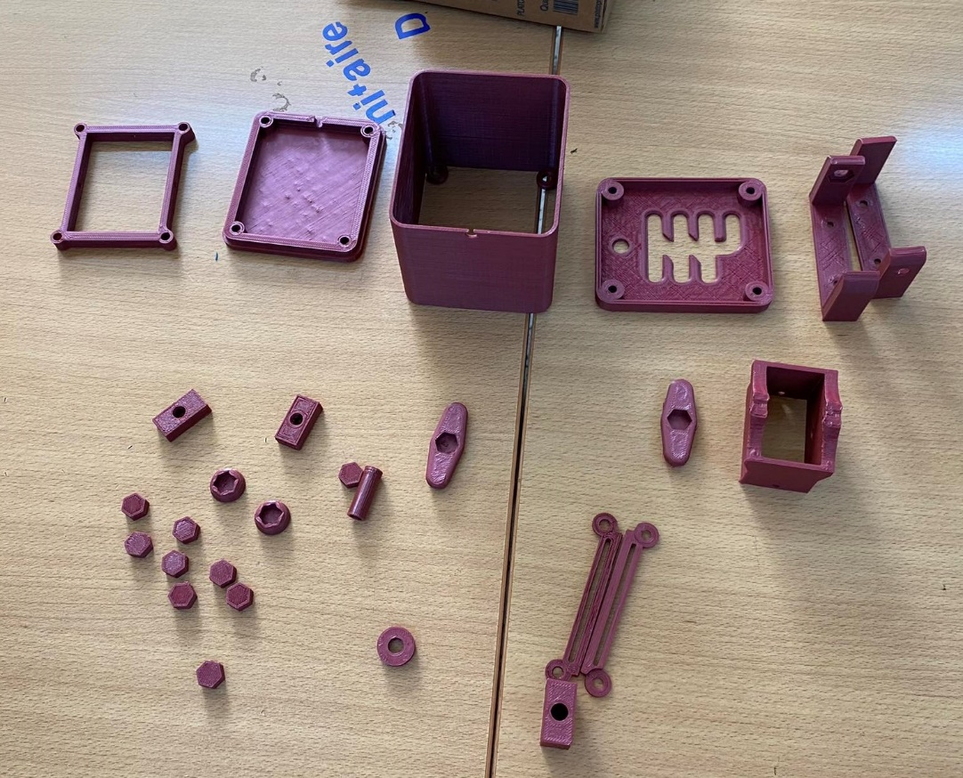
Figure 41 : Shifter parts

We started by installing the components together, then we installed the limit switches,
Next, we tested the function of the gearbox, so that at each gear change, the limit Switch detects the presence of an object when we change the level, and then we wired it and configured it,
we tested using WheelConfig software to make sure it was working properly, connected it to the microcontroller, and finally detached the pins to a DB9 RS232 connector.

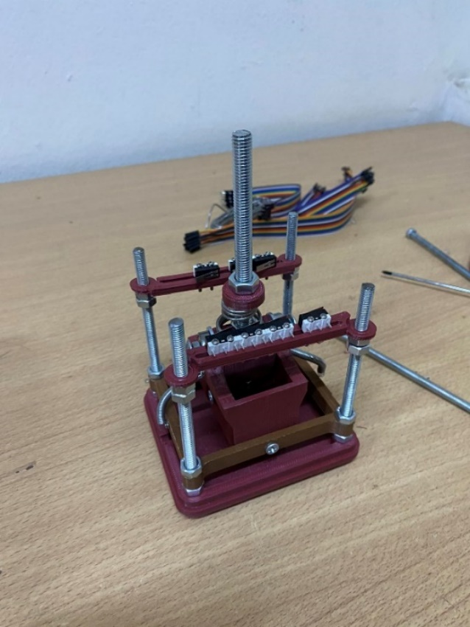

Figure 42 : Shifter

Here is the final prototype:

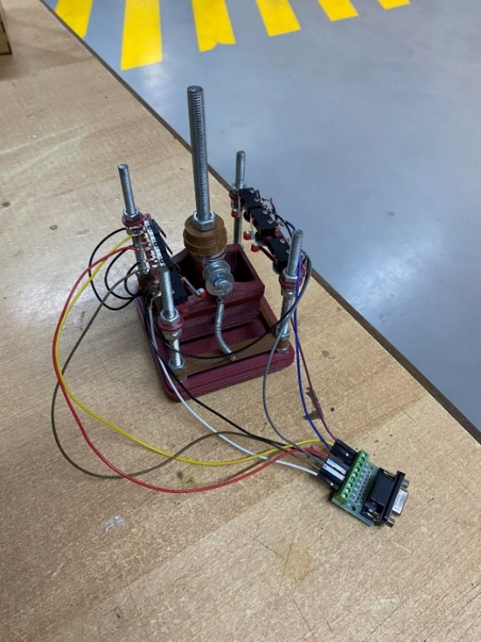
Figure 43: Final shifter wiring

- Handbrake:
Here are all the parts printed for the handbrake:
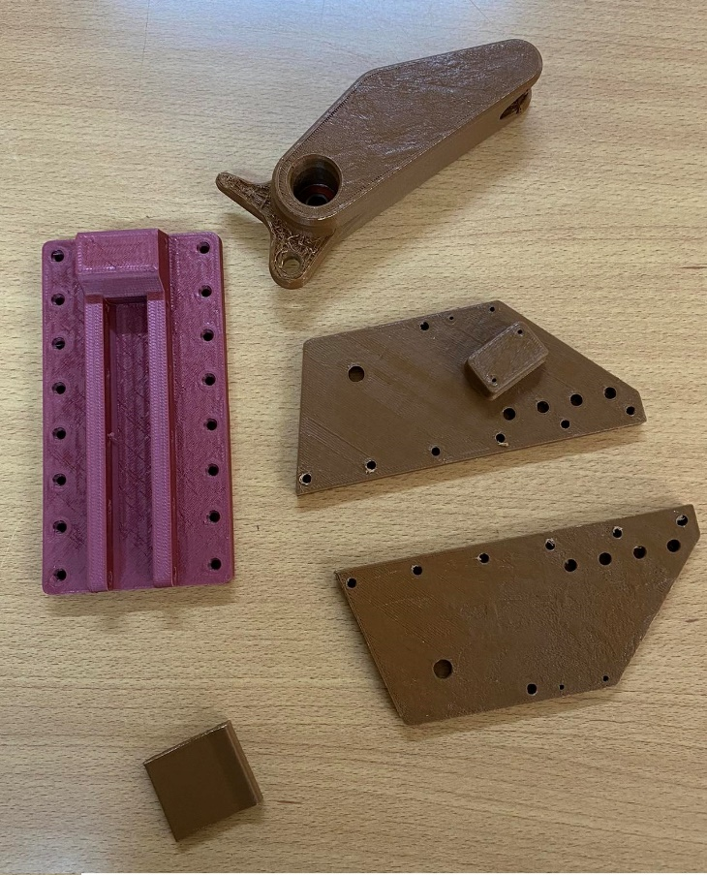
Figure 44 : Handbrake parts

We started by installing the parts together and adding the limit switch, then we wired the limit switch and tested it using wheelconfig and finally we added the last part, and the handbrake works perfectly.

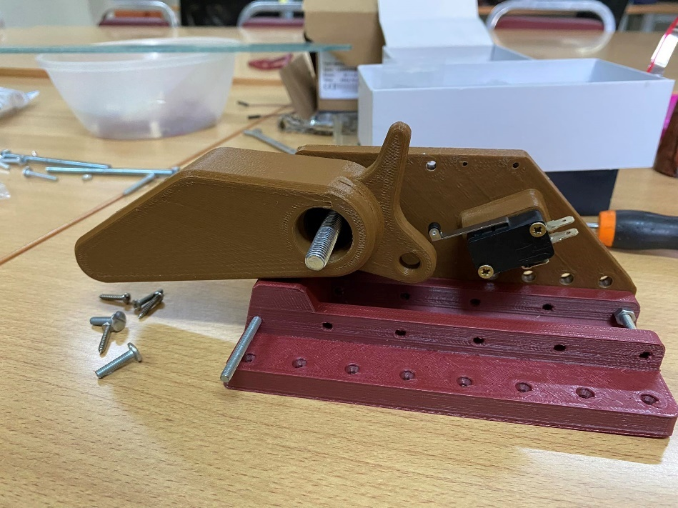
Figure 45: Handbrake wiring

Here is the final prototype:
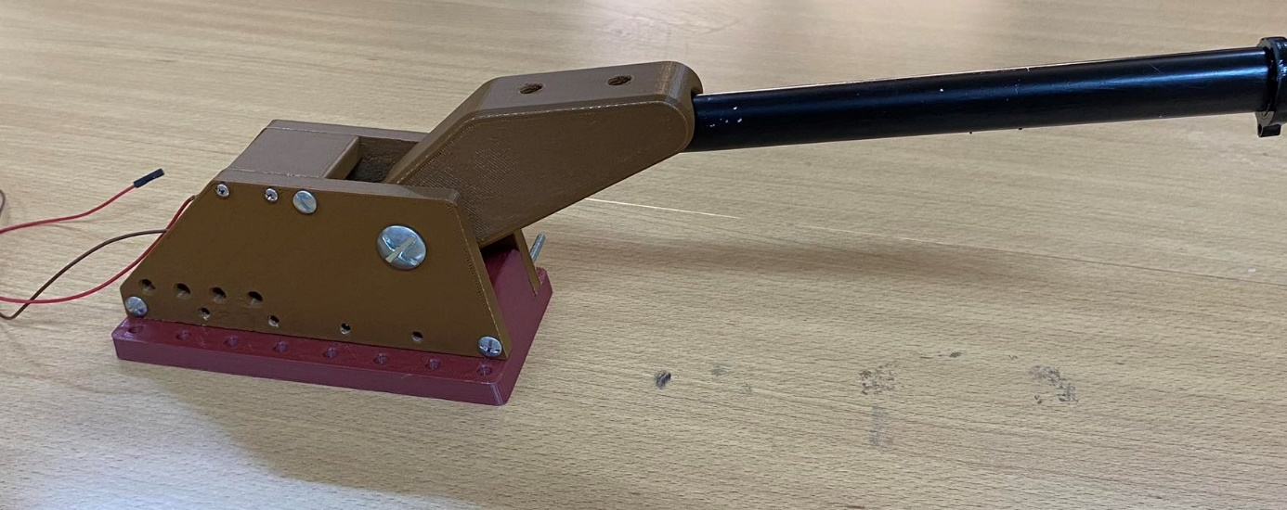
Figure 46 : Handbrake

- Steering Wheel:
Here are all the parts printed for the steering wheel:
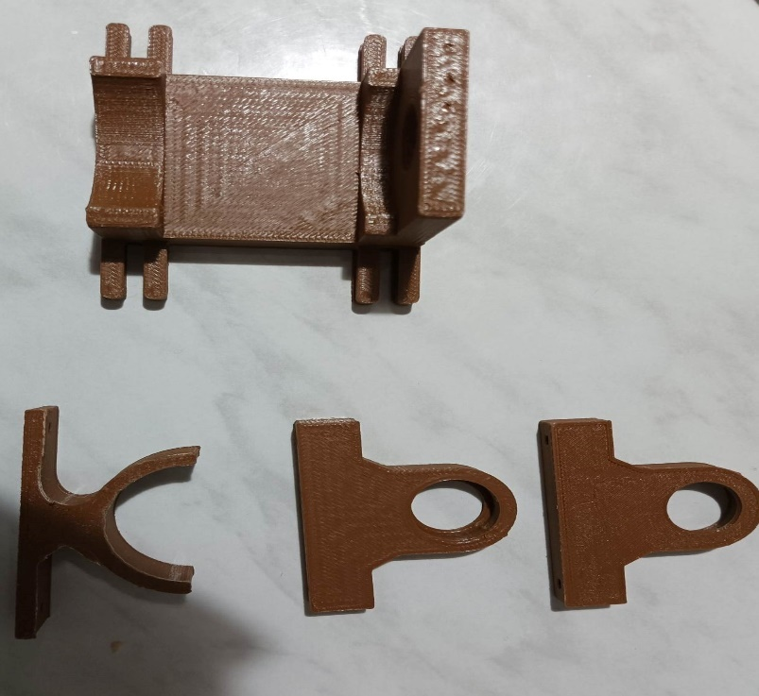
Figure 47 : Steering wheel parts

We cut the steering wheel using a CNC laser machine as shown:

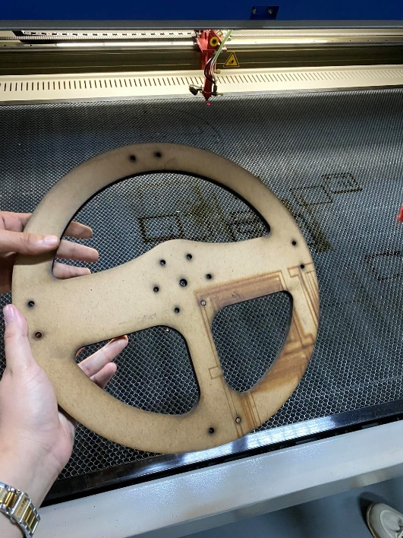
Figure 48 : Steering wheel

We installed the wheel parts in the center of the board using the GALVANIZED ROD, which is the wheel axle that will rotate every time the user turns it, and which is connected to a secondary motion transmission mechanism linked to the motor for force feedback.
Also, our axe connected with a coupling sleeve to the rotary encoder to measure the angle of rotation.

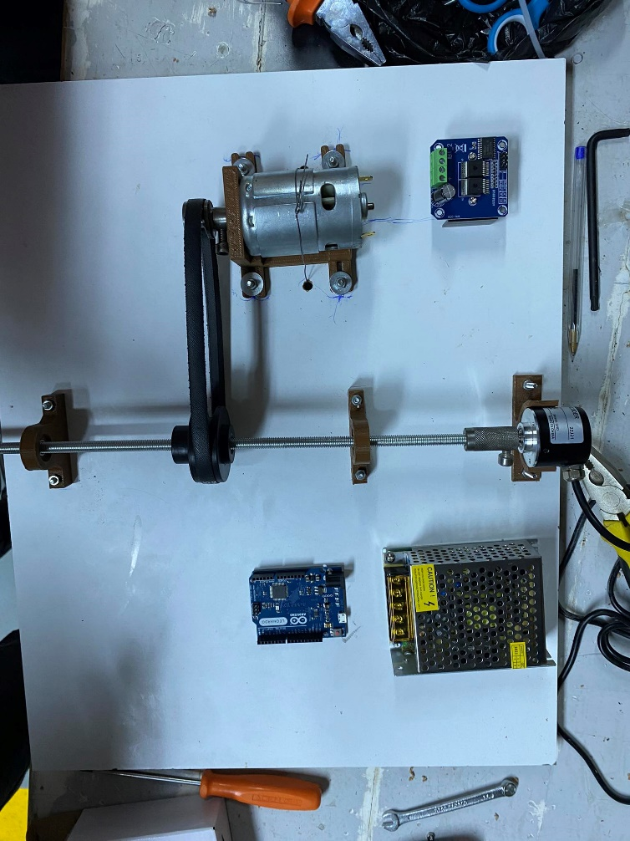
Figure 49: steering wheel wiring

- Conclusion
In this chapter, we set out the hardware and software working environments for our project, then proceed to describe the hardware and each component, and finally the hardware and software implementation, with a clear view of the cabling of each component.

General Conclusion

Our end-of-studies project, carried out at FabLab as part of our diploma course in Embedded and Mobile Systems, with the aim of developing an innovative solution to meet the needs of drivers who are gamers or even for those who want to master the art of driving.
The idea is to create a racing car simulation cockpit that offers learning and comfort thanks to pedals, a steering wheel with specifications such as Force Feedback that makes racing time more real for the user, offering a truer-to-nature representation, a steering wheel with power steering and vibration, a gearbox and especially a handbrake to activate the rear brakes as if driving in real time.
Our report is divided into four parts. In the first chapter, we began with a presentation of the host organization, followed by the areas of activity and an organization hierarchy.
This is followed by a presentation of the project framework, a study of the existing situation which leads us to propose a solution.
In the second chapter, we presented the existing methodologies and with the selection of the one we have chosen, we set out the choice of the scrum methodology revealing its roles, its artefacts, and its formal inspection, with detailed sprints.
In the third chapter, we specified the functional and non-functional requirements as well as explaining the system architecture and a more detailed overview of our work in the form of diagrams namely the use case, Sequence, and transition state diagrams.
All the above steps helped us to reach the final stage in the fourth chapter, where we described the development environment for carrying out our work, including both hard and soft materials, and the realization parts.
Finally, we showed screenshots of the construction of each component (the pedals, the handbrake, the steering wheel and the gearbox), to illustrate a more detailed view.
In addition, we are currently developing a video game that could be improved and compatible with our cockpit.
Thanks to this project, we have deepened our knowledge in the field of game technology, learning more about 3D design and game development.

References
1. [Online] 3 2023. https://fablabs.tn/fablab/fablab-solidaire-jeunes-science-tunis/?fbclid=IwAR3Y1XTL2py7MMJrDje-wRVxBvP3eMJchlKC-naxu1WHUZi6aysoa5CMygY.
2. [Online] 3 2023. https://www.fondationorange.com/fr/fablabs-solidaires-un-programme-international-deducation-numerique?fbclid=IwAR3hIjQOwv5-IbDkdmDS2ccnh6HJB3NiUVgUMT_FXrKQkCf88Ye7DISD8U0.
3. [Online] 2 2023. https://www.logitechg.com/fr-fr/products/driving/driving-force-racing-wheel.941-000123.html?searchclick=logi.
4. [Online] 2 2023. https://www.logitechg.com/fr-fr/products/driving/driving-force-shifter.941-000130.html?searchclick=logi.
5. [Online] 4 2023. https://jadealm.com/blog/comparison-of-different-agile-methodologies-pros-and-cons/?fbclid=IwAR0Dv9-LzpAkfW9PYLTyLkpgdVReJ2gKc2FZxbvdnWIWUIgUJgu31rWhpV4.
6. [Online] 4 2023. https://www.coursera.org/articles/scrum-roles-and-responsibilities?fbclid=IwAR2Oc8jxv0u1NC8yGPhY40tj9G6MiYRWLj9jJBGeiIzeY8o1mHOsDl8uHDI.
7. [Online] 4 2023. https://blog-gestion-de-projet.com/definition-des-artefacts-scrum/?fbclid=IwAR1j8Qhs1kblBbyDQko7itj3O9ZG88PIvMEx5qxU2nBbZcEISTY6OSdQtd4.
8. [Online] 4 2023. https://resources.scrumalliance.org/Article/product-increment?fbclid=IwAR1QvCfwzfVWOTyGzjUaQyZ4xnL0tLav2Wihh4QihbaXDqKuEcjIXajY3f8#:~:text=In%20scrum%2C%20a%20product%20increment,to%20be%20delivered%20or%20deployed.
9. [Online] 3 2023. https://www.3dbeginners.com/cubepro-3d-printer-review/?fbclid=IwAR2NdzOzF2I9pxs_6NNKClgukuRV7_Ey1irExwbY3FiX7z-moU56WBltpOA.
10. [Online] 3 2023. https://www.3ding.in/3dprinters/cube-pro?fbclid=IwAR3JSHZ5YoF_2hyu8lF0-R-ygQoErg54yaVf5CLP0AtZ89woop6xMHg8Rwc.
11. [Online] 3 2023. https://docs.rs-online.com/c852/0900766b813677ed.pdf?fbclid=IwAR3YIQyxhGcGxQNre9yNRtUV2LUAwcjvfvRtFXwwiYqYFouz0wcaeGOcsDg.
12. [Online] 3 2023. https://www.matterhackers.com/store/c/delta-printers?fbclid=IwAR1LWLcTUmetZciLPPWDa2FEQ_MnITH0PpQMHHFtTcDXGON9vHJY_YNVXLc.
13. [Online] 3 2023. https://tractus3d.com/knowledge/learn-3d-printing/3d-printing-technology-delta-versus-cartesian/?fbclid=IwAR1QvCfwzfVWOTyGzjUaQyZ4xnL0tLav2Wihh4QihbaXDqKuEcjIXajY3f8#:~:text=Delta%203D%20printer,the%20angles%20of%20these%20parallelograms.
14. [Online] 3 2023. https://all3dp.com/2/best-delta-3d-printer/?fbclid=IwAR0S33hLgbtXHkSK_sVpxVnGCMWz-TQNiiewXC5Uo87wpUeUsjoEchPMCc8.
15. [Online] 3 2023. https://www.solidworks.com/fr.
16. [Online] 4 2023. https://ultimaker.com/software/ultimaker-cura/.
17. [Online] 4 2023. https://all3dp.com/2/repetier-host-beginners-guide/?fbclid=IwAR0AMLdkMIPq26f4FjNbbytw_B3cq4wo7GlAyfLvWVSKZq_IpIcuPl_jbNg.
18. [Online] 3 2023. https://www.ressorts-sodemann.fr/faq/ressorts-de-compression/qu-est-ce-qu-un-ressort-de-compression?fbclid=IwAR0voGN546zdkiJTfs-V06wekmGyt2mT7bsOS1XYWLFUBq93O7gi4-cPdn4.
19. [Online] 3 2023. https://fr.wikipedia.org/wiki/Potentiomètre.
20. [Online] 3 2023. https://components.omron.com/us-en/products/switches/industrial-switches/limit-switch_features?fbclid=IwAR1WEJh6Km2DbqVCuXXdMB6dPQKtuzFQ00PXxgep2H9G3ky7VQhyw2fZ37U.
21. [Online] https://arduinogetstarted.com/tutorials/arduino-limit-switch?fbclid=IwAR0npJo-uJziKLMaIp41Sl6RqsOXXe_54SpxbzX4OuFIspC4Nn-RRNmLVa0.
22. [Online] https://www.automationdirect.com/adc/overview/catalog/sensors_-z-_encoders/limit_switches?fbclid=IwAR2qDDckkSD5OXMPpCny93Ob5j4NCiBCOanHgu0om77eVuYJDnyG0wtMjX0.
23. [Online] https://en.wikipedia.org/wiki/DC_motor?fbclid=IwAR1Yo2qlfvv3-0tsx3z-kCbRAeeud2UjdSQVMtMisO0XtU0EoJcrfh1H2HA.
24. [Online] https://www.one-elec.com/blog/qu-est-ce-qu-un-bloc-d-alimentation-one-elec?fbclid=IwAR15cWivc8z5vLUdZ-qleGgVUcnCRItxFAnuOPiTTBcro56tuMPnbZaC8ng.
25. [Online] https://boutique.semageek.com/fr/1207-driver-de-moteur-haute-puissance-bts7960-43a-3004387614055.html?fbclid=IwAR0V-_AaOKp_iSa2QWBgkzhnZ3ArMlxzGzwciD2l8fxho28jgaG4BTRZlgU.
26. [Online] https://fr.wikipedia.org/wiki/Modulation_de_largeur_d%27impulsion#:~:text=La%20modulation%20de%20largeur%20d,plus%20généralement%20à%20états%20discrets..
27. [Online] https://www.smart-cube.biz/produit/bts7960b-dc-motor-driver-43a-h-bridge-drive-pwm-pour-arduino/?fbclid=IwAR1Yo2qlfvv3-0tsx3z-kCbRAeeud2UjdSQVMtMisO0XtU0EoJcrfh1H2HA.
28. [Online] https://en.wikipedia.org/wiki/Rotary_encoder?fbclid=IwAR0d88yHvU6Z2i2HlHPyla1n2R-IUsy_mi9cTVrcmRF4neid7S6SEvcJixs.
29. [Online] https://www.hwlibre.com/fr/arduino-léonard/?fbclid=IwAR0V-_AaOKp_iSa2QWBgkzhnZ3ArMlxzGzwciD2l8fxho28jgaG4BTRZlgU#Que_es_Arduino_Leonardo.
30. [Online] https://docs.arduino.cc/hardware/leonardo?fbclid=IwAR0-_6QEjAteZ1r126SCOxwO6yIEfYHn2r2DLT4zaU7C4iOi-CYRtbS0tYI.

Appendix 1: Arduino firmware installation

First, we started by downloading and installing all the software and firmware we need to configure our wheel using the AI wave 2016-wheel configurator, firmware and Xloader.
Second, we’re going to flash our microcontroller with our firmware, and here are the steps to follow:
- We have to open The XLoader Software.
- We need to select our hex file also known as Firmware.
- We have to make sure that Arduino must be on Bootloader mode, so we have to open the Device Manger and we look at COM Port for example Arduino Leonardo (COM5)
- Push Reset Button on the Arduino board and check up if the COM Port has changed (E.g., From COM9 to COM10) on the Device Manger.
Note: Bootloader mode lasts just 8 seconds.
- Open the Xloader and change COM Port (E.g. COM10 Following the previous example).
- Click upload.

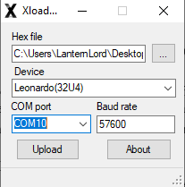
Figure 50: Xloader

Appendix 2: Configuration

After downloading the firmware to the microcontroller, we used the Ai wave 2016 Steering Wheel Configuration software to configure our cards as shown in the following image.
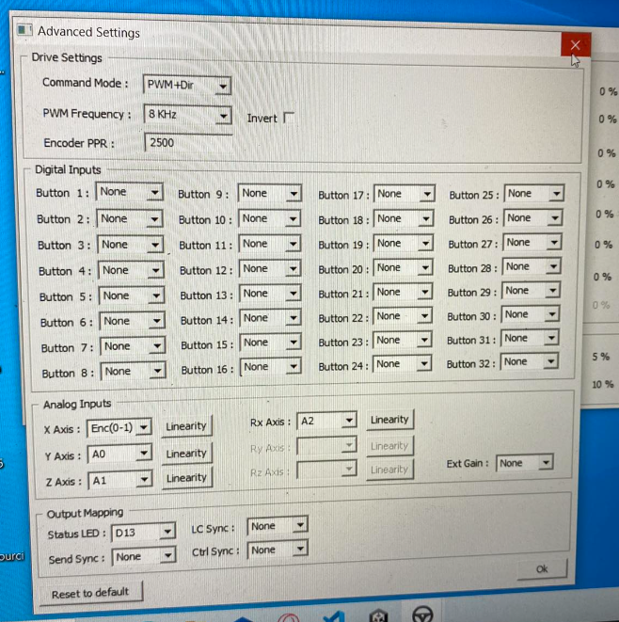
Figure 51 : AI Wave configuration

