FAILURE_PREDICTION_DATA.CSV

**4 Node CART® Regression: Failed versus Temperature, Pressure, Voltage**

|  |
| --- |
|  |

**Method**

|  |  |
| --- | --- |
| Node splitting | Least squared error |
| Optimal tree | Within 1 standard error of maximum R-squared |
| Model validation | 70/30% training/test sets |
| Rows used | 10000 |

**Response Information**

|  |  |  |  |  |  |  |  |  |  |
| --- | --- | --- | --- | --- | --- | --- | --- | --- | --- |
| **Data Set** | **N** | **% of N** | **Mean** | **StDev** | **Minimum** | **Q1** | **Median** | **Q3** | **Maximum** |
| Training | 6987 | 69.9 | 0.354802 | 0.478487 | 0 | 0 | 0 | 1 | 1 |
| Test | 3013 | 30.1 | 0.356123 | 0.478932 | 0 | 0 | 0 | 1 | 1 |

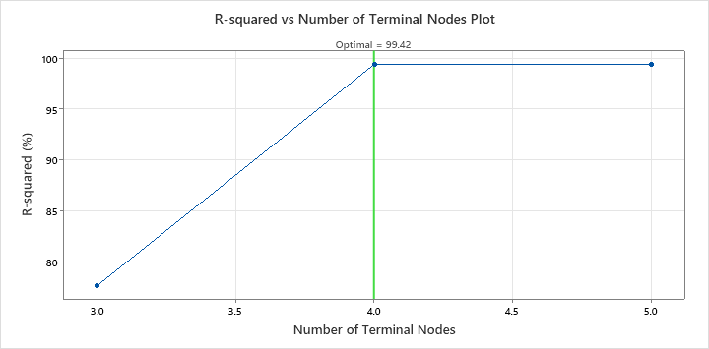

**Optimal Tree Diagram**

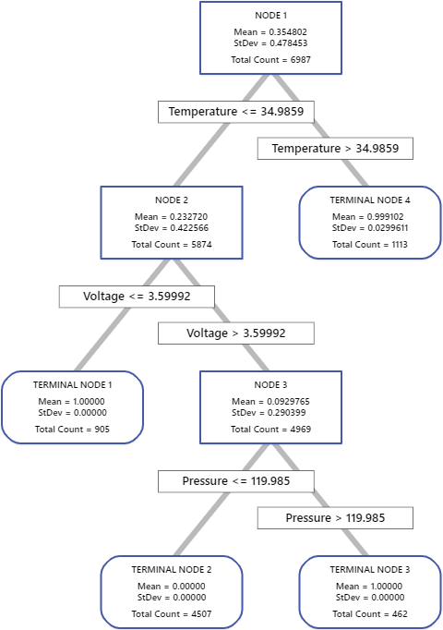

**Model Summary**

|  |  |
| --- | --- |
| Total predictors | 3 |
| Important predictors | 3 |
| Number of terminal nodes | 4 |
| Minimum terminal node size | 462 |
| **Statistics** | | | **Training** | **Test** |
| R-squared | | | 99.94% | 99.42% |
| Root mean squared error (RMSE) | | | 0.0120 | 0.0364 |
| Mean squared error (MSE) | | | 0.0001 | 0.0013 |
| Mean absolute deviation (MAD) | | | 0.0003 | 0.0015 |
| Mean absolute percent error (MAPE) | | | 0.0004 | 0.0023 |

