FAILURE_PREDICTION_DATA.CSV

**4 Node CART® Regression: Failed versus Temperature, Pressure, Voltage**

|  |
| --- |
|  |

**Method**

|  |  |
| --- | --- |
| Node splitting | Least squared error |
| Optimal tree | Within 1 standard error of maximum R-squared |
| Model validation | 10-fold cross-validation |
| Rows used | 10000 |

**Response Information**

|  |  |  |  |  |  |  |
| --- | --- | --- | --- | --- | --- | --- |
| **Mean** | **StDev** | **Minimum** | **Q1** | **Median** | **Q3** | **Maximum** |
| 0.3552 | 0.478598 | 0 | 0 | 0 | 1 | 1 |

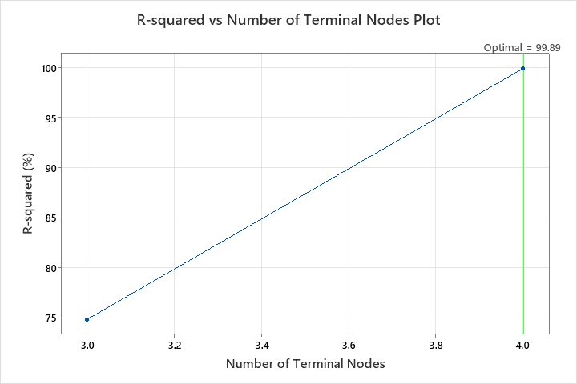

**Optimal Tree Diagram**

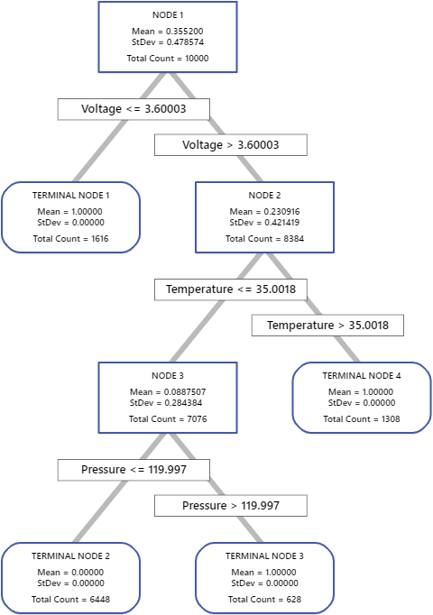

**Model Summary**

|  |  |
| --- | --- |
| Total predictors | 3 |
| Important predictors | 3 |
| Number of terminal nodes | 4 |
| Minimum terminal node size | 628 |
| **Statistics** | | | **Training** | **Test** |
| R-squared | | | 100.00% | 99.89% |
| Root mean squared error (RMSE) | | | 0.0000 | 0.0156 |
| Mean squared error (MSE) | | | 0.0000 | 0.0002 |
| Mean absolute deviation (MAD) | | | 0.0000 | 0.0003 |
| Mean absolute percent error (MAPE) | | | 0.0000 | 0.0000 |

