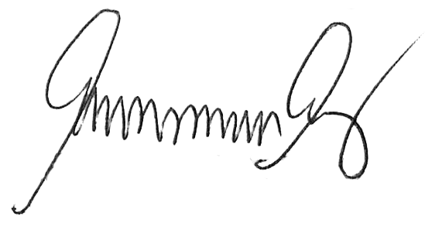JUNFIE

Civil Service Form No. 48

DAILY TIME RECORD
-----o0o-----
(Name)

For the month of
Official hours for arrival and departure |  | Regular days
 |  | Saturdays

Day | A.M. |  | P.M. |  | Undertime
 | Arrival | Depar-ture | Arrival | Depar-ture | Hours | Min-utes
1
2
3
4
5
6
7
8
9
10
11
12
13
14
15
16
17
18
19
20
21
22
23
24
25
26
27
28
29
30
31
Total--------------------------------------

I certify on my honor that the above is a true and correct report of the hours of work performed, record of which was made daily at the time of arrival and departure from office.

VERIFIED as to the prescribed office hours:

In Charge
(SEE INSTRUCTION ON BACK)

Civil Service Form No. 48

DAILY TIME RECORD
-----o0o-----
(Name)

For the month of
Official hours for arrival and departure |  | Regular days
 |  | Saturdays

Day | A.M. |  | P.M. |  | Undertime
 | Arrival | Depar-ture | Arrival | Depar-ture | Hours | Min-utes
1
2
3
4
5
6
7
8
9
10
11
12
13
14
15
16
17
18
19
20
21
22
23
24
25
26
27
28
29
30
31
Total--------------------------------------

I certify on my honor that the above is a true and correct report of the hours of work performed, record of which was made daily at the time of arrival and departure from office.

VERIFIED as to the prescribed office hours:

In Charge
(SEE INSTRUCTION ON BACK)

Civil Service Form No. 48

DAILY TIME RECORD
-----o0o-----
(Name)

For the month of
Official hours for arrival and departure |  | Regular days
 |  | Saturdays

Day | A.M. |  | P.M. |  | Undertime
 | Arrival | Depar-ture | Arrival | Depar-ture | Hours | Min-utes
1
2
3
4
5
6
7
8
9
10
11
12
13
14
15
16
17
18
19
20
21
22
23
24
25
26
27
28
29
30
31
Total--------------------------------------

I certify on my honor that the above is a true and correct report of the hours of work performed, record of which was made daily at the time of arrival and departure from office.

VERIFIED as to the prescribed office hours:

In Charge
(SEE INSTRUCTION ON BACK)

