**Target Variable:** The main focus of the okcupid_profiles.csv file is to determine the user's current dating situation, which can be classified as "single," "seeing someone," or "married" By analyzing factors such as personal information, hobbies, and daily routines, the goal of the project is to predict the user's relationship status in advance.

**Target Audience:**

The target audience who will benefit from this analysis includes:

* Using these findings can help improve their **online matchmaker**, give better recommendations to users, and make customers happier.
* People(**Researchers**) who study online dating and how people act on the internet can use what was discovered in this research to get a better idea of how different things affect the way people behave and whether they're in a relationship or not.
* **Salespeople and promoters** can use the findings from this research to get a better grasp of what customers want and like. This can help them create targeted ads for things like dating apps and related merchandise.
* Couple fixers (**relationship counsellors**) and therapists: These folks who help with people's relationships can take the results of this study into account to get a better handle on the things that affect people's relationships and give more targeted advice to their clients.
* People who make **rules** for dating apps and care about keeping people's privacy safe can check out what we found here when making choices about what kind of online dating laws and rules they want to put in place.
* **Smart people** who like working with data and know all about machine learning can use the OkCupid Profiles Dataset to create and test out prediction models that run on user data.
* The folks who study how humans (**social scientist**) act and relate (social geeks and head doctors) may use what they learn from this study to figure out how various things affect whether you're single or coupled up. It might also give them fresh thoughts and guesses on how we behave when we date in the digital age.

**Key Insights:**

**Chart-1:**

Below is gender-based bar chart depicts the distribution of relationship status across different genders, displaying how many people of each gender are single,available, unknown, or married.

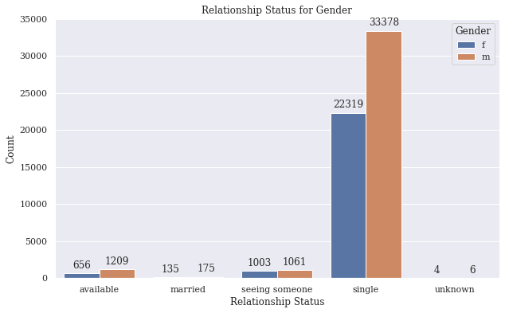

**Chart-2:**

Below is the bar graph that shows how people's relationship status is looking in various areas. You can see how often folks are living the solo life, dating someone, or hitched up, depending on where they're at.

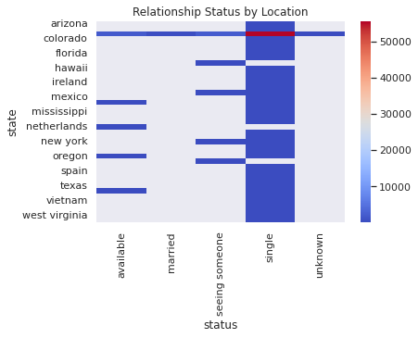

**Lead Statement:**

We have also created another graph on the relationship status based on age

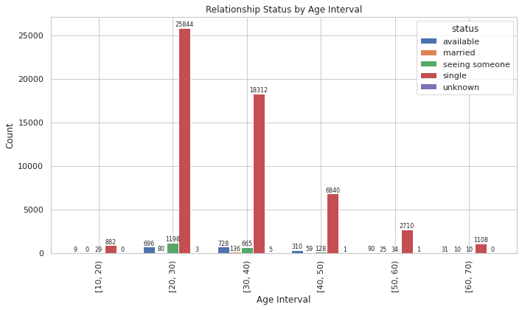

**“It's pretty clear from the above graph that we can guess if someone's single or not at various ages, especially from 20 to 30 years old!”**