
ASSESSMENT 1: PLANNING, REQUIREMENTS AND FEASIBILITY

Student Accommodation Management System
Subject code | ITC327W
Group name | TechWizards
Document | Initial Software Requirements Specification
Due date | 26 August 2026

GROUP MEMBERS
Name | Student number
Michell Kgatuke | 222029835
Polite Mashele | 224120975
Thato Malepe | 223015611
Salga Chauke | 223032277
Kananelo Mafohla | 223038263
Elelwani Manala | 222057458
Nxalati Mongwe | 222072446

Project Title
Student Accommodation Management System — a prototype platform consisting of a Flutter mobile application for students, an ASP.NET web application for landlords, and a shared Supabase backend.

Problem Statement
Student accommodation is currently managed through untrusted and fragmented channels such as WhatsApp, Facebook, telephone calls, paper records and spreadsheets. These methods make it difficult for landlords to keep accommodation listings, student enquiries, student information and maintenance requests organised in one place.
The problem affects both landlords and students. Landlords may lose track of enquiries and important documents including lease agreements, while students may experience delays when searching for available accommodation or submitting requests, and may be scammed by fake landlords. The lack of a centralised system results in lost information, duplicated communication, delayed responses and inefficient accommodation management.
An integrated digital solution is therefore needed to centralise accommodation information, student applications and maintenance requests, and to improve communication between landlords and students.

Purpose, Aim and Objectives

Purpose
The purpose of the prototype is to improve how student accommodation is advertised, managed and communicated. Students will be able to view accommodation, submit enquiries or applications and track application statuses. Landlords will be able to manage listings, approve or reject applications and send important announcements.

Aim
Develop a prototype that improves student accommodation management and communication between students and landlords.

Objectives
- Provide centralised accommodation listings.
- Allow students to search, filter and view available rooms.
- Support accommodation applications and enquiries.
- Allow students to track their application and request status.
- Allow landlords to manage listings, applications and maintenance requests.
- Centralise all accommodation data in a single shared database.

Project Scope
Scope element | Group response
Project aim | Develop a prototype that improves student accommodation management and communication between students and landlords.
Main objectives | - Provide accommodation listings  - Allow students to search and view rooms  - Support applications and enquiries  - Track application status  - Allow landlords to manage listings and requests  - Centralise data
In scope | - Student registration and login  - Accommodation listing management  - Applications and enquiries  - Maintenance request reporting and status tracking  - Shared Supabase database
Out of scope | - Online rental payments  - Advanced accounting  - Automated lease generation  - GPS tracking and external property-portal integration

Deliverables and Acceptance Criteria

Deliverables
Category | Deliverables
Project management | - Business case  - Stakeholder profile  - Scope statement  - Project schedule  - Status report  - Final project presentation  - Final project report  - Lessons-learned report
Product related | - Initial SRS and stakeholder evidence  - Current-process diagram and UML design  - Flutter mobile prototype  - ASP.NET web prototype  - Supabase backend  - Testing evidence and final documentation

Acceptance Criteria

ID | Criterion
AC1 | Students can register and log in, view accommodation, submit applications or enquiries, and track application status.
AC2 | Landlords can add, edit and remove listings, view applications and update maintenance requests.
AC3 | Data is stored in and retrieved successfully from the shared Supabase backend.
AC4 | Only authorised users can access protected system functions.
AC5 | The prototype is demonstrated end-to-end across the Flutter and ASP.NET applications.

Exclusions, Constraints and Assumptions
Category | Detail
Exclusions | - Online rental payments  - Advanced accounting features  - Automated lease generation  - GPS tracking  - External property-portal integration
Constraints | - Limited project time and resources  - Varying team skill levels  - Dependency on internet connectivity  - Obligation to protect stakeholder information
Assumptions | - Users have suitable devices and internet access  - Landlords provide accurate listing information  - The prototype uses test data rather than confidential tenant records  - Stakeholders remain available for feedback during the project

Definitions and Abbreviations

Term / abbreviation | Meaning
SRS | Software Requirements Specification
BMC | Business Model Canvas
Flutter | Framework used to develop the mobile application
ASP.NET | Framework used to develop the web application
Supabase | Shared online backend and database
UI / UX | User Interface / User Experience
CRUD | Create, Read, Update and Delete
Landlord | Person responsible for providing and managing accommodation
Tenant | Student or person occupying accommodation
Accommodation listing | Information describing an available property or room
Maintenance request | A request submitted to report a problem with accommodation

Stakeholders and User Groups
Stakeholder / user | Role in proposed system
External stakeholder  (Landlord) | Manage properties, rooms, listings, applications and maintenance requests.
Mobile application user  (Student) | Search for accommodation, view details, submit applications or enquiries, track applications and report maintenance problems.
Property manager | Assist landlords with property and tenant management where applicable.
System administrator | Manage user accounts and system information where required.
Development team | Analyse requirements, design, develop, test and demonstrate the prototype.

Current Process and Diagram
The current process involves students providing accommodation information and supporting documents to the landlord through informal channels. The landlord then reviews the documents and responds to the student manually.

Current process steps
- Students search for accommodation.
- Student contacts the landlord via WhatsApp, phone or Facebook Messenger.
- Landlord provides accommodation information.
- Student asks about availability, rent and facilities.
- Landlord invites the student to view the accommodation.

- Landlord reviews and manages the application.
- Landlord contacts the student about the application on WhatsApp.

Figure 1 — Current (as-is) process flow
STEP 1
Students search for accommodation.
STEP 2
Student contacts the landlord via WhatsApp,
phone or Facebook Messenger.
STEP 3
Landlord provides accommodation information.
STEP 4
Student asks about availability, rent and
facilities.
STEP 5
Landlord invites the student to view the
accommodation.
STEP 6
Landlord reviews and manages the application.
STEP 7
Landlord contacts the student about the
application on WhatsApp.

Main problems with the current process
- Lost information and misplaced documents.
- Outdated availability of rooms.
- Difficulty tracking maintenance requests.
- Slow responses and no central database.

Product Perspective
The proposed prototype will operate as one integrated system consisting of a Flutter mobile application, an ASP.NET web application and a shared Supabase backend database. The mobile application serves students, the web application serves landlords, and both communicate with the same Supabase database so that accommodation information, applications and maintenance requests remain consistent across the two front-ends.

Main Flutter, ASP.NET and Supabase Functions
Component | Main functions
Flutter mobile application | Register, sign in, view accommodation, search and filter listings, view property details, submit applications and enquiries, report maintenance and view request status.
ASP.NET web application | Landlord login, add / edit / remove accommodation, view student applications, manage maintenance requests and update request statuses.
Supabase backend | Store user accounts, accommodation information, applications, maintenance requests and other required data; provide authentication and shared data access.

Functional Requirements
ID | Requirement
FR1 | Students must be able to create an account through the mobile application.
FR2 | Users must be able to log into the system.
FR3 | Students must be able to view available accommodation.
FR4 | Students must be able to search or filter accommodation listings.
FR5 | Students must be able to view detailed accommodation information.
FR6 | Students must be able to submit an accommodation enquiry or application.
FR7 | Students must be able to submit maintenance requests.
FR8 | Students must be able to view the status of their requests.
FR9 | Landlords must be able to add accommodation listings.
FR10 | Landlords must be able to edit and remove accommodation listings.
FR11 | Landlords must be able to view student applications and enquiries.
FR12 | Landlords must be able to view and update maintenance requests.

Non-Functional Requirements
ID | Requirement
NFR1 | Only authorised users must be able to access protected system functions.
NFR2 | The system must provide clear and understandable error messages.
NFR3 | The system must protect user and accommodation information from unauthorised access.
NFR4 | The interface should be simple and easy for students and landlords to navigate.
NFR5 | The prototype must use test data rather than confidential personal information.
NFR6 | The system should respond to normal requests within a reasonable time when connectivity is available.

System Requirements
ID | Requirement
SR1 | The mobile application must be developed using Flutter.
SR2 | The web application must be developed using ASP.NET.
SR3 | The shared backend and database must use Supabase.
SR4 | The development team must use GitHub for source-code management.
SR5 | The project schedule must be maintained using Microsoft Project.

Integration Requirements
ID | Requirement
IR1 | Accommodation data captured through ASP.NET must be stored in Supabase.
IR2 | Accommodation information stored in Supabase must be available to the Flutter application.
IR3 | Applications submitted through Flutter must be stored in Supabase.
IR4 | Applications stored in Supabase must be accessible to authorised landlords through ASP.NET.
IR5 | Maintenance requests submitted through Flutter must be stored in Supabase.
IR6 | Maintenance status updates made by landlords must be available to the relevant student.

Requirements Prioritisation

ID | Requirement | Type | Priority | Related stakeholder need
FR1 | Students create accounts | Functional | Must Have | Identify and manage students
FR2 | Users log in | Functional | Must Have | Secure access
FR3 | Students view accommodation | Functional | Must Have | Find available accommodation
FR4 | Students search / filter listings | Functional | Should  Have | Find suitable accommodation
FR6 | Students submit applications | Functional | Must Have | Simplify accommodation enquiries
FR7 | Students report maintenance | Functional | Must Have | Improve maintenance reporting
FR8 | Students view request status | Functional | Should  Have | Improve communication
FR9 | Landlords add listings | Functional | Must Have | Manage available accommodation
FR10 | Landlords edit / remove listings | Functional | Must Have | Keep listings updated
FR11 | Landlords view applications | Functional | Must Have | Manage student enquiries
NFR1 | Only authorised users access protected functions | Non-functional | Must Have | Protect information
NFR4 | Interface should be easy to use | Non-functional | Must Have | Improve user experience
SR1 | Use Flutter | System | Must Have | Required technology
SR2 | Use ASP.NET | System | Must Have | Required technology
SR3 | Use Supabase | System | Must Have | Shared backend / database
IR1 | Accommodation data stored in  Supabase | Integration | Must Have | Centralise information
IR3 | Applications stored in Supabase | Integration | Must Have | Allow landlords to access applications

Requirements Change log
Requirement ID | Original requirement | Change made | Reason for change
FR8 | Students must be able to view the status of their requests. | Clarified: Students will be able to view simple status values such as Pending, In Progress and Resolved. | Simplifies implementation while still meeting the stakeholder need for request tracking.
FR12 | Landlords must be able to view and update maintenance requests. | Simplified: Landlords will update maintenance requests using predefined status values rather than advanced workflow management. | Reduces development complexity and makes the function achievable within the available project time.
NFR3 | The system must protect user and accommodation information from unauthorised access. | Updated: Access to protected information will use authenticated users and appropriate Supabase access controls. | Security was identified as important because the system stores user and accommodation information.
NFR5 | The prototype must use test data rather than confidential personal information. | Retained and strengthened: Only test or non-confidential demonstration data will be used during development and testing | Reduces privacy and data-security risks during prototype development.
NFR6 | The system should respond to normal requests within a reasonable time when connectivity is available. | Clarified: Performance depends on internet connectivity and the availability of Supabase services. | The feasibility study identified internet connectivity as a project constraint.
FR4 | Students must be able to search or filter accommodation listings. | Simplified: Basic filtering will be provided using available listing information such as location, price or availability. | Advanced search functionality would require additional development and testing.

.

Project Success Criteria
- Students and landlords can successfully register and log into the system.
- Students can search and find available accommodation.
- Students can view room details, pricing and facilities.
- Students can submit and track accommodation applications.
- Landlords can create and manage accommodation listings.
- Landlords can approve or reject applications.
- Landlords can send announcements and allocate rooms to students.
- User information is securely stored and managed.
- The system reduces reliance on manual accommodation management.
- The final system meets the agreed requirements within the available time and resources.

Feasibility Study
The proposed Student Accommodation Management System is intended to provide students, landlords and administrators with a centralized digital platform consisting of a web and mobile application.
The system will allow students to apply for an accommodation, submit supporting documents and track the progress of their applications. Administrators and landlords will be able to manage accommodation information, review applications and manage relevant student information.
The proposed system will use Flutter for the student mobile application, ASP.NET for the web-based administration and application management functionality. Supabase will be used for authentication, data storage and access control. PostgreSQL will be used as the relation database and the Row Level Security (RSL) implemented to restrict access to data according to user roles and permissions.
1. Technical Feasibility
The group has access to the primary technologies and development tools required to develop the system prototype, including Flutter, ASP.NET, Supabase and PostgreSQL.
Flutter will be used to develop the student mobile application interface, while ASP.NET will provide a web-based functional interface for both the administrators and landlord to manage and review accommodation applications. Supabase will support authentication, data storage and access control, while PostgreSQL will provide the relational database functionality. Row Level Security can be implemented to restrict access to records according to authenticated users and their assigned roles. The Model-View-ViewModel (MVVM) architecture can also be used to organise application logic and improve maintainability.
The project requires computers capable Flutter, Visual Studio and Android Studio, together with a stable internet connection. GitHub will be utilized for version control and collaborative development, while Supabase will provide the required backend services. These requirements are suitable for developing and testing the proposed prototype without requiring additional specialised hardware.
The key technical challenges are secure document uploading and storage. File handling may differ for mobile and web environments, which can create compatibility and integration challenges. Additional technical integration for the Google Maps functionality and events and announcement features. Google Maps integration will allow student to view the exact location of the accommodation, while the events and announcements will enable administrators and landlords to create and publish relevant information that can be viewed by students through the application. The group needs to allocate sufficient time for integration and testing.
Technical feasibility is feasible with changes, focusing on the document storage, database policies, cross-platform testing.

2. Operational Feasibility
The system directly addresses an existing operational problem where students search for accommodations on social media and communicate with landlords through WhatsApp. Students will be able to register, complete application form, upload supporting documents and view application status. Administrators will be able to view applications, applicant provided information and review applications.
The system can reduce manual application processing and make applications to follow-up applications. The role management ensures that students and administrators receive functionality based on the interface and responsibilities.
A potential operational challenge can be user adoption. Students, administrator and landlord will need to understand how the system work. The interface should therefore provide clear navigation and simple application processes. The group should demonstrate the prototype to the stakeholder and collect feedback before completion. The feedback should be used to identify usability problems and improve the interface.
The project is operational feasible with changes, provided that the stakeholder feedback is incorporated and the interface remains user-friendly.

3. Economic Feasibility
The main resources required include existing computers, internet access, development software and the technical skills of the group members. Flutter, ASP.NET and GitHub provide suitable development and collaboration capabilities without requiring any initial software expenditure. Supabse can provide services and functions required for the prototype, however the system can require additional cost if it is deployed at a larger scale to increase storage capacity for hosing, maintenance and technical support.
The system may provide economic benefits by reducing manual required work such as automated lease generation, GPS tracking and improve the efficiency of application management.
The project is economically feasible for the prototype because it uses accessible development technologies and avoids expensive functionality.

4. Schedule Feasibility
The group has identified approximately 20 major functions that need to be completed for the proposed system, The project can be completed within the available development time, if controlled and activities prioritised.
The main schedule risks to address are integration, debugging and testing, where multiple technologies must communicate with each other. Additional may also be required for authentication, database configuration, document uploading and cross-platform testing.
The group should prioritise the core system functionality before implementing secondary features, so therefore regular reviews should be conducted to identify early delays. Core requirements such as login, accommodation viewing, applications, Flutter, ASP.NET and Supabase must be developed first.
The project is schedule feasible with scope management.

5. Legal Feasibility
The system will process personal student information in accordance with the POPIA and relevant privacy principles. It will handle information associated with students, landlords, applications and accommodation which creates the privacy and information-security responsibilities.
Users should be accessible to information necessary for their role and responsibilities. Students should primarily have access to their own profile and application information, while administrators and landlords will only access information that they are authorised to view.
Supabase Row Level Security (RLS) should be configured to restrict access to database records and supporting documents will be stored securely rather than being publicly accessible without appropriate authorisation.
The project is therefore legally feasible with changes, in privacy and information-handling requirements to be considered.

6. Ethical Feasibility
The stakeholder required that only authorised users may access protected system functions. The administrator and landlord will have more access than students. The project serves the purpose of providing students with application to apply to safe accommodation and system that will treat applicants rather than irrelevant personal characteristics.
The group will ensure that application information is used for the intended purpose and decisions regarding applications should be based on legitimate selection criteria rather than personal characteristics.
The system should provide accurate information concerning application status and not mislead students to whether an application has been submitted, approved, rejected or is still under review. The project is ethically feasible, providing privacy, transparency and authentication and access-control practices.

Overall Feasibility Decision
Overall decision: FEASIBLE WITH CHANGES.
The Student Accommodation Management is feasible because the group has access to the required technology, resources and development skills to develop Flutter, ASP.NET and Supabase functions. The project addresses a clearly identified stakeholder problem, and the major risks can be managed throughout the management. The main focus should be on Must Have requirements and avoid adding more features that are outside the project scope.
However, successful implementation depends on addressing several technical, operational and security considerations. The final prototype should be considered successful when students and landlords can use the centralised system efficiently.
The main required changes are:
- Improve and test Supabase authentication and role-based access.
- Test and configure Row Level Security policies.
- Implement secure document uploading and storage.
- Testing functionalities on all intended platforms.
- Protecting student personal information in accordance with POPIA and privacy.
- Maintaining scope control of the project.
- Obtaining feedback from stakeholder before completing.
- Prioritise core functions before secondary features.
- Conduct sufficient functional, integration and usability testing.

Project Risk Register.

Risk ID | Risk Statement | Category | Likelihood | Impact | Score | Level | Mitigation | Contingency | Owner | Risk Current Status
R01 | Limited knowledge in Supabase may result in integration delays or implementation error, which could affect the schedule. | Technical | 3 | 3 | 9 | High | Conduct early integration testing and share Supabase knowledge among group members. | Reassign technical tasks and reduce non-essential functionality if required. | Salga | Open
R02 | Delayed stakeholder feedback may result in delay requirements confirmation and system development | Operational | 2 | 2 | 4 | Medium | Agree on feedback date with the stakeholder at the start of the development stage. | Request for written feedback and proceed with confirmed requirements | Michelle | Closed
R03 | Many major functions may result in scope expansion and short period of time for development and testing. | Schedule | 2 | 3 | 6 | Medium | Prioritise important and required function to complete first against the agreed project scope. | Defer non-essential functions and focus on the minimum viable system. | Elelwani & Nxalati | Monitoring
R04 | Incorrect Row Level Security may prevent authorised users from accessing required records or may expose information to unauthorised users. | Technical/ Legal | 3 | 3 | 9 | High | Testing the Select, Insert, Update functions using separate accounts | Temporarily reduce functions to verified secured operations, while correcting. | Group Members | Monitoring
R05 | Document uploading may fail because of file-handling differences in mobile and web file which prevent students from submitting required documents. | Technical | 2 | 3 | 6 | Medium | Test document selection and Supabase storage across all platforms. | Provide a controlled alternative upload method or temporarily limit supported file types until the issue is resolved. | Polite & Kananelo | Open & Monitoring
R06 | Dependence on Google Maps services may result in map functionality becoming unavailable or incurring unexpected usage costs. | Technical/ Economic | 2 | 3 | 6 | Medium | Configure API restriction, monitor usage and test map functionality during development. | Display the accommodation address and coordinates as an alternative solution if the map service is unavailable. | Thato | Open
R07 | Poor GitHub version-control practices may result in loss of code, conflicting changes and adoption of environment. | Technical | 3 | 3 | 9 | High | Use a shared repository, separate branches commit changes through development of changes and review changes before merging. | Revert the affected commit or merge to the last stable version, resolve conflicting changes through the pull request. | Thato & Group Members | Monitoring
R08 | Insufficient user testing may result usability problems being identified late in the development process. | Operational | 2 | 2 | 4 | Medium | Conduct student and administrator testing before final submission | Conduct and prioritise important usability functions | Group Members | Open
R09 | Incorrect calendar information may result in students receiving inaccurate dates for accommodation events, application deadlines or announcements | Operational | 2 | 3 | 6 | Medium | Allow authorised administrators and landlords to manage and verify calendar information before publishing. | Remove or correct inaccurate calendar entries and notify affected users of the updated information. | Nxalati & Group Members | Open

Refined Project Scope

Function | Decision | Reason | Stakeholder informed?
Student registration and login | Required so students can securely access the mobile application and use the system. | Keep | Yes
Accommodation listing management | This is a core function because landlords need to add, edit and remove available accommodation. | Keep | Yes
Application status tracking | Allows students to see the progress of their applications and improves communication between students and landlords. | Keep | Yes
Accommodation applications and inquiries | This addresses the current problem of applications and enquiries being handled through informal channels such as WhatsApp and phone calls. | Keep | Yes
External property-portal integration | Integration with third-party platforms would add unnecessary technical dependency and complexity. | Remove | Yes
Automated lease generation | Generating legally valid lease agreements would increase complexity and can be added as a future enhancement. | Postpone | Yes
Online rental payments | Payment processing requires additional security, financial integration and testing and is not necessary. | Remove | Yes
GPS tracking | It is unnecessary for the core stakeholder problem and would require additional mobile permissions and development effort. | Postpone | Yes
Landlord announcements | Keep basic text announcements only. Advanced notifications or messaging features would increase development complexity. | Simplify | Yes
Room allocation | Allow landlords to record a room allocation only. Do not implement advanced room-allocation automation. | Simplify | Yes

Highest project risk
Highest risk | Why is this important | What must the group do now
1.R01- Limited knowledge of Supabase. | Supabase is an important part of the system because it controls and supports services of the database. Limited knowledge may cause integration errors and possible delays of the project schedule. | Implement early integration testing of the functions and share Supabase functions and technical knowledge among the group.
2.R04- Incorrect Row Level Security configuration. | Incorrect RLS configuration could prevent authorised users from accessing important records and possibly expose accommodation student personal information to unauthorised users. | Test the RLS functions using separate student, administrator and landlord accounts. In completing the dependent features, verify SELECT, INSERT, UPDATE and DELETE permissions.
3.R07- GitHub version-control practices. | Poor GitHub version practice may lead to loss of code and conflicting being merged into the main project, which could affect the development schedule of the system and stability. | Use separate branches for individual commit with clear description and use pull request to review and test changes before merge.

Appendices — Stakeholder Evidence
The following appendices contain the supporting evidence collected from stakeholders during requirements elicitation. Each appendix is attached to the submitted evidence pack.
Appendix | Evidence | Source / stakeholder | Status
Appendix A | Stakeholder interview questions | Landlord and students | Attached
Appendix B | Questionnaire | TechWizards and landlord | Attached
Appendix C | Evidence of stakeholder engagement (correspondence and emails) | Landlord | Attached
Appendix D | Stakeholder confirmation of findings | Landlord | Attached
Appendix E | Current process evidence (screenshots and records of existing channels) | Landlord and students | Attached

Screenshots of Evidence

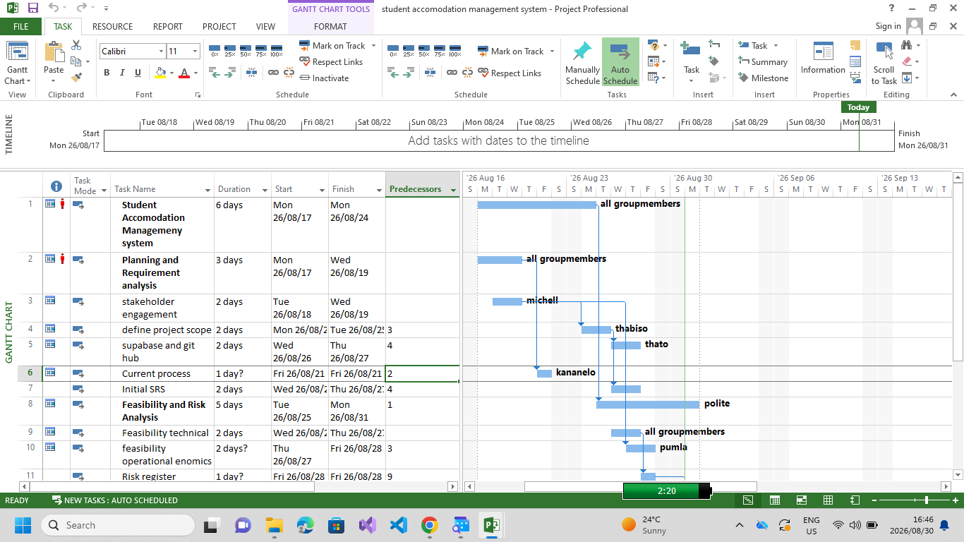

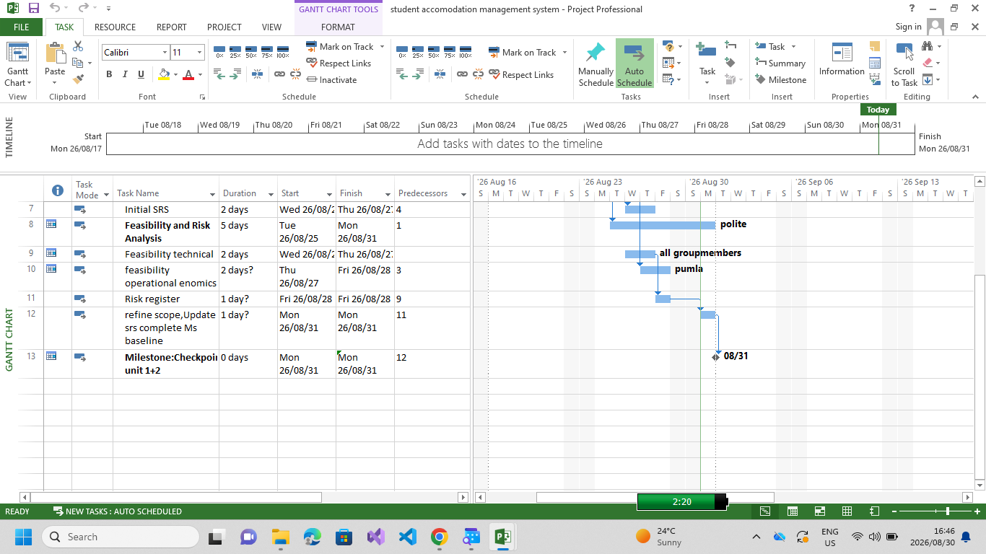
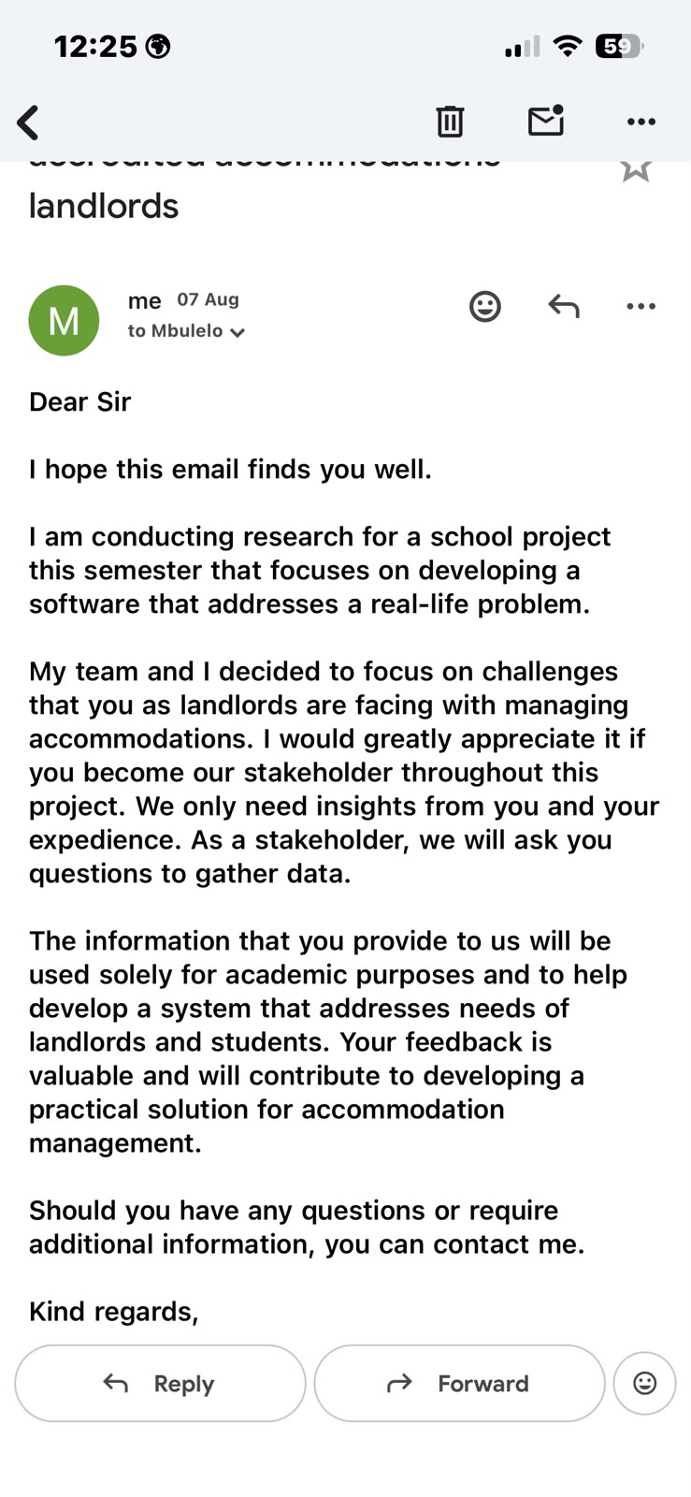

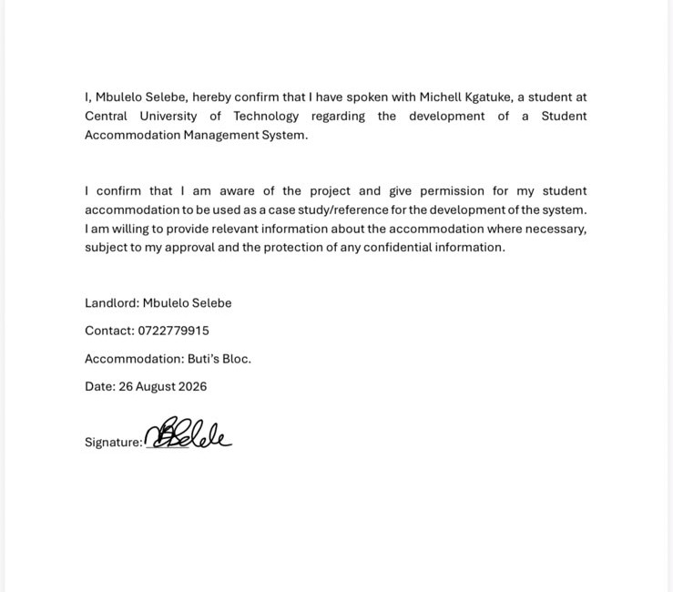

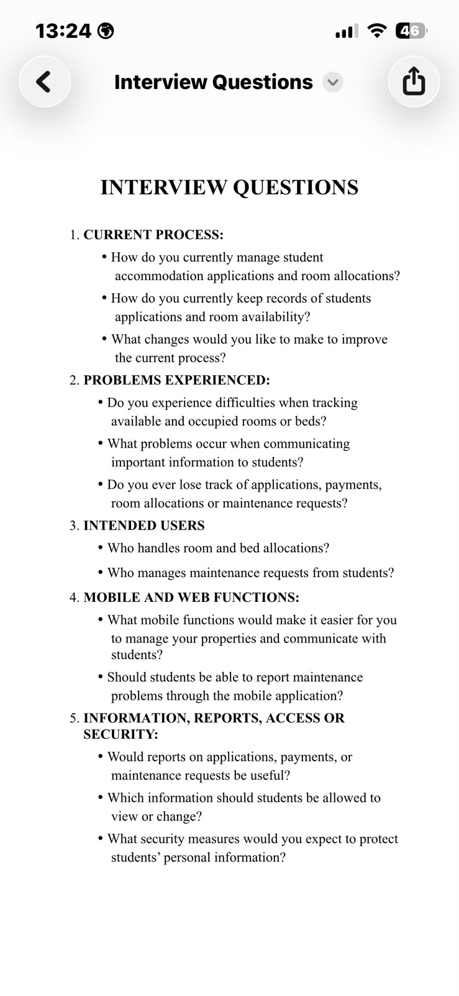

Supabase start-up
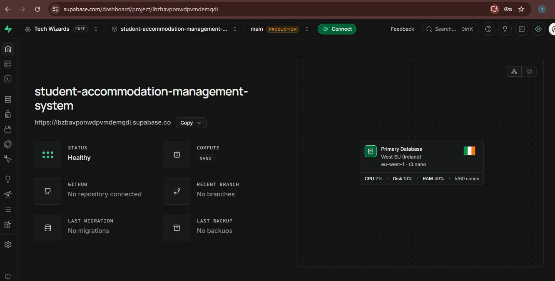

Github link

https://github.com/MalepeMM/student-accommodation-management-system

