|  |  |  |  |  |
| --- | --- | --- | --- | --- |
| |  |  | | --- | --- | | Nations Switch |  | |  |  | |
| *Pave your own journey*  *Travel across the globe, beginning at your current location. Map your journey and gather vital information such as currency, language, geographical location and more*  *Visit Now* |

# User Flow Flyer

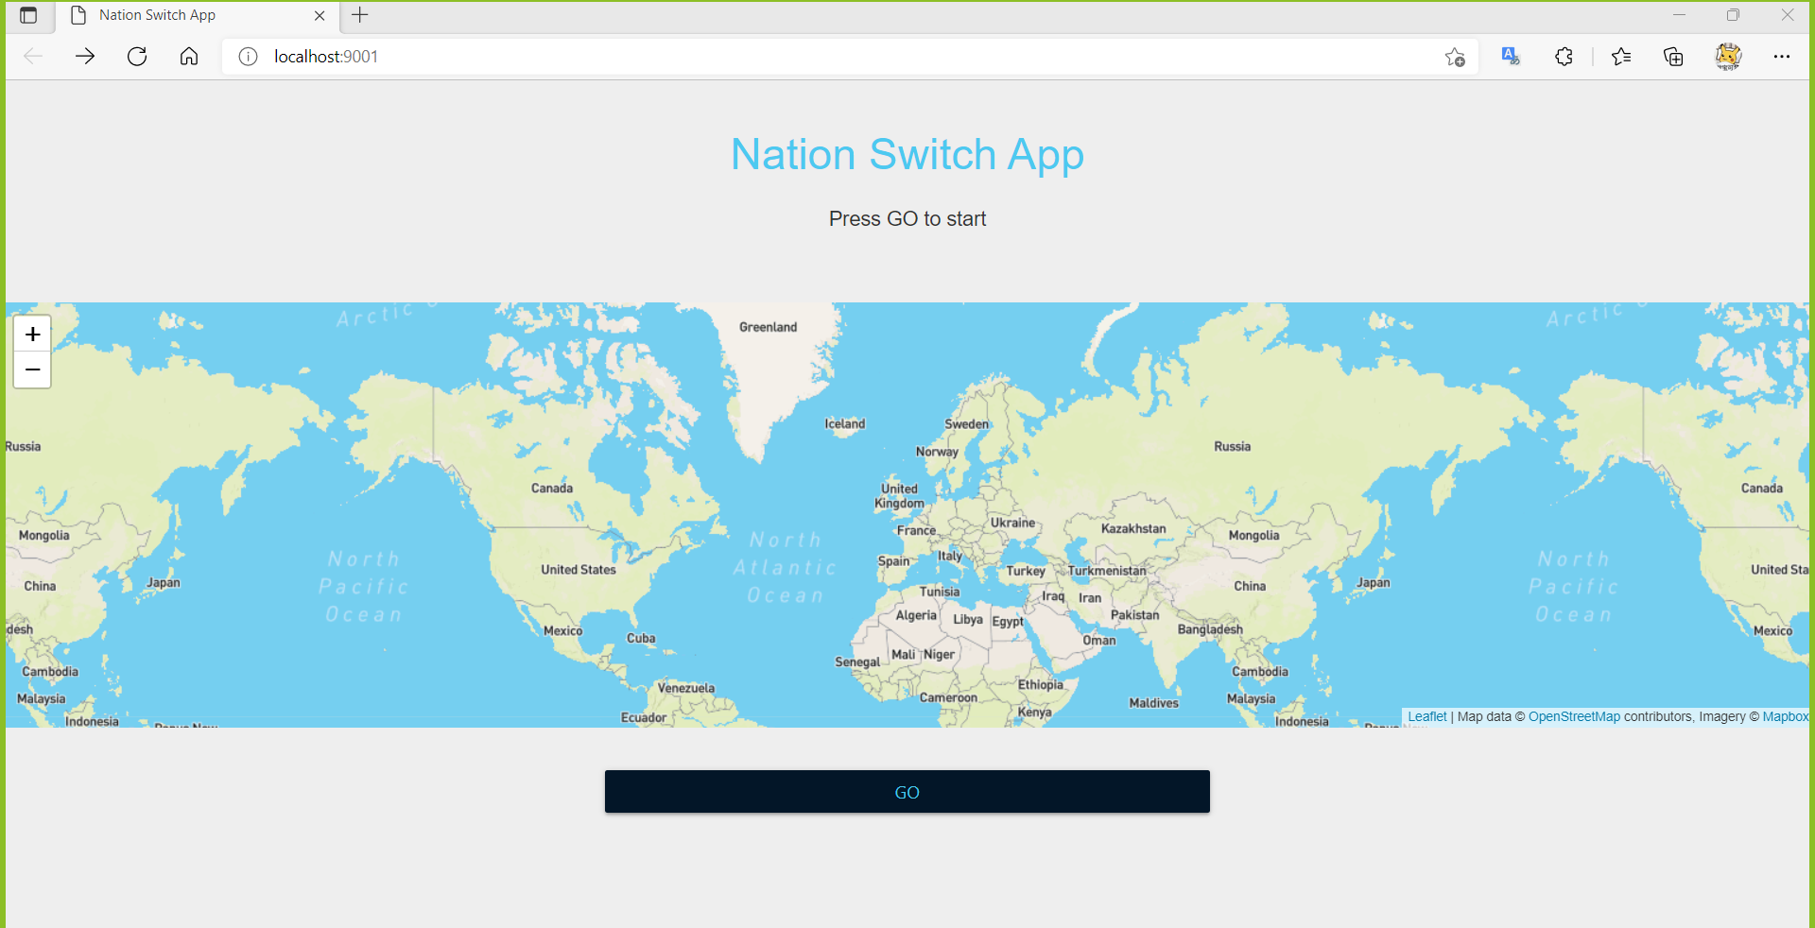

## Main Page

View quick description and map, when ready select GO to proceed with journey  
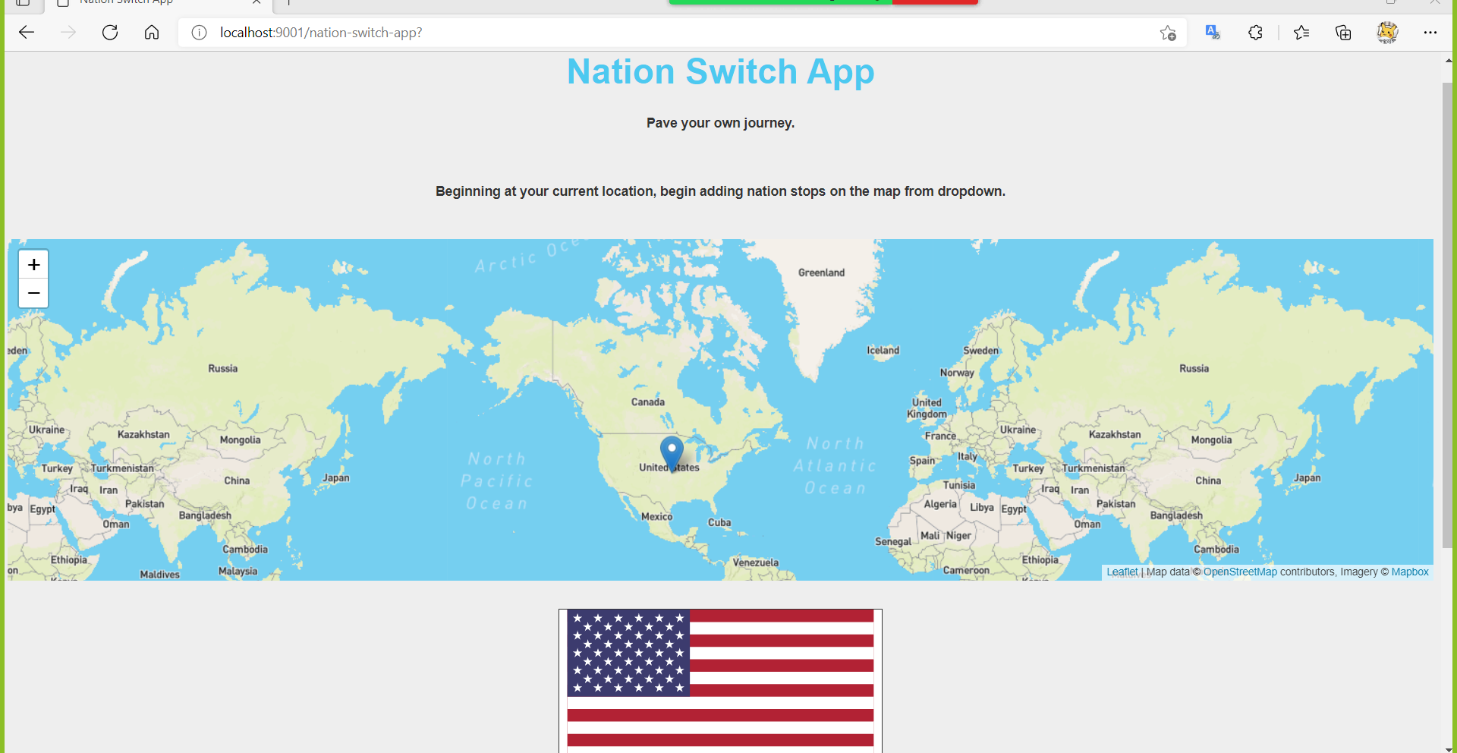

## Travel Page

View your current location on the map before you begin

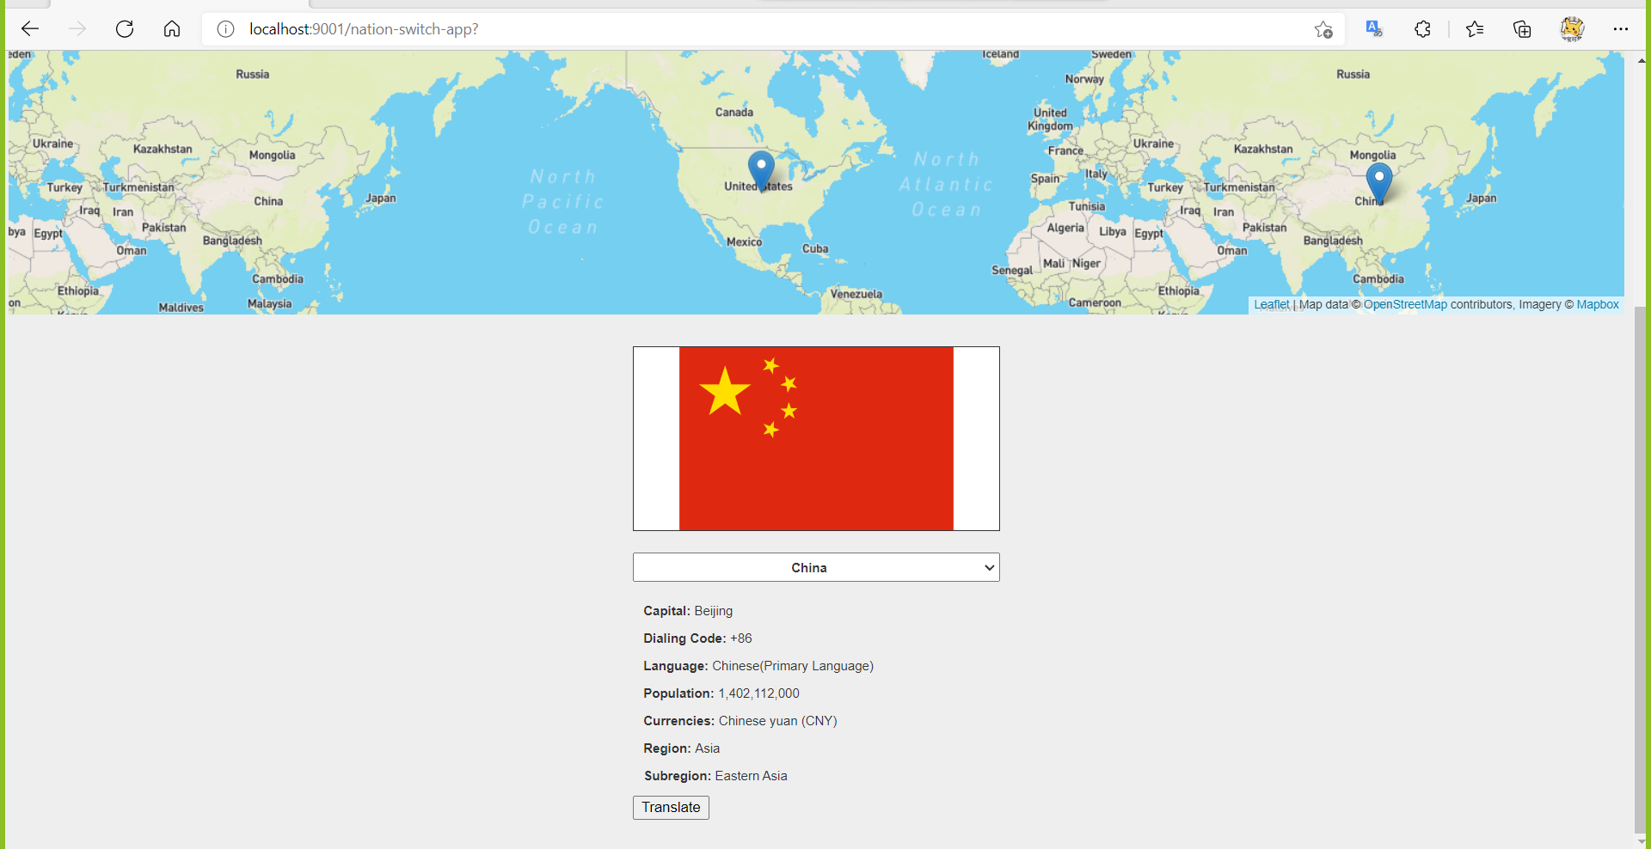

## Add Stops and Translate

Add stops to your trip by selecting a new country from drop down. Select Translate to learn new words of your destination’s native language.