1. Context diagram

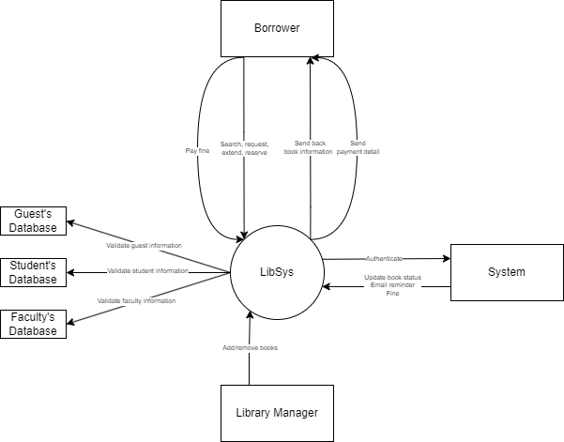

1. Tree diagram

1. Use case table

|  |  |  |
| --- | --- | --- |
| Actor | Use case | Description |
| Borrower | Authenticate | - Using ID card  - Using Login Web/Mobile app  + Change password  + Forget password |
| Search | Borrowers can search the library’s collection database using:  - Title  - Author  - Keywords  - ISBN |
| Borrow | Borrowers with valid ID card and condition can check out book. |
| Return | Borrowers return books. If the book is damaged, the last borrower will be assessed a fine. |
| Request | In case a book is already checked out, user can get notified once the book is available |
| Pay fines | Borrower who violates any rule will have to pay fines, and can either pay via cash or web/mobile app |
| Library Manager | Add books | Add a new book (purchased book) to the collection, updating both database and physically |
| Remove books | Remove a book (damaged book) from the collection, updating both database and physically |
| System | Validate | Validate based on user type:  - Student database (student)  - Personal database (staff, faculty)  - Library database (guest) Using NFC chips |

1. Overall level and detail

Overall level

Authenticate

Search

Borrow

Validate

1. 10 scenarios and 10 use stories

|  |  |
| --- | --- |
| **Use Case ID** | **UC01** |
| **Use Case Name** | Student Searches for a Book Using the Mobile App |
| **Created By** | Ngo Binh |
| **Last Updated By** | Ngo Binh |
| **Date Created** | 24/09/2024 |
| **Date Last Updated** | 24/09/2024 |
| **Actor** | Student |
| **Description** | A student searches for a book by title, author, or genre using the library mobile app. |
| **Preconditions** | The student must have the app installed and be logged in. |
| **Postconditions** | The book search results are displayed on the mobile app. |
| **Priority** | High |
| **Frequency of Use** | Multiple times daily |
| **Normal Course of Events** | 1. Student opens the app. |
|  | 2. Student enters search criteria. |
|  | 3. App displays search results. |
| **Alternative Courses** | None |
| **Exceptions** | No results found for search |
| **Includes** | Search filters, sorting options |
| **Special Requirements** | Stable internet connection |
| **Assumptions** | Book database is up-to-date. |
| **Notes and Issues** | None |

|  |  |
| --- | --- |
| **Use Case ID** | **UC02** |
| **Use Case Name** | Faculty Extends Loan Period Online |
| **Created By** | Ngo Binh |
| **Last Updated By** | Ngo Binh |
| **Date Created** | 24/09/2024 |
| **Date Last Updated** | 24/09/2024 |
| **Actor** | Faculty Member |
| **Description** | A faculty member extends the loan period of a book through the online library portal. |
| **Preconditions** | The faculty member must have an account and an active loan. |
| **Postconditions** | The loan period is successfully extended. |
| **Priority** | Medium |
| **Frequency of Use** | Weekly |
| **Normal Course of Events** | 1. Faculty logs into the portal. |
| 2. Faculty navigates to loaned books. |
| 3. Faculty extends the loan period. |
| **Alternative Courses** | None |
| **Exceptions** | Loan extension not available due to book being on hold by another user. |
| **Includes** | Notification of successful extension |
| **Special Requirements** | System updates loan database in real-time |
| **Assumptions** | Faculty member is eligible for extension. |
| **Notes and Issues** | None |

|  |  |
| --- | --- |
| **Use Case ID** | **UC03** |
| **Use Case Name** | Guest Reserves an Available Book for Pick-up |
| **Created By** | Ngo Binh |
| **Last Updated By** | Ngo Binh |
| **Date Created** | 24/09/2024 |
| **Date Last Updated** | 24/09/2024 |
| **Actor** | Guest |
| **Description** | A guest reserves an available book for pick-up at the library. |
| **Preconditions** | The guest must have a valid account with reservation privileges. |
| **Postconditions** | The book is reserved and a notification is sent for pick-up. |
| **Priority** | Medium |
| **Frequency of Use** | Daily |
| **Normal Course of Events** | 1. Guest searches for available books. |
| 2. Guest selects a book and reserves it. |
| 3. Guest receives a reservation confirmation. |
| **Alternative Courses** | None |
| **Exceptions** | Book is no longer available by the time of reservation. |
| **Includes** | Confirmation email, reservation system |
| **Special Requirements** | None |
| **Assumptions** | Reservation system works in real-time. |
| **Notes and Issues** | None |

|  |  |
| --- | --- |
| **Use Case ID** | **UC04** |
| **Use Case Name** | Student Pays Overdue Fine Using Smartphone |
| **Created By** | Ngo Binh |
| **Last Updated By** | Ngo Binh |
| **Date Created** | 24/09/2024 |
| **Date Last Updated** | 24/09/2024 |
| **Actor** | Student |
| **Description** | A student pays an overdue fine using the library mobile app. |
| **Preconditions** | The student must have the app installed, be logged in, and have a payment method set up. |
| **Postconditions** | The overdue fine is paid and the payment is confirmed. |
| **Priority** | High |
| **Frequency of Use** | Rare |
| **Normal Course of Events** | 1. Student logs into the app. |
| 2. Student navigates to fines section. |
| 3. Student pays the fine. |
| 4. App confirms successful payment. |
| **Alternative Courses** | Payment by alternative methods (e.g., at the library). |
| **Exceptions** | Payment method fails. |
| **Includes** | Payment gateway integration |
| **Special Requirements** | Secure connection for payment |
| **Assumptions** | Student has sufficient funds. |
| **Notes and Issues** | None |

|  |  |
| --- | --- |
| **Use Case ID** | **UC05** |
| **Use Case Name** | Borrower Requests Drone Delivery for a Book |
| **Created By** | Ngo Binh |
| **Last Updated By** | Ngo Binh |
| **Date Created** | 24/09/2024 |
| **Date Last Updated** | 24/09/2024 |
| **Actor** | Borrower |
| **Description** | A borrower requests drone delivery for a selected book. |
| **Preconditions** | Borrower must have an active account and book reservation. |
| **Postconditions** | Book is delivered by drone to the borrower. |
| **Priority** | Low |
| **Frequency of Use** | Occasional |
| **Normal Course of Events** | 1. Borrower selects a book. |
| 2. Borrower requests drone delivery. |
| 3. Borrower receives confirmation. |
| **Alternative Courses** | Pick-up option available at the library. |
| **Exceptions** | Weather prevents drone delivery. |
| **Includes** | Drone delivery system |
| **Special Requirements** | Stable weather conditions |
| **Assumptions** | Drone delivery is supported in the borrower's area. |
| **Notes and Issues** | None |

|  |  |
| --- | --- |
| **Use Case ID** | **UC06** |
| **Use Case Name** | Library Staff Processes Book Return and Assesses Damage |
| **Created By** | Ngo Binh |
| **Last Updated By** | Ngo Binh |
| **Date Created** | 24/09/2024 |
| **Date Last Updated** | 24/09/2024 |
| **Actor** | Library Staff |
| **Description** | Library staff processes the return of a borrowed book and assesses it for any damage. |
| **Preconditions** | A book must be returned by a borrower. |
| **Postconditions** | The book is either returned to the shelf or marked for repair. |
| **Priority** | High |
| **Frequency of Use** | Multiple times daily |
| **Normal Course of Events** | 1. Borrower returns the book. |
| 2. Staff logs the book as returned. |
| 3. Staff assesses the condition of the book. |
| 4. Book is either marked as undamaged or flagged for repair. |
| **Alternative Courses** | Damaged book requires a fine from the borrower. |
| **Exceptions** | None |
| **Includes** | Damage assessment, fine calculation |
| **Special Requirements** | None |
| **Assumptions** | Books are assessed immediately upon return. |
| **Notes and Issues** | None |

|  |  |
| --- | --- |
| **Use Case ID** | **UC07** |
| **Use Case Name** | Library Manager Adds Newly Purchased Book to Collection |
| **Created By** | Ngo Binh |
| **Last Updated By** | Ngo Binh |
| **Date Created** | 24/09/2024 |
| **Date Last Updated** | 24/09/2024 |
| **Actor** | Library Manager |
| **Description** | The library manager adds a newly purchased book to the collection by cataloging and storing it. |
| **Preconditions** | The book must be purchased and delivered to the library. |
| **Postconditions** | The book is available for borrowing in the library system. |
| **Priority** | Medium |
| **Frequency of Use** | Weekly |
| **Normal Course of Events** | 1. Manager receives the new book. |
| 2. Manager enters the book into the catalog system. |
| 3. Manager assigns a location for the book. |
| 4. The book becomes available for borrowing. |
| **Alternative Courses** | None |
| **Exceptions** | Book is delayed in transit or damaged upon arrival. |
| **Includes** | Cataloging, shelving process |
| **Special Requirements** | Integration with library database |
| **Assumptions** | Catalog system is functioning properly. |
| **Notes and Issues** | None |

|  |  |
| --- | --- |
| **Use Case ID** | **UC08** |
| **Use Case Name** | Borrower Receives Email Reminder About Overdue Book |
| **Created By** | Ngo Binh |
| **Last Updated By** | Ngo Binh |
| **Date Created** | 24/09/2024 |
| **Date Last Updated** | 24/09/2024 |
| **Actor** | Borrower |
| **Description** | A borrower receives an automated email reminder about an overdue book. |
| **Preconditions** | The borrower must have an active loan that is overdue. |
| **Postconditions** | Borrower is reminded to return the book or renew the loan. |
| **Priority** | High |
| **Frequency of Use** | Daily |
| **Normal Course of Events** | 1. System detects overdue book. |
| 2. Email reminder is generated. |
| 3. Borrower receives the email. |
| **Alternative Courses** | Borrower chooses to renew the book online. |
| **Exceptions** | Borrower did not receive the email (e.g., incorrect email address). |
| **Includes** | Email system integration |
| **Special Requirements** | System should send reminders automatically |
| **Assumptions** | Borrower’s contact details are correct. |
| **Notes and Issues** | None |

|  |  |
| --- | --- |
| **Use Case ID** | **UC09** |
| **Use Case Name** | Staff Checks Out a Book for Borrower with Invalid ID |
| **Created By** | Ngo Binh |
| **Last Updated By** | Ngo Binh |
| **Date Created** | 24/09/2024 |
| **Date Last Updated** | 24/09/2024 |
| **Actor** | Library Staff, Borrower |
| **Description** | A staff member processes a book checkout for a borrower with an invalid or expired ID. |
| **Preconditions** | The borrower must attempt to borrow a book with an invalid ID. |
| **Postconditions** | The borrower may or may not be able to borrow the book, depending on the staff decision. |
| **Priority** | Low |
| **Frequency of Use** | Occasional |
| **Normal Course of Events** | 1. Borrower attempts to check out a book. |
| 2. Staff notices invalid ID. |
| 3. Staff either allows or denies checkout. |
| **Alternative Courses** | Staff manually verifies borrower’s identity and updates the ID. |
| **Exceptions** | Borrower does not have any other form of ID. |
| **Includes** | Manual ID verification |
| **Special Requirements** | Staff discretion needed |
| **Assumptions** | Library system flags invalid IDs correctly. |
| **Notes and Issues** | Risk of unauthorized borrowing if mismanaged. |

|  |  |
| --- | --- |
| **Use Case ID** | **UC10** |
| **Use Case Name** | Borrower Attempts to Borrow a Book While Having Unpaid Fines |
| **Created By** | Ngo Binh |
| **Last Updated By** | Ngo Binh |
| **Date Created** | 24/09/2024 |
| **Date Last Updated** | 24/09/2024 |
| **Actor** | Borrower |
| **Description** | A borrower attempts to borrow a book but is blocked due to unpaid fines. |
| **Preconditions** | Borrower must have an outstanding fine on their account. |
| **Postconditions** | Borrower is unable to borrow the book until the fine is paid. |
| **Priority** | Medium |
| **Frequency of Use** | Rare |
| **Normal Course of Events** | 1. Borrower selects a book. |
| 2. System checks for unpaid fines. |
| 3. Borrower is blocked from borrowing. |
| 4. Borrower is informed to pay the fine. |
| **Alternative Courses** | Borrower pays the fine immediately and proceeds with borrowing. |
| **Exceptions** | System error does not block the transaction despite the fine. |
| **Includes** | Fine notification system |
| **Special Requirements** | Real-time fine tracking system |
| **Assumptions** | System is up-to-date with unpaid fines. |
| **Notes and Issues** | None |
|  |  |

|  |  |
| --- | --- |
| **User Stories** | **Acceptance Criteria** |
| As a student, I want to search for a book using the mobile app so that I can quickly find the materials I need. | - Enter search criteria by title, author, or genre |
| - View a list of search results |
| - Apply search filters and sorting options |
| - See a thumbnail image of each book |
| As a faculty member, I want to extend the loan period online so that I can keep the book for a longer time. | - Log into the online library portal |
| - View a list of currently loaned books |
| - Select a book to extend the loan period |
| - Receive a confirmation of successful extension |
| As a guest, I want to reserve an available book for pick-up so that I can ensure the book is available. | - Search for available books |
| - Select a book to reserve |
| - Receive a reservation confirmation |
| - Get a notification for pick-up |
| As a student, I want to pay overdue fines using my smartphone so that I can clear my account quickly. | - Log into the library mobile app |
| - View outstanding fines |
| - Select a payment method |
| - Receive a confirmation of successful payment |
| As a borrower, I want to request drone delivery for a book so that I can receive materials without visiting the library. | - Select a book for borrowing |
| - Choose drone delivery option |
| - Receive a delivery confirmation |
| - Track the status of the drone delivery |
| As a library staff member, I want to process book returns and assess damage so that I can maintain quality. | - Log returned books in the system |
| - Assess the condition of each book |
| - Mark books as undamaged or flag for repair |
| - Calculate fines for damaged books if necessary |
| As a library manager, I want to add newly purchased books to the collection so that they become available for borrowing. | - Enter new book details into the catalog system |
| - Assign a location for the book |
| - Make the book visible in the library system for borrowing |
| - Confirm the book is successfully added to the collection |
| As a borrower, I want to receive email reminders about overdue books so that I can return or renew them on time. | - Receive an automated email for overdue books |
| - View details of the overdue items in the email |
| - Have an option to renew the book directly from the email |
| - See information about potential fines |
| As a library staff member, I want to process book checkouts for borrowers with invalid IDs so that I can assist them. | - Identify invalid or expired IDs |
| - Have the option to manually verify borrower's identity |
| - Update borrower's ID information if necessary |
| - Make an informed decision to allow or deny checkout |
| As a borrower, I want to be notified of unpaid fines when attempting to borrow a book so that I can clear my account. | - Receive a notification of unpaid fines when attempting to borrow |
| - View the amount and reason for each fine |
| - Have an option to pay fines immediately |
| - Proceed with borrowing after clearing fines |

1. Activity diagram

Borrowing

Pay fine

Staff borrowing online

Transfer using drone

1. Class and CRC cards

|  |  |
| --- | --- |
| Book | |
| Store book information (ID, ISBN, title) | Author |
| Keep track of its status | BookType |
| Associate with an author and book type | Borrow |

|  |  |
| --- | --- |
| User | |
| Store user information (ID, name, address, email) | Account |
| Manage account status | Borrow |
| Borrow books | Fine |

|  |  |
| --- | --- |
| Library | |
| Manage collection of books | Book |
| Handle book circulation | Librarian |
|  | User |

|  |  |
| --- | --- |
| Librarian | |
| Add new books to the library | Book |
| Remove books from the library | Library |
| Process cash transactions | CashTransaction |

|  |  |
| --- | --- |
| Borrow | |
| Track borrowed books | Book |
| Manage borrowing dates | User |
| Associate books with users | Return |

|  |  |
| --- | --- |
| Fine | |
| Calculate fine amounts | User |
| Associate fines with users | FineTransaction |
|  |  |

|  |  |
| --- | --- |
| Catalog | |
| Maintain list of books | Book |
| Provide search functionality | Search (interface) |
|  |  |

|  |  |
| --- | --- |
| Account | |
| Store account information | User |
| Manage account status |  |
|  |  |

|  |  |
| --- | --- |
| Notification | |
| Create and send notifications | User |
| Store notification details | Fine |
|  |  |

|  |  |
| --- | --- |
| FineTransaction | |
| Process fine payments | Fine |
| Record transaction details | CreditCardTransaction |
|  | CashTransaction |

1. Class diagram

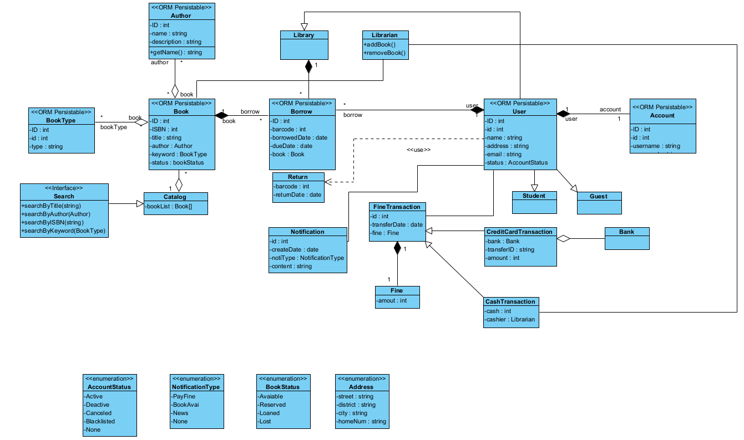

1. Sequence diagram  
   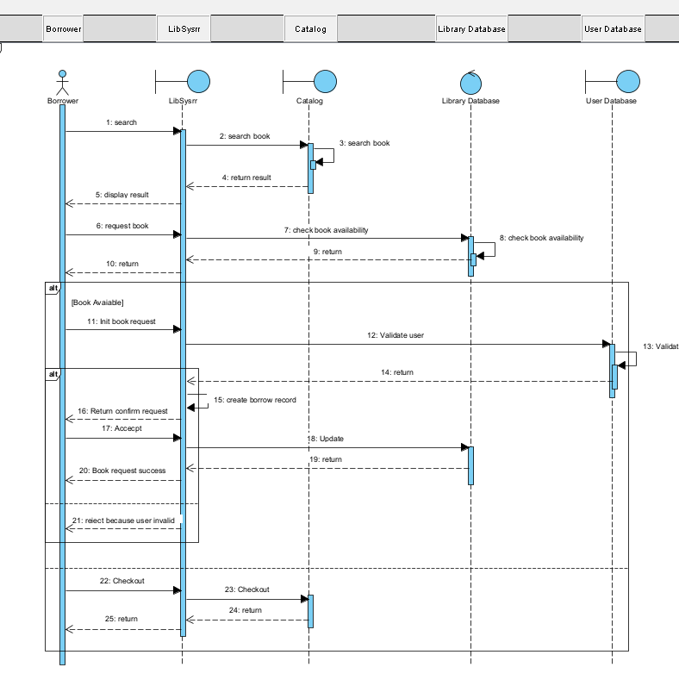
2. Data model  
   A diagram of a computer

   Description automatically generated