1. Customer, Address, Fullname, Account

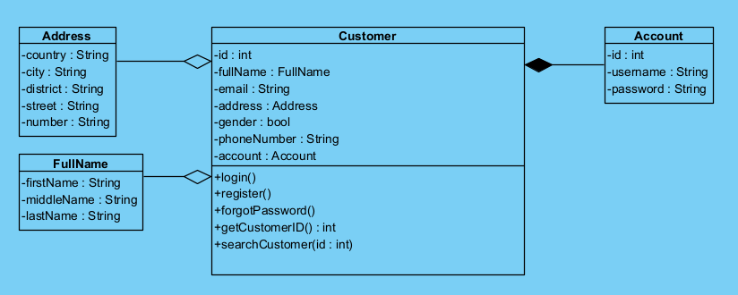

1. Book, Publisher, Author, Category

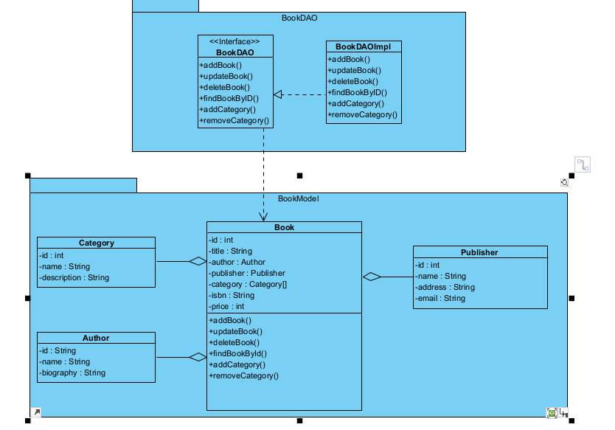

1. Clothes, Producer, Size, Category

1. Laptop, Producer, Type, Hardware

1. MobilePhone, Producer, Type, Hardware
2. Electronic, Supplier, Specification, Type

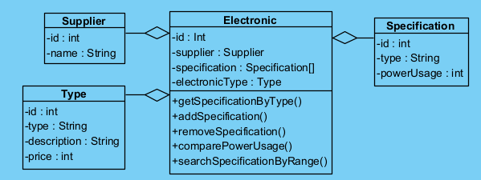

1. Association class: Customer, Cart, Item

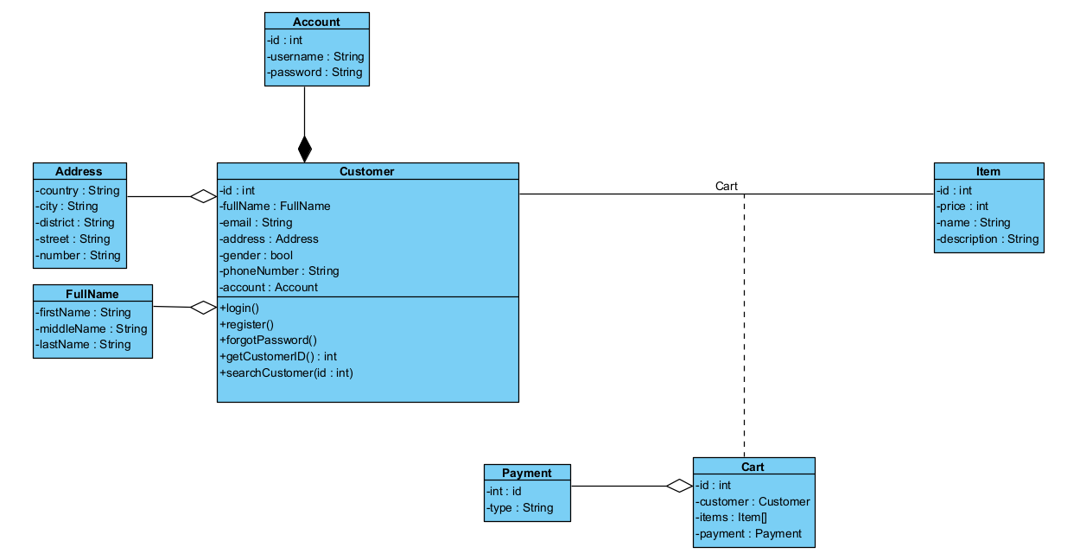

1. Association class: Patient,