**SkyLink Airlines**

Enterprise Systems Architecture

Project Report



Malgorzata Victor (20102772)

Raels Santers (20103026)

Tomás McGrath (20103551)

October, 2025

**Contents**

1.Introduction 3

2.Architecture Vision 3

2.1.Arline Context 3

2.1.1.Global airlines 3

2.1.2.Mixed aircrafts 3

2.1.3.Airport ground services 3

2.1.4.Partner codeshares 3

2.1.5.Real time flight tracking & status updates 3

2.1.6.Passenger reservations & loyalty management 4

2.1.7.Aircraft maintenance & operational analytics 4

2.1.8.Monitoring & incident-response 4

2.1.9.Crew scheduling & airport resource coordination 4

2.2.Strategic Drivers 5

2.2.1. Safety 5

2.2.2. Punctuality 5

2.2.3. Customer experience 5

2.2.4. Cost efficiency 5

2.3.Scope 6

2.4.Guiding Principles 6

3.Information Architecture Package 7

3.1.Data Models 7

3.1.1.Conceptual Data Model 7

3.1.2.Logical Data Model 8

3.1.3.Physical Data Model 9

3.2.Master Data Management Strategy 13

3.3.Metadata Catalog Sample 13

3.3.1.Data lineage for flight telemetry 13

3.3.2.Business Glossary for IATA codes 13

3.4.Business Operating Model 15

3.5.Information System Architecture 15

4.Bibliography 16

# Introduction

We are a software consultant company engaged by SkyLink Airlines to develop layered reference architecture. Airline systems can have many different parts to them. We will start by doing research into the context of airline systems to helps us gain a deeper understanding into the workings of how airline systems operate.

# Architecture Vision

## Arline Context

### Global airlines

Skylink Airline operate flights for people and goods over many countries with different routes around the world making them a global business and needing to comply with laws and regulations for the corresponding countries in which they operate.

### Mixed aircrafts

Skylink operates with a diverse range of different aircrafts used for both passenger and cargo flights to be able to serve different demands across the globe. The airline has flexibility and can choose the right aircraft for the demand of the flight which will result in saving costs.

### Airport ground services

Grounds services deal with loading and unloading and then transport to the necessary party. E.g. suitcases back to conveyor belts where passengers can get them after disembarking. This can be automated with the help of conveyor belts to reduce human handling and increase efficiency. Handled in cooperation between the airline and the airport.

Besides dealing with just cargo, ground services also help with , handling passengers getting on and off alongside cleaning up the plane before take-off. They handle these steps as efficiently as possible so we can take off again as soon as possible.

### Partner codeshares

Airlines can work with other companies and use code shares to sell tickets for flights with different companies. There could be different rates depending on which airline you book with even if it is for the same flight.

### Real time flight tracking & status updates

Flight tracking is important both for keeping your customers informed of when the plane is arriving and making sure things are staying on schedule. Also, the information is shared from the airline to the airports flight control towers to tell them if it is safe to land.

### Passenger reservations & loyalty management

Skylink provides flight booking system for passengers to book flights, check in online or at the airport. A loyalty program is included which allows passengers to earn points which they can redeem 10 Kilometres per Euro spent on SkyLink flights.

### Aircraft maintenance & operational analytics

Maintenance will be carried out by us on the plane on a regular basis to make sure the plane is fit and in good shape so that it can fly without any potential dangers from parts malfunctioning. t is super important to catch these potential issues before they happen as it could lead to loss of life if the plane was not working properly. Analysis can be done during maintenance to see how much fuel got used and optimize to make sure we always have enough when refuelling to reach our next destination.

### Monitoring & incident-response

Monitoring the data of how well the plane is flying is vital as flight controllers can now what is going on and if there is any danger. Live response using the data is important since urgency would be needed in case of an emergency. The data that was collected can be stored in the cloud and can be used for analysis later to see trends overall such as most common times that planes are landing or how many flights can a plane do a day on average. These can be analysed and used to assist in future business decisions for the company.

### Crew scheduling & airport resource coordination

The crew flies the plane and some work as flight attendants. There is a maximum number of hours that a pilot can work on a given day so there needs to be schedules for when another pilot is taking over, to maximise how often flights can take place. The crew also deal with maintenance and checking that the plane is flightworthy and capable of flying without issue and if there is anything that needs to be checked out or dealt with about the plane itself.

## Strategic Drivers

### 2.2.1. Safety

There are strategic important drivers that are important to airline systems. Safety should be maximised as there are lots of people about and large moving vehicles, there is a desire to avoid lots of life or harm as it would lead to lawsuits and bad public reception. Make sure that customers are safe and that planes are safe to land.

### 2.2.2. Punctuality

Punctuality wise the planes should arrive on times as listed. Any potential changes should be reflected real time in the app and on the public display flight schedule. Customers should be able to board as soon as possible after the plane has been cleaned from its previous flight and is ready for take-off.

### 2.2.3. Customer experience

As there are lots of customers it is important to deal with handling them. We are trusted to safely handle people's items. Issues like lost luggage can deeply upset customers. We try to have good customer service to encourage repeat customers by helping them solve their issues if they arise.

### 2.2.4. Cost efficiency

There is a wide variety of different people who go on flights. As a global airline we are prepared to handle a variety of customer Bases. Some of our competition like Ryanair offer cheaper flights. Some customer bases are there for cheaper flights to just get them to their destination, this is fine for shorter flights. As a global airline we also offer longer flights across the globe, so our flights can end up more expensive. For these longer flights we try to optimize comfort for our passengers for the long flight, so they feel relaxed and happy. For potential shorter cheaper flights, we could offer there could be limitations such as leg room or less baggage. We would sell different seats some with more leg room at a more expensive price.

Airlines must constantly optimize fuel consumption, crew scheduling, and airport fees to reduce operational costs. Technology and automation also play a role in lowering expenses, allowing SkyLink to remain competitive while still offering a quality service to customers.

## Scope

With all this context in mind we can set an achievable scope for what we aim to accomplish from keeping track of flights, making sure planes are maintained properly on scheduling and that we treat our customers well and give them a good experience making sure our flights arrive on time and that customers are aware of when they will be able to board.

This scope also ensures that both customer-facing systems and backend operational systems are considered, so improvements benefit both passengers and staff. It will help the airline focus on the most critical aspects first while leaving room for future scalability and integration with new services.

Our scope will incorporate the functional areas of the airline. We handle the tickets for our different flights and different prices for different seats. Up to date information on available seating. We need to keep track of what seats are booked and empty, how many passengers each plane can hold. Do we have enough staff for handling maintenance and handling passengers boarding and their luggage. Do we have legal permissions for the routes we are flying and agreements in place with airports for landing.

## Guiding Principles

We will do our best to satisfy our stake holders by increasing profits with process optimization while at the same time providing customers with a cost-effective flights and positive experience.

These guiding principles will act as a foundation for decision-making whenever trade-offs arise between cost, safety, and customer experience. They will ensure the architecture remains adaptable to change while still aligning with the long-term strategy of the airline.

# Information Architecture Package

## Data Models

### Conceptual Data Model

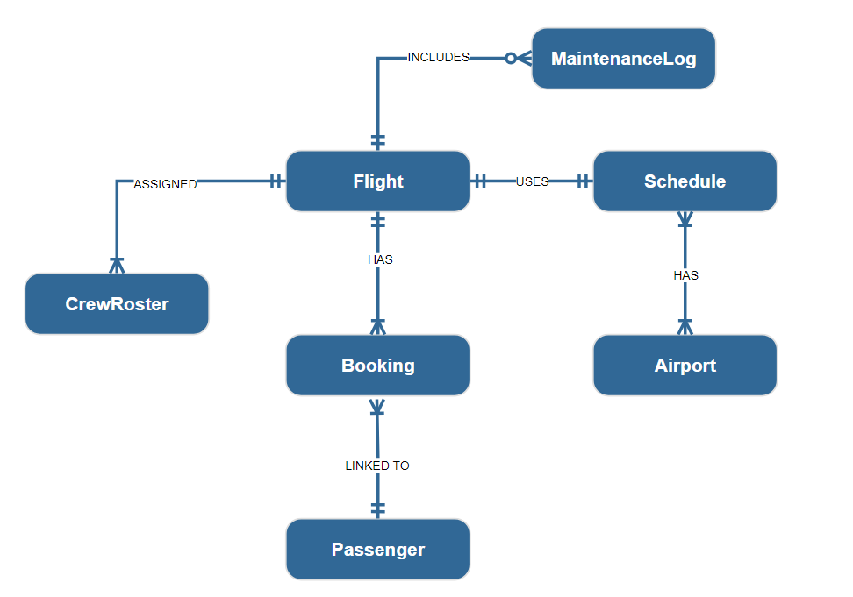 The Conceptual Data Model provides a high-level business view of our Airline Operations System, focusing on the core business entities and their relationships without technical implementation details. This model serves as a communication bridge between business stakeholders and technical teams, capturing the essential concepts of flight operations, passenger services, crew management, and aircraft maintenance that define our airline's operational ecosystem..

**Key** **Entities**:

|  |  |
| --- | --- |
| **Flight** | Central entity representing a scheduled journey between two airports. |
| **Booking** | Records the details of a passenger’s reservation on a specific flight. |
| **Passenger** | Represents individuals who make reservations and travel on flights. |
| **Schedule** | Defines the operational timing of flights (departure, arrival, duration). |
| **Airport** | Represents the location from which flights depart and arrive. |
| **MaintenanceLog** | Records maintenance activities related to flights. |
| **CrewRoster** | Represents crew assignments for a flight. |

**Key Relationships**

|  |  |  |
| --- | --- | --- |
| **Flight - CrewRoster** | Each flight must have multiple crew members  Each roster must belong to one flight | 1:N |
| **Flight - Booking** | A flight must have one or more bookings  Every booking must refer to one flight | 1:N |
| **Flight - Schedule** | Every flight must use exactly one schedule  Each schedule must be used by exactly one flight | 1:1 |
| **Flight - MaintenanceLog** | Some flight may have one or many maintenance logs.  A maintenance log must be included in only one flight | 1:N |
| **Booking - Passenger** | Each booking must be linked to one passenger  Each passenger must make one or more bookings | 1:N |
| **Schedule - Airport** | Schedule must have exactly one departure and one arrival airport  Each airport must be used in one or more schedules | 1:N |

### Logical Data Model

The Logical Data Model serves as the business foundation for our Airline Operations System, defining how core aviation entities interact and ensuring data integrity across flight operations, passenger services, and maintenance tracking. This conceptual blueprint aligns with airline industry standards and regulatory requirements, establishing clear relationships between flights, schedules, aircraft maintenance, and passenger bookings that reflect real-world aviation workflows.

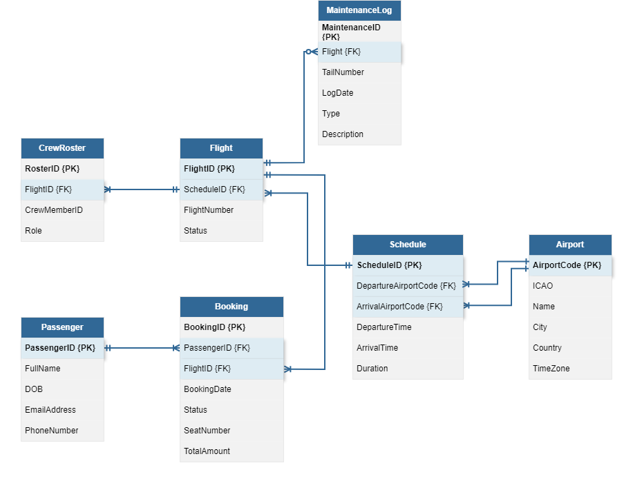

**Normalization Notes**

|  |  |  |
| --- | --- | --- |
| **Flight** | 3NF | ScheduledID FK enforces 1:1 with Schedule |
| **Booking** | 2NF | Stored directly for performance and audit purposes |
| **Passenger** | 3NF | No transitive dependencies |
| **Schedule** | 2NF | Stored for query performance and operational efficiency |
| **Airport** | 3NF | No redundancy |
| **MaintenanceLog** | 2NF | Denormalized for quick access and reporting |
| **CrewRoster** | 3NF | Role is specific to each flight assignment |

### Physical Data Model

The Physical Data Model implements our airline system with performance-optimized structures designed to handle high-volume booking transactions, real-time flight operations, and mandatory maintenance tracking. This implementation includes strategic partitioning for time-sensitive data and comprehensive indexing to support critical airline workflows like passenger bookings, crew scheduling, and aircraft maintenance compliance.

**Table Schemas:**

**Airport:**

|  |  |  |  |  |  |  |
| --- | --- | --- | --- | --- | --- | --- |
| *-- Stores static location and timezone information for all airports in the system.*  CREATE TABLE Airport (  AirportCode VARCHAR(5) PRIMARY KEY,  ICAO VARCHAR(4) NOT NULL UNIQUE,  Name VARCHAR(100) NOT NULL,  City VARCHAR(50) NOT NULL,  Country VARCHAR(50) NOT NULL,  TimeZone VARCHAR(50) NOT NULL  );  **Schedule**   |  | | --- | | *-- Defines the planned timetable for a flight, including departure/arrival times and airports.*  CREATE TABLE Schedule (  ScheduleID INT PRIMARY KEY,  DepartureAirportCode VARCHAR(5) NOT NULL,  ArrivalAirportCode VARCHAR(5) NOT NULL,  DepartureTime TIMESTAMP NOT NULL,  ArrivalTime TIMESTAMP NOT NULL,  Duration INT NOT NULL,  FOREIGN KEY (DepartureAirportCode) REFERENCES Airport(AirportCode),  FOREIGN KEY (ArrivalAirportCode) REFERENCES Airport(AirportCode)  ); |   **Flight**   |  | | --- | | *-- Represents a specific, operational instance of a scheduled journey.*  CREATE TABLE Flight (  FlightID INT PRIMARY KEY,  ScheduleID INT NOT NULL UNIQUE,  FlightNumber VARCHAR(10) NOT NULL,  Status VARCHAR(20) NOT NULL,  FOREIGN KEY (ScheduleID) REFERENCES Schedule(ScheduleID)  ); |   **Passenger**   |  | | --- | | *-- Holds the personal and contact details for all individuals who can make bookings.*  CREATE TABLE Passenger (  PassengerID INT PRIMARY KEY,  FullName VARCHAR(100) NOT NULL,  DOB DATE NOT NULL,  EmailAddress VARCHAR(255),  PhoneNumber VARCHAR(20)  ); |   **Booking**   |  | | --- | | *-- Records a passenger's reservation and payment for a seat on a specific flight.*  CREATE TABLE Booking (  BookingID BIGINT GENERATED ALWAYS AS IDENTITY,  PassengerID INT NOT NULL,  FlightID INT NOT NULL,  BookingDate TIMESTAMP NOT NULL,  Status VARCHAR(20) NOT NULL,  SeatNumber VARCHAR(5),  TotalAmount DECIMAL(10, 2) NOT NULL,  FOREIGN KEY (PassengerID) REFERENCES Passenger(PassengerID),  FOREIGN KEY (FlightID) REFERENCES Flight(FlightID)  ) PARTITION BY RANGE (BookingDate); |   **CrewRoster**   |  | | --- | | *-- Assigns crew members and their roles to a specific flight.*  CREATE TABLE CrewRoster (  RosterID BIGINT PRIMARY KEY,  FlightID INT NOT NULL,  CrewMemberID INT NOT NULL  Role VARCHAR(30) NOT NULL,  FOREIGN KEY (FlightID) REFERENCES Flight(FlightID)  ); |   **MaintenanceLog (Time-Series Fact Table)**   |  | | --- | | *-- Tracks all mandatory maintenance events performed on an aircraft, linked to the flight that necessitated it.*  CREATE TABLE MaintenanceLog (  MaintenanceID BIGINT GENERATED ALWAYS AS IDENTITY,  FlightID INT NOT NULL, *-- Mandatory link to a flight*  TailNumber VARCHAR(20) NOT NULL,  LogDate TIMESTAMP NOT NULL,  Type VARCHAR(50) NOT NULL,  Description TEXT,  FOREIGN KEY (FlightID) REFERENCES Flight(FlightID)  ) PARTITION BY RANGE (LogDate); | |

**Partitioning**

Partitioning is a database technique that splits a large table into smaller, more manageable pieces called partitions, while still treating it as a single table. This dramatically improves performance for queries that access a recent subset of data and simplifies data management operations like archiving old data.

Partition Key: BookingDate / LogDate

Method: Monthly Range Partitioning. This is ideal for time-series telemetry data, making it cheap to drop old records and fast to query recent maintenance history.

**Example Partitions**: maintenance_2024_01, maintenance_2024_02, etc.

|  |
| --- |
| *-- Booking table partitions*  CREATE TABLE booking_2024_01 PARTITION OF Booking  FOR VALUES FROM ('2024-01-01') TO ('2024-02-01');  CREATE TABLE booking_2024_02 PARTITION OF Booking  FOR VALUES FROM ('2024-02-01') TO ('2024-03-01');  *-- MaintenanceLog table partitions*  CREATE TABLE maintenance_2024_01 PARTITION OF MaintenanceLog  FOR VALUES FROM ('2024-01-01') TO ('2024-02-01');  CREATE TABLE maintenance_2024_02 PARTITION OF MaintenanceLog  FOR VALUES FROM ('2024-02-01') TO ('2024-03-01'); |

**Indexing**

An indexing strategy involves creating optimized data structures (indexes) that allow the database to find data without scanning the entire table. A good strategy is crucial for performance but adds overhead on writes; it should be tailored to common query patterns.

**Example Indexes:**

|  |
| --- |
| CREATE INDEX idx_booking_passenger_date ON Booking(PassengerID, BookingDate DESC);  CREATE INDEX idx_booking_flightid ON Booking(FlightID);  CREATE INDEX idx_maintenancelog_tail_date ON MaintenanceLog(TailNumber, LogDate DESC);  CREATE INDEX idx_maintenancelog_flightid ON MaintenanceLog(FlightID);  CREATE INDEX idx_schedule_departure_search ON Schedule(DepartureAirportCode, DepartureTime);  CREATE INDEX idx_crewroster_crew_flight ON CrewRoster(CrewMemberID, FlightID);  CREATE INDEX idx_passenger_email ON Passenger(EmailAddress); |

## Master Data Management Strategy

Skylink uses MDM system to create and maintain golden records for their most important business entities: Aircraft, Airports and loyalty.

**A golden record** is a single, authoritative version of truth and most accurate version of a data entity within and organisation system to ensure accuracy, consistency and reliability across multiple source systems to have the most trusted version of each record used across airline operations.

**Aircraft**: The golden record combines data from maintenance systems, flight operations, manufacturer specs to track each aircrafts maintenance status, registration and configurations.

**Airports**: airport data uses IATA/ICAO registries integrated with Skylinks operational database to standardize names, codes and locations for flight planning and scheduling systems

**Loyalty members**: Customer master database consolidates data from reservations, transactional history and CRM systems combined into one, to ensure accurate point tracking, identity management and personalised experiences.

## Metadata Catalog Sample

The metadata catalog stores key information about the datasets within skylink systems to ensure data transparency and traceability of data across the airline so users can understand and trust the data they use for operations and analytics.

### Data lineage for flight telemetry

Data lineage for flight telemetry describes how telemetry data is generated, transmitted, processed, stored and consumed across Skylinks ecosystem. This data is collected from aircraft sensors ADS-B transponder which is essential for ensuring accurate and traceable information is available for flight monitoring, maintenance and performance analytics

### Business Glossary for IATA codes

Each airport around the world is assigned with a unique code which is used for its quick and accurate identification in flight documentation, crew scheduling and everything related to the air operation.

The business glossary defines the key IATA terms Skylink uses across its airline systems to ensure consistent understanding of these aviation data.

|  |  |  |
| --- | --- | --- |
| **Term** | **Definition** | **Example** |
| **IATA Airport Code** | An IATA code is three-character code assigned by the international air transport association (IATA) to identify an airline or location such as an airport. | DUB - Dublin |
| **ICAO** | A four-letter code assigned by the international civil aviation organisation used in flight operations and air traffic control | EIDW - Dublin |
| **IATA Airline Code** | A two-character code assigned by IATA to identify airlines for commercial purposes such as reservations, timetables, telecommunications, cargo documentation and other stuff | SL – Skylink Airline |
| **PNR** | A passanger name record is a digital document containing the itinerary, passenger details, payment details and contact details for passengers | 1LUV67 |
| **AWB (Air Waybill)** | A unique IATA document and tracking number issued for cargo shipments used to identify and track for air freight | 911 - 12345678 |

**IATA Aiport Code:** Skylink operates global passenger and cargo flights, so every reservation, flight plan and ticket uses IATA’s 3 letter airport code

**ICAO Airport Code:** Skylink’s operations, crew and maintenance systems rely on the more technical ICAO codes for air traffic control.

**IATA airline designator:** As skylink is a global carries they need an IATA 2 letter airline code SL which identifies the airline on flight numbers like SL001

**PNR:** Skylink’s reservation, check-in and loyalty program uses PNR to link passenger bookings and service information.

**AWB:** Skylink’s cargo systems use Air Waybill number to track and manage air freight shipments ensuring accurate handling, custom documentation and visibility of cargo movement.

These codes are essential for Skylinks global passenger and cargo operations. They will ensure consistency and accuracy across all systems used for flight planning, cargo tracking, reservations and regulatory compliance. IATA and ICAO codes allows seamless communication between Skylink, airports and logistics providers.

## Business Operating Model

We use our operating model to show how we create and deliver value to our customers, it incorporates our people, processes and infrastructure. We provide customers with flights to places on our airplanes along with delivering their luggage.. They book seats and other services They book a particular flight and seat via the app. We allow them to book or just be assigned a random seat. Some seats have more leg room than others. Customers can also buy food, drink or other items while on the flight, or they can also book more luggage to bring with them.

As we are a global airline and can travel further distances, food on the flight, helps make sure people don’t get hungry. More legroom and comfort are nice for longer flights to help make customers feel more relaxed. We keep our processes as efficient as possible, in order to maximise time, we are flying. Customers check in at the airport and then we help them onto the plane and store their luggage onto the plane. Depending on the flight we might employ a shuttle bus depending on how far away the plane is from the airport to help customers get on. After the plane lands we help them off and transfer their luggage to the airports onto conveyor belts.

## Information System Architecture

Our information system tracks how information moves between our organization, it can be made up of our hardware, software, processes we use, people we employ and data we gather. Our main hardware is the planes themselves which keep track of lots of data. We also have servers for handling the backend servers and software and managing the ticket prices and bookings. Database for our customers and their information. This data is shared with the airport for when people are checking in. Customers book a flight, we take their information and money and update our systems so that their booking information is stored, and the airport can then access it when checking people in.

Flight attendants let people onto the plane and they sit down, when all are seated the plane takes off. Flight to destination, then landing, passengers disembark and the seats are cleaned and maintenance done to the plane, if necessary, before being ready for the next flight. We can keep track of how many empty seats per flight, what flights are most popular, fuel usage, weight per flight. We can keep passengers and airports updated with how far away we are with our flight data.

Can also see how much weight is on board with luggage and how much more we could potentially fit. Our system keeps track of what crew we have on each flight, and how long it takes them to clean and if more are needed to do things faster.

Our information systems keep our flight schedule updated, along with any delays from unexpected maintenance or other unforeseen issues. We make sure we have planes available for the times on the flight schedule and that we have crew available. We can see each crew members pay and qualifications and reallocate them as necessary. We keep track of metrics such as how much the plane and crew have flown in the last 24 hours. There is a maximum flight time to keep track of and not exceed. Sometimes the pilot needs rest, or the plane needs to cool down or be refuelled. Our systems keep track of these things and help automate them.

# Bibliography

Delta Air Lines (2025) SkyMiles Overview. Available at: <https://www.delta.com/eu/en/skymiles/overview>

Emerald Publishing (2020) Airline business models as complex systems: assessing component interdependencies through interpretive structural modelling. Journal of Hospitality and Tourism Insights. Available at: <https://www-emerald-com.ezproxy.itcarlow.ie/>

Boeing (2023) How your airline can reduce costs. Boeing Services. Available at: <https://services.boeing.com/resources/insights/how-your-airline-can-reduce-costs>

Lufthansa Systems (2022) Challenges and opportunities: Enhancing your airline’s on-time performance and cost efficiency. Lufthansa Systems. Available at: <https://www.lhsystems.com/blog-entry/challenges-opportunities-enhancing-your-airlines-time-performance-and-cost-efficiency>

Satair (2021) Six cost-cutting strategies for airlines. Available at: <https://www.satair.com/knowledge-hub/six-cost-cutting-strategies-for-airlines>

Informatica (n.d.) Golden record: What it is and why it matters. Available at: <https://www.informatica.com/blogs/golden-record.html>

Prodefis (n.d.) ADS-B information derived from on board systems. PRODEFIS AIS. Available at: <https://www.prodefis.com/>

One Education (n.d.) 3 Different Types of Airlines and What Makes Them Unique. Available at: <https://www.oneeducation.org.uk/>

IATA (n.d.) What are airport codes like IATA? Available at: <https://www.iata.org/en/publications/store/codes/>

IATA (n.d.) IATA code for Airlines. Available at: <https://www.iata.org/en/publications/store/codes/>