SkyLink Airlines
Enterprise Systems Architecture
Project Report
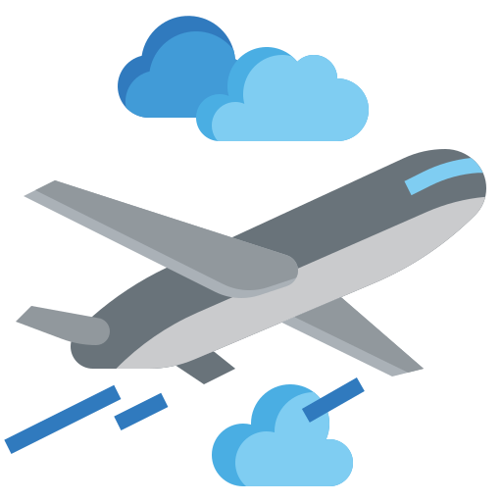

Malgorzata Victor (20102772)
Raels Santers (20103026)
Tomás McGrath (20103551)

Decmeber 2025
Table of Contents
1. Introduction 3
2. Architecture Vision 3
2.1. Arline Context 3
2.1.1. Global airlines 3
2.1.2. Mixed aircrafts 3
2.1.3. Airport ground services 3
2.1.4. Partner codeshares 3
2.1.5. Real time flight tracking & status updates 3
2.1.6. Passenger reservations & loyalty management 3
2.1.7. Aircraft maintenance & operational analytics 4
2.1.8. Monitoring & incident-response 4
2.1.9. Crew scheduling & airport resource coordination 4
2.2. Strategic Drivers 5
2.2.1. Safety 5
2.2.2. Punctuality 5
2.2.3. Customer experience 5
2.2.4. Cost efficiency 5
2.2.5. Driver KPI Metrics 6
2.3. Scope 7
2.4. Guiding Principles 7
3. Information Architecture Package 8
3.1. Data Models 8
3.1.1. Conceptual Data Model 8
3.1.2. Logical Data Model 9
3.1.3. Physical Data Model 10
3.2. Master Data Management Strategy 15
3.3. Metadata Catalog Sample 15
3.3.1. Data lineage for flight telemetry 15
3.3.2. Business Glossary for IATA codes 15
3.4. Business Operating Model 17
3.5. Information System Architecture 17
4. Application Architecture Package 18
4.1. Component Diagrams 18
4.2. Service Boundaries 19
4.3. API Contracts 20
4.3.1. REST Schema Flight Search 21
4.3.2. Streaming Definitions for ADS-B with MQTT 22
4.4. User Workflow 23
5. Integration & Middleware Architecture 24
5.1. Integration Patterns Matrix 24
5.2. Workflow Diagram 25
5.3. Middleware Rationale 26
6. Non-Functional Requirements & Quality 27
6.1. Security Model 27
6.2. Resilience Tactics 28
6.3. Scalability Strategy 28
6.4. Observability Plan 29
6.5. SLA Definitions and Capacity Planning 30
7. Deployment Topology Diagram 31
7.1. Environments 31
7.2. Compute Platforms 32
7.3. Network Zones & Connectivity 33
8. Reflective Summary: 34
9. Bibliography 38

Table of Figures
Figure 1. Conceptual Data Model 8
Figure 2. Logical Data Model 9
Figure 3. Physical Data Model 10
Figure 4. Component Diagram 18
Figure 5. User Workflow Diagram 23
Figure 6. Workflow Diagram 25
Figure 7. Deployment Architecture 31

Introduction
We are a software consultant company engaged by SkyLink Airlines to develop layered reference architecture. Airline systems can have many different parts to them. We will start by doing research into the context of airline systems to helps us gain a deeper understanding into the workings of how airline systems operate.

Architecture Vision

Arline Context

Global airlines
Skylink Airline operate flights for people and goods over many countries with different routes around the world making them a global business and needing to comply with laws and regulations for the corresponding countries in which they operate.

Mixed aircrafts
Skylink operates with a diverse range of different aircrafts used for both passenger and cargo flights to be able to serve different demands across the globe. The airline has flexibility and chooses the right aircraft for the flight and this results in lower costs

Airport ground services
Grounds services deal with loading and unloading and then transport to the necessary party. E.g. suitcases back to conveyor belts where passengers can get them after disembarking. This is automated with the help of conveyor belts to reduce human handling and increase efficiency, handled between the airline and the airport.
Besides dealing with just cargo, ground services also help with , handling passengers getting on and off alongside cleaning up the plane before take-off. They handle these steps as efficiently as possible so we can take off again as soon as possible.

Partner codeshares
Airlines can work with other companies and use code shares to sell tickets for flights with different companies. There could be different rates depending on which airline you book with even if it is for the same flight.

Real time flight tracking & status updates
Flight tracking is important both for keeping your customers informed of when the plane is arriving and making sure things are staying on schedule. Also, the information is shared from the airline to the airports flight control towers to tell them if it is safe to land.

Passenger reservations & loyalty management
Skylink provides flight booking system for passengers to book flights, check in online or at the airport. A loyalty program is included which allows passengers to earn points which they can receive by traveling with Skylink airline and redeeming points by how much kilometres they travel.

Aircraft maintenance & operational analytics
Maintenance will be carried out on the plane on a regular basis to make sure the plane is fit and in good shape so that it can fly without any potential dangers from parts malfunctioning. There will be different types of maintenance conducted on it such as scheduled maintenance, preventative maintenance, and corrective Maintenance. Scheduled is done at planned time interval such as after a specific number of flight hours. Preventative is for stopping issues before they happen and dealing with smaller defects before things get worse. Corrective maintenance is unscheduled and for dealing with a defect that has been found., e.g. fixing a faulty component. It is super important to catch these potential issues before they happen as it could lead to loss of life if the plane was not working properly. Analysis can be done during maintenance to see how much fuel got used and optimize to make sure we always have enough when refuelling to reach our next destination. Besides maintenance just to make sure the plane flies, maintenance also needs to be done to conform to certain national and international aviation regulations. As a global airline maintenance done at the plane must meet the standards for all regions that the plane flies in. Some different regulators include FAA (Federal Aviation Administration) for the USA, EASA (European Union Aviation Safety Agency) for the EU and the ICAO (International Civil Aviation Organization) for global aviation.

Monitoring & incident-response
Monitoring the data of how well the plane is flying is vital as flight controllers can now what is going on and if there is any danger. Live response using the data is important since urgency would be needed in case of an emergency. The data that was collected can be stored in the cloud and can be used for analysis later to see trends overall such as most common times that planes are landing or how many flights can a plane do a day on average. These can be analysed and used to assist in future business decisions for the company.

Crew scheduling & airport resource coordination
The cockpit crew flies the plane consisting of the pilot and copilot, other crew members are in the cabin crew and help deal with the services on the plane including interacting with passengers and pre and post flight clean up. There is a maximum number of hours that a pilot can work on a given day so there needs to be schedules for when another pilot is taking over, to maximise how often flights can take place. The crew also deal with maintenance and checking that the plane is flightworthy and capable of flying without issue and if there is anything that needs to be checked out or dealt with about the plane itself.

Strategic Drivers

2.2.1. Safety
There are strategic important drivers that are important to airline systems. Safety should be maximised as there are lots of people about and large moving vehicles, there is a desire to avoid lots of life or harm as it would lead to lawsuits and bad public reception. Make sure that customers are safe and that planes are safe to land.

2.2.2. Punctuality
Punctuality wise the planes should arrive on times as listed. Any potential changes should be reflected real time in the app and on the public display flight schedule. Customers should be able to board as soon as possible after the plane has been cleaned from its previous flight and is ready for take-off.

2.2.3. Customer experience
As there are lots of customers it is important to deal with handling them. We are trusted to safely handle people's items. Issues like lost luggage can deeply upset customers. We try to have good customer service to encourage repeat customers by helping them solve their issues if they arise.

2.2.4. Cost efficiency
There is a wide variety of different people who go on flights. As a global airline we are prepared to handle a variety of customer Bases. Different customers want different things, some want short flights to nearby places, while some are travelling far on long flights . There is also different classes of passengers such as economy, super economy, business class and first class. Economy is the basic standard and has limited leg room, super economy has more leg room and can have priority boarding, business class is higher and offers more comfort for travelling professionals or people willing to pay for the extra comfort. First class is the highest end and offers even more benefits such as high end seats with lots of comfort options and lots of space and expansive entertainment systems. As a global airline Skylink offer flight from and to many countries. Some of these flights can be long , some are shorter. Depending on the flights there are different options for passenger classes and within those there are also bonus optional add on benefits to improve the passengers comfort so they can feel relaxed and happy at a higher price, which includes bonuses such as seats with more leg room, or being allowed to bring along more baggage. These allow the airline to meet the needs for the various types of passengers.
The price of the flight can be influenced by a variety of factors, shorter flights have less fuel cost, but there are also other costs such as landing charge. Different airports can have different prices for being allowed to land there, busier airports closer to cities can be more expensive. Airlines must constantly optimize fuel consumption, crew scheduling, and airport fees to reduce operational costs and to be ready for take-off as soon as possible, as the airplane only makes money when it is in the air. There are also maintenance costs and storage costs when the plane is not in use. Technology and automation also play a role in lowering expenses, allowing SkyLink to remain competitive while still offering a quality service to customers.

2.2.5. Driver KPI Metrics
There are 4 main drivers that we are considering: Safety, punctuality, customer experience and cost efficiency.
Safety: measured by number of incidents, maintenance reports and incident reports. Keep track of most common types of maintenance and improve efficiency for how often the maintenance needs to happen and host fast to make sure everything works properly. We process the most common maintenance reasons into graphs to show how often they are done compared to other types of maintenance.

Punctuality: measured by scheduled vs actual departure and arrival times. (e.g. gotten from US department transport.) Why did the delay happen, to process split it into categories and then ways of improvement. Ryan Air keeps good records.
Customer Experience: measured by reviews, surveys and number of complaints received. We take this data and transform the data into useful information that we can extract. Close ended questions are easier to display in graphs and obtain information from, while open ended answers and reviews can be processed by large language models to compile all the different data and find out the most complaints from customers and areas for improvement.

Cost Efficiency: Measured by Fuel consumption per flight and maintenance costs. We compare our costs to profits for particular flights and flight routes. We display these in graphs and tables for the comparison of flight routes against each other.

As the airline is global, our strategic drivers are stored in regions and not all on one system. The raw sensor data is stored in edge devices for quick access and reacting to potential critical issues such as warning lights. While things like maintenance logs and reviews are stored and processed in the regional databases, the data is aggregated, and trends are found and predictive analysis is done for the future based on these trends. All the data logs, surveys and reports are brought together eventually in the cloud to give a global view, and graphs made out of the suitable information to present and display the information gathered for our KPIs in an easy-to-read way so that issues can be clearly seen and improvements made if necessary.

Scope
With all this context in mind we can set an achievable scope for what we aim to accomplish from keeping track of flights, making sure planes are maintained properly on scheduling and that we treat our customers well and give them a good experience making sure our flights arrive on time and that customers are aware of when they will be able to board.
This scope also ensures that both customer-facing systems and backend operational systems are considered, so improvements benefit both passengers and staff. It will help the airline focus on the most critical aspects first while leaving room for future scalability and integration with new services.
Our scope will incorporate the functional areas of the airline. We handle the tickets for our different flights and different prices for different seats. Up to date information on available seating. We need to keep track of what seats are booked and empty, how many passengers each plane can hold. Do we have enough staff for handling maintenance and handling passengers boarding and their luggage. Do we have legal permissions for the routes we are flying and agreements in place with airports for landing.

Guiding Principles
We will do our best to satisfy our stake holders by increasing profits with process optimization while at the same time providing customers with a cost-effective flights and positive experience.
These guiding principles will act as a foundation for decision-making whenever trade-offs arise between cost, safety, and customer experience. They will ensure the architecture remains adaptable to change while still aligning with the long-term strategy of the airline.

Information Architecture Package

Data Models

Conceptual Data Model
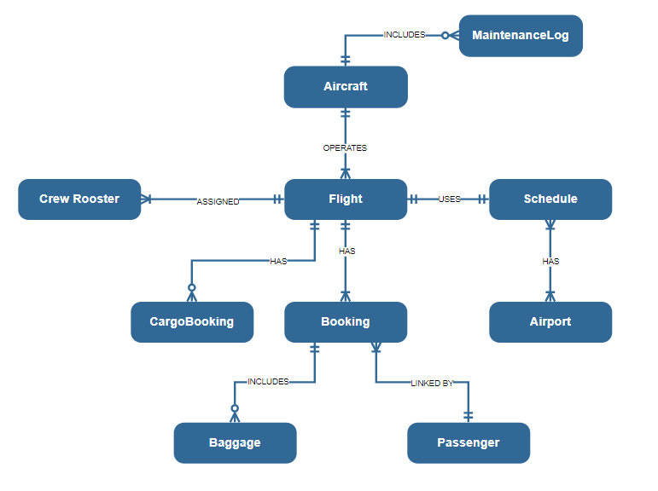
The Conceptual Data Model provides a high-level business view of our Airline Operations System, focusing on the core business entities and their relationships without technical implementation details. This model serves as a communication bridge between business stakeholders and technical teams, capturing the essential concepts of flight operations, passenger services, crew management, and aircraft maintenance that define our airline's operational ecosystem.
Figure 1. Conceptual Data Model

Key Entities:
Flight | Central entity representing a scheduled journey between two airports.
Aircraft | Represents each airplane in operation by SkyLink.
Booking | Records the details of a passenger’s reservation on a specific flight.
CargoBooking | Represents cargo or freight reservations linked to a flight.
Baggage | Linked to passenger bookings to represent checked-in luggage
Passenger | Represents individuals who make reservations and travel on flights.
Schedule | Defines the operational timing of flights (departure, arrival, duration).
Airport | Represents the location from which flights depart and arrive.
MaintenanceLog | Records maintenance activities related to flights.
CrewRoster | Represents crew assignments for a flight.

Key Relationships
Aircraft – Flight | Each aircraft can operate many flights.  Each flight is assigned to one aircraft. | 1:N
Flight - CrewRoster | Each flight must have multiple crew members  Each roster must belong to one flight | 1:N
Flight - Booking | A flight must have one or more bookings  Every booking must refer to one flight | 1:N
Flight – CargoBooking | A flight can include multiple cargo bookings.  Each cargo booking belongs to one flight. | 1:N
Booking – Baggage | Each passenger booking can include multiple baggage items.  Each baggage item can be linked to one booking | 1:N
Flight - Schedule | Every flight must use exactly one schedule  Each schedule must be used by exactly one flight | 1:1
Aircraft - MaintenanceLog | Each aircraft can have multiple maintenance logs over time.  Each maintenance log must refer to one aircraft | 1:N
Booking - Passenger | Each booking must be linked to one passenger  Each passenger must make one or more bookings | 1:N
Schedule - Airport | Schedule must have exactly one departure and one arrival airport  Each airport must be used in one or more schedules | 1:N

Logical Data Model
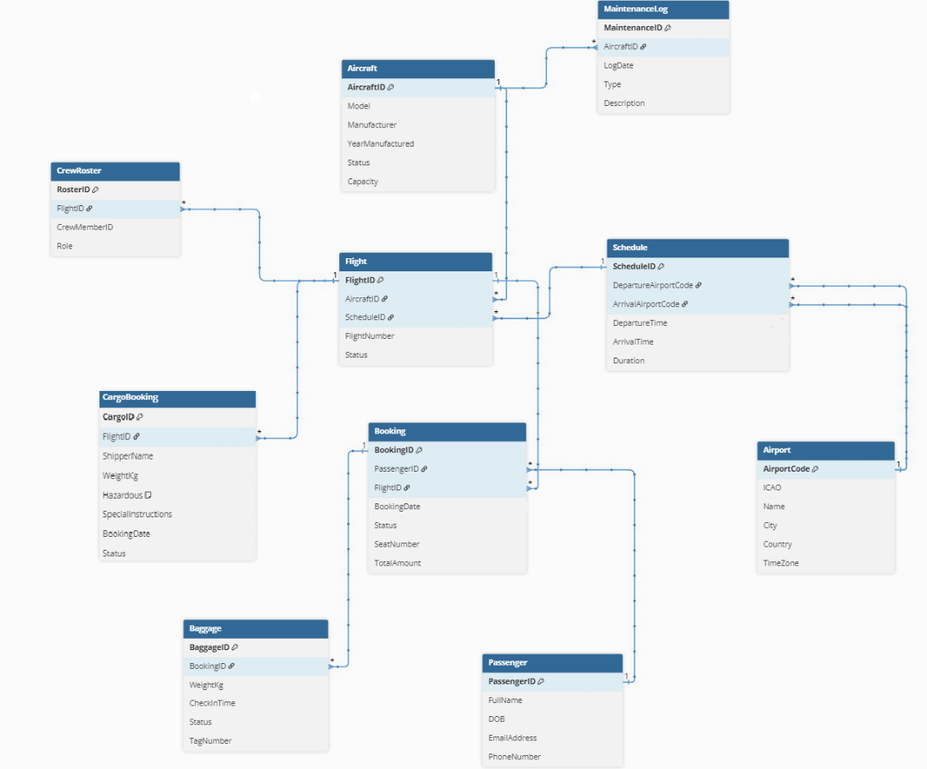
The Logical Data Model serves as the business foundation for our Airline Operations System, defining how core aviation entities interact and ensuring data integrity across flight operations, passenger services, and maintenance tracking. This conceptual blueprint aligns with airline industry standards and regulatory requirements, establishing clear relationships between flights, schedules, aircraft maintenance, and passenger bookings that reflect real-world aviation workflows.
Figure 2. Logical Data Model
Normalization Notes
Flight | 3NF | ScheduledID FK enforces 1:1 with Schedule
Aircraft | 3NF | Each aircraft identified by unique registration
Booking | 2NF | Stored directly for performance and audit purposes
CargoBooking | 3NF | Distinct from passenger bookings
Baggage | 2NF | Denormalized for operational speed
Passenger | 3NF | No transitive dependencies
Schedule | 2NF | Stored for query performance and operational efficiency
Airport | 3NF | No redundancy
MaintenanceLog | 2NF | Denormalized for quick access and reporting
CrewRoster | 3NF | Role is specific to each flight assignment

Physical Data Model
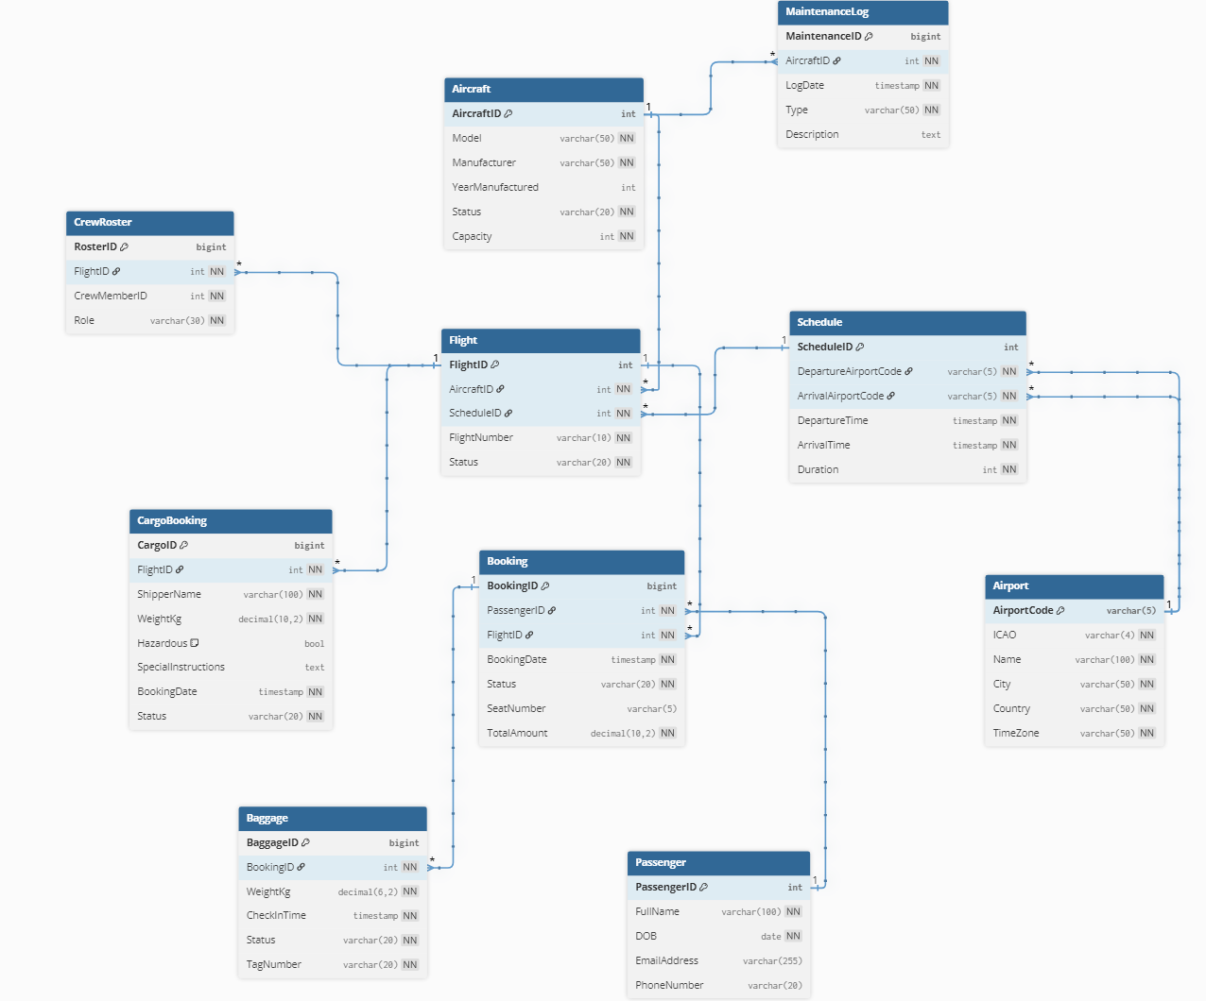
The Physical Data Model implements our airline system with performance-optimized structures designed to handle high-volume booking transactions, real-time flight operations, and mandatory maintenance tracking. This implementation includes strategic partitioning for time-sensitive data and comprehensive indexing to support critical airline workflows like passenger bookings, crew scheduling, and aircraft maintenance compliance.
Figure 3. Physical Data Model

Table Schemas:

Airport
-- Stores static location and timezone information for all airports in the system.
CREATE TABLE Airport (
AirportCode VARCHAR(5) PRIMARY KEY,
ICAO VARCHAR(4) NOT NULL UNIQUE,
Name VARCHAR(100) NOT NULL,
City VARCHAR(50) NOT NULL,
Country VARCHAR(50) NOT NULL,
TimeZone VARCHAR(50) NOT NULL
);

Schedule
-- Defines the planned timetable for a flight, including departure/arrival times and airports.
CREATE TABLE Schedule (
ScheduleID INT PRIMARY KEY,
DepartureAirportCode VARCHAR(5) NOT NULL,
ArrivalAirportCode VARCHAR(5) NOT NULL,
DepartureTime TIMESTAMP NOT NULL,
ArrivalTime TIMESTAMP NOT NULL,
Duration INT NOT NULL,

FOREIGN KEY (DepartureAirportCode) REFERENCES Airport(AirportCode),
FOREIGN KEY (ArrivalAirportCode) REFERENCES Airport(AirportCode)
);

Aircraft
-- Stores information about physical aircraft in the fleet.
CREATE TABLE Aircraft (
AircraftID INT PRIMARY KEY,
Model VARCHAR(50) NOT NULL,
Manufacturer VARCHAR(50) NOT NULL,
YearManufactured INT,
Status VARCHAR(20) NOT NULL,
Capacity INT NOT NULL
);

Flight
-- Represents a specific, operational instance of a scheduled journey.
CREATE TABLE Flight (
FlightID INT PRIMARY KEY,
AircraftID INT NOT NULL,
ScheduleID INT NOT NULL UNIQUE,
FlightNumber VARCHAR(10) NOT NULL,
Status VARCHAR(20) NOT NULL,

FOREIGN KEY (ScheduleID) REFERENCES Schedule(ScheduleID),
FOREIGN KEY (AircraftID) REFERENCES Aircraft(AircraftID)
);

Passenger
-- Holds the personal and contact details for all individuals who can make bookings.
CREATE TABLE Passenger (
PassengerID INT PRIMARY KEY,
FullName VARCHAR(100) NOT NULL,
DOB DATE NOT NULL,
EmailAddress VARCHAR(255),
PhoneNumber VARCHAR(20)
);

Booking
-- Records a passenger's reservation and payment for a seat on a specific flight.
CREATE TABLE Booking (
BookingID BIGINT PRIMARY KEY,
PassengerID INT NOT NULL,
FlightID INT NOT NULL,
BookingDate TIMESTAMP NOT NULL,
Status VARCHAR(20) NOT NULL,
SeatNumber VARCHAR(5),
TotalAmount DECIMAL(10, 2) NOT NULL,

FOREIGN KEY (PassengerID) REFERENCES Passenger(PassengerID),
FOREIGN KEY (FlightID) REFERENCES Flight(FlightID)

) PARTITION BY RANGE (BookingDate);

CrewRoster
-- Assigns crew members and their roles to a specific flight.
CREATE TABLE CrewRoster (
RosterID BIGINT PRIMARY KEY,
FlightID INT NOT NULL,
CrewMemberID INT NOT NULL,
Role VARCHAR(30) NOT NULL,

FOREIGN KEY (FlightID) REFERENCES Flight(FlightID)
);

MaintenanceLog
-- Tracks all mandatory maintenance events performed on an aircraft, linked to the flight that necessitated it.
CREATE TABLE MaintenanceLog (
MaintenanceID BIGINT PRIMARY KEY,
AircraftID INT NOT NULL,
LogDate TIMESTAMP NOT NULL,
Type VARCHAR(50) NOT NULL,
Description TEXT,

FOREIGN KEY (AircraftID) REFERENCES Aircraft(AircraftID)
);
PARTITION BY RANGE (LogDate);

Baggage
-- Tracks luggage associated with passenger bookings.
CREATE TABLE Baggage (
BaggageID BIGINT PRIMARY KEY,
BookingID INT NOT NULL,
WeightKg DECIMAL(6,2) NOT NULL,
CheckInTime TIMESTAMP NOT NULL,
Status VARCHAR(20) NOT NULL,
TagNumber VARCHAR(20) NOT NULL UNIQUE,

FOREIGN KEY (BookingID) REFERENCES Booking(BookingID)
);

Cargo Booking
-- Records freight and cargo shipments on flights.
CREATE TABLE CargoBooking (
CargoID BIGINT PRIMARY KEY,
FlightID INT NOT NULL,
ShipperName VARCHAR(100) NOT NULL,
WeightKg DECIMAL(10,2) NOT NULL,
Hazardous BOOLEAN DEFAULT FALSE,
SpecialInstructions TEXT,
BookingDate TIMESTAMP NOT NULL,
Status VARCHAR(20) NOT NULL,

FOREIGN KEY (FlightID) REFERENCES Flight(FlightID)
);

Partitioning
Partitioning is a database technique that splits a large table into smaller, more manageable pieces called partitions, while still treating it as a single table. This dramatically improves performance for queries that access a recent subset of data and simplifies data management operations like archiving old data.
Partition Key: BookingDate / LogDate
Method: Monthly Range Partitioning. This is ideal for time-series telemetry data, making it cheap to drop old records and fast to query recent maintenance history.

Example Partitions: maintenance_2024_01, maintenance_2024_02, etc.
-- Booking table partitions
CREATE TABLE booking_2024_01 PARTITION OF Booking
FOR VALUES FROM ('2024-01-01') TO ('2024-02-01');
CREATE TABLE booking_2024_02 PARTITION OF Booking
FOR VALUES FROM ('2024-02-01') TO ('2024-03-01');

-- MaintenanceLog table partitions
CREATE TABLE maintenance_2024_01 PARTITION OF MaintenanceLog
FOR VALUES FROM ('2024-01-01') TO ('2024-02-01');
CREATE TABLE maintenance_2024_02 PARTITION OF MaintenanceLog
FOR VALUES FROM ('2024-02-01') TO ('2024-03-01');

Indexing
An indexing strategy involves creating optimized data structures (indexes) that allow the database to find data without scanning the entire table. A good strategy is crucial for performance but adds overhead on writes; it should be tailored to common query patterns.

Example Indexes:
CREATE INDEX idx_booking_passenger_date ON Booking(PassengerID, BookingDate DESC);
CREATE INDEX idx_booking_flightid ON Booking(FlightID);
CREATE INDEX idx_maintenancelog_tail_date ON MaintenanceLog(TailNumber, LogDate DESC);
CREATE INDEX idx_maintenancelog_flightid ON MaintenanceLog(FlightID);
CREATE INDEX idx_schedule_departure_search ON Schedule(DepartureAirportCode, DepartureTime);
CREATE INDEX idx_crewroster_crew_flight ON CrewRoster(CrewMemberID, FlightID);
CREATE INDEX idx_passenger_email ON Passenger(EmailAddress);

Master Data Management Strategy
Skylink uses MDM system to create and maintain golden records for their most important business entities: Aircraft, Airports and loyalty.
A golden record is a single, authoritative version of truth and most accurate version of a data entity within and organisation system to ensure accuracy, consistency and reliability across multiple source systems to have the most trusted version of each record used across airline operations.
Aircraft: The golden record combines data from maintenance systems, flight operations, manufacturer specs to track each aircrafts maintenance status, registration and configurations.
Airports: airport data uses IATA/ICAO registries integrated with Skylinks operational database to standardize names, codes and locations for flight planning and scheduling systems
Loyalty members: Customer master database consolidates data from reservations, transactional history and CRM systems combined into one, to ensure accurate point tracking, identity management and personalised experiences.

Metadata Catalog Sample
The metadata catalog stores key information about the datasets within skylink systems to ensure data transparency and traceability of data across the airline so users can understand and trust the data they use for operations and analytics.

Data lineage for flight telemetry
Data lineage for flight telemetry describes how telemetry data is generated, transmitted, processed, stored and consumed across Skylinks ecosystem. This data is collected from aircraft sensors ADS-B transponder which is essential for ensuring accurate and traceable information is available for flight monitoring, maintenance and performance analytics

Business Glossary for IATA codes
Each airport around the world is assigned with a unique code which is used for its quick and accurate identification in flight documentation, crew scheduling and everything related to the air operation.
The business glossary defines the key IATA terms Skylink uses across its airline systems to ensure consistent understanding of these aviation data.

Term | Definition | Example
IATA Airport Code | An IATA code is three-character code assigned by the international air transport association (IATA) to identify an airline or location such as an airport. | DUB - Dublin
ICAO | A four-letter code assigned by the international civil aviation organisation used in flight operations and air traffic control | EIDW - Dublin
IATA Airline Code | A two-character code assigned by IATA to identify airlines for commercial purposes such as reservations, timetables, telecommunications, cargo documentation and other stuff | SL – Skylink Airline
PNR | A passenger name record is a digital document containing the itinerary, passenger details, payment details and contact details for passengers | 1LUV67
AWB (Air Waybill) | A unique IATA document and tracking number issued for cargo shipments used to identify and track for air freight | 911 - 12345678
Load factor | Percentage of available seats on a flight that are filled with passengers. | Flight SL123- 67% load factor
Baggage Tag number | This is unique barcode number that is attached to each checked bag used to track through airline baggage system | 123w67

IATA Aiport Code: Skylink operates global passenger and cargo flights, so every reservation, flight plan and ticket uses IATA’s 3 letter airport code
ICAO Airport Code: Skylink’s operations, crew and maintenance systems rely on the more technical ICAO codes for air traffic control.
IATA airline designator: As skylink is a global carries they need an IATA 2 letter airline code SL which identifies the airline on flight numbers like SL001
PNR: Skylink’s reservation, check-in and loyalty program uses PNR to link passenger bookings and service information.
AWB: Skylink’s cargo systems use Air Waybill number to track and manage air freight shipments ensuring accurate handling, custom documentation and visibility of cargo movement.
Load Factor: Skylink’s operation teams use load factor to measure how efficiently each aircraft seating capacity is being used. This helps the airline choose which aircraft if better on different routes which allows to adjust pricing and improving profitability.
Baggage tag number: Skylink’s baggage handling system uses baggage tag number to track each passengers checked luggage to ensure accurate transfers and reducing the risk of lost bags.

These codes are essential for Skylinks global passenger and cargo operations. They will ensure consistency and accuracy across all systems used for flight planning, cargo tracking, reservations and regulatory compliance. IATA and ICAO codes allows seamless communication between Skylink, airports and logistics providers.

Business Operating Model
We use our operating model to show how we create and deliver value to our customers, it incorporates our people, processes and infrastructure. We provide customers with flights to places on our airplanes along with delivering their luggage.. They book seats and other services They book a particular flight and seat via the app. We allow them to book or just be assigned a random seat. Some seats have more leg room than others. Customers can also buy food, drink or other items while on the flight, or they can also book more luggage to bring with them.
As we are a global airline and can travel further distances, food on the flight, helps make sure people don’t get hungry. More legroom and comfort are nice for longer flights to help make customers feel more relaxed. We keep our processes as efficient as possible, in order to maximise time, we are flying. Customers check in at the airport and then we help them onto the plane and store their luggage onto the plane. Depending on the flight we might employ a shuttle bus depending on how far away the plane is from the airport to help customers get on. After the plane lands we help them off and transfer their luggage to the airports onto conveyor belts.

Information System Architecture
Our information system tracks how information moves between our organization, it can be made up of our hardware, software, processes we use, people we employ and data we gather. Our main hardware is the planes themselves which keep track of lots of data. We also have servers for handling the backend servers and software and managing the ticket prices and bookings. Database for our customers and their information. This data is shared with the airport for when people are checking in.
Customers book a flight, we take their information and money and update our systems so that their booking information is stored, when they are at the airport they can check in at the counter or using the app. Flight attendants let people onto the plane and they sit down, when all are seated the plane takes off. Flight to destination, then landing, passengers disembark and the seats are cleaned and maintenance done to the plane.
We can keep track of load factor (seat occupancy rate), what flights are most popular, fuel usage and weight per flight. Passengers and airports can stay updated with our flight data. Can also see how much weight is on board with luggage and how much more we could potentially fit. Our system keeps track of what crew we have on each flight, and how long it takes them to clean.
Our information systems keep our flight schedule updated, along with any delays from unexpected maintenance or other unforeseen issues. We make sure we have planes available for the times on the flight schedule and that we have crew available. We can see each crew members pay and qualifications and reallocate them as necessary. We keep track of metrics such as how much the plane and crew have flown in the last 24 hours. There is a maximum flight time to keep track of and not exceed.

4. Application Architecture Package

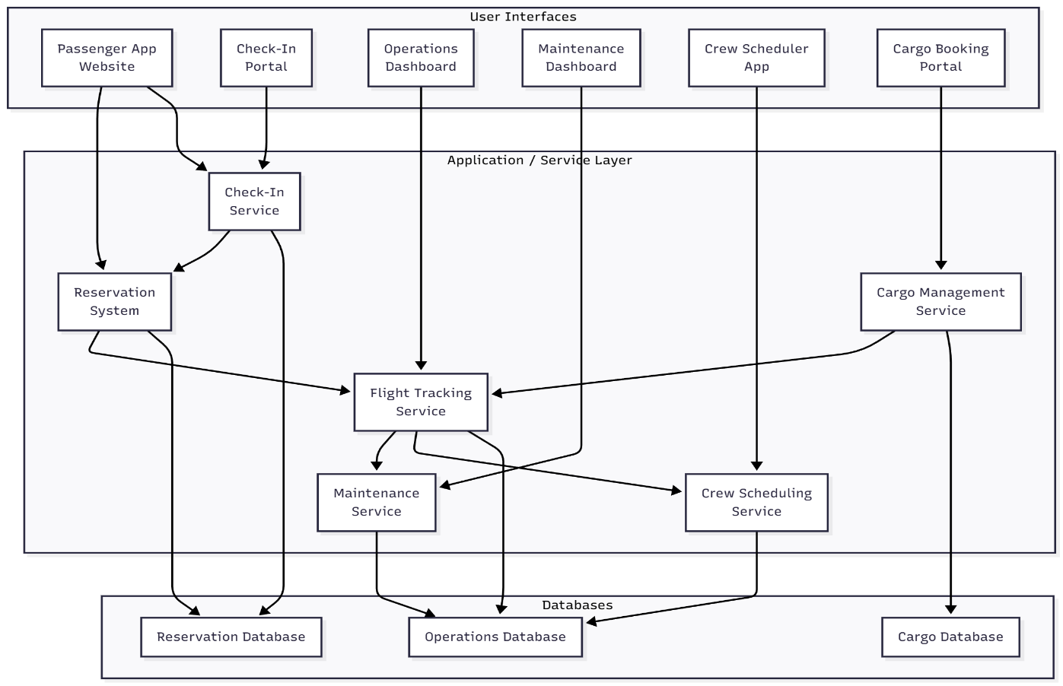
4.1. Component Diagrams
Figure 4. Component Diagram

This component diagram shows the main applications systems and data interactions within SkyLink Airlines. Each box represent key application component ( Reservation, Check-in, Flight tracking, Maintenance and Crew). The arrows show how the data flows between components
Reservation System: this is the core for Skylink passenger services. It manages bookings, payments and loyalty programmes.
Check-in Portal: the portal interacts with the reservation system via APIs to retrieve booking details and issue boarding pass.
Flight tracking system: receives real time flight and telemetry data which provides live updates to passengers and operations control centre.
Maintenance Dashboard: processes ADS-B data for predictive maintenance and safety checks.
Crew Scheduler: responsible for creating and managing flight schedule for pilots and flight attendants to ensure every flight has the right crew and in the right place and time.

4.2. Service Boundaries
SkyLink’s application design is built around the bounded context principle from domain-driven design, where each microservice models a specific business area of the airline. Each service includes all the logic, data, and components it needs to operate independently, reducing dependencies and avoiding tight coupling between systems. This approach allows SkyLink to evolve, scale, and deploy services separately while maintaining overall system stability. SkyLink defines its key service boundaries as follows:
Reservation Service – Manages flight search, ticket booking, payment, and loyalty point updates. It acts as the entry point for customers through the mobile app or web portal.

Check-in Service – Operates within its own context to issue boarding passes, verify identity, and assign seats, interacting with the Reservation Service through REST APIs only when required.

Flight Tracking Service – Processes live telemetry from aircraft via MQTT and provides real-time updates to the operations dashboard and passenger applications.

Maintenance Service – Handles aircraft diagnostics, logs, and predictive maintenance analytics. It is data-isolated and retrieves only necessary flight details through API calls.

Crew Scheduling Service – Manages pilot and cabin crew assignments, availability, and compliance with flight time regulations, coordinating schedules with flight operations but maintaining its own data store.

Service granularity is guided by business functionality rather than technical layers. Each service performs a complete workflow within its domain without requiring complex distributed transactions. For instance, reservation and payment logic stay within the Reservation Service, while maintenance events and telemetry analysis are contained in the Maintenance Service. This avoids unnecessary inter-service communication and improves reliability.
A key design rule is data isolation. Each service manages its own database and schema, preventing conflicts and enabling independent scaling. The Reservation Service may use a relational database for transactional consistency, while the Flight Tracking Service might use a time-series database for telemetry. This autonomy also allows teams to choose the best technology for their domain’s data needs.
Finding the right boundaries is an evolving process. As SkyLink’s systems grow, some services may be merged or split to reduce communication overhead or improve domain clarity. This iterative refinement ensures that microservice boundaries continue to align with real airline workflows, maintaining both efficiency and domain integrity.

4.3 API Contracts

API Contracts Information
The APIs serve as the connection point for transferring data between the front end website or app to the backend booking systems.
For our API endpoints we have GET /flights, POST /bookings, Post /check-in
GET /flights, POST /bookings
- These APIs allow customers to search for flights that are available. They can then choose from the available flights and create a booking that is sent off.
They help out the customers and support the business goals that we have set. Customers can search for available flights and then make bookings. Being able to book flights allows them to book ahead of them giving the customer a better experience and improves cost efficiency for us the airline as we know how many people will be on the flight and the booking is automated.
Post /check-in
- These give a better user experience for when the passenger is at the airport and going onto the plane. You can check in on the app which helps reduce waiting time for customers not having to go in as many lines and also for the airline as they can have customers book in earlier to confirm that they will be on the flight.

Also have ADS-B (Automatic Dependent Surveillance - Broadcast)
- We have decided on MQTT and use it to receive the real time position of the aircraft along with the movement data from ADS-B transponders. It helps to improve safety though being able to monitor aircraft data in real time. These conveys important safety information that the plane is flying correctly and it won’t end up crashing into anything else. It helps to track the plane and know when the plane will be arriving in its destination which helps to keep the next passengers that will be using the plane informed with accurate information.
We decided on the using REST schema with JSON for the Booking Management and the passenger Check In.

The base URL for the endpoints is: https://api.skylink.com/v1

4.3.1. REST Schema
Flight Search
GET /flights?origin=JFK&destination=LAX&date=2023-12-15{
"flights": [
{
"flightId": "SL101",
"origin": "JFK",
"destination": "LAX",
"departureTime": "2023-12-15T08:00:00Z",
"price": 299.99
}
]
}

Create Booking
POST /bookings
{
"flightId": "SL101",
"passengers": [
{
"firstName": "John",
"lastName": "Doe",
"email": "john@email.com"
}
]
}

Check In
POST /check-in
{
"bookingId": "BK789XYZ",
"seat": "14C"
}

4.3.2. Streaming Definitions for ADS-B with MQTT
Data Flow
Aircraft → ADS-B (Flight Position, Velocity, flight number) → MQTT → Airline Systems QOS (Quality of Service), will deliver at least once

MQTT Configuration:
broker:"mqtt://adsb-broker:1883"
topic_structure:"skylink/telemetry/{aircraft_id}"
qos: 1

Telemetry Message Format:
{
"aircraft_id":"ABC123",
"timestamp":"2024-01-15T10:30:00Z",
"position":{
"latitude":40.7128,
"longitude":-74.0060,
"altitude":35000
},
"movement":{
"ground_speed":450,
"heading":123.5
},
"flight":{
"callsign":"SKY101",
"squawk_code":"1234"
}
}

Topic Structure:
- skylink/telemetry/all - All aircraft
- skylink/telemetry/{aircraft_id} -Specific aircraft
- skylink/telemetry/airport/{code} - Airport area

4.4. User Workflow
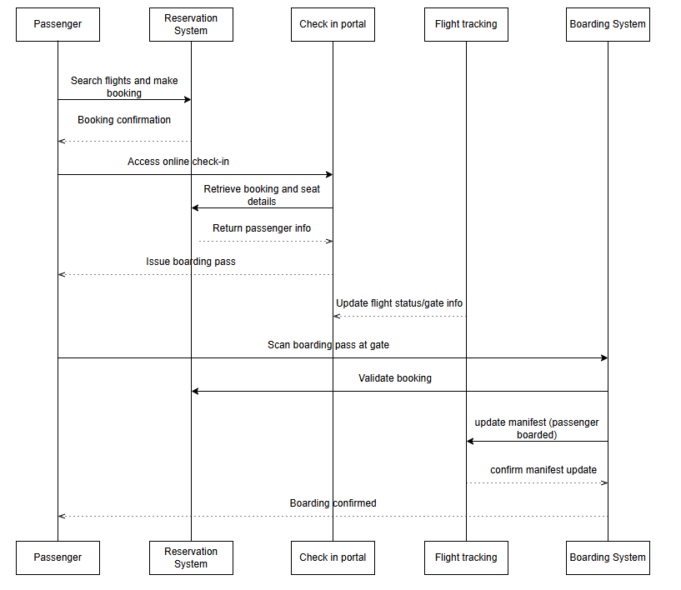
Figure 5. User Workflow Diagram
This sequence diagram shows how Skylink’s system interacts during a passenger’s journey. It shows how the booking, check-in and boarding information flow between the Reservation system, Check-in Portal, Flight tracking and Boarding system. This ensures that data for passengers, flight status and boarding get updated and remain synchronized across all Skylinks platforms.

Integration & Middleware Architecture

5.1 Integration Patterns Matrix
The integration patterns matrix describes how different system in Skylink airlines exchange data. Different processes require different methods such as batch processing or real-time streaming. The matrix shows which systems integrate and why a pattern was chosen for it e.g. BatchETL, CDC or Streaming.
Integration need | Source to Target System | Pattern type | Description
Flight logs for analytics | ERP flight operations -> Data Lake | Batch ETL | Large volumes of flight logs, crew hours, delays, fuel usage processed in scheduled batches.
Passenger profile & booking updates | Passenger management system -> CRM | CDC | Keeps customer profile, contact details and bookings synchronised in real time for CRM, marketing and customer service use
Real-time aircraft telemetry | Aircraft ADS-B -> Telemetry Stream  -> Ops Analytics | Streaming | Live data gathering of aircraft position, altitude, speed and flight status for real time flight tracking and operational analytics

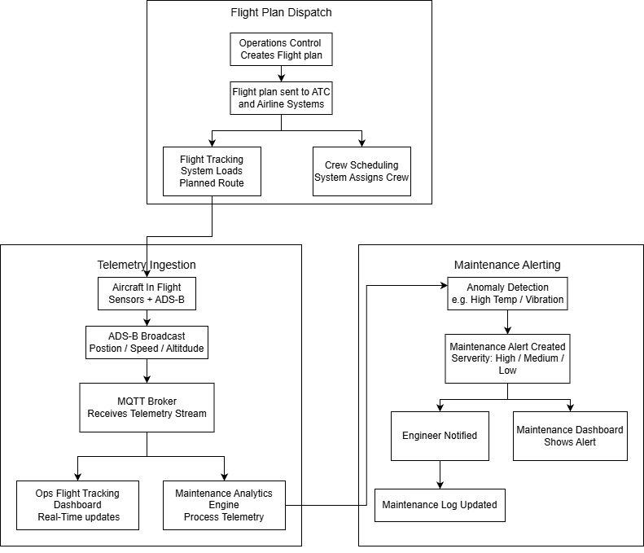
5.2 Workflow Diagram
Figure 6. Workflow Diagram
The workflow diagram shows the end-to-end data flow across Skylinks operations from the flight plan to telemetry ingestion and to aircraft maintenance alerts. It shows how the different systems interact in sequence.

Middleware Rationale
Skylink Airlines uses different middleware components to serve different purpose within their systems.

API Gateway:
The API Gateway is used for all the user-facing interactions such as Passenger App, Check-In portal, Cargo booking portal.
It is used to handle authentication, security and request routing to its correct backend service. It is used for real-time user operations like booking a flight, getting check-in details and viewing flight information.

Enterprise Service Bus (ESB):
The ESB is used to connect to internal enterprise systems to enable seamless communication and data exchange.
The ESB supports the handling of multi-step internal process such as:
reservation -> flight tracking -> crew scheduling.
Also, the ESB provides reliable message delivery and data transformation between backend systems.

Message Broker for Real-time Telemetry:
Aircraft telemetry (ADS-B), engine data and sensor readings generate high volume and real-time streams so they cannot go through an API Gateway or ESB.
A message Broker like MQTT is used because it supports high frequency streaming, Low latency and publish delivery to multiple consumers (e.g. flight tracking, maintenance analytics, dashboard).
MQTT is chosen over other brokers because its lightweight and designed for IoT and telemetry scenarios.

Non-Functional Requirements & Quality

6.1 Security Model
The system has different networks that are segmented into different categories such as public, partner and lan for handling different purposes. The public web is the front end that users access such as when they are booking. It takes in their data and stores it. From the public web it only allows data to come in and doesn’t allow log in to the database via that route. The database itself is managed via other routes from known trusted Ip addresses. The concept of least privilege is given for accessing the database, all access is only the bare minimum needed to prevent against the case of unauthorized access to all of the data, what they could do would be limited.
The partner APIs are the connections for transferring the data to the services that work in conjunction with us, and we need to send data to them. These can be used to send data to things like airports, fuel management, crew scheduling, online travel agencies or global distribution system. Global Distribution Systems(GDS) APIs such as Amadeus allow for flight searching, booking and check in. s. Online travel agencies would be able to see that there are flights happening at certain times going to certain places and if there are still seats and could help advertise them , and then seats on the plane could be booked from there.
Aircraft LAN can be in public or private categories. A public lan network can be used on certain flights to provide flight passengers Wi-Fi for things such as in-flight entertainment and payment for items being sold. While a private flight LAN is used to connect various onboard systems for their operational telemetry such as map and air traffic data and other maintenance data. This telemetry data is sent from the aircraft using secure channels to the ground systems and it is used to help protect the flight critical functions.
For the encryption strategy used for the security model, the main focus is on keeping all the data secure while it is moving between the systems. All communications will use TLS (transport layer security) to protect the data as it travels across the internet or inside of the system. TLS uses a handshake protocol to authenticate the parties that are communicating and prevent attacks such as tampering
VPNs (virtual private networks) creates a secured tunnel to help the service provider exchange data over non secured networks. SATCOMs is satellite communication where data is transmitted over satellites. Using SATCOM can be less secure than traditionally slower than other forms of data transfer across networks. In modern times, VPNs can now be used with SATCOM to provide more security while still keeping a lower latency. This is useful for the plane transmitting telemetry data securely to ground services using VPN tunnels over SATCOM.

6.2 Resilience Tactics
Circuit breakers patterns are used when an application connects to remote services to help handle faults and recover. If failure is detected the circuit breaker blocks access. These stop repeated attempts so that recovery can happen effectively. This improves application stability and resiliency. States such as closed, half open and open to detect timeout failure. With partner APIs such as booking systems, if there was no circuit breaker then the repeated request could slow down or overwhelm the system leading to failures in aspects such as booking to ticketing.

6.3 Scalability Strategy
For our network, we have different demands in different places that can vary at different times. To deal with this we use scalable cloud computing on a provider like AWS to handling the varying capacity, this allows us to deal with lots of customers trying to book at once for busy, popular flights and less computing capacity is needed when less people are booking flights at the same time. This ability to scale to meet demand improves efficiency, reliability and increases revenue as not paying for too much unneeded compute capacity.
Sharding distributes the data across multiple nodes, which improves the speed of queries and updates. When scaling we can do it horizontally instead of vertically, we are able to get more efficient improvements in compute performance by running tasks on multiple nodes that are automatically created to meet demand as needed. Sharding is useful for handling the large volume of data that is generated for the time series telemetry, which is the telemetry data that is being created and continuously streamed over time from the aircraft. Sharding helps to avoid bottlenecks that would occur from just one node. The data can be sharded in groups such as time ranges or by the particular aircraft.

6.4 Observability Plan
Observability is about making the system understandable and monitorable so that when issues are detected, they can be resolved quickly. SkyLink Airlines improves observability by using centralized logging, metrics, and distributed tracing.
Logs are stored from applications and centralized logging is used with ELK (Elasticsearch, Logstash, Kibana). Logstash allows data to be collected, transformed and sent to the desired destination. Elasticsearch is a distributed search and analytic engine. Kibana is used for data visualization and explore for analytics. ELK makes it easy to search, to analyse and to visualize errors or unusual activities within the logs. This is important as there could be very large amounts of data generated and present inside the logs so it can be hard to filter and find the important data, which ELK helps a lot with.
Prometheus collects and stores its metrics as time series data, for metrics such as system performance, API response times and telemetry rates. This time series data is useful and allows metric trends to be observed and queried, and spot issues from any potential bottlenecks.
Modern apps are composed of lots of multiple interconnected services. Distributed Tracing tracks requests across multiple services and improves end to end visibility for critical flows such as a passenger booking a flight or telemetry being processed from the aircraft. The data can be observed at its multiple stages for how it moved source to destination. WE can see exactly where the delays and error in the application may be coming from and fix them faster.

6.5 SLA Definitions and Capacity Planning
SLA is a service level agreement that is expected by a customer from a supplier. It lays out the metrics by which the service is measured and penalties if the service levels end up not being achieved. They help define accountability, clarity of expectations, resolve conflict and improve customer experience.
Capacity planning is the strategic process of determining and preparing just the right amount of needed resources, that are required to meet current and future customer command. These resources are things such as personnel, equipment and infrastructure. For the following parts of the airline the capacity revolves around being able to meet spikes in user demand. It is handled similarly for each of the following systems; each system will be able to scale in the cloud and provision additional nodes for computing power as is necessary.
In the case of the booking system, the SLA focuses on response time, to make sure that passengers can search and reserve flights within a few seconds even during peak times that are busy.
For telemetry ingestion, is a continuous flow in near real time and expected to be handled in near real time as well. This must be done to ensure operational teams receive the data while it is timely and useful to be used for monitoring and decision making. This helps improve monitoring and safety and this processing is handled with sharded horizontal scaling.
The SLA for data Throughputs would cover how much data or how many requests the system could handle across all services. Too many requests could overload the system causing slowdowns and bottle necks due to traffic spikes, capacity is able to keep up by scaling as necessary.
Crews are normally emailed the crew schedule once a month their roster for the upcoming month, it includes details such as flights the crew will be on, rest days, crew pairings and aircraft type. The turnaround is the total time it would take for the crew schedule to be created, updated, or processed for a flight Changes can happen for a variety of reasons such as crew sickness last minute delays due to weather. The airline must ensure that the crew schedule is finalized before the flight departs, any changes must be processes quickly to avoid delays. The SLA would be the system must be able to handle lots of simultaneous schedule changes such as many flights getting delayed at once due to bad weather.

7. Deployment Topology Diagram

7.1 Environments
Skylink has different environments for different purposes. These help to balance performance, scalability and reliability to the correct environment for the corresponding service.
On-Premises Data Centre:
This is used to host sensitive internal services that we don’t want the public to have access to. These host core operational databases. On premises ensures secure, controlled access to essential resources. Check in occurs hybrid cloud and on premise. Secure database stored on premise but check in is done through online portal and gateway. The passenger checks in, data goes to on premises. When passenger through the gateway, their status is updated.
Cloud region:
This is used for global aggregation, analytics and reporting. The cloud helps to consolidate regional data such as maintenance logs and handling requests to the system. It also helps with predictive analysis and global performance visibility. The cloud is able to handle in demand from peaks in reservation all at the same time. It can scale up and down horizontally in order to adapt its computing power and available nodes to best meet the current demands and minimize wasted resources. Also partner integrations for sending future flights plans to things like booking websites.
Edge Nodes:
This is for handle the near real time telemetry from the aircraft and critical operational data. These edge nodes allow faster processing and rapid responses if any potential safety issues end up arising, such as system alert, without needing to rely on constant connectivity to the cloud system.

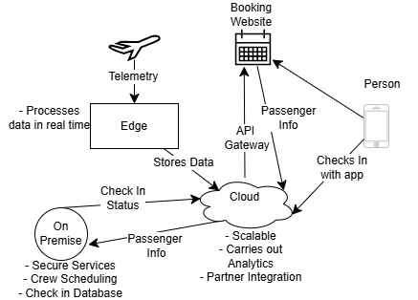
Figure 7. Deployment Architecture

7.2 Compute Platforms
Skylink Airlines deploys its system to different compute platforms to ensure high availability, real-time performance and global scalability. Each platform will be picked based on their workload it supports.

Kubernetes Cluster for Microservices:
Skylinks core operational services runs on a Kubernetes cluster. The platform hosts all its core microservices (Reservation System, Check-In Service, Flight Tracking Service, Maintenance Service, Crew Scheduling Service, Cargo Management Service).
Kubernetes provides high availability so when a node fails the services continue operating. It also supports automatic scaling so during peak load it allows for scaling to handle increased traffic.

Time-Series DB at edge
Aircraft generates continuous high-volume telemetry from ADS-B, sensors and engine diagnostics.
The purpose of Edge time-series DB is to gather and process high frequency data such as position, altitude, vibration and temperature in real time. This allows for low latency processing which is required for maintenance monitoring and flight analytics.

CDN for passenger portals
Public-facing web services are delivered through content delivery network to ensure fast customer access.
This is used for the passenger app/website, online check-in portal, cargo booking, loyalty Membership portal.
CDN provides low latency delivery, so passengers receive fast loading times. CDN has high availability and continues serving cached content even if the origan servers have downtime.

7.3 Network Zones & Connectivity
Skylink Airlines operates across multiple different network zones to ensure secure, reliable and continuous connection. These multiple zones ensure secure communication between aircraft, ground systems, and partner services.
SATCOM links
SATCOM links provide the primary connection from the aircraft to the ground infrastructure, enabling telemetry, operational data and passenger connectivity to flow safely over satellite channels.
VPN tunnels
VPN tunnels are used to protect sensitive operational data and secure the SATCOM links, ensuring confidentiality and integrity even over potentially untrusted satellite networks.
High Availability and Failover
The network is designed with high availability and failover mechanisms. High availability ensures continuous operation even during planned or unplanned outages while failover ensures automatic switches to a redundant system if the primary system fails. So even if one communication path or ground station becomes unavailable, traffic still flows and is automatically rerouted through alternate links to maintain continuous connectivity.

Reflective Summary:
Here we will discuss some of some or architectural decisions along with our rational for them, and also some airline-specific challenges that occurs for designing this kind off system, and lessons that were learned both about airlines and also about us a team.
We have worked well together as are a team and managed to each do our parts. While working through the project there came times when we had to make certain choices for what architecture design choices that we decided to go with. While most of us had a base understanding of airlines from having flown on planes before, for doing this project we had to do lots of research online into the inner workings of how airlines operate in order to increase our understanding so that any potential systems that we design would integrate correctly with the airline.
Starting off we researched the airline context and all the different services that make it up. We learned about what partners that the airline works with during its operations. These range from some services such as booking sites getting flight information to maintenance service needed to be done at certain intervals based on certain metrics. We researched the different flight types that there are and how things would change for us working with a global airline and different challenges and laws that a global airline needs to abide by.
Our view of the architecture was deepened by exploring its scope, strategic drivers and guiding principles. The business wants to help make money for its shareholders but also needs to satisfy the customers’ needs and deliver a good experience. The flights need to be efficient as the plane will make money only when flying in the air, so maintenance and clean up needs to be done as quickly as possible but also to a safe standard to ensure that the airplane is safe for flight.
After the architecture vision we investigated into the information architecture and what was needed to be measured. After researching online , we designed our data models, operating models and information systems . There were some assumptions we had made to things like the data model that we improved after receiving feedback. We had forgotten to add the aircraft itself and also hadn’t included cargo. We made sure to have them in the following version and managed to make a more complete version of the data model. The full version had things ranging from passenger baggage and booking, to cargo, to the crew and aircraft itself for the different flights.
In application architecture, we connected up the different components and services and how they talk to each other alongside suitable APIs for things like check in. Integration and middle ware helped us see what was needed to integrate the different parts and the work flows what happens for a flight.
Non-functional requirements were looked at for the back end to make sure that safety was considered, the system was resilient, scalable to meet changing demands and observable to ensure understandability.
Finally, we decided how we handled our deployment and networks. Ranging from on premise to the cloud to local.
We worked on the project week by week, breaking the overall project down into smaller tasks and divide them up. This helped to divide up the workload fairly and make sure that no one was overwhelmed. We went to class for feedback and implemented it into the necessary places in order to improve this project to a high standard. When one of us was not busy for the week we redistributed the work between the other members and then took that into account for how to divide up the work for the week after. OneNote was used to keep track of all the different versions of the file that we were working on to make sure we stayed consistent and were all editing the same document. We had a new version for each section that we were working on. After each document part was complete and uploaded to Moodle, we kept track of the different document versions by also uploading them to GitHub to keep a trail log of the version history of the document and what was added over time to each version.
Discord was used as our primary form of communication outside of class, we shared links to the documents, and we used it to share feedback and to help split up work and see how people were getting on. Discord also used it to make sure that everyone was satisfied before we committed to uploading the documents.

Tomás Reflection: I feel like I worked hard and managed to do my parts well. I researched online when I didn’t know things when looking for information. Malgosia and Raels and I all worked really well together. Working with them helped to make this project a lot more manageable and I knew I could trust them to get their portions of the work for the week done. Raels wrote his parts well and Malgosia designed and created an amazing poster and presentation slides.
Some architectural decisions that I had to make some choices on were things such as what is stored on premise, what on the edge and what in the cloud. There is multiple ways some things could be done, for example some airlines have old legacy systems that are traditionally more on premise for doing things such as checking in. But with the internet and cloud allowing connected databases across the world, cloud is now used more for doing things like checking in. I chose to use the combination approach used by some airlines where the check in can be done in the cloud and then the check in confirmation is stored on the on-premise database. This on-premise database can also be updated after a person passes the security gate and has boarded onto the plane. This information can then be sent back to the cloud so that passengers can see their information on the app that they have successfully boarded.
Raels Reflection: At the beginning of this assignment, I didn't know much about the whole architecture behind airline systems, so I had to do a bunch of research on stuff like ADS-B telemetry, real time flight tracking and how big operational systems exchange data. learning about this helped me understand why airlines rely on edge processing and message brokers. I focused a lot on architectural diagrams, integration patterns and explaining how services communicate with each other.
As a team I think we worked really well together. We always communicated on what parts were doing and if anyone needed support we just asked with no problems. Getting feedback from Tomas and Malgosia was great as I was able to improve the parts that I was doing and made the project much easier.
Overall, this project has taught me a lot about airline architecture and working as a team together. I feel like my understanding of real-world enterprise systems has gotten a lot better after doing this project. I now have a understanding of how complex operational requirements is for technology choices. I gained a lot of experience not just technical learning but also collaborative documentation and architectural decision making. We also learned how important consistency is across a large system as even a small change in one service can affect other services so planning ahead was important. The project also showed me how important clear diagrams and good communication are for keeping everything aligned. Overall, the project made me better at analysing systems, presenting our technical work and understanding how enterprise architecture decisions are made. The project was very large and detailed which showed me the value of doing teamwork to be able to share ideas and reviewing each other’s work to get the best results.
Malgosia Reflection: Throughout this project, I feel that I grew a lot both technically and collaboratively. At the beginning, airline architectures felt a bit overwhelming because of how many components and strict requirements were involved, but as I kept researching and working with the team, everything became clearer. Designing the poster and the presentation slides helped me understand the system visually, and it also pushed me to think about how to communicate complex ideas in a simple and structured way.
Working with Tomás and Raels made the entire process smoother and more enjoyable. We constantly shared updates, supported each other, and gave feedback that really improved the final result. Their work helped me understand the deeper technical decisions—like edge processing, real-time tracking, and cloud vs on-prem choices—and that made it easier for me to contribute confidently.
Overall, this project taught me how detailed and sensitive airline system design can be, especially when dealing with real-time data and high reliability. I also learned how important teamwork, communication, and consistency are when building something this large. I’m proud of what we accomplished together, and I feel much more confident now in my ability to analyse, design, and present complex system architectures.

In the end, we all got on well as a team and feel like we completed this project on time to a high standard. We have learned a lot more about how airlines as a business operate and all the different architectures within them and what data is needed and how it flows through the business. Our enhanced understanding allows us to make sure that the systems that we design for the airline are fit to purpose and meet the needs of the airline and are able to integrate correctly.

9. Bibliography
Delta Air Lines (2025) SkyMiles Overview. Available at: https://www.delta.com/eu/en/skymiles/overview
Emerald Publishing (2020) Airline business models as complex systems: assessing component interdependencies through interpretive structural modelling. Journal of Hospitality and Tourism Insights. Available at: https://www-emerald-com.ezproxy.itcarlow.ie/
Boeing (2023) How your airline can reduce costs. Boeing Services. Available at: https://services.boeing.com/resources/insights/how-your-airline-can-reduce-costs
Lufthansa Systems (2022) Challenges and opportunities: Enhancing your airline’s on-time performance and cost efficiency. Lufthansa Systems. Available at: https://www.lhsystems.com/blog-entry/challenges-opportunities-enhancing-your-airlines-time-performance-and-cost-efficiency
Satair (2021) Six cost-cutting strategies for airlines. Available at: https://www.satair.com/knowledge-hub/six-cost-cutting-strategies-for-airlines
Informatica (n.d.) Golden record: What it is and why it matters. Available at: https://www.informatica.com/blogs/golden-record.html
Prodefis (n.d.) ADS-B information derived from on board systems. PRODEFIS AIS. Available at: https://www.prodefis.com/
One Education (n.d.) 3 Different Types of Airlines and What Makes Them Unique. Available at: https://www.oneeducation.org.uk/
IATA (n.d.) What are airport codes like IATA? Available at: https://www.iata.org/en/publications/store/codes/
IATA (n.d.) IATA code for Airlines. Available at: https://www.iata.org/en/publications/store/codes/
Aviationstack (n.d.) Aviationstack API. APILayer. Available at:
https://aviationstack.com/
Citrus (n.d.) Flight Booking Sample. Citrus Reference Guide. Available at: https://www.citrus.com/flight-booking-sample
Amadeus (n.d.) Flight APIs Tutorial. Amadeus for Developers. Available at: https://developers.amadeus.com/
IBM (n.d.) API Gateway Overview. Available at: https://www.ibm.com/think/topics/api-gateway

TSA (n.d.) TSA Mandates Network Segmentation for Aviation Industry. Available at: https://www.tsa.gov/
Travel APIs (n.d.) Types, Best Providers, and Integration Tips. Available at: https://www.travelpayouts.com/blog/travel-apis/
Local Area Networks (LANs) in Aircraft (n.d.) Available at: https://www.skybrary.aero/articles/local-area-network-lan-aircraft
VPN over SATCOM Recommendations (n.d.) Recommendations on using VPN over SATCOM (PDF). Available at: https://apps.dtic.mil/sti/pdfs/AD1108043.pdf
Microsoft Learn (n.d.) Circuit Breaker Pattern – Azure Architecture Center. Available at: https://learn.microsoft.com/azure/architecture/patterns/circuit-breaker
Time Series Data Storage (n.d.) Sharding and Partitioning for Time Series. Available at: https://www.timescale.com/learn/time-series-data
AWS (n.d.) What is the ELK Stack? Available at: https://aws.amazon.com/what-is/elk-stack/
Prometheus (n.d.) Overview. Available at: https://prometheus.io/docs/introduction/overview/
Riverbed (n.d.) What is End-to-End Distributed Tracing and Why It’s Vital. Available at: https://www.riverbed.com/blogs/distributed-tracing
Atlassian (n.d.) What Is an SLA? Service Level Agreements Explained. Available at: https://www.atlassian.com/incident-management/kpis/sla
IBM (n.d.) What Is Capacity Planning? Available at: https://www.ibm.com/topics/capacity-planning
Cabin Crew Talk (n.d.) What Are Turnaround and Layover Flights? Available at: https://cabincrewtalk.com/turnaround-and-layover-flights
Ground Control (n.d.) VPN Over Satellite. Available at: https://www.groundcontrol.com/technology/vpn-over-satellite/

