Game Design Document

Fill up the Following document

1. Write the title of your project.

* **Engager**

1. What is the goal of the game?

* The goal game is to run for life .

1. Write a brief story of your game?

* Our player has entered in new planet or world and for that world he is alien .So he have to run and escape form there .

1. Which are the playing characters of this game?

* Playing characters are the ones which respond to the user based on the input from the user
* Cars, monkeys, dinos, wizards etc, are the playing characters in the game.

|  |  |  |
| --- | --- | --- |
| Number | Character Name | What can this character do? |
| 1 | Runner | He can run , jump. |
| 2 | Shooter | They sometime can shoot the runner (where rarely) |
| 3 |  |  |
| 4 |  |  |
| 5 |  |  |
| 6 |  |  |
| 7 |  |  |
| 8 |  |  |

1. Which are the Non Playing Characters of this game?

* Non Playing characters are the ones which don't have an action or a behaviour when the user interacts with the game.
* Hurdles, stones, bananas, coins, etc are non playing characters in the game.

|  |  |  |
| --- | --- | --- |
| Number | Character Name | What can this character do? |
| 1 | Ground | Its is static where our playing character can stand |
| 2 | Broken machines | They are just static  (just like in trex – cactus ) |
| 3 |  |  |
| 4 |  |  |
| 5 |  |  |
| 6 |  |  |
| 7 |  |  |
| 8 |  |  |

Draw your imagination of this game. What does this game look like?

* Draw the game either on your computer or on paper,
* Add images of scenes of the game to show each of the playing and non-playing characters at least once.

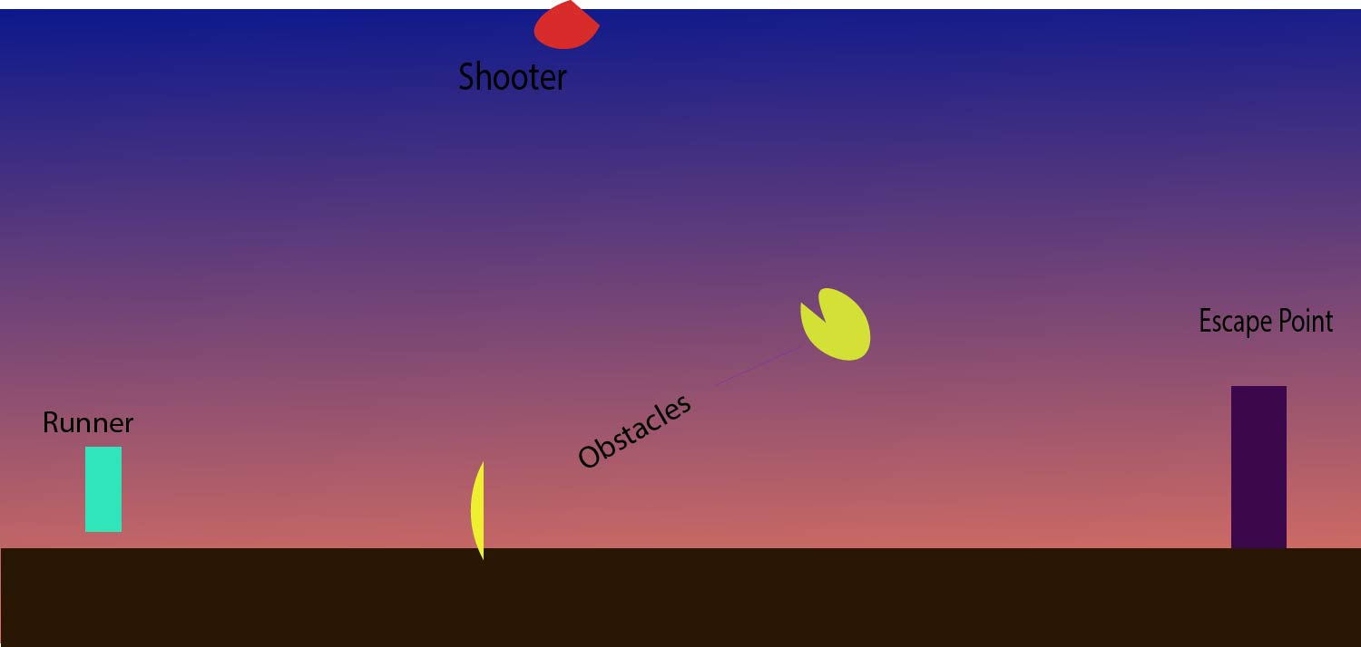

Cyan – runner

Yellow – Obstacles

Violet – Escape Room

Red – shooter

How do you plan to make your game engaging?

* To make the game engaging .When the player enter the escape room there will be new graphics like – background will change , now there will be more obstacles and now there will be no escape room .