250243120054 DotNet Exam Prasad-R-Patil

Models

1-> Customer

namespace DotNetExam.Models;

public class Customer
{
public int CustomerId { get; set; }
public string ContactName { get; set; } = string.Empty;
public string City { get; set; } = string.Empty;
}

2-> Order

namespace DotNetExam.Models;

public class Order
{
public int OrderId { get; set; }
public DateTime OrderDate { get; set; }
public int Quantity { get; set; }
public double UnitPrice { get; set; }
public int CustomerId { get; set; }
}

View

1-> CustomerList

@model List<Customer>

<div>
<h1>Welcome To Customers List!</h1>
<table class="table table-hover table-striped">
<thead>
<tr>
<th>Customer Id</th>
<th>Contact Name</th>
<th>City</th>
</tr>
</thead>
<tbody>
@foreach (var customer in Model)
{
<tr>
<td>@customer.CustomerId</td>
<td>@customer.ContactName</td>
<td>@customer.City</td>
</tr>
}
</tbody>
</table>

</div>

2-> OrderList

@model List<Order>

<div>
<h1>Welcome To Order List!</h1>
<table class="table table-hover table-striped">
<thead>
<tr>
<th>Order Id</th>
<th>CustomerId</th>
<th>OrderDate</th>
<th>Quantity</th>
<th>UnitPrice</th>
<th>Quantity</th>
<th>Total Ammount</th>
</tr>
</thead>
<tbody>
@foreach (var order in Model)
{
<tr>
<td>@order.OrderId</td>
<td>@order.CustomerId</td>
<td>@order.OrderDate</td>
<td>@order.Quantity</td>
<td>@order.UnitPrice</td>
<td>@(order.UnitPrice * order.Quantity)</td>
</tr>
}
</tbody>
</table>

</div>

3-> CustomerOrderList

@using DotNetExam.ViewModels
@model CustomersOrdersVM

<div>
<h1>Customer & Order List</h1>
<hr />

<table class="table table-hover table-striped">
<thead>
<tr>
<th>Customer Id</th>
<th>Contact Name</th>
<th>City</th>
</tr>
</thead>
<tbody>
@foreach (var customer in Model.Customers)
{
<tr>
<td>@customer.CustomerId</td>
<td>@customer.ContactName</td>
<td>@customer.City</td>
</tr>
}
</tbody>
</table>
<br />
<table class="table table-hover table-striped">
<thead>
<tr>
<th>Order Id</th>
<th>Order Date</th>
<th>Quantity</th>
<th>Unit Price</th>
<th>Total Amount</th>
</tr>
</thead>
<tbody>
@foreach (var order in Model.Orders)
{
<tr>
<td>@order.OrderId</td>
<td>@order.OrderDate</td>
<td>@order.Quantity</td>
<td>@order.UnitPrice</td>
<td>@(order.Quantity * order.UnitPrice)</td>
</tr>
}
</tbody>
</table>
</div>

ViewModel

- CustomerOrderVewModel

using DotNetExam.Models;

namespace DotNetExam.ViewModels;

public class CustomersOrdersVM
{
public List<Customer> Customers { get; set; }
public List<Order> Orders { get; set; }

public CustomersOrdersVM()
{
Customers = new List<Customer>()
{
new(){CustomerId = 1, ContactName="Prasad",City="Pune"},
new(){CustomerId = 2, ContactName="Sagar",City="Sangli"},
new(){CustomerId = 3, ContactName="Tejas",City="Satara"},
new(){CustomerId = 4, ContactName="Vikrant",City="Kokan"},
new(){CustomerId = 5, ContactName="Pawan",City="Pune"},
new(){CustomerId = 6, ContactName="Ankesh",City="Akurdi"},
};

Orders = new List<Order>()
{
new(){OrderId = 1, OrderDate= DateTime.Now,Quantity=10,UnitPrice= 450 ,CustomerId = 1},
new(){OrderId = 2, OrderDate= DateTime.Now,Quantity=12,UnitPrice= 120 ,CustomerId = 1},
new(){OrderId = 3, OrderDate= DateTime.Now,Quantity=100,UnitPrice= 150 ,CustomerId = 2},
new(){OrderId = 4, OrderDate= DateTime.Now,Quantity=110,UnitPrice= 50 ,CustomerId = 3},
new(){OrderId = 5, OrderDate= DateTime.Now,Quantity=50,UnitPrice= 450 ,CustomerId = 4},
new(){OrderId = 6, OrderDate= DateTime.Now,Quantity=90,UnitPrice= 490 ,CustomerId = 5},
new(){OrderId = 7, OrderDate= DateTime.Now,Quantity=40,UnitPrice= 450 ,CustomerId = 5},
new(){OrderId = 8, OrderDate= DateTime.Now,Quantity=5,UnitPrice= 4050 ,CustomerId = 4},
new(){OrderId = 9, OrderDate= DateTime.Now,Quantity=11,UnitPrice= 500 ,CustomerId = 2},
new(){OrderId = 10, OrderDate= DateTime.Now,Quantity=110,UnitPrice= 440 ,CustomerId = 1},

};
}
}

Controller

1-> CustomerController

using DotNetExam.Models;
using DotNetExam.ViewModels;
using Microsoft.AspNetCore.Mvc;

namespace DotNetExam.Controllers
{
public class CustomersController : Controller
{
private readonly CustomersOrdersVM customersOrdersVm = new CustomersOrdersVM();
private List<Customer> _customers;
public CustomersController()
{
_customers = new List<Customer>()
{
new(){CustomerId = 1, ContactName="Prasad",City="Pune"},
new(){CustomerId = 2, ContactName="Sagar",City="Sangli"},
new(){CustomerId = 3, ContactName="Tejas",City="Satara"},
new(){CustomerId = 4, ContactName="Vikrant",City="Kokan"},
new(){CustomerId = 5, ContactName="Pawan",City="Pune"},
new(){CustomerId = 6, ContactName="Ankesh",City="Akurdi"},
};
}

public IActionResult List()
{
return View(_customers);
}

public IActionResult CustomersOrders()
{
return View(customersOrdersVm);
}

}
}

2-> OrderController

using DotNetExam.Models;
using Microsoft.AspNetCore.Mvc;

namespace DotNetExam.Controllers
{
public class OrdersController : Controller
{
private List<Order> _orders;
public OrdersController()
{
_orders = new List<Order>()
{
new(){OrderId = 1, OrderDate= DateTime.Now,Quantity=10,UnitPrice= 450 ,CustomerId = 1},
new(){OrderId = 2, OrderDate= DateTime.Now,Quantity=12,UnitPrice= 120 ,CustomerId = 1},
new(){OrderId = 3, OrderDate= DateTime.Now,Quantity=100,UnitPrice= 150 ,CustomerId = 2},
new(){OrderId = 4, OrderDate= DateTime.Now,Quantity=110,UnitPrice= 50 ,CustomerId = 3},
new(){OrderId = 5, OrderDate= DateTime.Now,Quantity=50,UnitPrice= 450 ,CustomerId = 4},
new(){OrderId = 6, OrderDate= DateTime.Now,Quantity=90,UnitPrice= 490 ,CustomerId = 5},
new(){OrderId = 7, OrderDate= DateTime.Now,Quantity=40,UnitPrice= 450 ,CustomerId = 5},
new(){OrderId = 8, OrderDate= DateTime.Now,Quantity=5,UnitPrice= 4050 ,CustomerId = 4},
new(){OrderId = 9, OrderDate= DateTime.Now,Quantity=11,UnitPrice= 500 ,CustomerId = 2},
new(){OrderId = 10, OrderDate= DateTime.Now,Quantity=110,UnitPrice= 440 ,CustomerId = 1},

};
}

public IActionResult List()
{
return View(_orders);
}
}
}

OutPut

1 - https://localhost:7045/customers/list

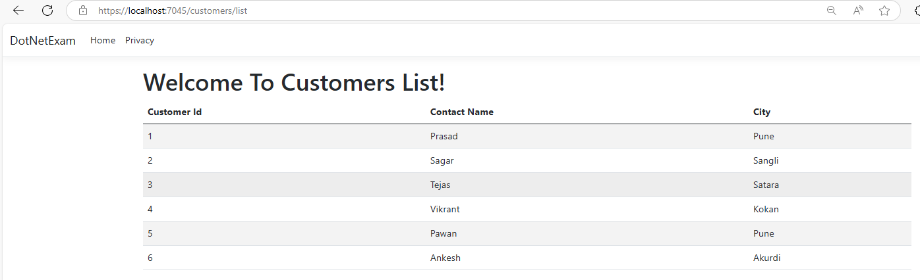

2- https://localhost:7045/orders/list

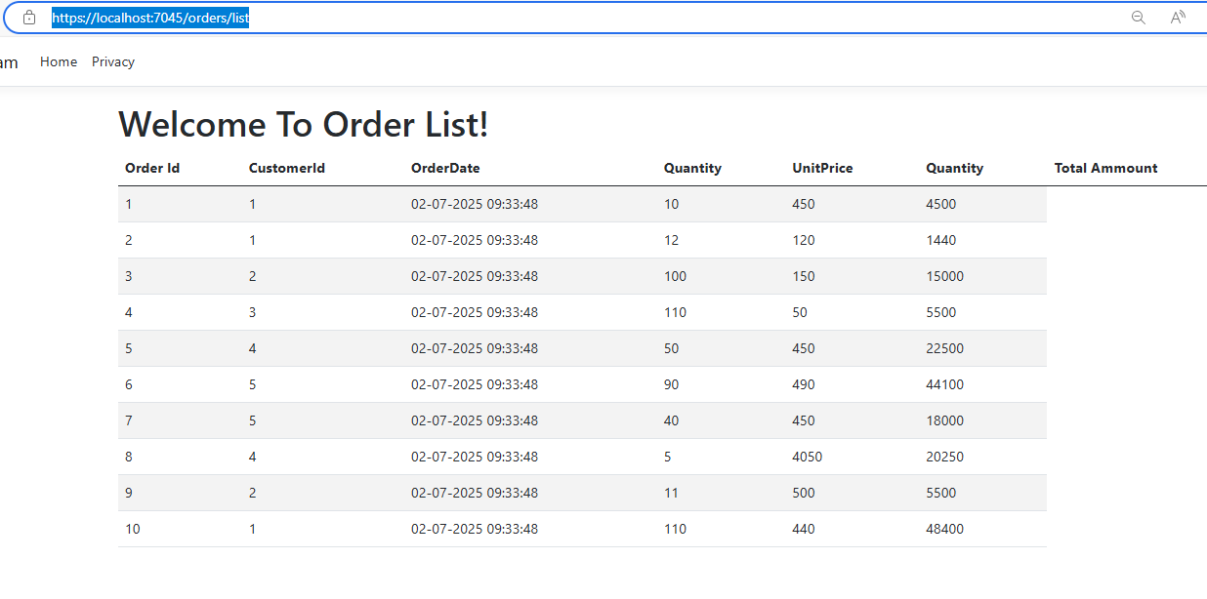

3- https://localhost:7045/orders/customersorders

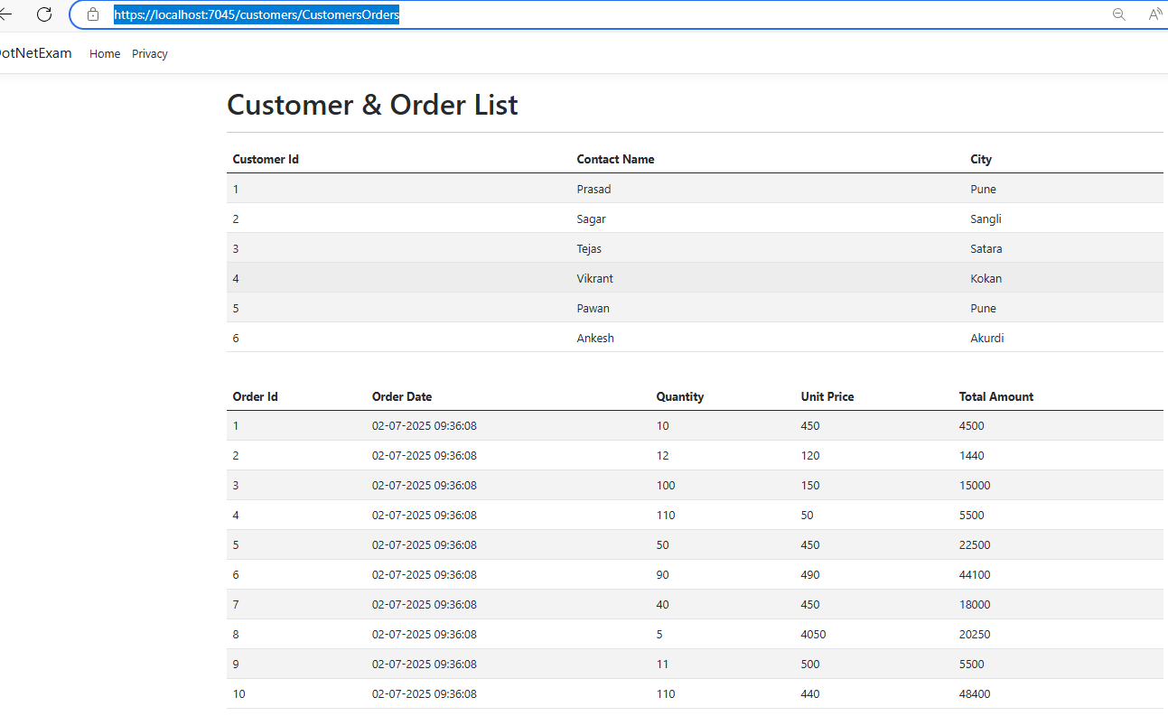

The End

