Pre-requisites are Ubuntu 20.04 and ROS Noetic

Create a folder using terminal

|  |
| --- |
| mkdir -p ~/catkin_ws  cd catkin_ws |

Extract src.rar file in catkin_ws directory

Run below command

|  |
| --- |
| catkin_make |

Run below command

|  |
| --- |
| sudo apt-get install ros-noetic-joy ros-noetic-teleop-twist-joy \  ros-noetic-teleop-twist-keyboard ros-noetic-laser-proc \  ros-noetic-rgbd-launch ros-noetic-rosserial-arduino \  ros-noetic-rosserial-python ros-noetic-rosserial-client \  ros-noetic-rosserial-msgs ros-noetic-amcl ros-noetic-map-server \  ros-noetic-move-base ros-noetic-urdf ros-noetic-xacro \  ros-noetic-compressed-image-transport ros-noetic-rqt* ros-noetic-rviz \  ros-noetic-gmapping ros-noetic-navigation ros-noetic-interactive-markers |

Then run below command

|  |
| --- |
| cd  sudo nano .bashrc |

Add following lines in .bashrc

|  |
| --- |
| source /opt/ros/noetic/setup.bash  source ~/catkin_ws/devel/setup.bash  export TURTLEBOT3_MODEL=burger |

Then close terminal and run below steps

In one terminal run

|  |
| --- |
| roslaunch turtlebot3_gazebo multi_turtlebot3.launch |

In other terminal run

|  |
| --- |
| roslaunch turtlebot3_navigation multi_nav_bringup.launch |

There, there, you'll see the Gazebo window showing house model and three turtlebot3 -- tb3_0, tb3_1, tb3_2,tb3_3

Rviz would be like this.

At the top of rviz you will see three 2D Nav goal options   
click one by one and give location to each robot one by one, you will see like below

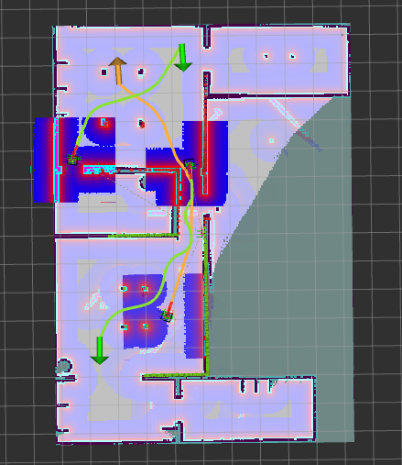

For forth turtlebot3, change topics in Tool properties,

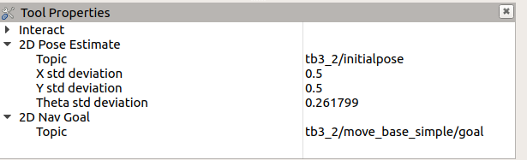

Change them to tb3_3/initialpose and tb3_0/move_base_simple/goal

And now set Pose estimation of the bot by clicking on 2D pose option on top of rviz

And then using 2D Nav goal give final location.