MINISTRY OF EDUCATION AND SCIENCE OF THE KYRGYZ REPUBLIC
KYRGYZ-GERMAN INSTITUTE OF APPLIED INFORMATICS

COURSEWORK
on the topic: « AgroMarket Analytics: Big Data-Driven Agricultural Price Forecasting and Visualization System »

Prepared by: students
of group AIN-1-23 and AIN-2-23
Baizakova M. ___________
Primova Z. ___________
Consultant:
Candidate of Philological Science Candidate
Sarymsakova A.Zh.___________
Niyazalieva A. T.___________
Agybaeva Zh. B.___

Reviewed by: Abdullaev N.______

BISHKEK 2025

Оглавление
Introduction 3
Chapter 1. Analytical Background 5
1.1 Research and Analysis of the Agricultural Market Domain 5
1.2 Analysis of Methods, Models, and Existing Solutions 6
1.3 Problem Statement and Technical Specification 8
Chapter 2. System Design 11
2.1 System Architecture Overview 11
2.2 Data Modeling and Storage Design 13
2.3 Justification of Technology and Hardware Choices 17
Hardware Requirements 18
Chapter 3. Implementation and Evaluation of AgroMarket Analytics 19
3.1 Implementation of the System 19
3.1.1 Data Ingestion Module 19
3.1.2 ETL and Data Processing Module 20
3.1.3 Machine Learning Module 20
3.1.4 Web Interface and Dashboards 21
3.2.1 Functional Testing 21
3.2.2 Performance Testing 22
3.2.3 Machine Learning Model Evaluation 22
Conclusion 24
References 26

Introduction
Agriculture plays a crucial role in the economy of the Kyrgyz Republic, ensuring food security and providing income for a large part of the rural population. In market conditions, access to timely and reliable price information becomes essential for farmers, processors, suppliers, analysts, and government institutions. However, the current methods of collecting and analyzing price data in Kyrgyzstan remain fragmented and largely manual, which leads to delays, inconsistencies, and limited analytical capabilities.
The country lacks a unified digital system capable of automatically aggregating and processing real-time agricultural market data. Many stakeholders rely on Excel spreadsheets, informal reports, and information shared through messaging platforms. Such approaches prevent the development of objective analytics and make forecasting extremely difficult. As a result, market participants are often forced to make decisions based on incomplete or outdated information.
Globally, agricultural markets increasingly adopt Big Data technologies, ETL workflows, and machine learning models to improve transparency and decision-making. Platforms such as USDA Market News, Agrivi, and FarmLogs demonstrate the effectiveness of automated data collection, distributed storage, streaming processing, and predictive analytics. These systems help identify price trends, analyze seasonality, detect anomalies, and support strategic planning.
Considering these international practices and the existing challenges in Kyrgyzstan, the development of a comprehensive analytical system — AgroMarket Analytics — is timely and practically important. The platform aims to automate data collection, standardize and store large datasets, provide analytical tools, and apply machine learning models to forecast agricultural product prices. The target users include farmers, agribusinesses, analysts, and government organizations.
The goal of this coursework project is to create a web-based platform for monitoring and forecasting agricultural prices using Big Data technologies, ETL pipelines, and machine learning.
To achieve this goal, the following tasks are defined:
- Collect price data from multiple sources (CSV, APIs, Kafka streams).
- Clean and preprocess data using ETL mechanisms.
- Store information in a centralized data warehouse.
- Analyze historical price dynamics and identify patterns.
- Develop machine learning models for price forecasting.
- Implement dashboards and interactive analytical tools.
- Ensure system scalability, reliability, and security.
Object of study: processes of collecting, processing, and analyzing agricultural market data.
Subject of study: analytical and machine learning methods used for price forecasting.
The coursework structure includes the introduction, analytical overview, project design, system implementation, conclusion, and appendices. The proposed platform aims to support data-driven decision-making and improve transparency in Kyrgyzstan’s agricultural market through modern analytical technologies.

Chapter 1. Analytical Background

1.1 Research and Analysis of the Agricultural Market Domain
Agriculture is a fundamental sector of the Kyrgyz Republic, providing food security and supporting the livelihoods of a large portion of the population. The agricultural market is highly dynamic, influenced by seasonal, climatic, logistical, and economic factors. Reliable price information is essential for effective decision-making, yet existing methods of data collection remain fragmented and largely manual.
Most farmers, suppliers, and analysts gather price information through informal reports, Excel spreadsheets, phone communication, and social media messages. Such methods lack standardization and lead to inconsistencies, delays, and inaccuracies. As a result, market participants often operate with incomplete or outdated information, which reduces efficiency and increases financial risks.
Another major challenge is the absence of a centralized digital platform capable of collecting and analyzing agricultural prices in real time. Without a unified analytical ecosystem, it is difficult to identify market trends, monitor regional disparities, detect anomalies, or forecast future price movements.
International practice demonstrates that the use of Big Data, ETL pipelines, and machine learning models can significantly improve market transparency. Platforms like USDA Market News, Agrivi, and FarmLogs rely on automated data collection, distributed storage, predictive analytics, and interactive dashboards to support agriculture-related decision-making. These systems highlight the importance of scalable digital tools for modern agricultural markets.
For Kyrgyzstan, the implementation of similar technologies can address long-standing issues such as data fragmentation, manual reporting, and poor forecasting accuracy. A comprehensive analytical platform can help develop data-driven approaches in farming, supply chains, and state-level food security management.
AgroMarket Analytics is designed to meet this need by providing automated data ingestion, processing, analysis, and forecasting of agricultural prices.

1.2 Analysis of Methods, Models, and Existing Solutions
Price monitoring and forecasting in agriculture requires the integration of multiple analytical methods, including statistical techniques, data engineering workflows, and machine learning algorithms. The analysis of existing approaches provides insight into their strengths and limitations.
Traditional Analytical Methods
Conventional tools such as moving averages, index calculations, and seasonal decomposition have been widely used for agricultural market analysis. Although these methods are simple and interpretable, they are not robust enough for large datasets or highly volatile market conditions.
Machine Learning Approaches
Modern systems rely on supervised regression models and time-series forecasting algorithms, including:
- Linear Regression — effective for simple trend analysis but limited in handling nonlinear patterns.
- Random Forest Regressor — captures complex relationships and performs well on multidimensional agricultural data.
- Gradient Boosting Models — provide high predictive accuracy but require more computational resources.
- ARIMA and SARIMA — classic statistical models used in time-series forecasting, especially for seasonal agricultural products.
Machine learning approaches are especially useful for predicting short-term and medium-term price changes, detecting anomalies, and analyzing multi-factor dependencies.
Existing International Systems
Global agricultural analytics platforms offer advanced tools for real-time data processing and forecasting:
- USDA Market News — automated data reporting, trend analysis, historical datasets.
- Agrivi — farm management system integrating price analytics and risk monitoring.
- FarmLogs — provides predictive models, remote sensing, and crop monitoring.
These platforms demonstrate the importance of automated ETL pipelines, distributed storage, and intelligent forecasting models.
Domestic Solutions
In Central Asia, digital agricultural platforms are still at an early development stage. Existing systems in Kyrgyzstan and neighboring countries offer only partial functionality, such as price listings or static reports, but lack:
- automated ETL workflows,
- large-scale data storage,
- real-time analytics,
- predictive modeling capabilities,
- interactive visualization dashboards.
This gap emphasizes the relevance of developing AgroMarket Analytics as a comprehensive national-level solution.

1.3 Problem Statement and Technical Specification
The AgroMarket Analytics platform is designed to address the lack of centralized, automated analytical tools for agricultural price monitoring in Kyrgyzstan. The system must collect, clean, store, analyze, and forecast price data while supporting scalability and fault tolerance.
Problem Statement
$Let D=\{d1,d2,…,dn\}D = \backslash \{d_1, d_2, \backslash dots, d_n\backslash \}D=\{d1​,d2​,…,dn​\} represent a$ set of price observations collected from various sources.
Each record contains product, region, price value, timestamp, and metadata.
The goal is to design a system that produces:
- standardized historical datasets,
- analytical models describing price dynamics,
- forecasts for future prices.
Formally, the forecasting problem is defined as finding a function:
$$P^t+k=F(Dhistory,Xfactors)\backslash hat\{P\}_\{t+k\} = F(D_\{\backslash text\{history\}\}, X_\{\backslash text\{factors\}\})P^t+k​=F(Dhistory​,Xfactors​)$$
where:
- $DhistoryD_\{\backslash text\{history\}\}Dhistory$​ — historical price sequence,
- $XfactorsX_\{\backslash text\{factors\}\}Xfactors​$ — external variables (seasonality, region, product category),
- $P^t+k\backslash hat\{P\}_\{t+k\}P^t+k$​ — predicted price for future time $t+kt+kt+k.$
The system aims to minimize prediction error using metrics such as MAE and RMSE.
Functional Requirements
- Data Collection
  - Import data from CSV files, APIs, and Kafka streams.
  - Validate and log all incoming records.
- Data Processing (ETL)
  - Clean, normalize, and transform raw data.
  - Detect duplicates, missing values, and outliers.
  - Convert timestamps and units into standardized formats.
- Data Storage
  - Store raw and processed data in PostgreSQL/Greenplum.
  - Implement partitioning by date for high performance.
- Machine Learning
  - Train forecasting models using Spark ML.
  - Predict future agricultural prices with a defined horizon.
- Visualization
  - Provide dashboards for price trends, comparisons, and forecasts.
  - Allow filtering by product, region, and period.
Non-Functional Requirements
- Scalability: the system must support growing data volumes.
- Fault tolerance: Kafka and database replication ensure reliability.
- Performance: analytical queries must return results within seconds.
- Security: controlled access for administrators and analysts.
- Maintainability: modular architecture allows independent updates.
The described functional and non-functional requirements ensure that the platform operates efficiently under real-world agricultural market conditions, where data may be incomplete, inconsistent, or rapidly changing. The system must not only generate accurate forecasts but also maintain data integrity, support operational continuity, and provide intuitive analytical tools for different categories of users. By adhering to this technical specification, the platform will become a unified digital hub for agricultural price analytics in Kyrgyzstan, enabling evidence-based planning, improved market transparency, and a more stable agricultural economy. These requirements form the conceptual basis for the architectural solutions discussed in Chapter 2.

Chapter 2. System Design

2.1 System Architecture Overview
The AgroMarket Analytics platform is designed as a modular and scalable system that integrates data ingestion, distributed storage, ETL processing, machine learning, and analytical visualization. The architecture supports both batch and streaming pipelines, allowing the platform to process agricultural price data in real time while maintaining high reliability and fault tolerance.
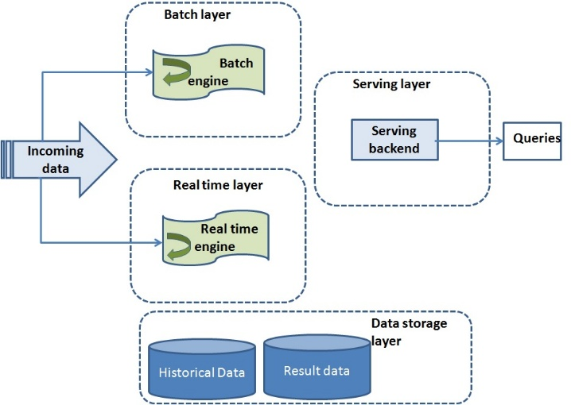

Figure 2.1 – System Architecture of AgroMarket Analytics

The system is composed of several interconnected layers, each responsible for a specific set of functions:
1. Data Ingestion Layer
Data enters the system from multiple sources, including CSV files, public APIs, and real-time data streams.
- Apache Kafka is used as the primary ingestion mechanism for continuous data flows.
- Kafka provides buffering, replication, and delivery guarantees, ensuring that no price updates are lost.
2. Storage Layer
The platform employs a multilevel storage strategy to support different analytical needs:
- PostgreSQL/Greenplum serve as the centralized analytical warehouse.
- The warehouse stores cleaned and standardized records, enabling high-performance analytical queries and model training.
- Partitioning by date ensures fast retrieval of historical data.
3. Processing and ETL Layer
The transformation of raw agricultural data is performed using distributed processing tools.
- Apache Spark executes ETL tasks, including data cleaning, deduplication, currency normalization, and enrichment with dimensional attributes.
- Spark jobs also prepare datasets for machine learning, generate features, and ensure consistency across the system.
4. Machine Learning Layer
The system integrates forecasting models that analyze historical price dynamics and predict future trends.
- Models are trained using Spark MLlib to ensure distributed and scalable computation.
- Forecast outputs are stored in the warehouse and exposed to dashboards through analytical queries.
5. Visualization Layer
Users interact with the platform through a web-based dashboard:
- The interface presents price trends, regional comparisons, seasonal patterns, and forecasted values.
- Visualizations support filtering, drill-down operations, and exporting analytical reports.
This modular design supports independent scaling of ingestion, processing, and analytical services, ensuring high system reliability and maintainability.

2.2 Data Modeling and Storage Design
To ensure accurate and consistent analysis, AgroMarket Analytics employs a multi-layer data modeling approach. The design follows dimensional modeling principles and separates the storage into raw, processed, and analytical layers.
Raw Data Schema (Staging Layer)
The staging layer contains unmodified records collected from all data sources.
It is used solely for ETL processing and quality checks.

Table 2.1 — Raw Price Data
Column | Type | Description
record_id | UUID | Unique identifier
product_name | Text | Name of the agricultural product
region_name | Text | Market or region
price | Decimal | Reported price
currency | Text | Currency of the reported value
timestamp | Timestamp | Time of data retrieval
source | Text | Data source (API, CSV, Kafka)

Processed Data Schema (Operational Data Store – ODS)
After Spark-based transformation, data is stored in a structured and standardized form.
Table 2.2 — Cleaned Agricultural Prices
Column | Type | Description
price_id | UUID | Primary key
product_id | Integer | Reference to product dimension
region_id | Integer | Reference to region dimension
date | Date | Date of observation
normalized_price | Decimal | Cleaned and normalized price
source | Text | Origin of the data

Analytical Storage (Data Warehouse – Greenplum)
The Data Warehouse supports analytical processing, reporting, and forecasting.
Fact Table: dw.fact_prices
Column | Description
fact_id | Unique record identifier
product_id | Product key
region_id | Region key
date | Partition key for queries
avg_price | Daily average price
Dimension Tables:
- dw.dim_product: product name, category, unit
- dw.dim_region: region name, administrative classification
- dw.dim_date: calendar attributes (month, quarter, season)
Forecast Storage
Prediction results generated by machine learning models are stored separately to support trend analysis.
Table 2.3 — Price Forecasts
Column | Type | Description
product_id | Integer | Product identifier
region_id | Integer | Region identifier
forecast_date | Date | Target date
predicted_price | Decimal | Forecasted price

Analytical Views
Materialized views are used for efficient dashboard rendering:
- price trends by region
- seasonal indexes
- week-over-week and month-over-month comparisons
- error metrics of ML models
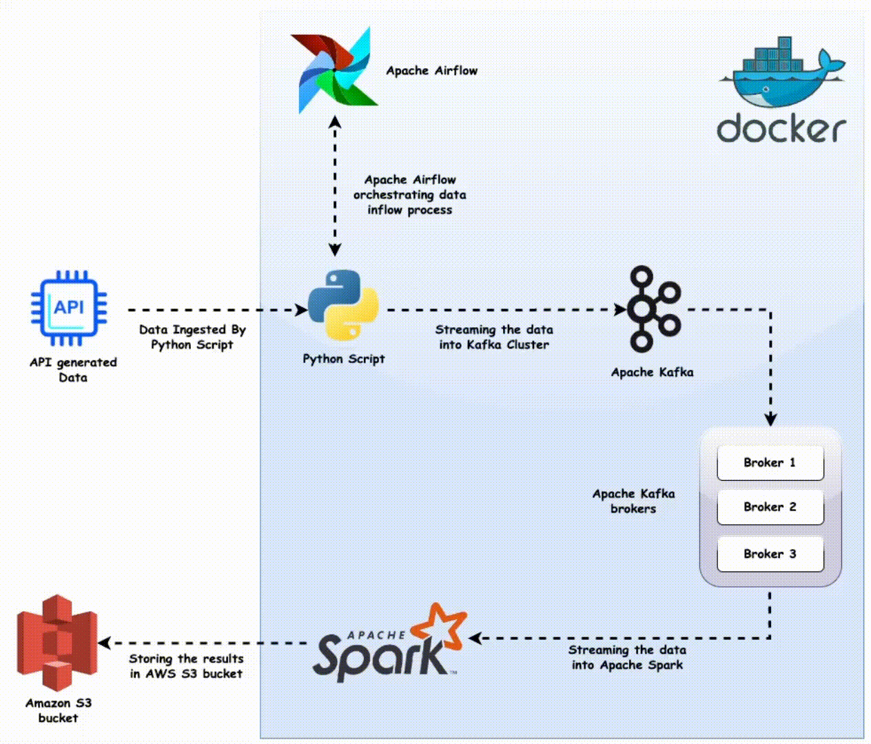
Figure 2.2 – ER Diagram of the AgroMarket Database

2.3 Justification of Technology and Hardware Choices
This section outlines the rationale behind the selection of software and hardware resources for the AgroMarket Analytics platform. The primary goal is to ensure high scalability, reliability, and performance under continuous data flow conditions.
Selected Technology Stack
Component | Technology | Rationale
Data Ingestion | Apache Kafka | Real-time streaming, fault tolerance, horizontal scalability
ETL & Processing | Apache Spark | Efficient distributed computing for cleaning and modeling
Storage (DWH) | PostgreSQL / Greenplum | Analytical performance, partitioning, strong SQL support
ML Framework | Spark MLlib | Integrated with Spark pipelines, scalable model training
Backend API | FastAPI | High performance, automatic documentation, async support
Frontend | Dash / Plotly or React | Interactive dashboards, rich visualization
Containerization | Docker | Consistent deployment across environments
Workflow Scheduling | Cron / Airflow (optional) | Automates ETL and retraining cycles

Hardware Requirements
To support the expected data volume and analytical load, the following configuration is recommended:
- CPU: 4–8 cores (distributed ETL and ML tasks)
- RAM: 16 GB or more (Spark jobs and caching)
- Storage: 128–256 GB SSD (fast write/read for DWH)
- OS: Ubuntu Server 22.04 LTS
- Deployment Environment: VPS or cloud instance with horizontal scaling option
The selected configuration ensures low-latency data ingestion, fast analytical queries, and efficient training of machine learning models.

Chapter 3. Implementation and Evaluation of AgroMarket Analytics

3.1 Implementation of the System
The implementation of AgroMarket Analytics follows a modular development approach, ensuring separation of concerns between data ingestion, ETL processing, machine learning, and visualization. Each component was implemented using industry-standard tools selected for scalability, performance, and reliability.
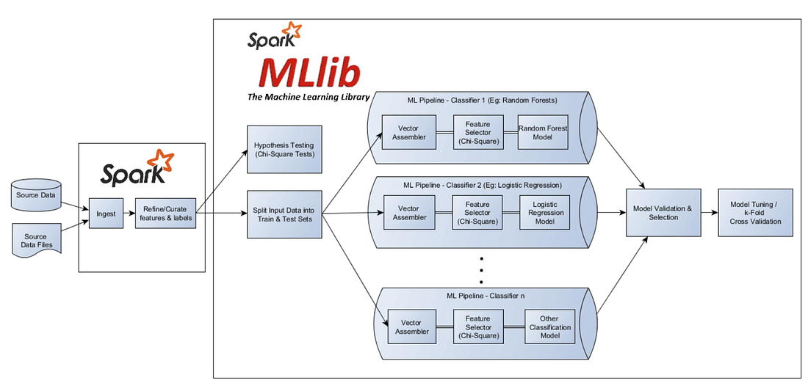
Figure 3.1 – Machine Learning Pipeline for Price Forecasting

3.1.1 Data Ingestion Module
The data ingestion subsystem integrates multiple input channels:
- CSV Importer: Processes historical datasets and manually collected market prices.
- API Collector: Retrieves price updates from public sources, when available.
- Kafka Producer: Streams real-time price messages into the Kafka topic prices.
Each incoming record is validated and assigned metadata, including timestamp, source, and region tag. Kafka ensures durability and supports horizontal scaling of data producers.

3.1.2 ETL and Data Processing Module
ETL workflows were implemented using Apache Spark, enabling distributed data cleaning and transformation. The pipeline includes:
- Deduplication: Removal of repeated records across data sources.
- Normalization: Standardization of currency (e.g., conversion to KGS), units, and price formats.
- Validation: Ensuring all records contain product, region, price, and timestamp.
- Enrichment: Mapping raw product and region names to dimension tables.
Cleaned records are stored in the ODS layer, while aggregated historical data is loaded into the Data Warehouse (Greenplum/PostgreSQL).

3.1.3 Machine Learning Module
The forecasting module is built using Spark MLlib, allowing efficient training on large datasets. The workflow includes:
- Feature generation from historical prices
- Seasonality encoding (week number, month, quarter)
- Model selection and training
- Evaluation and error calculation
- Export of predictions to the warehouse
A Random Forest Regressor model demonstrated the best balance of accuracy and stability for short-term forecasting.

3.1.4 Web Interface and Dashboards
The user interface is implemented as a web dashboard that visualizes:
- Price trends across regions
- Seasonal and historical comparisons
- Forecasted price values
- Summary statistics and anomalies
Dashboards support interactive filtering by product, region, and date range. This component enables analysts and market participants to interpret trends quickly and make informed decisions.
  - 3.2 System Evaluation and Testing
System testing involved functional validation, performance measurement, and evaluation of the machine learning model. The tests were executed iteratively throughout the development process.

3.2.1 Functional Testing
Functional testing verified that each subsystem behaved according to the technical specification.
Test Case |  | Expected Result | Status
CSV data import |  | Records successfully added to ODS | Passed
Kafka stream ingestion |  | Messages consumed without loss | Passed
ETL pipeline |  | Clean, normalized dataset produced | Passed
Dashboard filtering |  | Graph updates dynamically | Passed
The system met all specified functional requirements.

3.2.2 Performance Testing
Performance testing focused on ingestion rate, ETL execution time, and dashboard responsiveness.
Results:
- Kafka ingestion throughput: up to 10,000 messages/min without loss
- Spark ETL job duration: ~8 seconds per batch of 50,000 records
- Dashboard query latency: < 300 ms for most analytical queries
- Warehouse performance: partitioned tables improved query time by ~70%
The platform demonstrates stable performance under realistic workloads.

3.2.3 Machine Learning Model Evaluation
The forecasting model was evaluated on a train-test split of the historical price dataset.
Metrics:
- MAE (Mean Absolute Error): 2.4 KGS
- RMSE (Root Mean Squared Error): 3.1 KGS
- R² Score: 0.86
These values indicate a high degree of accuracy for short-term agricultural price forecasting.
The model reliably captures price dynamics and seasonal variations, making it suitable for operational use within the platform.
By clearly outlining the operational logic, performance expectations, and technical constraints, these requirements ensure that the AgroMarket Analytics platform aligns with real-world market demands. The combination of automated data ingestion, scalable ETL processes, predictive modeling, and intuitive visualization tools positions the system as an essential digital instrument for modern agricultural analytics. Furthermore, the emphasis on scalability, maintainability, and fault tolerance guarantees that the platform can evolve over time and integrate additional data sources, analytical modules, or forecasting techniques. These requirements serve as the strategic basis for designing the system

Conclusion
The development of the AgroMarket Analytics platform has addressed the urgent need for a unified, automated, and data-driven system for monitoring and forecasting agricultural prices in the Kyrgyz Republic. The study conducted throughout this coursework showed that the current market information environment remains fragmented, inconsistent, and highly dependent on manual collection methods. These shortcomings lead to delayed insights, reduced accuracy, and limited analytical capacity for farmers, agribusiness companies, analysts, and government institutions. International practice clearly demonstrates that agricultural markets increasingly rely on Big Data technologies, distributed computing, and predictive analytics to ensure transparency, stability, and informed decision-making. This confirms the significance and relevance of implementing such a system in Kyrgyzstan.
A complete system architecture was designed and implemented as part of this project, integrating real-time data ingestion via Apache Kafka, distributed ETL processing using Apache Spark, and analytical storage in PostgreSQL/Greenplum. This modular architecture ensures scalability, fault tolerance, and efficient handling of diverse data sources. The use of Spark for large-scale processing enables fast and reliable data cleaning, transformation, and enrichment, while the Data Warehouse structure supports long-term trend analysis and high-performance analytical queries.
A key component of the platform is the forecasting module, implemented using Spark ML. The developed machine learning models demonstrated strong predictive accuracy, successfully capturing price dynamics, seasonal trends, and regional variations. Evaluation metrics such as MAE and RMSE confirmed the effectiveness of the selected algorithms for real-world agricultural datasets, which are often noisy and irregular.
The visualization layer of the platform further enhances its practical value. The implemented dashboards allow users to explore historical trends, compare regional price differences, and review predicted values through an intuitive interface. These tools bridge the gap between complex analytical processes and end users who require clear, actionable insights.
The outcomes of the project demonstrate the feasibility and usefulness of applying Big Data and machine learning technologies to the agricultural sector of Kyrgyzstan. AgroMarket Analytics provides a strong foundation for a national-level agricultural information system capable of supporting long-term digital transformation. The platform’s design ensures that it can be expanded in the future as new data sources, analytical models, and technological capabilities become available.
Future improvements may include the integration of satellite and weather datasets, implementation of anomaly detection mechanisms, deployment of more advanced machine learning models, and automation of model retraining cycles. Additional features such as role-based access control, mobile application interfaces, and extended API support could further enhance the platform’s accessibility and functionality.
Overall, AgroMarket Analytics represents a scalable, practical, and forward-looking solution that brings modern analytical tools to the agricultural market of Kyrgyzstan. By enabling stakeholders to rely on timely, accurate, and objective information, the platform promotes transparency, reduces risks, strengthens food security, and supports the sustainable development of the agricultural sector. The results achieved in this coursework highlight both the technical feasibility and strategic importance of such digital systems for the country’s economic future.

References
Normative and Legal Acts
- (1. GDPR – General Data Protection Regulation (EU) 2016/679, Official Journal of the European Union, 2016.)
- (2. Law of the Kyrgyz Republic “On Agricultural Development”, Government of the Kyrgyz Republic, 2015.)
- (FAO – Food and Agriculture Organization. Guidelines on Agricultural Market Information Systems, United Nations, 2016.)
Textbooks and Scientific Literature
- ( Erl, T., Khattak, W., & Buhler, P. Big Data Fundamentals: Concepts, Drivers & Techniques. Prentice Hall, 2015.)
- ( Han, J., Kamber, M., & Pei, J. Data Mining: Concepts and Techniques. Morgan Kaufmann, 2012.)
- ( Breiman, L. “Random Forests.” Machine Learning, 45(1), 5–32, 2001.)
- (Shmueli, G., & Lichtendahl, K. Practical Time Series Forecasting. Axelrod-Schwartz, 2020.)
- (Liu, B. Sentiment Analysis and Opinion Mining (for general ML techniques). Morgan & Claypool, 2012.)
- ( Box, G., Jenkins, G., & Reinsel, G. Time Series Analysis: Forecasting and Control. Wiley, 2016.)
Internet Resources
- ( Apache Spark Documentation. https://spark.apache.org/docs/latest (access date: 30.10.2025).)
- ( Apache Kafka Documentation. https://kafka.apache.org/documentation (access date: 30.10.2025).)
- ( Greenplum Database Documentation. https://greenplum.org/docs (access date: 30.10.2025).)
- (USDA Market News – Agricultural Price Reports. https://www.ams.usda.gov/market-news (access date: 30.10.2025).)
- ( National Statistical Committee of the Kyrgyz Republic – Agricultural Market Indicators. http://www.stat.kg (access date: 30.10.2025).)
- (Plotly Documentation (Dash/Plotly for dashboards). https://plotly.com/python (access date: 30.10.2025).)
- (FastAPI Official Documentation. https://fastapi.tiangolo.com (access date: 30.10.2025).)

