**COMSATS University Islamabad, Wah Campus**Department of Computer Science

Course : **Introduction to Data Science** Total Marks : **10**

Class : **SE-7**  Dated : **20/10/2023**

Semester: **FALL 2023 Submission Deadline: (23-Oct-2023) 11:59 PM.**

**Assignment (02) (CLO 2)**

**Instructions:**

* **Make sure to read all instructions**
* **Make sure this page is the first page of your assignment file.**
* **All answers should start from page 2.**
* **Assignment should be handwritten, scanned, and submitted in PDF format.**
* **Mention both name and roll number on this page.**
* **Give justifications where necessary!**
* **MARKS WILL BE DEDUCTED ON NOT FOLLOWING THE FORMAT.**

**Assignment Tasks:**

**You are paired up with a highway authority for analyzing data of roadmaps to figure out their busiest intersections where they would need to place traffic signals to regulate traffic. Given below is one such map. Find out the points that need the most traffic regulation.**

F

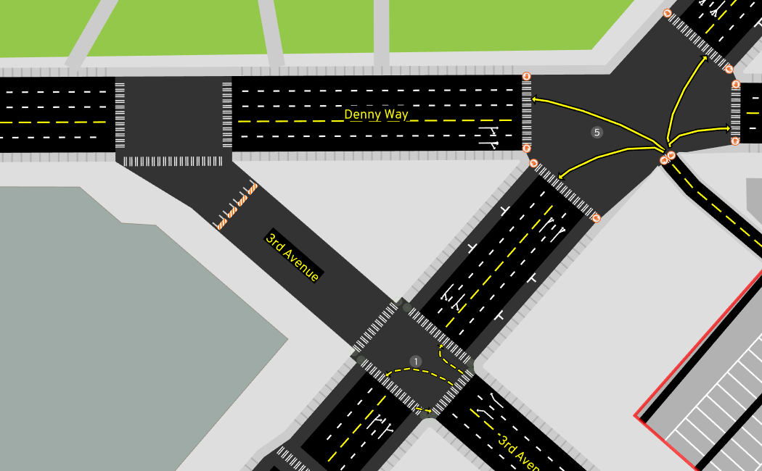

B

C

H

D

G

E

A