|  |
| --- |
| TEKNOLOJI HABER UYGULAMASI (MaliNews) |
| Muhammet Ali KARAKAYA |
| Okul Numarası: 211110037 |



03.01.2023

2022-2023 GÜZ DÖNEMİ

BİLGİSAYAR PROGRAMCILIĞI 2. ÖĞRETİM

BLP211 MOBİL UYGULAMALAR

Gedik Meslek Yüksekokulu

Dr. Öğr. Üyesi Şenay KOCAKOYUN AYDOĞAN

senay.aydogan@gedik.edu.tr

2. Sayfa

**Proje Özeti:**

Kullanıcılar için ideal bir teknoloji haber uygulamasıdır. Anasayfasında, güncel teknoloji haberlerini bulabilir ve arama sayfası aracılığıyla istediğiniz konuda ayrıntılı arama yapabilirsiniz. Bu uygulama, Kullanıcıların teknoloji hakkında daha fazla bilgi edinmelerine ve bu alanda kendilerini geliştirmelerine yardımcı olur. Teknoloji Severler için kolay ve verimli hale getirecek bir araçtır

**Proje Açıklaması:**

Bu mobil uygulama, teknoloji haberleri içeren güncel bir arama motorudur ve animasyonlar kullanarak kullanıcılara hitap eder. Açılır menü seçeneğinde, canlı yayınlar izlenebilir ve ana sayfada döviz kurları görüntülenebilir. Bu sayede, dünyadaki güncel teknoloji haberleri arasında gezinti yapılabilir.

Projede yer alan java, layout klasörleri içinde yer alan dosyalarının isimleri ve altında da ekran görüntüleri yer alacak.

**JAVA**

MainActiviyt.java

AnaSayfa.java

canliizle.java

Haber1.java

Haber2.java

Haber3.java

Haber4.java

Haber5.java

Haber6.java

OkuActivity.java

search.java

**LAYOUT**

activit_main.xml

acilirmenu.xml

activitiy_canliizle.xml

activitiy_haber1.xml

activitiy_haber2.xml

activitiy_haber3.xml

activitiy_haber4.xml

activitiy_haber5.xml

activitiy_haber6.xml

activitiy_oku.xml

activitiy_search.xml

anasayfa.xml

main_toolbar.xml

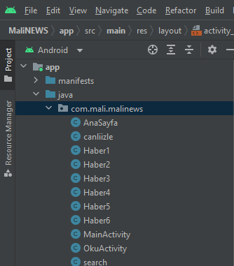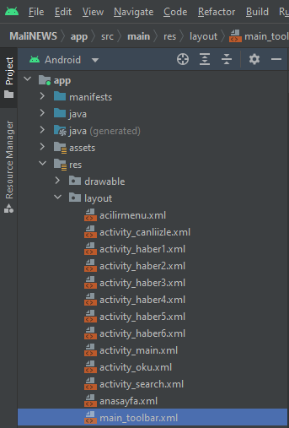

**String.xml(Tüm Sayfalarda Ortak)**

<resources>  
 <string name="app_name">Mali NEWS</string>

<string name="title_activity_acilirmenu2">acilirmenu2</string>  
 <string name="navigation_drawer_open">Open navigation drawer</string>  
 <string name="navigation_drawer_close">Close navigation drawer</string>  
 <string name="nav_header_title">Android Studio</string>  
 <string name="nav_header_subtitle">android.studio@android.com</string>  
 <string name="nav_header_desc">Navigation header</string>  
 <string name="action_settings">Settings</string>  
 <string name="menu_home">Home</string>  
 <string name="menu_gallery">Gallery</string>  
 <string name="menu_slideshow">Slideshow</string>  
 <string name="arama">Arama Yapın</string>  
</resources>

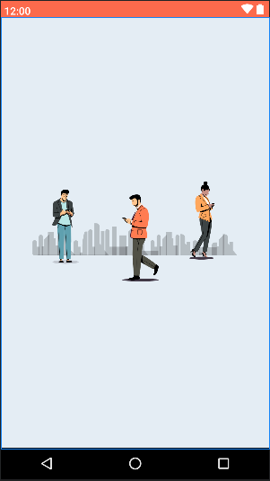

**Activity_main.xml**

*<?*xml version="1.0" encoding="utf-8"*?>*<LinearLayout xmlns:android="http://schemas.android.com/apk/res/android"  
 xmlns:app="http://schemas.android.com/apk/res-auto"  
 xmlns:tools="http://schemas.android.com/tools"  
 android:layout_width="match_parent"  
 android:layout_height="match_parent"  
 android:background="#E4EDF4"  
 android:gravity="center"  
 tools:context=".MainActivity">  
 <com.airbnb.lottie.LottieAnimationView  
 android:layout_width="350dp"  
 android:layout_height="350dp"  
 app:lottie_autoPlay="true"  
 app:lottie_loop="true"  
 app:lottie_fileName="girisanimasyon.json">  
 </com.airbnb.lottie.LottieAnimationView>  
</LinearLayout>

**MainActivity.java**

*<?*xml version="1.0" encoding="utf-8"*?>*<LinearLayout xmlns:android="http://schemas.android.com/apk/res/android"  
 xmlns:app="http://schemas.android.com/apk/res-auto"  
 xmlns:tools="http://schemas.android.com/tools"  
 android:layout_width="match_parent"  
 android:layout_height="match_parent"  
 android:background="#E4EDF4"  
 android:gravity="center"  
 tools:context=".MainActivity">  
 <com.airbnb.lottie.LottieAnimationView  
 android:layout_width="350dp"  
 android:layout_height="350dp"  
 app:lottie_autoPlay="true"  
 app:lottie_loop="true"  
 app:lottie_fileName="girisanimasyon.json">  
 </com.airbnb.lottie.LottieAnimationView>  
</LinearLayout>

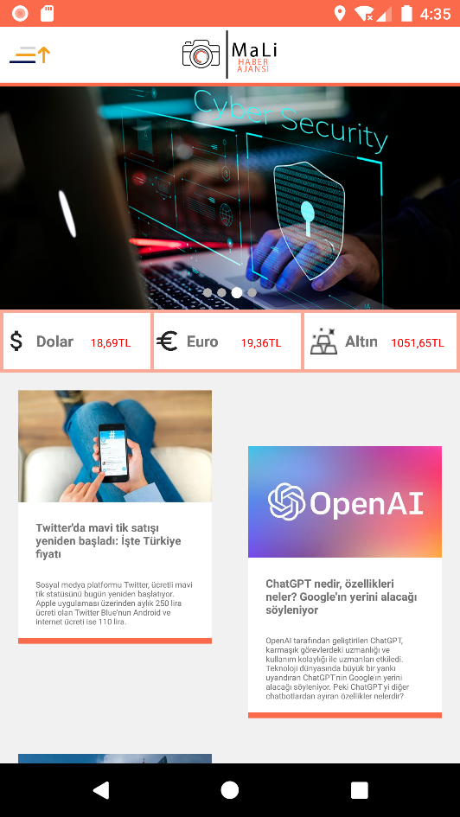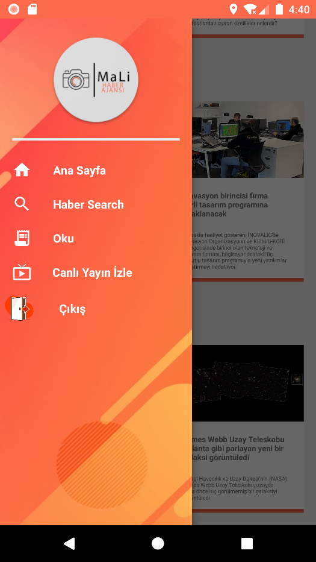

**anasayfa.xml**

*<?*xml version="1.0" encoding="utf-8"*?>*<androidx.drawerlayout.widget.DrawerLayout xmlns:android="http://schemas.android.com/apk/res/android"  
 xmlns:app="http://schemas.android.com/apk/res-auto"  
 xmlns:tools="http://schemas.android.com/tools"  
 android:layout_width="match_parent"  
 android:layout_height="match_parent"  
 android:id="@+id/acilirMenu"  
 tools:context=".AnaSayfa">  
 <ScrollView  
 android:layout_width="match_parent"  
 android:background="#f1f1f1"  
 android:layout_height="match_parent">  
 <LinearLayout  
 android:layout_width="match_parent"  
 android:layout_height="wrap_content"  
 android:orientation="vertical" >  
 <LinearLayout  
 android:layout_width="match_parent"  
 android:layout_height="match_parent"  
 android:orientation="vertical">  
 <include layout="@layout/main_toolbar"/>  
 <View  
 android:layout_width="match_parent"  
 android:layout_height="3dp"  
 android:background="@color/logoturuncu" />  
 </LinearLayout>  
 <LinearLayout  
 android:layout_width="match_parent"  
 android:layout_height="wrap_content">  
 <com.denzcoskun.imageslider.ImageSlider  
 android:layout_width="match_parent"  
 android:layout_height="200dp"  
 app:iss_period="2000"  
 app:iss_auto_cycle="true"  
 android:id="@+id/imageSlider"/>  
 </LinearLayout>  
 <View  
 android:layout_width="match_parent"  
 android:layout_height="3dp"  
 android:background="@color/turuncu" />  
 <LinearLayout  
 android:background="#FFFFFF"  
 android:layout_width="match_parent"  
 android:layout_height="wrap_content"  
 android:orientation="horizontal">  
 <View  
 android:layout_width="3dp"  
 android:layout_height="match_parent"  
 android:background="@color/turuncu"/>  
 <ImageView  
 android:layout_width="wrap_content"  
 android:layout_height="wrap_content"  
 android:src="@drawable/ic_dolaricon"  
 android:layout_gravity="center"/>  
 <TextView  
 android:layout_width="match_parent"  
 android:layout_height="50dp"  
 android:layout_marginLeft="5dp"  
 android:textStyle="bold"  
 android:layout_weight="1"  
 android:text="Dolar"/>  
 <TextView  
 android:id="@+id/textUsd"  
 android:layout_width="match_parent"  
 android:layout_height="50dp"  
 android:layout_weight="1"  
 android:text="18,69TL"  
 android:textSize="10dp"  
 android:textColor="@color/kırmızı"/>  
 <View  
 android:layout_width="3dp"  
 android:layout_height="match_parent"  
 android:background="@color/turuncu" />  
 <ImageView  
 android:layout_width="wrap_content"  
 android:layout_height="wrap_content"  
 android:src="@drawable/ic_euroicon"  
 android:layout_gravity="center"/>  
 <TextView  
 android:layout_width="match_parent"  
 android:layout_height="wrap_content"  
 android:layout_marginLeft="5dp"  
 android:textStyle="bold"  
 android:layout_weight="1"  
 android:text="Euro"/>  
 <TextView  
 android:layout_width="match_parent"  
 android:layout_height="wrap_content"  
 android:layout_weight="1"  
 android:text="19,36TL"  
 android:textSize="10dp"  
 android:textColor="@color/kırmızı"/>  
 <View  
 android:layout_width="3dp"  
 android:layout_height="match_parent"  
 android:background="@color/turuncu" />  
 <ImageView  
 android:layout_width="wrap_content"  
 android:layout_height="wrap_content"  
 android:src="@drawable/altinicon"  
 android:layout_marginLeft="5dp"  
 android:layout_gravity="center"/>  
 <TextView  
 android:layout_width="match_parent"  
 android:layout_height="50dp"  
 android:layout_weight="1"  
 android:layout_marginLeft="-10dp"  
 android:textStyle="bold"  
 android:gravity="center"  
 android:text="Altın" />  
 <TextView  
 android:layout_width="match_parent"  
 android:layout_height="wrap_content"  
 android:layout_weight="1"  
 android:text="1051,65TL"  
 android:textSize="10dp"  
 android:layout_marginLeft="-5dp"  
 android:textColor="@color/kırmızı"/>  
 <View  
 android:layout_width="3dp"  
 android:layout_height="match_parent"  
 android:background="@color/turuncu"/>  
 </LinearLayout>  
 <View  
 android:layout_width="match_parent"  
 android:layout_height="3dp"  
 android:background="@color/turuncu"/>  
 <LinearLayout  
 android:layout_width="match_parent"  
 android:layout_height="wrap_content"  
 android:orientation="horizontal">  
 <LinearLayout  
 android:layout_width="match_parent"  
 android:layout_height="wrap_content"  
 android:layout_weight="1"  
 android:onClick="HaberBir"  
 android:orientation="vertical">  
 <RelativeLayout  
 android:layout_width="match_parent"  
 android:layout_height="wrap_content"  
 android:layout_margin="16dp"  
 android:clickable="true"  
 android:elevation="4dp"  
 android:onClick="HaberBir">  
 <LinearLayout  
 android:layout_width="match_parent"  
 android:layout_height="wrap_content"  
 android:background="#FFFFFF"  
 android:onClick="HaberBir"  
 android:orientation="vertical">  
 <ImageView  
 android:layout_width="match_parent"  
 android:layout_height="100dp"  
 android:scaleType="centerCrop"  
 android:src="@drawable/twiter" />  
 <TextView  
 android:layout_width="match_parent"  
 android:layout_height="wrap_content"  
 android:layout_margin="16dp"  
 android:onClick="HaberBir"  
 android:text="Twitter'da mavi tik satışı yeniden başladı: İşte Türkiye fiyatı"  
 android:textSize="10sp"  
 android:textStyle="bold" />  
 <TextView  
 android:layout_width="match_parent"  
 android:layout_height="wrap_content"  
 android:layout_marginLeft="16dp"  
 android:layout_marginRight="16dp"  
 android:onClick="HaberBir"  
 android:text="Sosyal medya platformu Twitter, ücretli mavi tik statüsünü bugün yeniden başlatıyor. Apple uygulaması üzerinden aylık 250 lira ücreti olan Twitter Blue'nun Android ve internet ücreti ise 110 lira."  
 android:textSize="7sp" />  
 <View  
 android:layout_width="match_parent"  
 android:layout_height="5dp"  
 android:layout_marginTop="10dp"  
 android:background="@color/logoturuncu" />  
 </LinearLayout>  
 </RelativeLayout>  
 </LinearLayout>  
 <LinearLayout  
 android:layout_width="match_parent"  
 android:layout_height="wrap_content"  
 android:layout_marginTop="50dp"  
 android:layout_weight="1"  
 android:alwaysDrawnWithCache="false"  
 android:animateLayoutChanges="false"  
 android:animationCache="false"  
 android:clickable="false"  
 android:orientation="vertical">  
 <RelativeLayout  
 android:layout_width="match_parent"  
 android:layout_height="wrap_content"  
 android:layout_margin="16dp"  
 android:clickable="true"  
 android:elevation="4dp">  
 <LinearLayout  
 android:onClick="HaberIki"  
 android:background="#FFFFFF"  
 android:layout_width="match_parent"  
 android:layout_height="wrap_content"  
 android:orientation="vertical">  
 <ImageView  
 android:layout_width="match_parent"  
 android:layout_height="100dp"  
 android:scaleType="centerCrop"  
 android:src="@drawable/haber2" />  
 <TextView  
 android:layout_width="match_parent"  
 android:layout_height="wrap_content"  
 android:layout_margin="16dp"  
 android:text="ChatGPT nedir, özellikleri neler? Google'ın yerini alacağı söyleniyor"  
 android:textSize="10sp"  
 android:textStyle="bold" />  
 <TextView  
 android:layout_width="match_parent"  
 android:layout_height="wrap_content"  
 android:layout_marginLeft="16dp"  
 android:layout_marginRight="16dp"  
 android:text="OpenAI tarafından geliştirilen ChatGPT, karmaşık görevlerdeki uzmanlığı ve kullanım kolaylığı ile uzmanları etkiledi. Teknoloji dünyasında büyük bir yankı uyandıran ChatGPT'nin Google'ın yerini alacağı söyleniyor. Peki ChatGPT'yi diğer chatbotlardan ayıran özellikler nelerdir?"  
 android:textSize="7sp" />  
 <View  
 android:layout_width="match_parent"  
 android:layout_height="5dp"  
 android:layout_marginTop="10dp"  
 android:background="@color/logoturuncu" />  
 </LinearLayout>  
 </RelativeLayout>  
 </LinearLayout>  
 </LinearLayout>  
 <LinearLayout  
 android:layout_width="match_parent"  
 android:layout_height="wrap_content"  
 android:orientation="horizontal">  
 <LinearLayout  
 android:layout_width="match_parent"  
 android:layout_height="wrap_content"  
 android:layout_weight="1"  
 android:onClick="HaberBir"  
 android:orientation="vertical">  
 <RelativeLayout  
 android:layout_width="match_parent"  
 android:layout_height="wrap_content"  
 android:layout_margin="16dp"  
 android:clickable="true"  
 android:elevation="4dp"  
 android:onClick="HaberBir">  
 <LinearLayout  
 android:layout_width="match_parent"  
 android:layout_height="wrap_content"  
 android:background="#FFFFFF"  
 android:onClick="HaberUc"  
 android:orientation="vertical">  
 <ImageView  
 android:layout_width="match_parent"  
 android:layout_height="100dp"  
 android:scaleType="centerCrop"  
 android:src="@drawable/haber3" />  
 <TextView  
 android:layout_width="match_parent"  
 android:layout_height="wrap_content"  
 android:layout_margin="16dp"  
 android:text="ABD 36 Çinli şirketi kara listeye ekledi"  
 android:textSize="10sp"  
 android:textStyle="bold" />  
 <TextView  
 android:layout_width="match_parent"  
 android:layout_height="wrap_content"  
 android:layout_marginLeft="16dp"  
 android:layout_marginRight="16dp"  
 android:text="ABD Ticaret Bakanlığı'ndan yapılan açıklamada, 36 Çinli şirkete Amerikan malları, yazılımları ve teknolojilerine erişimi ciddi şekilde kısıtlayacak katı lisans gereklilikleri uygulanacağı aktarıldı."  
 android:textSize="7sp" />  
 <View  
 android:layout_width="match_parent"  
 android:layout_height="5dp"  
 android:layout_marginTop="10dp"  
 android:background="@color/logoturuncu" />  
 </LinearLayout>  
 </RelativeLayout>  
 </LinearLayout>  
 <LinearLayout  
 android:layout_width="match_parent"  
 android:layout_height="wrap_content"  
 android:layout_marginTop="50dp"  
 android:layout_weight="1"  
 android:alwaysDrawnWithCache="false"  
 android:animateLayoutChanges="false"  
 android:animationCache="false"  
 android:clickable="false"  
 android:orientation="vertical">  
 <RelativeLayout  
 android:layout_width="match_parent"  
 android:layout_height="wrap_content"  
 android:layout_margin="16dp"  
 android:clickable="true"  
 android:elevation="4dp">  
 <LinearLayout  
 android:background="#FFFFFF"  
 android:layout_width="match_parent"  
 android:layout_height="wrap_content"  
 android:onClick="HaberDort"  
 android:orientation="vertical">  
 <ImageView  
 android:layout_width="match_parent"  
 android:layout_height="100dp"  
 android:scaleType="centerCrop"  
 android:src="@drawable/haber4" />  
 <TextView  
 android:layout_width="match_parent"  
 android:layout_height="wrap_content"  
 android:layout_margin="16dp"  
 android:text="İnovasyon birincisi firma yerli tasarım programına odaklanacak"  
 android:textSize="10sp"  
 android:textStyle="bold" />  
 <TextView  
 android:layout_width="match_parent"  
 android:layout_height="wrap_content"  
 android:layout_marginLeft="16dp"  
 android:layout_marginRight="16dp"  
 android:text="Bursa'da faaliyet gösteren, İNOVALİG'de İnovasyon Organizasyonu ve Kültürü-KOBİ kategorisinde birinci olan teknoloji ve tasarım firması, bilgisayar destekli üç boyutlu tasarım programıyla yeni yazılımlar geliştirmeyi hedefliyor."  
 android:textSize="7sp" />  
 <View  
 android:layout_width="match_parent"  
 android:layout_height="5dp"  
 android:layout_marginTop="10dp"  
 android:background="@color/logoturuncu" />  
 </LinearLayout>  
 </RelativeLayout>  
 </LinearLayout>  
 </LinearLayout>  
 <LinearLayout  
 android:layout_width="match_parent"  
 android:layout_height="wrap_content"  
 android:orientation="horizontal">  
 <LinearLayout  
 android:layout_width="match_parent"  
 android:layout_height="wrap_content"  
 android:layout_weight="1"  
 android:onClick="HaberBir"  
 android:orientation="vertical">  
 <RelativeLayout  
 android:layout_width="match_parent"  
 android:layout_height="wrap_content"  
 android:layout_margin="16dp"  
 android:clickable="true"  
 android:elevation="4dp"  
 android:onClick="HaberBir">  
 <LinearLayout  
 android:layout_width="match_parent"  
 android:layout_height="wrap_content"  
 android:background="#FFFFFF"  
 android:onClick="HaberBes"  
 android:orientation="vertical">  
 <ImageView  
 android:layout_width="match_parent"  
 android:layout_height="100dp"  
 android:scaleType="centerCrop"  
 android:src="@drawable/haber5" />  
 <TextView  
 android:layout_width="match_parent"  
 android:layout_height="wrap_content"  
 android:layout_margin="16dp"  
 android:text="TEKNOFEST’ten başvuru süreci devam eden yarışmalara davet"  
 android:textSize="10sp"  
 android:textStyle="bold" />  
 <TextView  
 android:layout_width="match_parent"  
 android:layout_height="wrap_content"  
 android:layout_marginLeft="16dp"  
 android:layout_marginRight="16dp"  
 android:text="TEKNOFEST Havacılık, Uzay ve Teknoloji Festivali'nde bu yıl 41 ana yarışma 102 farklı kategoride düzenlenen teknoloji yarışmalarından bazılarının başvuru süreci devam ediyor."  
 android:textSize="7sp" />  
 <View  
 android:layout_width="match_parent"  
 android:layout_height="5dp"  
 android:layout_marginTop="10dp"  
 android:background="@color/logoturuncu" />  
 </LinearLayout>  
 </RelativeLayout>  
 </LinearLayout>  
 <LinearLayout  
 android:layout_width="match_parent"  
 android:layout_height="wrap_content"  
 android:layout_marginTop="50dp"  
 android:layout_weight="1"  
 android:alwaysDrawnWithCache="false"  
 android:animateLayoutChanges="false"  
 android:animationCache="false"  
 android:clickable="false"  
 android:orientation="vertical">  
 <RelativeLayout  
 android:layout_width="match_parent"  
 android:layout_height="wrap_content"  
 android:layout_margin="16dp"  
 android:clickable="true"  
 android:elevation="4dp">  
 <LinearLayout  
 android:onClick="HaberAlti"  
 android:background="#FFFFFF"  
 android:layout_width="match_parent"  
 android:layout_height="wrap_content"  
 android:orientation="vertical">  
 <ImageView  
 android:layout_width="match_parent"  
 android:layout_height="100dp"  
 android:scaleType="centerCrop"  
 android:src="@drawable/haber6" />  
 <TextView  
 android:layout_width="match_parent"  
 android:layout_height="wrap_content"  
 android:layout_margin="16dp"  
 android:text="James Webb Uzay Teleskobu pırlanta gibi parlayan yeni bir galaksi görüntüledi"  
 android:textSize="10sp"  
 android:textStyle="bold" />  
 <TextView  
 android:layout_width="match_parent"  
 android:layout_height="wrap_content"  
 android:layout_marginLeft="16dp"  
 android:layout_marginRight="16dp"  
 android:text="Ulusal Havacılık ve Uzay Dairesi'nin (NASA) James Webb Uzay Teleskobu, uzayda daha önce hiç görülmemiş bir galaksiyi görüntüledi."  
 android:textSize="7sp" />  
 <View  
 android:layout_width="match_parent"  
 android:layout_height="5dp"  
 android:layout_marginTop="10dp"  
 android:background="@color/logoturuncu" />  
 </LinearLayout>  
 </RelativeLayout>  
 </LinearLayout>  
 </LinearLayout>  
 </LinearLayout>  
 </ScrollView>  
 <RelativeLayout  
 android:layout_width="250dp"  
 android:layout_height="match_parent"  
 android:background="@color/E4EDF4"  
 android:layout_gravity="start">  
 <include layout="@layout/acilirmenu"/>  
 </RelativeLayout>  
</androidx.drawerlayout.widget.DrawerLayout>

**AnaSayfa.java**

package com.mali.malinews;  
  
import androidx.appcompat.app.AlertDialog;  
import androidx.appcompat.app.AppCompatActivity;  
import androidx.core.view.GravityCompat;  
import androidx.drawerlayout.widget.DrawerLayout;  
  
import android.content.DialogInterface;  
import android.content.Intent;  
import android.graphics.Color;  
import android.os.AsyncTask;  
import android.os.Bundle;  
import android.view.Gravity;  
import android.view.View;  
import android.widget.LinearLayout;  
import android.widget.TextView;  
import android.widget.Toast;  
  
  
  
import com.denzcoskun.imageslider.ImageSlider;  
import com.denzcoskun.imageslider.constants.ScaleTypes;  
import com.denzcoskun.imageslider.models.SlideModel;  
  
import org.json.JSONException;  
import org.json.JSONObject;  
  
import java.io.IOException;  
import java.util.ArrayList;  
  
import okhttp3.OkHttpClient;  
import okhttp3.Request;  
import okhttp3.Response;  
  
public class AnaSayfa extends AppCompatActivity {  
 DrawerLayout aciliirmenu;  
 private ImageSlider imageSlider;  
  
 @Override  
 protected void onCreate(Bundle savedInstanceState) {  
 super.onCreate(savedInstanceState);  
 setContentView(R.layout.*anasayfa*);  
  
 imageSlider = findViewById(R.id.*imageSlider*);  
 ArrayList<SlideModel> slideModels = new ArrayList<>();  
 slideModels.add(new SlideModel(R.drawable.*slider1*, ScaleTypes.*FIT*));  
 slideModels.add(new SlideModel(R.drawable.*slider2*, ScaleTypes.*FIT*));  
 slideModels.add(new SlideModel(R.drawable.*slider3*, ScaleTypes.*FIT*));  
 slideModels.add(new SlideModel(R.drawable.*slider4*, ScaleTypes.*FIT*));  
 imageSlider.setImageList(slideModels, ScaleTypes.*FIT*);  
 aciliirmenu =(DrawerLayout) this.findViewById(R.id.*acilirMenu*);  
  
  
  
 }  
  
  
  
  
 public void MenuTikla(View view)  
 {  
 *MenuAc*(aciliirmenu);  
 }  
  
 public static void MenuAc(DrawerLayout aciliirmenu)  
 {  
 aciliirmenu.openDrawer(GravityCompat.*START*);  
 }  
  
 public void logotikla(View view)  
 {  
 *MenuKapat*(aciliirmenu);  
 }  
  
 public static void MenuKapat(DrawerLayout aciliirmenu)  
 {  
 if (aciliirmenu.isDrawerOpen(GravityCompat.*START*))  
 {  
 aciliirmenu.closeDrawer(GravityCompat.*START*);  
 }  
 }  
  
 public void AnaSayfaTiklama(View view)  
 {  
 Intent intent=new Intent(AnaSayfa.this,AnaSayfa.class);  
 startActivity(intent);  
 }  
 public void HaberSearch(View view)  
 {  
  
 Intent intent=new Intent(AnaSayfa.this,search.class);  
 startActivity(intent);  
 }  
 public void Oku(View view)  
 {  
 Intent intent=new Intent(AnaSayfa.this,OkuActivity.class);  
 startActivity(intent);  
 }  
 public void CanliTiklama(View view)  
 {  
 Intent intent=new Intent(AnaSayfa.this,canliizle.class);  
 startActivity(intent);  
 }  
  
 public void CikisTiklama(View view)  
 {  
 AlertDialog.Builder uyariPenceresi = new AlertDialog.Builder(AnaSayfa.this);  
 uyariPenceresi.setTitle("Çıkış");  
 uyariPenceresi.setMessage("Çıkış Yapılsın Mı ?");  
  
  
 uyariPenceresi.setPositiveButton("EVET", new DialogInterface.OnClickListener() {  
 @Override  
 public void onClick(DialogInterface dialogInterface, int i) {  
 finishAffinity();  
 System.*exit*(0);  
 }  
 });  
  
  
  
 uyariPenceresi.setNegativeButton("HAYIR", new DialogInterface.OnClickListener() {  
 @Override  
 public void onClick(DialogInterface dialogInterface, int i) {  
 dialogInterface.dismiss();  
 }  
 });  
 uyariPenceresi.show();  
 }  
  
  
  
  
  
  
  
  
  
 public void HaberBir(View view)  
 {  
 Intent intent=new Intent(AnaSayfa.this,Haber1.class);  
 startActivity(intent);  
 }  
 public void HaberIki(View view)  
 {  
 Intent intent=new Intent(AnaSayfa.this,Haber2.class);  
 startActivity(intent);  
 }  
 public void HaberUc(View view)  
 {  
 Intent intent=new Intent(AnaSayfa.this,Haber3.class);  
 startActivity(intent);  
 }  
 public void HaberDort(View view)  
 {  
 Intent intent=new Intent(AnaSayfa.this,Haber4.class);  
 startActivity(intent);  
 }  
 public void HaberBes(View view)  
 {  
 Intent intent=new Intent(AnaSayfa.this,Haber5.class);  
 startActivity(intent);  
 }  
 public void HaberAlti(View view)  
 {  
 Intent intent=new Intent(AnaSayfa.this,Haber6.class);  
 startActivity(intent);  
 }  
  
  
  
****}

**activitiy_search.xml**

*<?*xml version="1.0" encoding="utf-8"*?>*<androidx.drawerlayout.widget.DrawerLayout xmlns:android="http://schemas.android.com/apk/res/android"  
 xmlns:app="http://schemas.android.com/apk/res-auto"  
 xmlns:tools="http://schemas.android.com/tools"  
 android:layout_width="match_parent"  
 android:layout_height="match_parent"  
 android:background="#E4EDF4"  
 android:id="@+id/acilirMenu"  
 tools:context=".search">  
 <LinearLayout  
 android:layout_width="match_parent"  
 android:layout_height="match_parent"  
 android:orientation="vertical">  
 <include layout="@layout/main_toolbar"/>  
 <View  
 android:layout_width="match_parent"  
 android:layout_height="3dp"  
 android:background="@color/logoturuncu" />  
 <SearchView  
 android:layout_width="match_parent"  
 android:layout_height="wrap_content"  
 android:layout_marginLeft="15dp"  
 android:layout_marginRight="15dp"  
 android:id="@+id/search_view"  
 android:layout_marginTop="10dp"  
 android:layout_alignParentTop="true"  
 android:background="#fff"/>  
 <View  
 android:layout_width="match_parent"  
 android:layout_height="3dp"  
 android:background="#678CF8"  
 android:layout_marginLeft="15dp"  
 android:layout_marginRight="15dp"/>  
 <com.airbnb.lottie.LottieAnimationView  
 android:layout_width="350dp"  
 android:layout_gravity="center"  
 android:layout_height="350dp"  
 app:lottie_autoPlay="true"  
 app:lottie_loop="true"  
 app:lottie_fileName="search.json">  
 </com.airbnb.lottie.LottieAnimationView>  
 <TextView  
 android:layout_width="match_parent"  
 android:layout_height="wrap_content"  
 android:layout_marginLeft="15dp"  
 android:layout_marginRight="15dp"  
 android:gravity="center"  
 android:text="Ulaşmak Ve Merak Ettiğiniz Her Şey İçin Arama Yapabilirsiniz..."  
 android:textSize="20sp"  
 android:layout_marginTop="30dp"  
 android:textColor="#444A5E"/>  
 </LinearLayout>  
 <RelativeLayout  
 android:layout_width="250dp"  
 android:layout_height="match_parent"  
 android:background="@color/E4EDF4"  
 android:layout_gravity="start">  
 <include layout="@layout/acilirmenu"/>  
 </RelativeLayout>  
</androidx.drawerlayout.widget.DrawerLayout>

**search.java**

package com.mali.malinews;  
  
import androidx.appcompat.app.AlertDialog;  
import androidx.appcompat.app.AppCompatActivity;  
import androidx.core.view.GravityCompat;  
import androidx.drawerlayout.widget.DrawerLayout;  
  
import android.content.DialogInterface;  
import android.content.Intent;  
import android.net.Uri;  
import android.os.Bundle;  
import android.text.TextUtils;  
import android.view.View;  
import android.widget.ArrayAdapter;  
import android.widget.ListView;  
import android.widget.SearchView;  
  
public class search extends AppCompatActivity {  
 DrawerLayout aciliirmenu;  
 private SearchView searchView;  
 @Override  
 protected void onCreate(Bundle savedInstanceState) {  
 super.onCreate(savedInstanceState);  
 setContentView(R.layout.*activity_search*);  
 aciliirmenu =(DrawerLayout) this.findViewById(R.id.*acilirMenu*);  
  
 searchView = findViewById(R.id.*search_view*);  
  
 searchView.setOnQueryTextListener(new SearchView.OnQueryTextListener() {  
 @Override  
 public boolean onQueryTextSubmit(String query) {  
 searchOnGoogle(query);  
 return false;  
 }  
  
 @Override  
 public boolean onQueryTextChange(String newText) {  
 return false;  
 }  
 });  
  
 }  
 private void searchOnGoogle(String query) {  
 String googleSearchUrl = "https://www.google.com/search?q=" + query;  
 Intent intent = new Intent(Intent.*ACTION_VIEW*, Uri.*parse*(googleSearchUrl));  
 startActivity(intent);  
 }  
 public void MenuTikla(View view)  
 {  
 *MenuAc*(aciliirmenu);  
 }  
  
 public static void MenuAc(DrawerLayout aciliirmenu)  
 {  
 aciliirmenu.openDrawer(GravityCompat.*START*);  
 }  
  
 public void logotikla(View view)  
 {  
 *MenuKapat*(aciliirmenu);  
 }  
  
 public static void MenuKapat(DrawerLayout aciliirmenu)  
 {  
 if (aciliirmenu.isDrawerOpen(GravityCompat.*START*))  
 {  
 aciliirmenu.closeDrawer(GravityCompat.*START*);  
 }  
 }  
  
 public void AnaSayfaTiklama(View view)  
 {  
 Intent intent=new Intent(search.this,AnaSayfa.class);  
 startActivity(intent);  
 }  
 public void HaberSearch(View view)  
 {  
 Intent intent=new Intent(search.this,search.class);  
 startActivity(intent);  
 }  
 public void Oku(View view)  
 {  
 Intent intent=new Intent(search.this,OkuActivity.class);  
 startActivity(intent);  
 }  
 public void CanliTiklama(View view)  
 {  
 Intent intent=new Intent(search.this,canliizle.class);  
 startActivity(intent);  
 }  
  
 public void CikisTiklama(View view)  
 {  
 AlertDialog.Builder uyariPenceresi = new AlertDialog.Builder(search.this);  
 uyariPenceresi.setTitle("Çıkış");  
 uyariPenceresi.setMessage("Çıkış Yapılsın Mı ?");  
  
  
 uyariPenceresi.setPositiveButton("EVET", new DialogInterface.OnClickListener() {  
 @Override  
 public void onClick(DialogInterface dialogInterface, int i) {  
 finishAffinity();  
 System.*exit*(0);  
 }  
 });  
  
  
  
 uyariPenceresi.setNegativeButton("HAYIR", new DialogInterface.OnClickListener() {

@Override  
 public void onClick(DialogInterface dialogInterface, int i) {  
 dialogInterface.dismiss();  
 }  
 });  
 uyariPenceresi.show();  
 }  
  
  
}

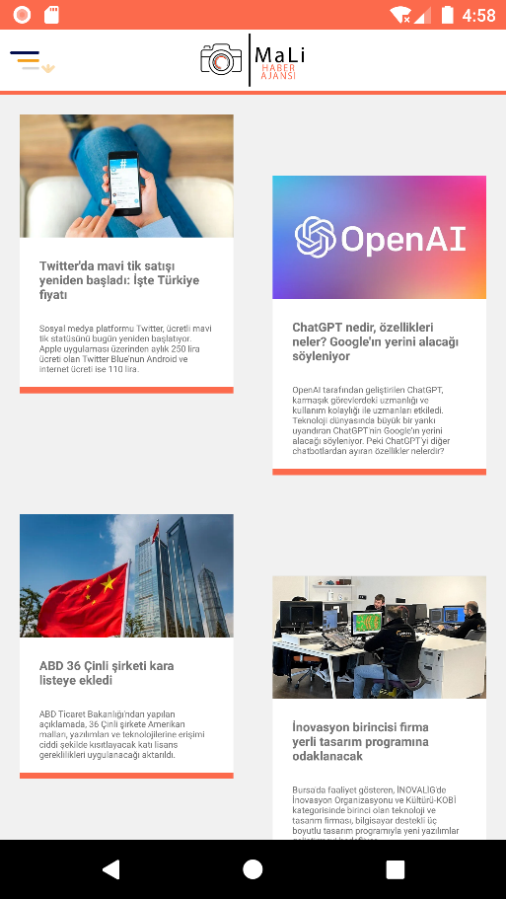

**activitiy_oku.xml**

*<?*xml version="1.0" encoding="utf-8"*?>*<androidx.drawerlayout.widget.DrawerLayout xmlns:android="http://schemas.android.com/apk/res/android"  
 xmlns:app="http://schemas.android.com/apk/res-auto"  
 xmlns:tools="http://schemas.android.com/tools"  
 android:layout_width="match_parent"  
 android:layout_height="match_parent"  
 android:id="@+id/acilirMenu"  
 tools:context=".OkuActivity">  
 <LinearLayout  
 android:layout_width="match_parent"  
 android:layout_height="match_parent"  
 android:orientation="vertical">  
 <include layout="@layout/main_toolbar"/>  
 <View  
 android:layout_width="match_parent"  
 android:layout_height="3dp"  
 android:background="@color/logoturuncu" />  
 </LinearLayout>  
 <ScrollView  
 android:layout_width="match_parent"  
 android:background="#f1f1f1"  
 android:layout_height="match_parent">  
 <LinearLayout  
 android:layout_width="match_parent"  
 android:layout_height="wrap_content"  
 android:orientation="vertical" >  
 <LinearLayout  
 android:layout_width="match_parent"  
 android:layout_height="match_parent"  
 android:orientation="vertical">  
 <include layout="@layout/main_toolbar"/>  
 <View  
 android:layout_width="match_parent"  
 android:layout_height="3dp"  
 android:background="@color/logoturuncu" />  
 </LinearLayout>  
 <LinearLayout  
 android:layout_width="match_parent"  
 android:layout_height="wrap_content"  
 android:orientation="horizontal">  
 <LinearLayout  
 android:layout_width="match_parent"  
 android:layout_height="wrap_content"  
 android:layout_weight="1"  
 android:onClick="HaberBir"  
 android:orientation="vertical">  
 <RelativeLayout  
 android:layout_width="match_parent"  
 android:layout_height="wrap_content"  
 android:layout_margin="16dp"  
 android:clickable="true"  
 android:elevation="4dp"  
 android:onClick="HaberBir">  
 <LinearLayout  
 android:layout_width="match_parent"  
 android:layout_height="wrap_content"  
 android:background="#FFFFFF"  
 android:onClick="HaberBir"  
 android:orientation="vertical">  
 <ImageView  
 android:layout_width="match_parent"  
 android:layout_height="100dp"  
 android:scaleType="centerCrop"  
 android:src="@drawable/twiter" />  
 <TextView  
 android:layout_width="match_parent"  
 android:layout_height="wrap_content"  
 android:layout_margin="16dp"  
 android:onClick="HaberBir"  
 android:text="Twitter'da mavi tik satışı yeniden başladı: İşte Türkiye fiyatı"  
 android:textSize="10sp"  
 android:textStyle="bold" />  
 <TextView  
 android:layout_width="match_parent"  
 android:layout_height="wrap_content"  
 android:layout_marginLeft="16dp"  
 android:layout_marginRight="16dp"  
 android:onClick="HaberBir"  
 android:text="Sosyal medya platformu Twitter, ücretli mavi tik statüsünü bugün yeniden başlatıyor. Apple uygulaması üzerinden aylık 250 lira ücreti olan Twitter Blue'nun Android ve internet ücreti ise 110 lira."  
 android:textSize="7sp" />  
 <View  
 android:layout_width="match_parent"  
 android:layout_height="5dp"  
 android:layout_marginTop="10dp"  
 android:background="@color/logoturuncu" />  
 </LinearLayout>  
 </RelativeLayout>  
 </LinearLayout>  
 <LinearLayout  
 android:layout_width="match_parent"  
 android:layout_height="wrap_content"  
 android:layout_marginTop="50dp"  
 android:layout_weight="1"  
 android:alwaysDrawnWithCache="false"  
 android:animateLayoutChanges="false"  
 android:animationCache="false"  
 android:clickable="false"  
 android:orientation="vertical">  
 <RelativeLayout  
 android:layout_width="match_parent"  
 android:layout_height="wrap_content"  
 android:layout_margin="16dp"  
 android:clickable="true"  
 android:elevation="4dp">  
 <LinearLayout  
 android:onClick="HaberIki"  
 android:background="#FFFFFF"  
 android:layout_width="match_parent"  
 android:layout_height="wrap_content"  
 android:orientation="vertical">  
 <ImageView  
 android:layout_width="match_parent"  
 android:layout_height="100dp"  
 android:scaleType="centerCrop"  
 android:src="@drawable/haber2" />  
 <TextView  
 android:layout_width="match_parent"  
 android:layout_height="wrap_content"  
 android:layout_margin="16dp"  
 android:text="ChatGPT nedir, özellikleri neler? Google'ın yerini alacağı söyleniyor"  
 android:textSize="10sp"  
 android:textStyle="bold" />  
 <TextView  
 android:layout_width="match_parent"  
 android:layout_height="wrap_content"  
 android:layout_marginLeft="16dp"  
 android:layout_marginRight="16dp"  
 android:text="OpenAI tarafından geliştirilen ChatGPT, karmaşık görevlerdeki uzmanlığı ve kullanım kolaylığı ile uzmanları etkiledi. Teknoloji dünyasında büyük bir yankı uyandıran ChatGPT'nin Google'ın yerini alacağı söyleniyor. Peki ChatGPT'yi diğer chatbotlardan ayıran özellikler nelerdir?"  
 android:textSize="7sp" />  
 <View  
 android:layout_width="match_parent"  
 android:layout_height="5dp"  
 android:layout_marginTop="10dp"  
 android:background="@color/logoturuncu" />  
 </LinearLayout>  
 </RelativeLayout>  
 </LinearLayout>  
 </LinearLayout>  
 <LinearLayout  
 android:layout_width="match_parent"  
 android:layout_height="wrap_content"  
 android:orientation="horizontal">  
 <LinearLayout  
 android:layout_width="match_parent"  
 android:layout_height="wrap_content"  
 android:layout_weight="1"  
 android:onClick="HaberBir"  
 android:orientation="vertical">  
 <RelativeLayout  
 android:layout_width="match_parent"  
 android:layout_height="wrap_content"  
 android:layout_margin="16dp"  
 android:clickable="true"  
 android:elevation="4dp"  
 android:onClick="HaberBir">  
 <LinearLayout  
 android:layout_width="match_parent"  
 android:layout_height="wrap_content"  
 android:background="#FFFFFF"  
 android:onClick="HaberUc"  
 android:orientation="vertical">  
 <ImageView  
 android:layout_width="match_parent"  
 android:layout_height="100dp"  
 android:scaleType="centerCrop"  
 android:src="@drawable/haber3" />  
 <TextView  
 android:layout_width="match_parent"  
 android:layout_height="wrap_content"  
 android:layout_margin="16dp"  
 android:text="ABD 36 Çinli şirketi kara listeye ekledi"  
 android:textSize="10sp"  
 android:textStyle="bold" />  
 <TextView  
 android:layout_width="match_parent"  
 android:layout_height="wrap_content"  
 android:layout_marginLeft="16dp"  
 android:layout_marginRight="16dp"  
 android:text="ABD Ticaret Bakanlığı'ndan yapılan açıklamada, 36 Çinli şirkete Amerikan malları, yazılımları ve teknolojilerine erişimi ciddi şekilde kısıtlayacak katı lisans gereklilikleri uygulanacağı aktarıldı."  
 android:textSize="7sp" />  
 <View  
 android:layout_width="match_parent"  
 android:layout_height="5dp"  
 android:layout_marginTop="10dp"  
 android:background="@color/logoturuncu" />  
 </LinearLayout>  
 </RelativeLayout>  
 </LinearLayout>  
 <LinearLayout  
 android:layout_width="match_parent"  
 android:layout_height="wrap_content"  
 android:layout_marginTop="50dp"  
 android:layout_weight="1"  
 android:alwaysDrawnWithCache="false"  
 android:animateLayoutChanges="false"  
 android:animationCache="false"  
 android:clickable="false"  
 android:orientation="vertical">  
 <RelativeLayout  
 android:layout_width="match_parent"  
 android:layout_height="wrap_content"  
 android:layout_margin="16dp"  
 android:clickable="true"  
 android:elevation="4dp">  
 <LinearLayout  
 android:background="#FFFFFF"  
 android:layout_width="match_parent"  
 android:layout_height="wrap_content"  
 android:onClick="HaberDort"  
 android:orientation="vertical">  
 <ImageView  
 android:layout_width="match_parent"  
 android:layout_height="100dp"  
 android:scaleType="centerCrop"  
 android:src="@drawable/haber4" />  
 <TextView  
 android:layout_width="match_parent"  
 android:layout_height="wrap_content"  
 android:layout_margin="16dp"  
 android:text="İnovasyon birincisi firma yerli tasarım programına odaklanacak"  
 android:textSize="10sp"  
 android:textStyle="bold" />  
 <TextView  
 android:layout_width="match_parent"  
 android:layout_height="wrap_content"  
 android:layout_marginLeft="16dp"  
 android:layout_marginRight="16dp"  
 android:text="Bursa'da faaliyet gösteren, İNOVALİG'de İnovasyon Organizasyonu ve Kültürü-KOBİ kategorisinde birinci olan teknoloji ve tasarım firması, bilgisayar destekli üç boyutlu tasarım programıyla yeni yazılımlar geliştirmeyi hedefliyor."  
 android:textSize="7sp" />  
 <View  
 android:layout_width="match_parent"  
 android:layout_height="5dp"  
 android:layout_marginTop="10dp"  
 android:background="@color/logoturuncu" />  
 </LinearLayout>  
 </RelativeLayout>  
 </LinearLayout>  
 </LinearLayout>  
 <LinearLayout  
 android:layout_width="match_parent"  
 android:layout_height="wrap_content"  
 android:orientation="horizontal">  
 <LinearLayout  
 android:layout_width="match_parent"  
 android:layout_height="wrap_content"  
 android:layout_weight="1"  
 android:onClick="HaberBir"  
 android:orientation="vertical">  
  
 <RelativeLayout  
 android:layout_width="match_parent"  
 android:layout_height="wrap_content"  
 android:layout_margin="16dp"  
 android:clickable="true"  
 android:elevation="4dp"  
 android:onClick="HaberBir">  
 <LinearLayout  
 android:layout_width="match_parent"  
 android:layout_height="wrap_content"  
 android:background="#FFFFFF"  
 android:onClick="HaberBes"  
 android:orientation="vertical">  
 <ImageView  
 android:layout_width="match_parent"  
 android:layout_height="100dp"  
 android:scaleType="centerCrop"  
 android:src="@drawable/haber5" />  
 <TextView  
 android:layout_width="match_parent"  
 android:layout_height="wrap_content"  
 android:layout_margin="16dp"  
 android:text="TEKNOFEST’ten başvuru süreci devam eden yarışmalara davet"  
 android:textSize="10sp"  
 android:textStyle="bold" />  
 <TextView  
 android:layout_width="match_parent"  
 android:layout_height="wrap_content"  
 android:layout_marginLeft="16dp"  
 android:layout_marginRight="16dp"  
 android:text="TEKNOFEST Havacılık, Uzay ve Teknoloji Festivali'nde bu yıl 41 ana yarışma 102 farklı kategoride düzenlenen teknoloji yarışmalarından bazılarının başvuru süreci devam ediyor."  
 android:textSize="7sp" />  
 <View  
 android:layout_width="match_parent"  
 android:layout_height="5dp"  
 android:layout_marginTop="10dp"  
 android:background="@color/logoturuncu" />  
 </LinearLayout>  
 </RelativeLayout>  
 </LinearLayout>  
 <LinearLayout  
 android:layout_width="match_parent"  
 android:layout_height="wrap_content"  
 android:layout_marginTop="50dp"  
 android:layout_weight="1"  
 android:alwaysDrawnWithCache="false"  
 android:animateLayoutChanges="false"  
 android:animationCache="false"  
 android:clickable="false"  
 android:orientation="vertical">  
 <RelativeLayout  
 android:layout_width="match_parent"  
 android:layout_height="wrap_content"  
 android:layout_margin="16dp"  
 android:clickable="true"  
 android:elevation="4dp">  
 <LinearLayout  
 android:onClick="HaberAlti"  
 android:background="#FFFFFF"  
 android:layout_width="match_parent"  
 android:layout_height="wrap_content"  
 android:orientation="vertical">  
 <ImageView  
 android:layout_width="match_parent"  
 android:layout_height="100dp"  
 android:scaleType="centerCrop"  
 android:src="@drawable/haber6" />  
 <TextView  
 android:layout_width="match_parent"  
 android:layout_height="wrap_content"  
 android:layout_margin="16dp"  
 android:text="James Webb Uzay Teleskobu pırlanta gibi parlayan yeni bir galaksi görüntüledi"  
 android:textSize="10sp"  
 android:textStyle="bold" />  
 <TextView  
 android:layout_width="match_parent"  
 android:layout_height="wrap_content"  
 android:layout_marginLeft="16dp"  
 android:layout_marginRight="16dp"  
 android:text="Ulusal Havacılık ve Uzay Dairesi'nin (NASA) James Webb Uzay Teleskobu, uzayda daha önce hiç görülmemiş bir galaksiyi görüntüledi."  
 android:textSize="7sp" />  
 <View  
 android:layout_width="match_parent"  
 android:layout_height="5dp"  
 android:layout_marginTop="10dp"  
 android:background="@color/logoturuncu" />  
 </LinearLayout>  
 </RelativeLayout>  
 </LinearLayout>  
 </LinearLayout>  
 </LinearLayout>  
 </ScrollView>  
 <RelativeLayout  
 android:layout_width="250dp"  
 android:layout_height="match_parent"  
 android:background="@color/E4EDF4"  
 android:layout_gravity="start">  
 <include layout="@layout/acilirmenu"/>  
 </RelativeLayout>  
</androidx.drawerlayout.widget.DrawerLayout>

**OkuActivity.java**

package com.mali.malinews;  
  
import androidx.appcompat.app.AlertDialog;  
import androidx.appcompat.app.AppCompatActivity;  
import androidx.core.view.GravityCompat;  
import androidx.drawerlayout.widget.DrawerLayout;  
  
import android.content.DialogInterface;  
import android.content.Intent;  
import android.os.Bundle;  
import android.view.View;  
  
public class OkuActivity extends AppCompatActivity {  
 DrawerLayout aciliirmenu;  
 @Override  
 protected void onCreate(Bundle savedInstanceState) {  
 super.onCreate(savedInstanceState);  
 setContentView(R.layout.*activity_oku*);  
 aciliirmenu =(DrawerLayout) this.findViewById(R.id.*acilirMenu*);  
 }  
 public void MenuTikla(View view)  
 {  
 *MenuAc*(aciliirmenu);  
  
 }  
 public static void MenuAc(DrawerLayout aciliirmenu)  
 {  
 aciliirmenu.openDrawer(GravityCompat.*START*);  
 }  
 public void logotikla(View view)  
 {  
 *MenuKapat*(aciliirmenu);  
  
 }  
 public static void MenuKapat(DrawerLayout aciliirmenu)  
 {  
 if (aciliirmenu.isDrawerOpen(GravityCompat.*START*))  
 {  
 aciliirmenu.closeDrawer(GravityCompat.*START*);  
 }  
 }  
 public void AnaSayfaTiklama(View view)  
 {  
 Intent intent=new Intent(OkuActivity.this,AnaSayfa.class);  
 startActivity(intent);  
 }  
 public void HaberSearch(View view)  
 {  
 Intent intent=new Intent(OkuActivity.this,search.class);  
 startActivity(intent);  
 }  
 public void Oku(View view)  
 {  
 Intent intent=new Intent(OkuActivity.this,OkuActivity.class);  
 startActivity(intent);  
 }  
 public void CanliTiklama(View view)  
 {  
 Intent intent=new Intent(OkuActivity.this,canliizle.class);  
 startActivity(intent);  
 }  
 public void CikisTiklama(View view)  
 {  
 AlertDialog.Builder uyariPenceresi = new AlertDialog.Builder(OkuActivity.this);  
 uyariPenceresi.setTitle("Çıkış");  
 uyariPenceresi.setMessage("Çıkış Yapılsın Mı ?");  
  
  
 uyariPenceresi.setPositiveButton("EVET", new DialogInterface.OnClickListener() {  
 @Override  
 public void onClick(DialogInterface dialogInterface, int i) {  
 finishAffinity();  
 System.*exit*(0);  
 }  
 });  
 uyariPenceresi.setNegativeButton("HAYIR", new DialogInterface.OnClickListener() {  
 @Override  
 public void onClick(DialogInterface dialogInterface, int i) {  
 dialogInterface.dismiss();  
 }  
 });  
 uyariPenceresi.show();  
 }  
 public void HaberBir(View view)  
 {  
 Intent intent=new Intent(OkuActivity.this,Haber1.class);  
 startActivity(intent);  
 }  
 public void HaberIki(View view)  
 {  
 Intent intent=new Intent(OkuActivity.this,Haber2.class);  
 startActivity(intent);  
 }  
 public void HaberUc(View view)  
 {  
 Intent intent=new Intent(OkuActivity.this,Haber3.class);  
 startActivity(intent);  
 }  
 public void HaberDort(View view)  
 {  
 Intent intent=new Intent(OkuActivity.this,Haber4.class);  
 startActivity(intent);  
 }  
 public void HaberBes(View view)  
 {  
 Intent intent=new Intent(OkuActivity.this,Haber5.class);  
 startActivity(intent);  
 }  
 public void HaberAlti(View view)  
 {  
 Intent intent=new Intent(OkuActivity.this,Haber6.class);  
 startActivity(intent);  
 }  
  
}

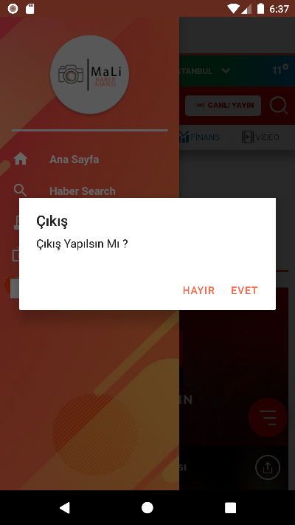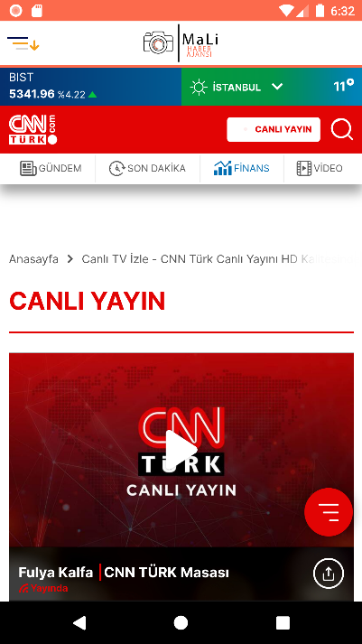

**activity_canliizle.xml**

*<?*xml version="1.0" encoding="utf-8"*?>*<androidx.drawerlayout.widget.DrawerLayout xmlns:android="http://schemas.android.com/apk/res/android"  
 xmlns:app="http://schemas.android.com/apk/res-auto"  
 xmlns:tools="http://schemas.android.com/tools"  
 android:layout_width="match_parent"  
 android:layout_height="match_parent"  
 tools:context=".canliizle"  
 android:id="@+id/acilirMenu">  
 <LinearLayout  
 android:layout_width="match_parent"  
 android:layout_height="match_parent"  
 android:orientation="vertical">  
 <include layout="@layout/main_toolbar"/>  
 <View  
 android:layout_width="match_parent"  
 android:layout_height="3dp"  
 android:background="@color/logoturuncu" />  
 <WebView  
 android:id="@+id/webview"  
 android:layout_width="match_parent"  
 android:layout_height="match_parent" />  
 </LinearLayout>  
 <RelativeLayout  
 android:layout_width="250dp"  
 android:layout_height="match_parent"  
 android:background="@color/E4EDF4"  
 android:layout_gravity="start">  
 <include layout="@layout/acilirmenu"/>  
 </RelativeLayout>  
</androidx.drawerlayout.widget.DrawerLayout>

**canliizle.java**

package com.mali.malinews;  
  
import androidx.appcompat.app.AlertDialog;  
import androidx.appcompat.app.AppCompatActivity;  
import androidx.core.view.GravityCompat;  
import androidx.drawerlayout.widget.DrawerLayout;  
  
import android.content.DialogInterface;  
import android.content.Intent;  
import android.os.Bundle;  
import android.view.View;  
import android.webkit.WebView;  
import android.webkit.WebViewClient;  
import android.widget.Toast;  
  
public class canliizle extends AppCompatActivity {  
 DrawerLayout aciliirmenu;  
 WebView webview;  
 @Override  
 protected void onCreate(Bundle savedInstanceState) {  
 super.onCreate(savedInstanceState);  
 setContentView(R.layout.activity_canliizle);  
 webview = (WebView) findViewById(R.id.webview);  
 webview.getSettings().setJavaScriptEnabled(true);  
 webview.loadUrl("https://www.cnnturk.com/canli-yayin");  
 aciliirmenu =(DrawerLayout) this.findViewById(R.id.acilirMenu);  
  
 }  
 public void MenuTikla(View view)  
 {  
 MenuAc(aciliirmenu);  
  
 }  
 public void MenuAc(DrawerLayout aciliirmenu)  
 {  
 aciliirmenu.openDrawer(GravityCompat.*START*);  
  
 }  
 public void logotikla(View view)  
 {  
 MenuKapat(aciliirmenu);  
  
 }  
 public void MenuKapat(DrawerLayout aciliirmenu)  
 {  
 if (aciliirmenu.isDrawerOpen(GravityCompat.*START*))  
 {  
 aciliirmenu.closeDrawer(GravityCompat.*START*);  
 }  
 }  
 public void AnaSayfaTiklama(View view)  
 {  
 Intent intent=new Intent(canliizle.this,AnaSayfa.class);  
 startActivity(intent);  
 }  
 public void HaberSearch(View view)  
 {  
 Intent intent=new Intent(canliizle.this,search.class);  
 startActivity(intent); }  
 public void Oku(View view)  
 {  
 Intent intent=new Intent(canliizle.this,OkuActivity.class);  
 startActivity(intent); }  
 public void CanliTiklama(View view)  
 {  
 Intent intent=new Intent(canliizle.this,canliizle.class);  
 startActivity(intent);  
  
 }  
 public void CikisTiklama(View view)  
 {  
 AlertDialog.Builder uyariPenceresi = new AlertDialog.Builder(canliizle.this);  
 uyariPenceresi.setTitle("Çıkış");  
 uyariPenceresi.setMessage("Çıkış Yapılsın Mı ?");  
  
  
 uyariPenceresi.setPositiveButton("EVET", new DialogInterface.OnClickListener() {  
 @Override  
 public void onClick(DialogInterface dialogInterface, int i) {  
 finishAffinity();  
 System.exit(0);  
 }  
 });  
  
  
  
 uyariPenceresi.setNegativeButton("HAYIR", new DialogInterface.OnClickListener() {  
 @Override  
 public void onClick(DialogInterface dialogInterface, int i) {  
 dialogInterface.dismiss();  
 }  
 });  
 uyariPenceresi.show();  
 }  
}

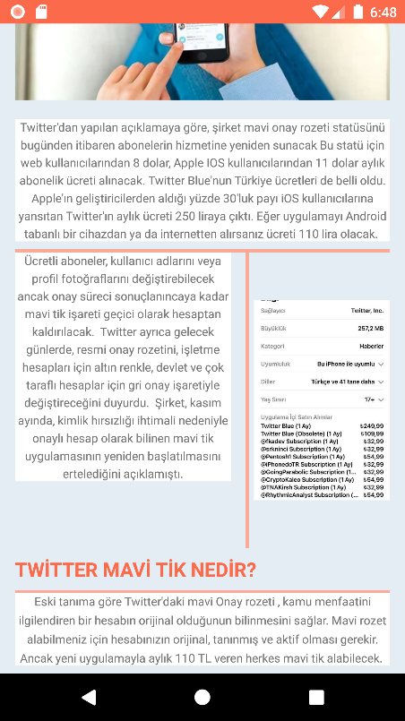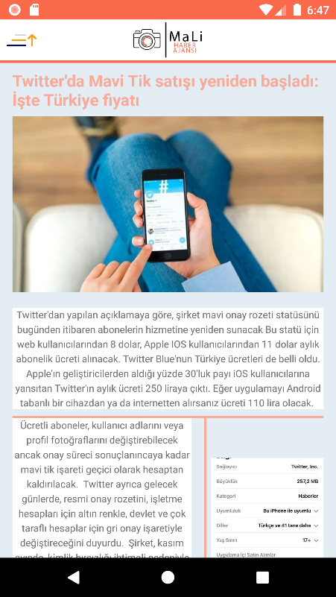

**activitiy_haber1.xml**

*<?*xml version="1.0" encoding="utf-8"*?>*<androidx.drawerlayout.widget.DrawerLayout xmlns:android="http://schemas.android.com/apk/res/android"  
 xmlns:app="http://schemas.android.com/apk/res-auto"  
 xmlns:tools="http://schemas.android.com/tools"  
 android:id="@+id/acilirMenu"  
 android:layout_width="match_parent"  
 android:layout_height="match_parent"  
 android:background="#E4EDF4"  
 tools:context=".Haber1">  
 <ScrollView  
 android:layout_width="match_parent"  
 android:layout_height="match_parent">  
 <LinearLayout  
 android:layout_width="match_parent"  
 android:layout_height="wrap_content"  
 android:orientation="vertical">  
 <LinearLayout  
 android:layout_width="match_parent"  
 android:layout_height="match_parent"  
 android:orientation="vertical">  
 <include layout="@layout/main_toolbar"/>  
 <View  
 android:layout_width="match_parent"  
 android:layout_height="3dp"  
 android:background="@color/logoturuncu" />  
 <LinearLayout  
 android:layout_width="match_parent"  
 android:layout_height="match_parent"  
 android:orientation="vertical">  
 <TextView  
 android:id="@+id/textView"  
 android:layout_width="wrap_content"  
 android:layout_height="wrap_content"  
 android:layout_marginRight="15dp"  
 android:layout_marginLeft="15dp"  
 android:textColor="@color/turuncu"  
 android:text="Twitter'da Mavi Tik satışı yeniden başladı: İşte Türkiye fiyatı"  
 android:textStyle="bold"  
 android:textSize="20sp"  
 android:layout_marginTop="8dp"  
 android:layout_marginBottom="8dp" />  
 <ImageView  
 android:layout_marginTop="-80dp"  
 android:layout_width="wrap_content"  
 android:layout_height="wrap_content"  
 android:layout_marginLeft="15dp"  
 android:layout_marginRight="15dp"  
 android:src="@drawable/twiter" />  
 <TextView  
 android:layout_marginTop="-60dp"  
 android:layout_width="wrap_content"  
 android:layout_height="wrap_content"  
 android:background="#fff"  
 android:layout_marginLeft="15dp"  
 android:layout_marginRight="15dp"  
 android:lineSpacingExtra="4dp"  
 android:gravity="center"  
 android:text="Twitter'dan yapılan açıklamaya göre, şirket mavi onay rozeti statüsünü bugünden itibaren abonelerin hizmetine yeniden sunacak  
Bu statü için web kullanıcılarından 8 dolar, Apple IOS kullanıcılarından 11 dolar aylık abonelik ücreti alınacak.  
Twitter Blue'nun Türkiye ücretleri de belli oldu. Apple'ın geliştiricilerden aldığı yüzde 30'luk payı iOS kullanıcılarına yansıtan Twitter'ın aylık ücreti 250 liraya çıktı. Eğer uygulamayı Android tabanlı bir cihazdan ya da internetten alırsanız ücreti 110 lira olacak. "  
 android:textSize="12sp"  
 android:layout_marginBottom="8dp" />  
 <View  
 android:layout_width="match_parent"  
 android:layout_height="3dp"  
 android:background="@color/turuncu"  
 android:layout_marginRight="15dp"  
 android:layout_marginLeft="15dp"/>  
 <LinearLayout  
 android:layout_width="wrap_content"  
 android:layout_height="wrap_content"  
 android:layout_weight="1"  
 android:orientation="horizontal">  
 <TextView  
 android:id="@+id/textView3"  
 android:layout_width="wrap_content"  
 android:layout_height="wrap_content"  
 android:background="#fff"  
 android:layout_marginLeft="15dp"  
 android:layout_marginRight="15dp"  
 android:lineSpacingExtra="4dp"  
 android:gravity="center"  
 android:layout_weight="1"  
 android:text="Ücretli aboneler, kullanıcı adlarını veya profil fotoğraflarını değiştirebilecek ancak onay süreci sonuçlanıncaya kadar mavi tik işareti geçici olarak hesaptan kaldırılacak.  
  
Twitter ayrıca gelecek günlerde, resmi onay rozetini, işletme hesapları için altın renkle, devlet ve çok taraflı hesaplar için gri onay işaretiyle değiştireceğini duyurdu.  
  
Şirket, kasım ayında, kimlik hırsızlığı ihtimali nedeniyle onaylı hesap olarak bilinen mavi tik uygulamasının yeniden başlatılmasını ertelediğini açıklamıştı."  
 android:textSize="12sp" />  
 <View  
 android:layout_width="3dp"  
 android:layout_height="match_parent"  
 android:background="@color/turuncu" />  
 <ImageView  
 android:layout_marginLeft="5dp"  
 android:layout_marginRight="15dp"  
 android:layout_width="300dp"  
 android:layout_height="300dp"  
 android:layout_weight="1"  
 android:src="@drawable/twiter2" />  
 </LinearLayout>  
 <TextView  
 android:layout_width="wrap_content"  
 android:layout_height="wrap_content"  
 android:text="TWİTTER MAVİ TİK NEDİR?"  
 android:textStyle="bold"  
 android:textSize="20sp"  
 android:layout_marginTop="8dp"  
 android:layout_marginBottom="8dp"  
 android:textColor="@color/logoturuncu"  
 android:layout_marginLeft="15dp"/>  
 <View  
 android:layout_width="match_parent"  
 android:layout_height="3dp"  
 android:background="@color/turuncu"  
 android:layout_marginRight="15dp"  
 android:layout_marginLeft="15dp"/>  
 <TextView  
 android:layout_width="wrap_content"  
 android:layout_height="wrap_content"  
 android:text="Eski tanıma göre Twitter'daki mavi Onay rozeti , kamu menfaatini ilgilendiren bir hesabın orijinal olduğunun bilinmesini sağlar. Mavi rozet alabilmeniz için hesabınızın orijinal, tanınmış ve aktif olması gerekir.  
  
  
Ancak yeni uygulamayla aylık 110 TL veren herkes mavi tik alabilecek.  
"  
 android:lineSpacingExtra="5dp"  
 android:layout_marginLeft="15dp"  
 android:layout_marginRight="15dp"  
 android:background="#fff"  
 android:textSize="12sp"  
 android:gravity="center"  
 android:layout_marginBottom="8dp" />  
 </LinearLayout>  
 </LinearLayout>  
 </LinearLayout>  
 </ScrollView>  
 <RelativeLayout  
 android:layout_width="250dp"  
 android:layout_height="match_parent"  
 android:background="@color/E4EDF4"  
 android:layout_gravity="start">  
 <include layout="@layout/acilirmenu"/>  
 </RelativeLayout>  
</androidx.drawerlayout.widget.DrawerLayout>

**Haber1.java**

package com.mali.malinews;  
  
import androidx.appcompat.app.AlertDialog;  
import androidx.appcompat.app.AppCompatActivity;  
import androidx.core.view.GravityCompat;  
import androidx.drawerlayout.widget.DrawerLayout;  
  
import android.content.DialogInterface;  
import android.content.Intent;  
import android.os.Bundle;  
import android.view.View;  
  
public class Haber1 extends AppCompatActivity {  
 DrawerLayout aciliirmenu;  
 @Override  
 protected void onCreate(Bundle savedInstanceState) {  
 super.onCreate(savedInstanceState);  
 setContentView(R.layout.*activity_haber1*);  
 aciliirmenu =(DrawerLayout) this.findViewById(R.id.*acilirMenu*);  
 }  
 public void MenuTikla(View view)  
 {  
 *MenuAc*(aciliirmenu);  
 }  
  
 public static void MenuAc(DrawerLayout aciliirmenu)  
 {  
 aciliirmenu.openDrawer(GravityCompat.*START*);  
 }  
  
 public void logotikla(View view)  
 {  
 *MenuKapat*(aciliirmenu);  
 }  
  
 public static void MenuKapat(DrawerLayout aciliirmenu)  
 {  
 if (aciliirmenu.isDrawerOpen(GravityCompat.*START*))  
 {  
 aciliirmenu.closeDrawer(GravityCompat.*START*);  
 }  
 }  
  
 public void AnaSayfaTiklama(View view)  
 {  
 Intent intent=new Intent(Haber1.this,AnaSayfa.class);  
 startActivity(intent);  
 }  
 public void HaberSearch(View view)  
 {  
 Intent intent=new Intent(Haber1.this,search.class);  
 startActivity(intent);  
 }  
 public void Oku(View view)  
 {  
 Intent intent=new Intent(Haber1.this,OkuActivity.class);  
 startActivity(intent);  
 }  
 public void CanliTiklama(View view)  
 {  
 Intent intent=new Intent(Haber1.this,canliizle.class);  
 startActivity(intent);  
 }  
  
 public void CikisTiklama(View view)  
 {  
 AlertDialog.Builder uyariPenceresi = new AlertDialog.Builder(Haber1.this);  
 uyariPenceresi.setTitle("Çıkış");  
 uyariPenceresi.setMessage("Çıkış Yapılsın Mı ?");  
  
  
 uyariPenceresi.setPositiveButton("EVET", new DialogInterface.OnClickListener() {  
 @Override  
 public void onClick(DialogInterface dialogInterface, int i) {  
 finishAffinity();  
 System.*exit*(0);  
 }  
 });  
  
  
  
 uyariPenceresi.setNegativeButton("HAYIR", new DialogInterface.OnClickListener() {  
 @Override  
 public void onClick(DialogInterface dialogInterface, int i) {  
 dialogInterface.dismiss();  
 }  
 });  
 uyariPenceresi.show();  
 }  
****}

**activitiy_haber2.xml**

*<?*xml version="1.0" encoding="utf-8"*?>*<androidx.drawerlayout.widget.DrawerLayout xmlns:android="http://schemas.android.com/apk/res/android"  
 xmlns:app="http://schemas.android.com/apk/res-auto"  
 xmlns:tools="http://schemas.android.com/tools"  
 android:id="@+id/acilirMenu"  
 android:layout_width="match_parent"  
 android:layout_height="match_parent"  
 android:background="#E4EDF4"  
 tools:context=".Haber2">  
 <ScrollView  
 android:layout_width="match_parent"  
 android:layout_height="match_parent">  
 <LinearLayout  
 android:layout_width="match_parent"  
 android:layout_height="wrap_content"  
 android:orientation="vertical">  
 <LinearLayout  
 android:layout_width="match_parent"  
 android:layout_height="match_parent"  
 android:orientation="vertical">  
 <include layout="@layout/main_toolbar"/>  
 <View  
 android:layout_width="match_parent"  
 android:layout_height="3dp"  
 android:background="@color/logoturuncu" />  
 <LinearLayout  
 android:layout_width="match_parent"  
 android:layout_height="match_parent"  
 android:orientation="vertical">  
 <TextView  
 android:layout_width="wrap_content"  
 android:layout_height="wrap_content"  
 android:text="ChatGPT nedir, özellikleri neler? Google'ın yerini alacağı söyleniyor"  
 android:textStyle="bold"  
 android:textSize="20sp"  
 android:layout_marginTop="8dp"  
 android:layout_marginBottom="8dp"  
 android:layout_marginLeft="15dp"  
 android:layout_marginRight="15dp"  
 android:textColor="@color/turuncu"/>  
 <TextView  
 android:layout_width="wrap_content"  
 android:layout_height="wrap_content"  
 android:background="#fff"  
 android:text="OpenAI tarafından geliştirilen ChatGPT, karmaşık görevlerdeki uzmanlığı ve kullanım kolaylığı ile uzmanları etkiledi. Teknoloji dünyasında büyük bir yankı uyandıran ChatGPT'nin Google'ın yerini alacağı söyleniyor. Peki ChatGPT'yi diğer chatbotlardan ayıran özellikler nelerdir? "  
 android:textSize="12sp"  
 android:gravity="center"  
 android:lineSpacingExtra="4dp"  
 android:layout_marginBottom="8dp"  
 android:layout_marginLeft="15dp"  
 android:layout_marginRight="15dp"/>  
 <ImageView  
 android:layout_marginTop="-150dp"  
 android:layout_width="match_parent"  
 android:layout_height="match_parent"  
 android:src="@drawable/haber2"  
 android:layout_marginLeft="15dp"  
 android:layout_marginRight="15dp"/>  
 <TextView  
 android:layout_marginTop="-150dp"  
 android:layout_width="wrap_content"  
 android:layout_height="wrap_content"  
 android:gravity="center"  
 android:text="Yapay zeka araştırma şirketi OpenAI, GPT-3.5 dil modeline dayalı bir sohbet robotu olan ChatGPT'yi beta olarak piyasaya sürdü. ChatGPT henüz test aşamasında olmasına rağmen yetenekleri ile dikkatleri üzerine çekmeyi başardı."  
 android:textSize="12sp"  
 android:lineSpacingExtra="4dp"  
 android:background="#fff"  
 android:layout_marginBottom="8dp"  
 android:layout_marginLeft="15dp"  
 android:layout_marginRight="15dp"/>  
 <ImageView  
 android:layout_marginTop="-150dp"  
 android:layout_width="match_parent"  
 android:layout_height="match_parent"  
 android:src="@drawable/google2"  
 android:layout_marginLeft="15dp"  
 android:layout_marginRight="15dp"/>  
 <TextView  
 android:layout_marginTop="-150dp"  
 android:layout_width="wrap_content"  
 android:layout_height="wrap_content"  
 android:text="ChatGPT, doğal insan dilini anlayabilen ve etkileyici derecede ayrıntılı, insan benzeri yazılı metinler üretebilen, prototip diyalog tabanlı bir yapay zeka sohbet robotudur. İnsanmış gibi davranan bu sohbet robotu, verdiği cevaplarda derin öğrenme temelli dil modeli GPT-3.5 sayesinde bu kadar nokta atışı cevaplar verebiliyor."  
 android:textSize="12sp"  
 android:gravity="center"  
 android:lineSpacingExtra="4dp"  
 android:background="#fff"  
 android:layout_marginBottom="8dp"  
 android:layout_marginLeft="15dp"  
 android:layout_marginRight="15dp"/>  
 <ImageView  
 android:layout_marginTop="-150dp"  
 android:layout_marginBottom="-250dp"  
 android:layout_width="match_parent"  
 android:layout_height="match_parent"  
 android:src="@drawable/google"  
 android:layout_marginLeft="15dp"  
 android:layout_marginRight="15dp"/>  
 </LinearLayout>  
 </LinearLayout>  
 </LinearLayout>  
 </ScrollView>  
 <RelativeLayout  
 android:layout_width="250dp"  
 android:layout_height="match_parent"  
 android:background="@color/E4EDF4"  
 android:layout_gravity="start">  
 <include layout="@layout/acilirmenu"/>  
 </RelativeLayout>  
</androidx.drawerlayout.widget.DrawerLayout>

**Haber2.java**

package com.mali.malinews;  
  
import androidx.appcompat.app.AlertDialog;  
import androidx.appcompat.app.AppCompatActivity;  
import androidx.core.view.GravityCompat;  
import androidx.drawerlayout.widget.DrawerLayout;  
  
import android.content.DialogInterface;  
import android.content.Intent;  
import android.os.Bundle;  
import android.view.View;  
  
public class Haber2 extends AppCompatActivity {  
 DrawerLayout aciliirmenu;  
 @Override  
 protected void onCreate(Bundle savedInstanceState) {  
 super.onCreate(savedInstanceState);  
 setContentView(R.layout.*activity_haber2*);  
 aciliirmenu =(DrawerLayout) this.findViewById(R.id.*acilirMenu*);  
 }  
 public void MenuTikla(View view)  
 {  
 *MenuAc*(aciliirmenu);  
 }  
  
 public static void MenuAc(DrawerLayout aciliirmenu)  
 {  
 aciliirmenu.openDrawer(GravityCompat.*START*);  
 }  
  
 public void logotikla(View view)  
 {  
 *MenuKapat*(aciliirmenu);  
 }  
  
 public static void MenuKapat(DrawerLayout aciliirmenu)  
 {  
 if (aciliirmenu.isDrawerOpen(GravityCompat.*START*))  
 {  
 aciliirmenu.closeDrawer(GravityCompat.*START*);  
 }  
 }  
  
 public void AnaSayfaTiklama(View view)  
 {  
 Intent intent=new Intent(Haber2.this,AnaSayfa.class);  
 startActivity(intent);  
 }  
 public void HaberSearch(View view)  
 {  
 Intent intent=new Intent(Haber2.this,search.class);  
 startActivity(intent);  
 }  
 public void Oku(View view)  
 {  
 Intent intent=new Intent(Haber2.this,OkuActivity.class);  
 startActivity(intent);  
 }  
 public void CanliTiklama(View view)  
 {  
 Intent intent=new Intent(Haber2.this,canliizle.class);  
 startActivity(intent);  
 }  
  
 public void CikisTiklama(View view)  
 {  
 AlertDialog.Builder uyariPenceresi = new AlertDialog.Builder(Haber2.this);  
 uyariPenceresi.setTitle("Çıkış");  
 uyariPenceresi.setMessage("Çıkış Yapılsın Mı ?");  
  
  
 uyariPenceresi.setPositiveButton("EVET", new DialogInterface.OnClickListener() {  
 @Override  
 public void onClick(DialogInterface dialogInterface, int i) {  
 finishAffinity();  
 System.*exit*(0);  
 }  
 });  
  
  
  
 uyariPenceresi.setNegativeButton("HAYIR", new DialogInterface.OnClickListener() {  
 @Override  
 public void onClick(DialogInterface dialogInterface, int i) {  
 dialogInterface.dismiss();  
 }  
 });

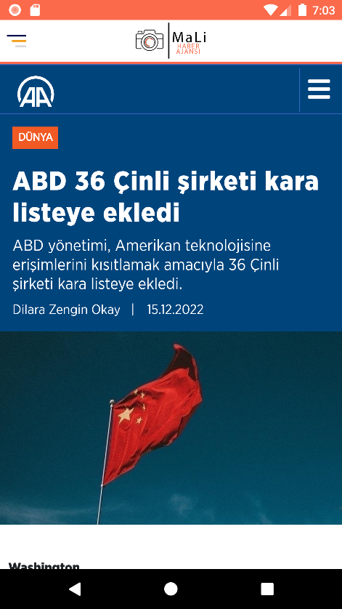  
 uyariPenceresi.show();  
 }  
}

**activitiy_haber3.xml**

*<?*xml version="1.0" encoding="utf-8"*?>*<androidx.drawerlayout.widget.DrawerLayout xmlns:android="http://schemas.android.com/apk/res/android"  
 xmlns:app="http://schemas.android.com/apk/res-auto"  
 xmlns:tools="http://schemas.android.com/tools"  
 android:id="@+id/acilirMenu"  
 android:layout_width="match_parent"  
 android:layout_height="match_parent"  
 tools:context=".Haber3">  
 <ScrollView  
 android:layout_width="match_parent"  
 android:layout_height="match_parent">  
 <LinearLayout  
 android:layout_width="match_parent"  
 android:layout_height="wrap_content"  
 android:orientation="vertical">  
 <LinearLayout  
 android:layout_width="match_parent"  
 android:layout_height="match_parent"  
 android:orientation="vertical">  
 <include layout="@layout/main_toolbar"/>  
 <View  
 android:layout_width="match_parent"  
 android:layout_height="3dp"  
 android:background="@color/logoturuncu" />  
 <WebView  
 android:id="@+id/webview"  
 android:layout_width="match_parent"  
 android:layout_height="match_parent" />  
 </LinearLayout>  
 </LinearLayout>  
 </ScrollView>  
 <RelativeLayout  
 android:layout_width="250dp"  
 android:layout_height="match_parent"  
 android:background="@color/E4EDF4"  
 android:layout_gravity="start">  
 <include layout="@layout/acilirmenu"/>  
 </RelativeLayout>  
</androidx.drawerlayout.widget.DrawerLayout>

**Haber3.java**

package com.mali.malinews;  
  
import androidx.appcompat.app.AlertDialog;  
import androidx.appcompat.app.AppCompatActivity;  
import androidx.core.view.GravityCompat;  
import androidx.drawerlayout.widget.DrawerLayout;  
  
import android.content.DialogInterface;  
import android.content.Intent;  
import android.os.Bundle;  
import android.view.View;  
import android.webkit.WebView;  
  
public class Haber3 extends AppCompatActivity {  
 DrawerLayout aciliirmenu;  
 @Override  
 protected void onCreate(Bundle savedInstanceState) {  
 super.onCreate(savedInstanceState);  
 setContentView(R.layout.*activity_haber3*);  
 aciliirmenu =(DrawerLayout) this.findViewById(R.id.*acilirMenu*);  
 WebView webview = (WebView) findViewById(R.id.*webview*);  
 webview.getSettings().setJavaScriptEnabled(true);  
 webview.loadUrl("https://www.aa.com.tr/tr/dunya/abd-36-cinli-sirketi-kara-listeye-ekledi/2765025");  
  
 }  
 public void MenuTikla(View view)  
 {  
 MenuAc(aciliirmenu);  
  
 }  
 public void MenuAc(DrawerLayout aciliirmenu)  
 {  
 aciliirmenu.openDrawer(GravityCompat.*START*);  
  
 }  
 public void logotikla(View view)  
 {  
 MenuKapat(aciliirmenu);  
  
 }  
 public void MenuKapat(DrawerLayout aciliirmenu)  
 {  
 if (aciliirmenu.isDrawerOpen(GravityCompat.*START*))  
 {  
 aciliirmenu.closeDrawer(GravityCompat.*START*);  
 }  
 }  
 public void AnaSayfaTiklama(View view)  
 {  
 Intent intent=new Intent(Haber3.this,AnaSayfa.class);  
 startActivity(intent);  
 }  
 public void HaberSearch(View view)  
 {  
 Intent intent=new Intent(Haber3.this,search.class);  
 startActivity(intent); }  
 public void Oku(View view)  
 {  
 Intent intent=new Intent(Haber3.this,OkuActivity.class);  
 startActivity(intent); }  
 public void CanliTiklama(View view)  
 {  
 Intent intent=new Intent(Haber3.this,canliizle.class);  
 startActivity(intent);  
  
 }  
 public void CikisTiklama(View view)  
 {  
 AlertDialog.Builder uyariPenceresi = new AlertDialog.Builder(Haber3.this);  
 uyariPenceresi.setTitle("Çıkış");  
 uyariPenceresi.setMessage("Çıkış Yapılsın Mı ?");  
  
  
 uyariPenceresi.setPositiveButton("EVET", new DialogInterface.OnClickListener() {  
 @Override  
 public void onClick(DialogInterface dialogInterface, int i) {  
 finishAffinity();  
 System.*exit*(0);  
 }  
 });  
  
  
  
 uyariPenceresi.setNegativeButton("HAYIR", new DialogInterface.OnClickListener() {  
 @Override  
 public void onClick(DialogInterface dialogInterface, int i) {  
 dialogInterface.dismiss();  
 }  
 });  
 uyariPenceresi.show();  
 }  
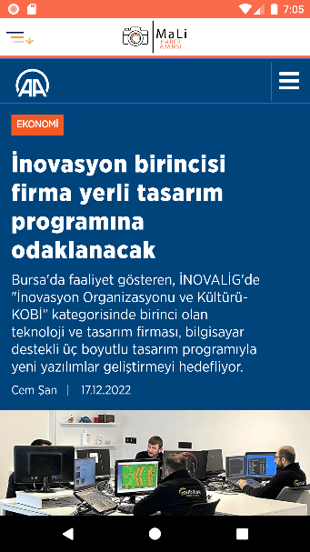}

**activitiy_haber4.xml**

*<?*xml version="1.0" encoding="utf-8"*?>*<androidx.drawerlayout.widget.DrawerLayout xmlns:android="http://schemas.android.com/apk/res/android"  
 xmlns:app="http://schemas.android.com/apk/res-auto"  
 xmlns:tools="http://schemas.android.com/tools"  
 android:id="@+id/acilirMenu"  
 android:layout_width="match_parent"  
 android:layout_height="match_parent"  
 tools:context=".Haber4">  
 <ScrollView  
 android:layout_width="match_parent"  
 android:layout_height="match_parent">  
 <LinearLayout  
 android:layout_width="match_parent"  
 android:layout_height="wrap_content"  
 android:orientation="vertical">  
 <LinearLayout  
 android:layout_width="match_parent"  
 android:layout_height="match_parent"  
 android:orientation="vertical">  
 <include layout="@layout/main_toolbar"/>  
 <View  
 android:layout_width="match_parent"  
 android:layout_height="3dp"  
 android:background="@color/logoturuncu" />  
 <WebView  
 android:id="@+id/webView"  
 android:layout_width="match_parent"  
 android:layout_height="match_parent" />  
 </LinearLayout>  
 </LinearLayout>  
 </ScrollView>  
 <RelativeLayout  
 android:layout_width="250dp"  
 android:layout_height="match_parent"  
 android:background="@color/E4EDF4"  
 android:layout_gravity="start">  
 <include layout="@layout/acilirmenu"/>  
 </RelativeLayout>  
</androidx.drawerlayout.widget.DrawerLayout>

**Haber4.java**

package com.mali.malinews;  
  
import androidx.appcompat.app.AlertDialog;  
import androidx.appcompat.app.AppCompatActivity;  
import androidx.core.view.GravityCompat;  
import androidx.drawerlayout.widget.DrawerLayout;  
  
import android.content.DialogInterface;  
import android.content.Intent;  
import android.os.Bundle;  
import android.view.View;  
import android.webkit.WebView;  
  
public class Haber4 extends AppCompatActivity {  
 DrawerLayout aciliirmenu;  
 @Override  
 protected void onCreate(Bundle savedInstanceState) {  
 super.onCreate(savedInstanceState);  
 setContentView(R.layout.*activity_haber4*);  
 aciliirmenu =(DrawerLayout) this.findViewById(R.id.*acilirMenu*);  
 WebView webview = (WebView) findViewById(R.id.*webView*);  
 webview.getSettings().setJavaScriptEnabled(true);  
 webview.loadUrl("https://www.aa.com.tr/tr/ekonomi/inovasyon-birincisi-firma-yerli-tasarim-programina-odaklanacak/2766244");  
 }  
 public void MenuTikla(View view)  
 {  
 MenuAc(aciliirmenu);  
  
 }  
 public void MenuAc(DrawerLayout aciliirmenu)  
 {  
 aciliirmenu.openDrawer(GravityCompat.START);  
  
 }  
 public void logotikla(View view)  
 {  
 MenuKapat(aciliirmenu);  
  
 }  
 public void MenuKapat(DrawerLayout aciliirmenu)  
 {  
 if (aciliirmenu.isDrawerOpen(GravityCompat.START))  
 {  
 aciliirmenu.closeDrawer(GravityCompat.START);  
 }  
 }  
 public void AnaSayfaTiklama(View view)  
 {  
 Intent intent=new Intent(Haber4.this,AnaSayfa.class);  
 startActivity(intent);  
 }  
 public void HaberSearch(View view)  
 {  
 Intent intent=new Intent(Haber4.this,search.class);  
 startActivity(intent); }  
 public void Oku(View view)  
 {  
 Intent intent=new Intent(Haber4.this,OkuActivity.class);  
 startActivity(intent); }  
 public void CanliTiklama(View view)  
 {  
 Intent intent=new Intent(Haber4.this,canliizle.class);  
 startActivity(intent);  
  
 }  
 public void CikisTiklama(View view)  
 {  
 AlertDialog.Builder uyariPenceresi = new AlertDialog.Builder(Haber4.this);  
 uyariPenceresi.setTitle("Çıkış");  
 uyariPenceresi.setMessage("Çıkış Yapılsın Mı ?");  
  
  
 uyariPenceresi.setPositiveButton("EVET", new DialogInterface.OnClickListener() {  
 @Override  
 public void onClick(DialogInterface dialogInterface, int i) {  
 finishAffinity();  
 System.exit(0);  
 }  
 });  
  
  
  
 uyariPenceresi.setNegativeButton("HAYIR", new DialogInterface.OnClickListener() {  
 @Override  
 public void onClick(DialogInterface dialogInterface, int i) {  
 dialogInterface.dismiss();  
 }  
 });  
 uyariPenceresi.show();  
 }  
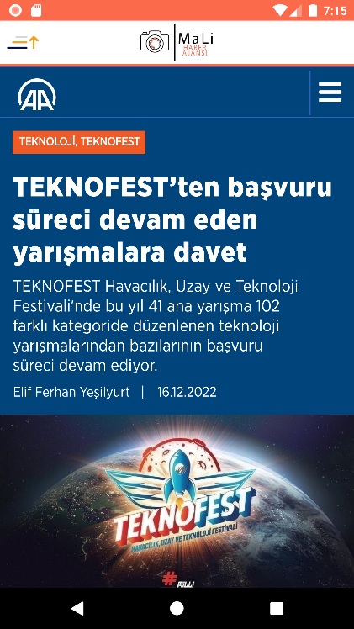}

**activitiy_haber5.xml**

*<?*xml version="1.0" encoding="utf-8"*?>*<androidx.drawerlayout.widget.DrawerLayout xmlns:android="http://schemas.android.com/apk/res/android"  
 xmlns:app="http://schemas.android.com/apk/res-auto"  
 xmlns:tools="http://schemas.android.com/tools"  
 android:id="@+id/acilirMenu"  
 android:layout_width="match_parent"  
 android:layout_height="match_parent"  
 tools:context=".Haber5">  
 <ScrollView  
 android:layout_width="match_parent"  
 android:layout_height="match_parent">  
 <LinearLayout  
 android:layout_width="match_parent"  
 android:layout_height="wrap_content"  
 android:orientation="vertical">  
 <LinearLayout  
 android:layout_width="match_parent"  
 android:layout_height="match_parent"  
 android:orientation="vertical">  
 <include layout="@layout/main_toolbar"/>  
 <View  
 android:layout_width="match_parent"  
 android:layout_height="3dp"  
 android:background="@color/logoturuncu" />  
 <WebView  
 android:id="@+id/webView"  
 android:layout_width="match_parent"  
 android:layout_height="match_parent" />  
 </LinearLayout>  
 </LinearLayout>  
 </ScrollView>  
 <RelativeLayout  
 android:layout_width="250dp"  
 android:layout_height="match_parent"  
 android:background="@color/E4EDF4"  
 android:layout_gravity="start">  
 <include layout="@layout/acilirmenu"/>  
 </RelativeLayout>  
</androidx.drawerlayout.widget.DrawerLayout>

**Haber5.java**

package com.mali.malinews;  
  
import androidx.appcompat.app.AlertDialog;  
import androidx.appcompat.app.AppCompatActivity;  
import androidx.core.view.GravityCompat;  
import androidx.drawerlayout.widget.DrawerLayout;  
  
import android.content.DialogInterface;  
import android.content.Intent;  
import android.os.Bundle;  
import android.view.View;  
import android.webkit.WebView;  
  
public class Haber5 extends AppCompatActivity {  
 DrawerLayout aciliirmenu;  
 @Override  
 protected void onCreate(Bundle savedInstanceState) {  
 super.onCreate(savedInstanceState);  
 setContentView(R.layout.*activity_haber5*);  
 aciliirmenu =(DrawerLayout) this.findViewById(R.id.*acilirMenu*);  
 WebView webView = (WebView) findViewById(R.id.*webView*);  
 webView.getSettings().setJavaScriptEnabled(true);  
 webView.loadUrl("https://www.aa.com.tr/tr/teknofest/teknofest-ten-basvuru-sureci-devam-eden-yarismalara-davet/2765493");  
  
 }  
 public void MenuTikla(View view)  
 {  
 MenuAc(aciliirmenu);  
  
 }  
 public void MenuAc(DrawerLayout aciliirmenu)  
 {  
 aciliirmenu.openDrawer(GravityCompat.*START*);  
  
 }  
 public void logotikla(View view)  
 {  
 MenuKapat(aciliirmenu);  
  
 }  
 public void MenuKapat(DrawerLayout aciliirmenu)  
 {  
 if (aciliirmenu.isDrawerOpen(GravityCompat.*START*))  
 {  
 aciliirmenu.closeDrawer(GravityCompat.*START*);  
 }  
 }  
 public void AnaSayfaTiklama(View view)  
 {  
 Intent intent=new Intent(Haber5.this,AnaSayfa.class);  
 startActivity(intent);  
 }  
 public void HaberSearch(View view)  
 {  
 Intent intent=new Intent(Haber5.this,search.class);  
 startActivity(intent); }  
 public void Oku(View view)  
 {  
 Intent intent=new Intent(Haber5.this,OkuActivity.class);  
 startActivity(intent); }  
 public void CanliTiklama(View view)  
 {  
 Intent intent=new Intent(Haber5.this,canliizle.class);  
 startActivity(intent);  
  
 }  
 public void CikisTiklama(View view)  
 {  
 AlertDialog.Builder uyariPenceresi = new AlertDialog.Builder(Haber5.this);  
 uyariPenceresi.setTitle("Çıkış");  
 uyariPenceresi.setMessage("Çıkış Yapılsın Mı ?");  
  
  
 uyariPenceresi.setPositiveButton("EVET", new DialogInterface.OnClickListener() {  
 @Override  
 public void onClick(DialogInterface dialogInterface, int i) {  
 finishAffinity();  
 System.*exit*(0);  
 }  
 });  
  
  
  
 uyariPenceresi.setNegativeButton("HAYIR", new DialogInterface.OnClickListener() {  
 @Override  
 public void onClick(DialogInterface dialogInterface, int i) {  
 dialogInterface.dismiss();  
 }  
 });  
 uyariPenceresi.show();  
 }  
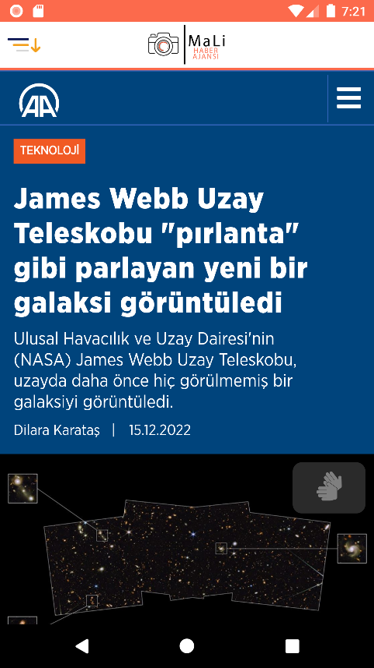}

**activitiy_haber6.xml**

*<?*xml version="1.0" encoding="utf-8"*?>*<androidx.drawerlayout.widget.DrawerLayout xmlns:android="http://schemas.android.com/apk/res/android"  
 xmlns:app="http://schemas.android.com/apk/res-auto"  
 xmlns:tools="http://schemas.android.com/tools"  
 android:id="@+id/acilirMenu"  
 android:layout_width="match_parent"  
 android:layout_height="match_parent"  
 tools:context=".Haber5">  
 <ScrollView  
 android:layout_width="match_parent"  
 android:layout_height="match_parent">  
 <LinearLayout  
 android:layout_width="match_parent"  
 android:layout_height="wrap_content"  
 android:orientation="vertical">  
 <LinearLayout  
 android:layout_width="match_parent"  
 android:layout_height="match_parent"  
 android:orientation="vertical">  
 <include layout="@layout/main_toolbar"/>  
 <View  
 android:layout_width="match_parent"  
 android:layout_height="3dp"  
 android:background="@color/logoturuncu" />  
 <WebView  
 android:id="@+id/webView"  
 android:layout_width="match_parent"  
 android:layout_height="match_parent" />  
 </LinearLayout>  
 </LinearLayout>  
 </ScrollView>  
 <RelativeLayout  
 android:layout_width="250dp"  
 android:layout_height="match_parent"  
 android:background="@color/E4EDF4"  
 android:layout_gravity="start">  
 <include layout="@layout/acilirmenu"/>  
 </RelativeLayout>  
</androidx.drawerlayout.widget.DrawerLayout>

**Haber6.java**

package com.mali.malinews;  
  
import androidx.appcompat.app.AlertDialog;  
import androidx.appcompat.app.AppCompatActivity;  
import androidx.core.view.GravityCompat;  
import androidx.drawerlayout.widget.DrawerLayout;  
  
import android.content.DialogInterface;  
import android.content.Intent;  
import android.os.Bundle;  
import android.view.View;  
import android.webkit.WebView;  
  
public class Haber6 extends AppCompatActivity {  
 DrawerLayout aciliirmenu;  
 @Override  
 protected void onCreate(Bundle savedInstanceState) {  
 super.onCreate(savedInstanceState);  
 setContentView(R.layout.*activity_haber6*);  
 aciliirmenu =(DrawerLayout) this.findViewById(R.id.*acilirMenu*);  
 WebView webView = (WebView) findViewById(R.id.*webView*);  
 webView.getSettings().setJavaScriptEnabled(true);  
 webView.loadUrl("https://www.aa.com.tr/tr/bilim-teknoloji/james-webb-uzay-teleskobu-pirlanta-gibi-parlayan-yeni-bir-galaksi-goruntuledi/2764387");  
  
 }  
 public void MenuTikla(View view)  
 {  
 MenuAc(aciliirmenu);  
  
 }  
 public void MenuAc(DrawerLayout aciliirmenu)  
 {  
 aciliirmenu.openDrawer(GravityCompat.*START*);  
  
 }  
 public void logotikla(View view)  
 {  
 MenuKapat(aciliirmenu);  
  
 }  
 public void MenuKapat(DrawerLayout aciliirmenu)  
 {  
 if (aciliirmenu.isDrawerOpen(GravityCompat.*START*))  
 {  
 aciliirmenu.closeDrawer(GravityCompat.*START*);  
 }  
 }  
 public void AnaSayfaTiklama(View view)  
 {  
 Intent intent=new Intent(Haber6.this,AnaSayfa.class);  
 startActivity(intent);  
 }  
 public void HaberSearch(View view)  
 {  
 Intent intent=new Intent(Haber6.this,search.class);  
 startActivity(intent); }  
 public void Oku(View view)  
 {  
 Intent intent=new Intent(Haber6.this,OkuActivity.class);  
 startActivity(intent); }  
 public void CanliTiklama(View view)  
 {  
 Intent intent=new Intent(Haber6.this,canliizle.class);  
 startActivity(intent);  
  
 }  
 public void CikisTiklama(View view)  
 {  
 AlertDialog.Builder uyariPenceresi = new AlertDialog.Builder(Haber6.this);  
 uyariPenceresi.setTitle("Çıkış");  
 uyariPenceresi.setMessage("Çıkış Yapılsın Mı ?");  
  
  
 uyariPenceresi.setPositiveButton("EVET", new DialogInterface.OnClickListener() {  
 @Override  
 public void onClick(DialogInterface dialogInterface, int i) {  
 finishAffinity();  
 System.*exit*(0);  
 }  
 });  
  
  
  
 uyariPenceresi.setNegativeButton("HAYIR", new DialogInterface.OnClickListener() {  
 @Override  
 public void onClick(DialogInterface dialogInterface, int i) {  
 dialogInterface.dismiss();  
 }  
 });  
 uyariPenceresi.show();  
 }  
}

**main_tolbar.xml**

*<?*xml version="1.0" encoding="utf-8"*?>*<LinearLayout xmlns:android="http://schemas.android.com/apk/res/android"  
 android:layout_width="match_parent"  
 android:layout_height="wrap_content"  
 xmlns:app="http://schemas.android.com/apk/res-auto"  
 android:orientation="horizontal"  
  
 android:background="#FFFFFF"  
 android:layout_centerHorizontal="true">  
 <com.airbnb.lottie.LottieAnimationView  
 android:onClick="MenuTikla"  
 android:layout_width="50dp"  
 android:layout_height="50dp"  
 app:lottie_autoPlay="true"  
 app:lottie_loop="true"  
 app:lottie_fileName="menu.json">  
  
 </com.airbnb.lottie.LottieAnimationView>  
 <ImageView  
 android:layout_marginRight="50dp"  
 android:layout_gravity="center"  
 android:layout_width="match_parent"  
 android:layout_height="44dp"  
 android:layout_weight="1"  
 android:src="@drawable/logom"  
 />  
</LinearLayout>

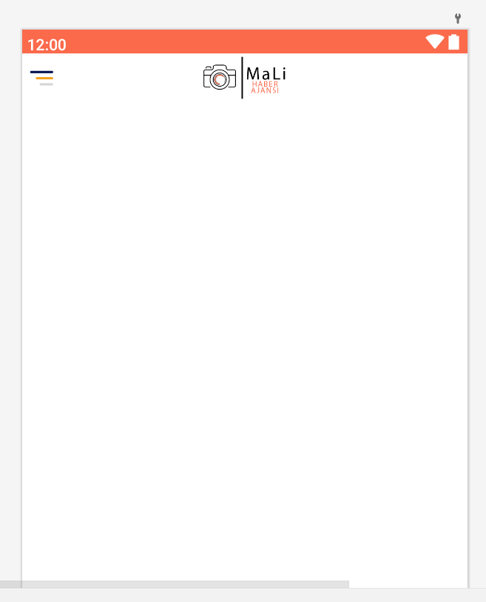

**acilirmenu.xml**

*<?*xml version="1.0" encoding="utf-8"*?>*<LinearLayout xmlns:android="http://schemas.android.com/apk/res/android"  
 android:layout_width="match_parent"  
 android:layout_height="match_parent"  
 xmlns:app="http://schemas.android.com/apk/res-auto"  
 android:background="@drawable/menuarkaplan"  
 android:orientation="vertical">  
 <LinearLayout  
 android:layout_width="match_parent"  
 android:layout_height="wrap_content"  
 android:gravity="center_vertical"  
 android:paddingTop="20dp"  
 android:orientation="vertical"  
 >  
 <ImageView  
 android:layout_width="match_parent"  
 android:layout_height="120dp"  
 android:onClick="logotikla"  
 android:src="@drawable/ic_logoicon"/>  
 <View  
 android:layout_width="match_parent"  
 android:layout_height="3dp"  
 android:layout_margin="16dp"  
 android:background="#E4EDF4"/>  
 </LinearLayout>  
 <LinearLayout  
 android:layout_width="match_parent"  
 android:layout_height="wrap_content"  
 android:gravity="center_vertical"  
 android:onClick="AnaSayfaTiklama"  
 android:orientation="horizontal">  
 <ImageView  
 android:layout_width="25dp"  
 android:layout_height="25dp"  
 android:layout_marginStart="16dp"  
 android:src="@drawable/ic_anasayfa" />  
 <TextView  
 android:layout_width="0dp"  
 android:onClick="AnaSayfaTiklama"  
 android:layout_height="wrap_content"  
 android:layout_marginStart="16dp"  
 android:layout_weight="1"  
 android:padding="12dp"  
 android:textColor="@color/white"  
 android:text="Ana Sayfa"  
 android:textSize="15sp"  
 android:textStyle="bold" />  
 </LinearLayout>  
 <LinearLayout  
 android:layout_width="match_parent"  
 android:layout_height="wrap_content"  
 android:gravity="center_vertical"  
 android:onClick="HaberSearch"  
 android:orientation="horizontal">  
 <ImageView  
 android:layout_width="25dp"  
 android:layout_height="25dp"  
 android:layout_marginStart="16dp"  
 android:src="@drawable/ic_ara" />  
 <TextView  
 android:layout_width="0dp"  
 android:layout_height="wrap_content"  
 android:layout_marginStart="16dp"  
 android:layout_weight="1"  
 android:padding="12dp"  
 android:textColor="@color/white"  
 android:text="Haber Search"  
 android:textSize="15sp"  
 android:textStyle="bold" />  
 </LinearLayout>  
 <LinearLayout  
 android:layout_width="match_parent"  
 android:layout_height="wrap_content"  
 android:gravity="center_vertical"  
 android:orientation="horizontal"  
 android:onClick="Oku">  
 <ImageView  
 android:layout_width="25dp"  
 android:layout_height="25dp"  
 android:layout_marginStart="16dp"  
 android:src="@drawable/ic_oku" />  
 <TextView  
 android:layout_width="0dp"  
 android:layout_height="wrap_content"  
 android:layout_marginStart="16dp"  
 android:layout_weight="1"  
 android:padding="12dp"  
 android:textColor="@color/white"  
 android:text="Oku"  
 android:textSize="15sp"  
 android:textStyle="bold" />  
 </LinearLayout>  
 <LinearLayout  
 android:layout_width="match_parent"  
 android:layout_height="wrap_content"  
 android:gravity="center_vertical"  
 android:onClick="CanliTiklama"  
 android:orientation="horizontal">  
 <ImageView  
 android:layout_width="25dp"  
 android:layout_height="25dp"  
 android:layout_marginStart="16dp"  
 android:src="@drawable/ic_canli" />  
 <TextView  
 android:layout_width="0dp"  
 android:layout_height="wrap_content"  
 android:layout_marginStart="15dp"  
 android:layout_weight="1"  
 android:padding="12dp"  
 android:textColor="@color/white"  
 android:text="Canlı Yayın İzle"  
 android:textSize="15sp"  
 android:textStyle="bold"/>  
 </LinearLayout>  
 <LinearLayout  
 android:layout_width="match_parent"  
 android:layout_height="wrap_content"  
 android:gravity="center_vertical"  
 android:id="@+id/cikis"  
 android:onClick="CikisTiklama"  
 android:orientation="horizontal">  
 <com.airbnb.lottie.LottieAnimationView  
 android:layout_width="50dp"  
 android:layout_height="50dp"  
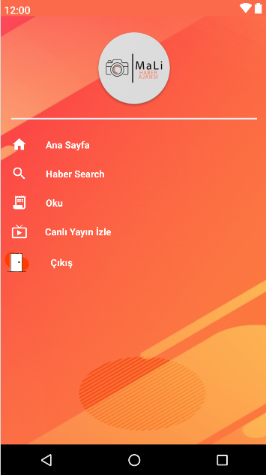 app:lottie_autoPlay="true"  
 app:lottie_loop="true"  
 app:lottie_fileName="exit.json"/>  
 <TextView  
 android:layout_width="0dp"  
 android:layout_height="wrap_content"  
 android:layout_marginStart="15dp"  
 android:layout_weight="1"  
 android:padding="12dp"  
 android:textColor="@color/white"  
 android:text="Çıkış"  
 android:textSize="15sp"  
 android:textStyle="bold" />  
 </LinearLayout>  
</LinearLayout>