## Automated ELK Stack Deployment

The files in this repository were used to configure the network depicted below.

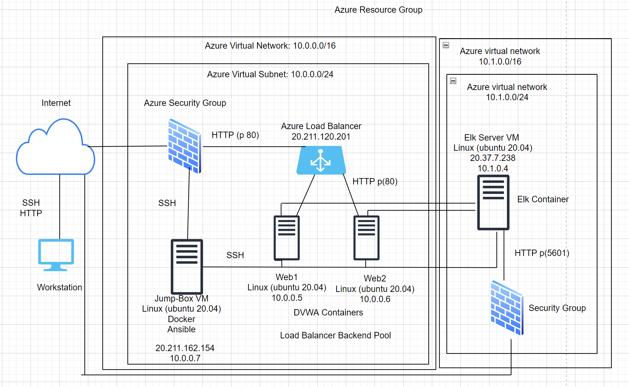

(Images/Week 13 [Mali Munasinghe] V2)

These files have been tested and used to generate a live ELK deployment on Azure. They can be used to either recreate the entire deployment pictured above. Alternatively, select portions of the config file may be used to install only certain pieces of it, such as Filebeat.

- elk-playbook.yml -

This document contains the following details:
- Description of the Topology
- Access Policies
- ELK Configuration
- Beats in Use
- Machines Being Monitored
- How to Use the Ansible Build

### Description of the Topology

The main purpose of this network is to expose a load-balanced and monitored instance of DVWA, the D*mn Vulnerable Web Application.

Load balancing ensures that the application will be highly available/redundant, in addition to restricting access to the network.

The load balancer receives any traffic that comes into the website and distributes it across multiple web servers. This helps distribute traffic evenly among the servers and mitigates DoS attacks.

A Jump box allows controlled access to a an environment. By limiting access to through a secure jumpbox (I.E SSH), this helps improve security posture and reduces exposure.

Integrating an ELK server allows users to easily monitor the vulnerable VMs for changes to the web traffic and system logs
Filebeat collects data about the file system
Metricbeat collects machine metrics, such as uptime.

The configuration details of each machine may be found below.
_Note: Use the [Markdown Table Generator](http://www.tablesgenerator.com/markdown_tables) to add/remove values from the table_.

| Name | Function | IP Address | Operating System |
|----------|------------|--------------------------|------------------|
| Jump Box | Gateway | 10.0.0.1 20.211.162.154 | Linux |
| Web1 | Web Server | 10.0.0.5 | Linux |
| Web2 | Web Server | 10.0.0.6 | Linux |
| Elk | Elk Server | 10.1.0.4 20.70.5.133 | Linux

### Access Policies

The machines on the internal network are not exposed to the public Internet.

Only the Jump Box machine can accept connections from the Internet. Access to this machine is only allowed from the following IP addresses:
- 220.240.239.2

Machines within the network can only be accessed by the Jump Box
The Public IP address of the Jump Box is 20.211.162.154

A summary of the access policies in place can be found in the table below.

| Name | Publicly Accessible | Allowed IP Address |
|----------|---------------------|-------------------------|
| Jump Box | Yes | 220.240.239.2 |
| Web1 | No | 10.0.0.7 |
| Web2 | No | 10.0.0.7 |
| Elk | Yes | 10.0.0.7 220.240.239.2 |

### Elk Configuration

Ansible was used to automate configuration of the ELK machine. No configuration was performed manually, which is advantageous because...
a.) Drastically reduces the potential for human error
b.) Makes it easy to configure potentially thousands of identical machines all at once (scale)

The playbook implements the following tasks:
- Install Docker deb and python3-pip packages
- Install the Docker Python pip module.
- Download and run the ELK (ebp/elk:761)container.
- increase the memory allocation for the ELK container
- Command to ensure Docker Service is persistent

The following screenshot displays the result of running `docker ps` after successfully configuring the ELK instance.

(Images/docker_ps_output.png)

### Target Machines & Beats
This ELK server is configured to monitor the following machines:

| Name | Function | IP Address | Operating System |
|----------|------------|------------|------------------|
| Web1 | Web Server | 10.0.0.5 | Linux |
| Web2 | Web Server | 10.0.0.6 | Linux |

We have installed the following Beats on these machines:
Filebeats
Metricbeats

These Beats allow us to collect the following information from each machine:

Filebeat helps generate and organize log files to send to Logstash and Elasticsearch. Specifically, it logs information about the file system, including which files have changed and when. Filebeat is often used to collect log files from very specific files, such as those generated by Apache, Microsoft Azure tools, the Nginx web server, and MySQL databases.

Metricbeat periodically collects metrics from the operating system and from services running on the server. Metricbeat takes the metrics and statistics that it collects and ships them to the output that you specify, such as Elasticsearch or Logstash.

### Using the Playbook
In order to use the playbook, you will need to have an Ansible control node already configured. Assuming you have such a control node provisioned:

SSH into the control node and follow the steps below:
-Copy the elk-playbook.yml playbook to /etc/ansible/ (within your ansible container)
- Update the hosts file to replace the internal IP address under the [webservers] header with your own internal webservers IP's
- Update the ansible.cfg file to replace azdmin with your admin username
- Run the playbook, and navigate to http://20.70.5.133:5601/app/kibana to check that the installation worked as expected.

##HOST files and Ansible config files
In order to run the playbook, you will need to have the correct ansible host file and config file
-Copy the hosts file to /etc/ansible/ (within your ansible container)
- Copy the ansible.cfg file to /etc/ansible/ (within your anisble container)
- Update the ansible.cfg file to replace azdmin with your admin username

_As a **Bonus**, provide the specific commands the user will need to run to download the playbook, update the files, etc._

Use this command to download the ELK playbook straight from the repository:

curl -JLO https://github.com/MaliMunasinghe/Cyber-HW/blob/main/Ansible/elk-playbook.yml.txt

To update the config files/playbooks, use the nano command.
To run the playbook, use the ansible-playbook command.

