Marko Popovic 19323 PONG

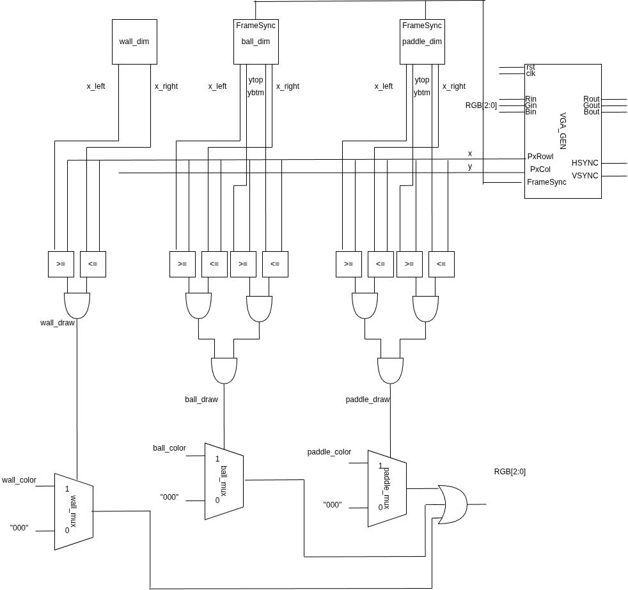

Mogla je da se izvrsi optimizacija podelom operatora, ali u svrhu modulranosti projekta, optimizacija nije bila izvrsena. Detektciija kolizije uradjena je na osnovu koordinata strana loptice. Dok je njeno odbijanje vrseno pomocu promene koeficijenta K u zavisnosti od toga da li je naisla na zid, ivicu ekrana ili reket.

entity pong is
Port ( rst : in STD_LOGIC;
clk : in STD_LOGIC;
up : in STD_LOGIC;
down : in STD_LOGIC;
VGA_HSYNC : out STD_LOGIC;
VGA_VSYNC : out STD_LOGIC;
VGA_RED : out STD_LOGIC;
VGA_GREEN : out STD_LOGIC;
VGA_BLUE : out STD_LOGIC
);
end pong;

architecture Behavioral of pong is
component VGA_GEN is
Port ( rst : in STD_LOGIC;
clk : in STD_LOGIC;
Rin : in STD_LOGIC;
Gin : in STD_LOGIC;
Bin : in STD_LOGIC;

PxRow : out STD_LOGIC_VECTOR (9 downto 0);
PxCol : out STD_LOGIC_VECTOR (9 downto 0);
PxDisp : out STD_LOGIC;
PxClk : out STD_LOGIC;
LnClk : out STD_LOGIC;
FrameSync: out STD_LOGIC;
VGA_HSYNC : out STD_LOGIC;
VGA_VSYNC : out STD_LOGIC;
VGA_RED : out STD_LOGIC;
VGA_GREEN : out STD_LOGIC;
VGA_BLUE : out STD_LOGIC);
end component;
--pozicije objekata ------------------------------------
----ZIIIIIDDDDD--------------------------------------------
constant wall_x_l: integer :=40;
constant wall_x_r: integer :=50;
constant wall_color: std_logic_vector(2 downto 0):="111";
signal wall_draw:std_logic;
--REKETTT -------------------------------------------
--constant paddle_top_y : integer:=360;
-- constant paddle_bottom_y : integer :=230;
constant paddle_left_x:integer:=500;
constant paddle_right_x:integer:=510;
constant paddle_color: std_logic_vector(2 downto 0):="111";
signal paddle_draw:std_logic;
--BALLLLL------------------------------------------
--constant ball_top_y : integer :=310;
--constant ball_bottom_y :integer :=300;
-- constant ball_left_x :integer :=300;
-- constant ball_right_x: integer :=310;
constant ball_color: std_logic_vector(2 downto 0):="010";
signal ball_draw:std_logic;
----------------------------singal-------------------------
signal RGB: std_logic_vector(2 downto 0):="000";
signal FrameSync: std_logic;
signal x: integer range 0 to 640;
signal y :integer range 0 to 480;
signal PxRow,PxCol : std_logic_vector(9 downto 0);
---movement_signals----
signal paddle_top_y : integer:=300;
signal paddle_bottom_y : integer :=230;

signal ball_top_y : integer :=240;
signal ball_bottom_y :integer :=230;
signal ball_left_x :integer :=300;
signal ball_right_x: integer :=310;
------------------------
signal dir,paddle_hit,wall_hit,paddle_top,paddle_bottom: std_logic :='0';
signal K: integer:=1;

begin
vga_sin: VGA_GEN port map (rst=>rst,clk=>clk,
Rin=>RGB(2),Gin=>RGB(1),Bin=>RGB(0),
VGA_HSYNC=>VGA_HSYNC,VGA_VSYNC=>VGA_VSYNC,
VGA_GREEN=>VGA_GREEN,VGA_RED=>VGA_RED,VGA_BLUE=>VGA_BLUE,
FrameSync=>FrameSync,PxCol=>PxCol,PxRow=>PxRow,
PxClk=>open,LnClk=>open,PxDisp=>open);
x<=to_integer(unsigned(pxCol));
y<=to_integer(unsigned(pxRow));
-----pokusaj generisanja slika------
wall_draw<='1' when (x>=wall_x_l and x<=wall_x_r) else '0';
paddle_draw<='1' when (x>=paddle_left_x and x<=paddle_right_x) and (y>=paddle_bottom_y and y<=paddle_top_y) else '0';
ball_draw<='1' when (x>=ball_left_x and x<=ball_right_x) and (y>=ball_bottom_y and y<=ball_top_y) else '0';

RGB<=wall_color when (wall_draw='1' and wall_hit='0') else
"100" when (wall_draw='1' and wall_hit='1') else
ball_color when ball_draw='1' else
paddle_color when paddle_draw='1' else
"000";
-----------PADDLE_MOVEMENT------------------
process(FrameSync)
begin
if(rising_edge(FrameSync)) then
if(up='1' and paddle_bottom_y>=10) then
paddle_bottom_y<=paddle_bottom_y-3;
paddle_top_y<=paddle_top_y-3;
elsif(down='1' and paddle_top_y<=470) then
paddle_bottom_y<=paddle_bottom_y+3;
paddle_top_y<=paddle_top_y+3;
end if;
end if;
end process;
----BALL_MOVEMENTS--------------------------
process(FrameSync)
begin
if(rising_edge(FrameSync)) then
if(ball_top_y<=479 and ball_bottom_y>=5) then
if(K=1) then
ball_top_y<=ball_top_y-1;
ball_bottom_y<=ball_bottom_y-1;
elsif(K=-1) then
ball_top_y<=ball_top_y+1;
ball_bottom_y<=ball_bottom_y+1;
end if;
end if;
if(dir='1') then --needs to go left
ball_left_x<=ball_left_x-1;
ball_right_x<=ball_right_x-1;
else --needs to go right
ball_left_x<=ball_left_x+1;
ball_right_x<=ball_right_x+1;
end if;
if(paddle_hit='1' or paddle_bottom='1' or paddle_top='1') then --paddle hit ide levo
dir<='1';
K<=-K;
----------------------------------------------------------
elsif(wall_hit='1') then --wall hit y=kx+n -- ide desno
dir<='0';
----------------------------------------------------------
elsif(ball_bottom_y=10) then --bottom screen hit
K<=-1;
elsif(ball_top_y=470) then
K<=+1;
elsif(ball_right_x>=630) then --respawn
ball_right_x<=210;
ball_left_x<=200;
ball_top_y<=240;
ball_bottom_y<=230;
dir<='0';
end if;
end if;
end process;
--paddle_lenght<=to_unsigned(paddle_top_y - paddle_bottom_y,10);
paddle_hit<='1' when (ball_right_x=paddle_left_x-1 and (ball_top_y>paddle_bottom_y and ball_bottom_y<paddle_top_y)) else '0';
wall_hit<='1' when ball_left_x=wall_x_r+1 else '0';
paddle_top<='1' when (ball_top_y=paddle_bottom_y and ball_right_x>paddle_left_x and ball_right_x<paddle_right_x) else '0';
paddle_bottom<='1' when (ball_bottom_y=paddle_bottom_y and ball_right_x>paddle_left_x and ball_right_x<paddle_right_x) else '0';

end Behavioral;

