[1]

Enlighten DarkWeb Markets with Data Mining

First A. Author, *Fellow, IEEE*, Second B. Author, and Third C. Author, Jr., Member, IEEE

*Abstract*—These instructions give you guidelines for preparing papers for IEEE Transactions and Journals*.* Use this document as a template if you are using Microsoft *Word* 6.0 or later. Otherwise, use this document as an instruction set. The electronic file of your paper will be formatted further at IEEE. Paper titles should be written in uppercase and lowercase letters, not all uppercase. Avoid writing long formulas with subscripts in the title; short formulas that identify the elements are fine (e.g., "Nd–Fe–B"). Do not write “(Invited)” in the title. Full names of authors are preferred in the author field, but are not required. Put a space between authors’ initials. The abstract must be a concise yet comprehensive reflection of what is in your article. In particular, the abstract must be self-contained, without abbreviations, footnotes, or references. It should be a microcosm of the full article. The abstract must be between 150–250 words. Be sure that you adhere to these limits; otherwise, you will need to edit your abstract accordingly. The abstract must be written as one paragraph, and should not contain displayed mathematical equations or tabular material. The abstract should include three or four different keywords or phrases, as this will help readers to find it. It is important to avoid over-repetition of such phrases as this can result in a page being rejected by search engines. Ensure that your abstract reads well and is grammatically correct.

*Index Terms*—Enter key words or phrases in alphabetical order, separated by commas. For a list of suggested keywords, send a blank e-mail to [keywords@ieee.org](mailto:keywords@ieee.org) or visit <http://www.ieee.org/organizations/pubs/ani_prod/keywrd98.txt>

# INTRODUCTION

P

OLICE forces have been fighting strenuously against illegal websites (e.g. Megaupload [1]), but new ones resurface or re-migrate frequently [2]. This is also happening on the dark web. As a matter of fact, plenty of marketplaces have been shut down, however there are still a lot of them online at the time of this research [3]. On top of that, currently, we don't really know in detail how these websites operate.

This paper presents a research carried out between June and September 2017 on the largest web market at the time (especially for drugs) on Internet, AlphaBay. This web market has caught the attention of governmental agencies since two teenagers aged of 13 and 18 died after overdosing on a powerful synthetic opioid. It has been shut down on July 2017, at the same time of Hansa, as a part of a law enforcement operation by the Federal Bureau of Investigation, the Drugs Enforcement Administration and European law enforcement agencies acting through Europol. [4] [5]

According to US Attorney General Jeff Sessions the aim of this action was to caution criminals from thinking that they could evade prosecution by using the dark web. Looking at previous large shut down marketplaces it is widely believed that other web markets will take the place of AlphaBay. By the way, the popularity of AlphaBay can be explained by the shutdown of Silk Road 2.0 on 2013 since it has been launched on September 2014.

This paper reports on the last weeks of life of Alphabay. Its nature, its different countries of origin, its main sellers, its predominance of items will be analyzed.

# Method

[AB part].

During a first phase "Basic Statistics" will be carried out on the Database, in order to discover the web market and to point out its trends. Then, experimental results of data mining techniques will be discussed.

# Technical Implementation

## Software Stack

There is a number of technologies and programming languages that can be used for Data Analysis. The 3 main programming languages for this kind of research are Python, SAS and R. Since we would like to use open-source languages, we exclude SAS and eventually chose R. [6]

Beside standard libraries, we have made extensive use of:

### units: Unit library including solution for conversion.

### rpart: Package that contains a wide library for decision tree method.

### arules: Used for association rules.

### e1071: Bayesian Naive implementation library.

### bnlearn: Library including solution for Bayesian network creation and visualization.

We have used RStudio for implementing code. As for publishing the results, we have used R Notebooks [7].

## Code Repository

All the code is publicly available in the GitHub project "Data Mining - Dark Web Market". The repository is accessible from the following link: <https://github.com/SimonDele/Data-Ming-Dark-Web-Market>

You can also find the whole list of packages used in the GitHub repository.

## Detailed Diagram

This is the representation of the technical implementation taking place during this project:

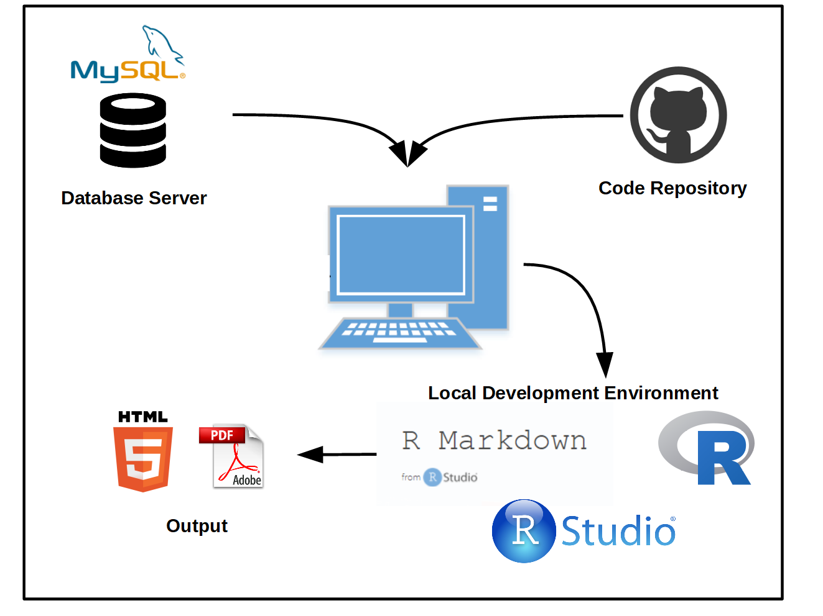

Fig. 1. Technical implementation

# Data Retrieval

For each product we have collected and analyzed ad title, description, price (in USD), URL, seller, payment, origin, destination, category, collection timestamp, date of posting and number of products sold.

[AB to refine] The data represents approximately *1/10* of the Web Market, but gives a pretty good representation since the uploaded ads were fairly distributed.

Thus, the first step was to clean the data and to make it readable in a computer way. This is our pipelines:

### Removing special characters, switching in lowercase.

### Finding in the title or description of the ads the amount (number and mass) of the product.

### Calculating the price of one unit of one dose (1 gram) each time.

# Alphabay Market

As it has been said in the INTRODUCTION, AlphaBay, due to its popularity, drew the police forces attentions. As a matter of fact its reputation can be reflected by looking at Google search statistics with the keywords Alphabay and dream market between January 2015 until June 2017. [8]

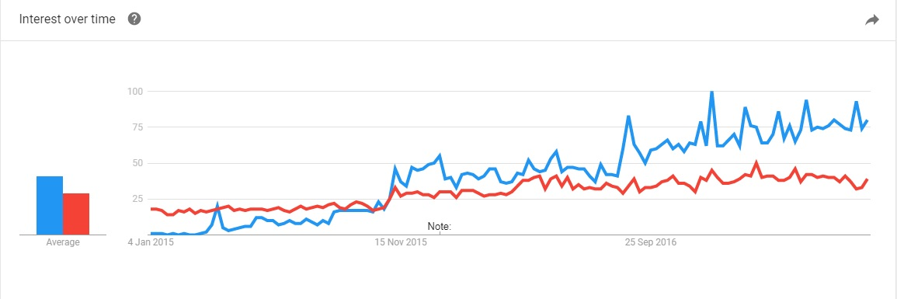

Fig. 2 Evolution of AlphaBay and Dream Market Google researches

On this graph, AlphaBay is in blue and Dream Market is in red, which is another Dark Web Market still operating. AlphaBay has become more and more popular since the demise of Agora, and before being shut down, it was the most popular dark web market [9]

Let's now try to look at the evolution of the market with the collected data on AlphaBay. Here you can see the number of ads posted per month from January 2015 until June 2017.

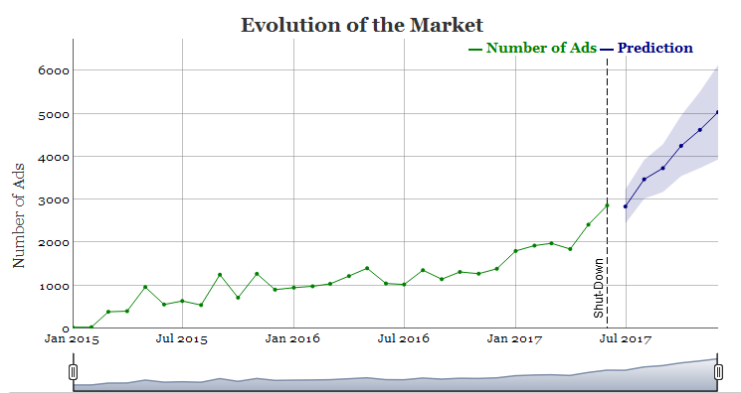

Fig. 3 Evolution f AlphaBay web market

The overall appearance and the growing popularity can be again pointed out with this graph. Between 2015 and 2016, there was a significant jump, the amount of ads rose from 7,712 up to14,161. Nevertheless the most surprising thing is that the number of ads that have been posted during the six first months of 2017 (before the closing) is 12,878 which is almost the same that in the whole 2016.

In order to see how the market would have looked like in the end of 2017 a prediction also has been added on this graph. Therefore, according to prognoses, the amount of ads would have reached a pick of 5,000 ads by the end of year.

# Basic Statistics

As it has been said before, basic statistics have been first realized. Let's see the general distribution and trend of the market.

## General Distribution

### Global view of ads distribution

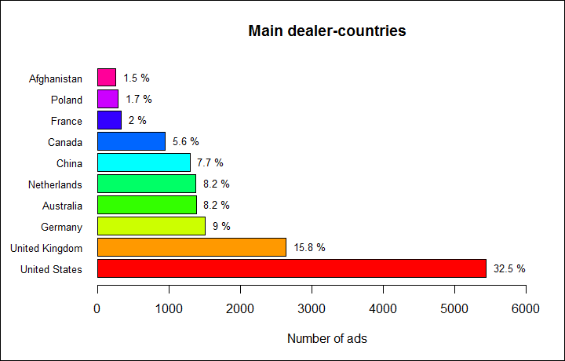

Fig. 4 Main dealer countries

This bar-chart represents the 10 main countries in the world regarding the number of ads. As we can see, United States are the biggest dealer far ahead of the rest. Their number of ads is more than twice as the number of the second one, United Kingdom.

Moreover, it is noticeable that most of these countries have strong economies. Five of the top 10 countries belong to the Group of Seven (G7), only Japan and Italy are not present. And other ones are also located in powerful areas where a lot of trade are made with other countries.

Furthermore it is worth pointing out that the first four countries are exactly the ones where the word "AlphaBay" is the most researched on Google [10] !

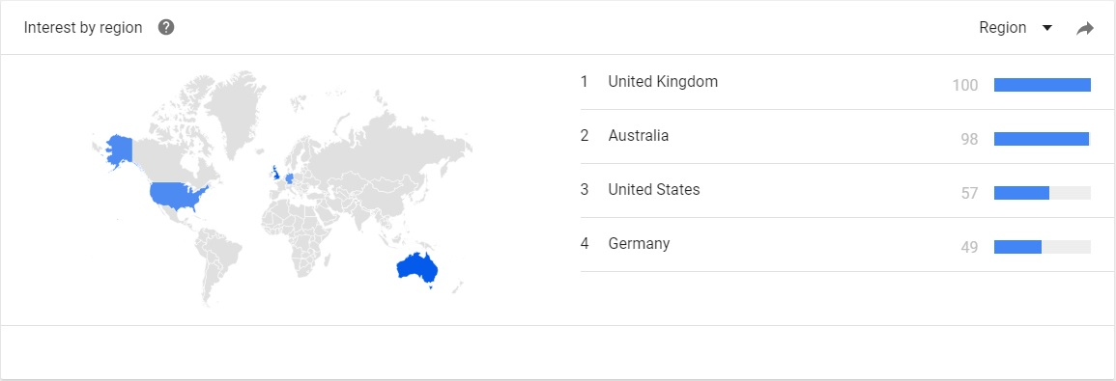

Fig. 5 AlphaBay world Google researches

### Distribution of ads per category

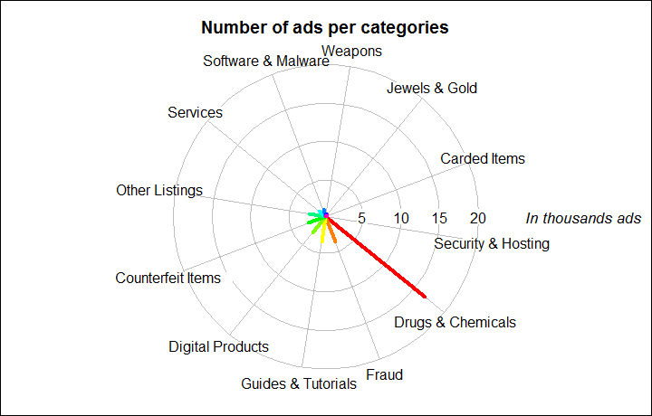

Fig. 6 Distribution of the market

There are 12 main categories in this web marketplace. "Drugs and Chemicals" group is the largest one, representing 45.64 % of the global market.

It is also worth noting that the second most popular category is "Fraud", that is to say all the ads regarding impersonation, deception papers and accounts. It represents 13.5 % of the market. Eventually, all other items (digital product, weapons, jewelry ...) represent a small rate of the marketplace.

## Drug Market

AlphaBay core focus is clearly on Drugs (cf. Fig. 6.).

### Distribution of drugs

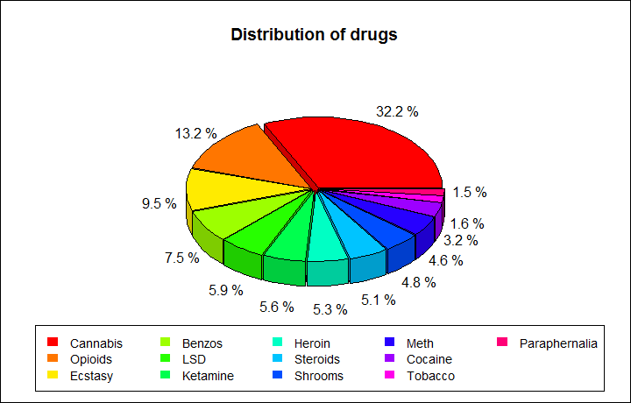

Fig. 7 Drug distribution

AlphaBay includes 13 subcategories for drugs. That said, Cannabis, Opioids and Ecstasy cover more than 50 % of the market.

### World distribution of drugs

When looking at drug-related ads by country, it is worth noting that the distribution of Figure 8 has a strong resemblance with the overall ad distribution by country on AlphaBay (Fig. 4). This is coherent, indeed, by comparing the ratio between drugs ads and the total number of ads, it is intelligible that they are mainly dealing drugs.

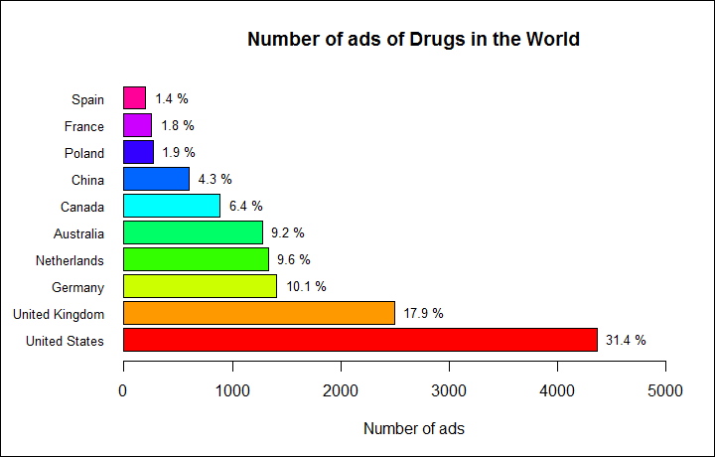

Fig. 8 Main drug dealer countries

So far it is possible to conclude that the market of drugs is gathered in Europe and the north of America.

### Global view of the drugs market in Europe

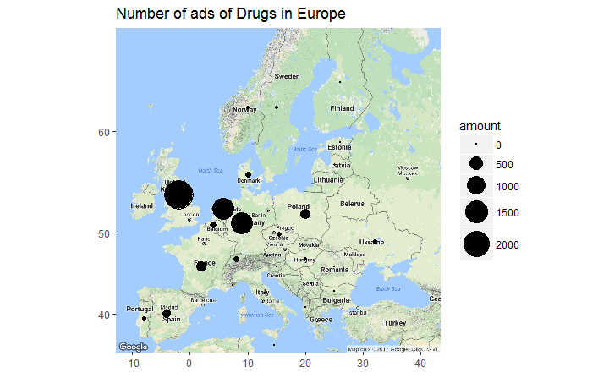

Fig. 9 European drug dealers

Circles show the amount of ads concerning drugs. The map confirms previous assumptions that the majority of the products is supposedly originating from United Kingdom, Netherlands and Germany.

It appears that dealer-countries are located on the Atlantic Coast and own huge harbours where there is important merchant shipping. Whereas on the East part there are not a lot of activities. This is probably due to the fact that dealers are using international commercial maritime traffics in order to dispatch their drugs all around the world. Maritime transport is an option increasingly used since it allows them to carry large quantities at one time. Drugs can be transported in small and fast boats (Go-Fast-Boat between countries border) or in containers on commercial vessels. Thus, significant seaports in Europe such as Rotterdam in Netherlands or Antwerp in Belgium are key points for this type of trafficking. In 2014 “Dutch police estimated that 25-50 % of the cocaine reaching Europe now enters via the port, which handles around 11 million containers a year.” [11]

## Product Flow By Country

Let’s now focus more specifically on different countries and study their trend. To do so, export and import flows of the country have been investigated.

### United Kingdom exportation

The chart below (Fig. 10) represents the repartition of each category that United Kingdom supposedly exports.

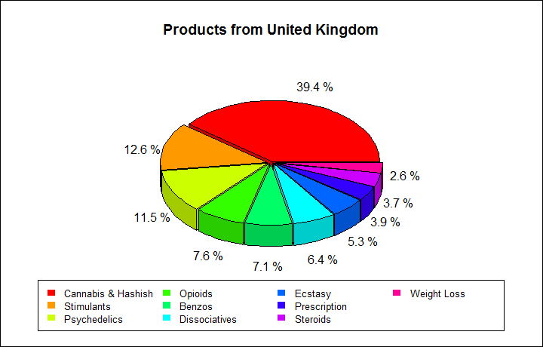

Fig. 10 Products from United Kingdom

Once again this chart shows the market diversity. Although a huge part concerns “Cannabis & Hashish” category, “Stimulants” and other illegal drugs are significantly present as well.

Most of European countries follows the same pattern as United Kingdom and this confirms previous assumptions.

### Products from Afghanistan

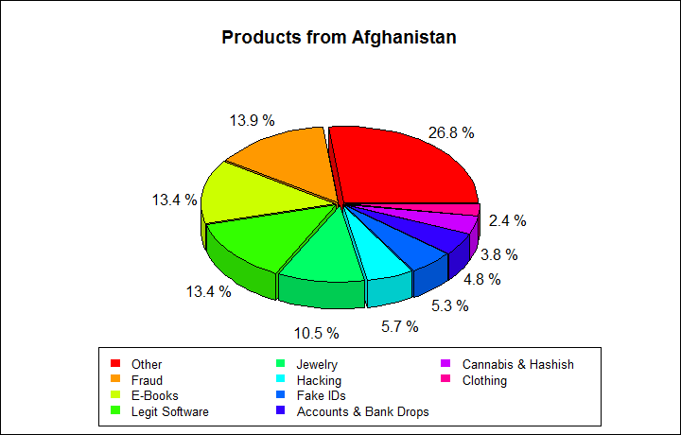

Fig. 11 Products from Afghanistan

It is interesting to notice that, unlike most of countries, Afghanistan doesn’t really retail drugs on AlphaBay market. Actually, a vast majority of exported products are false identity, deception accounts… Afghanistan is also dealing electronic devices or software.

### France export & import flows

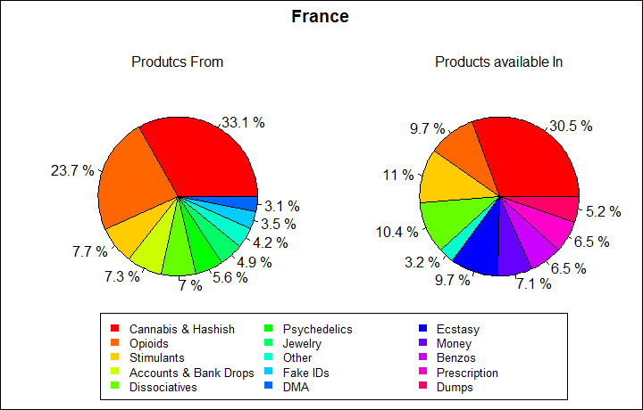

Fig. 12 Products from and available in France

It is noticeable that both charts are different. The percentages of each category are not equal and some of them don’t appear systematically in the other chart.

Nevertheless these conclusions should be moderated since targeting one particular country reduces significantly the number of information used for statistics.

## Market Prices

After analyzing general trend and flows, one interesting topic to analyze is market prices. One may ask if sold products in AlphaBay are cheaper than in the streets.

### Average prices

Firstly, the median price of one gram of the most common drugs has been calculated and results below has been obtained.

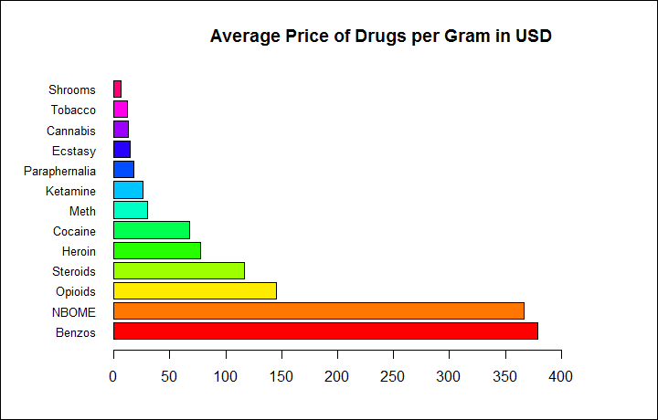

Fig. 13 AlphaBay drug prices

### Comparison with the “street”

Information on street prices for commonly available drugs have been collected on websites.

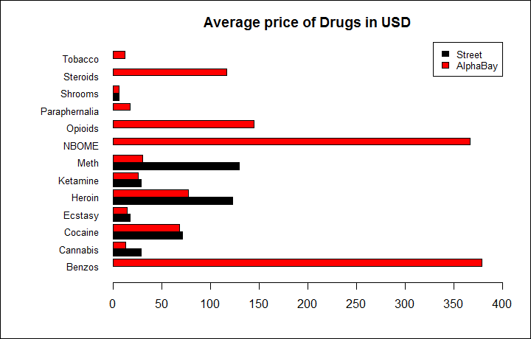

Fig. 14 Comparison of Prices between AlphaBay and Street

`Globally, it appears that prices of street sellers are often largely higher than AlphaBay ads. In few cases both prices tend to be similar. (Please find in the last section all references used: [12] [13] [14] [15] [16])

# Drugs on AlphaBay - Exploration analysis

Secondly, data mining techniques have been performed in order to discover hidden rules and correlations in the database.

## Sellers Predictions

The first thing to wonder is how to guess the seller of an ad. This knowledge could enable to identify sellers in other web market. To answer this question, different data mining methods have been used, especially Decision Tree and Bayesian classification.

Algorithm has been run on a subset of the database with by rows ads and by columns the origin, category, seller and price. The aim is to predict who is selling each ads. By training the algorithm on one half of the data, predictions could be made on other half. Given that most of sellers own just few ads (occasional advertisements) only the main ones were selected, which represent at best the market. Otherwise, data mining techniques will fail in finding rules for them.

To check efficiency of the algorithm a measure of accuracy must be calculated. It is obtain by comparing the prediction of decision tree method with the true value.

### Decision tree

Using rpart package, which is based on the CART Algorithm, a decision tree has been created. Thanks to it, predictions of the seller could be made. Prognoses on the five most significant sellers and the related tree can be found below.

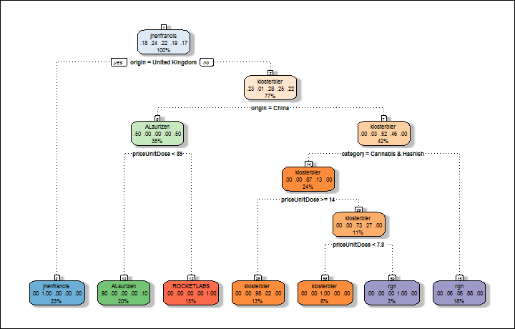

Fig. 15 Seller prediction - Decision tree

The accuracy is: 94.27 %. It is striking to realize that predictions are very reliable since the accuracy is very high.

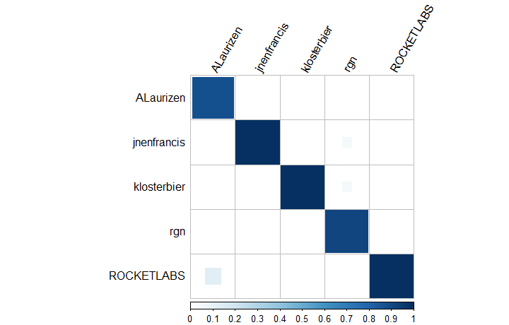

Fig. 16 Confusion matrix – Decision tree

The confusion matrix (Fig 16) presents the different results of the prognoses, by row you can find the real sellers and by column our predictions. The color scale shows our precision out of one. In other words the diagonal shows the correct predictions (1 mean 100 % of success) and all other values are mistakes made by the algorithm.

The tree enables to have a good visual aspect and gives a lot of essential information on these five main sellers.

Predictions have been done here on only five sellers in order to have a readable tree (otherwise the size of the tree is too big for being plotted). However, prognoses with more sellers can be made and with still a good accuracy. For instance, with 10 sellers the accuracy is: 88.79 %.

### Bayesian classification - Naive algorithm

Bayesian Classification has been used in the same objective as decision tree, making predictions. When running Bayesian Naive Algorithm with the same data, the results are:

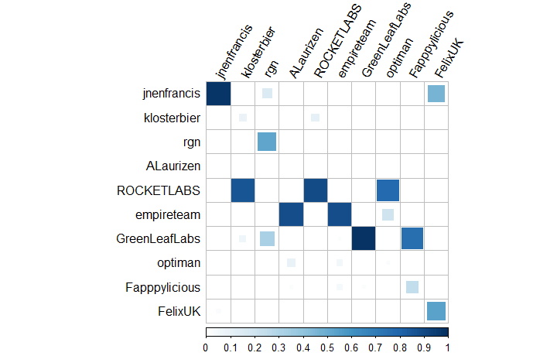

Fig. 17 Confusion matrix - Bayesian classification

The accuracy is 56.37 % which is not very good comparing to decision tree. One way to improve the prognosis is to add new variables to the data which could be relevant like the number of ads already sold and the creation date of the ad.

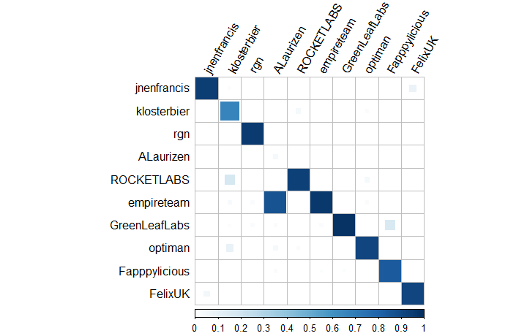

Fig. 18 Confusion matrix - Bayesian classification 2

Results show that the algorithm succeeds in predicting most of the sellers. The accuracy is 79.8 %. Which is still a little bit less than with decision tree. However with more sellers (i.e., more than 40 sellers for instance), this algorithm tends to be more accurate than the one based on decision tree method.

Later in the section Prediction of profitability, it will be discussed how to exploit at best this two values: the creation date of ads and the number of sold products.

### Text Mining

One last method, but not least: Text mining. It can be used for text classification (determination the topic, the tone, etc.), but here it will be used for predicting who has written the text (i.e., sellers).

The main interest comparing to previous methods is that it is only based on the words used by the sellers. Thus, it is possible to identify the seller according to his writing style in other type websites, such as Social Network. What previous methods cannot do because they are trained with variables specific to AlphaBay. Furthermore, there is no need to explain the interest of identifying in Social Network illegal sellers…

The method consists in training the algorithm with words from the ad description of each seller. Then, it is tested with a part of the data which has not been used for training. The algorithm chosen for this method is Support Vector Machine but other algorithms have been tested such as decision tree and random forest and results are similar. The result below has been obtained with a data containing the ads description from the 50 main sellers.

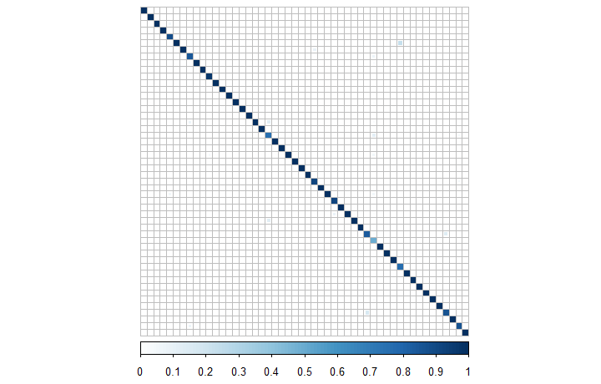

Fig. 19 Confusion matrix - Text mining

The accuracy is 93.83 % which is very high. For more sellers, (which own enough ads, in order to have some of them in the training dataset) the accuracy decreased but it is still very high. For instance for 150 main sellers it is around 90%.

However, this accuracy has to be taken with precaution. Indeed, most of the ads descriptions from one seller are very similar. The reason is that they create various ads for the same product with different quantities. Thus, ads description are almost the same. That is why, it is not surprising that the accuracy is so high.

Anyway, that show us that the algorithm is working properly and it can be used in order to find hidden identities of one seller in AlphaBay or in other Website and eventually discover his real identity.

## Clustering of drugs

Secondly, one can wonder if there were links between some drugs. That is to say, if this is possible to cluster some drugs.

To do so, firstly, a new data frame has been created with by rows sellers and by columns different sub-categories of “Drugs & Chemicals”. In each cell, value is True or False if the dealer has already sold something in this sub-category or not. Then, Apriori algorithm of Association Rules has been used. One drug has been selected that must be in the item set. Here it is Ecstasy and results can be seen below.

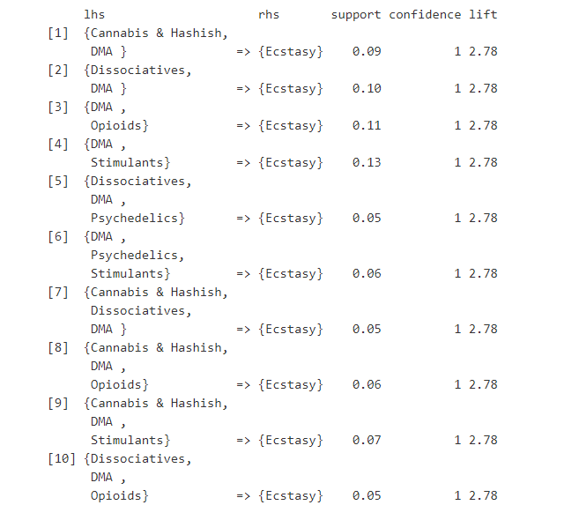

Fig. 20 Cluster of drugs - Association rules

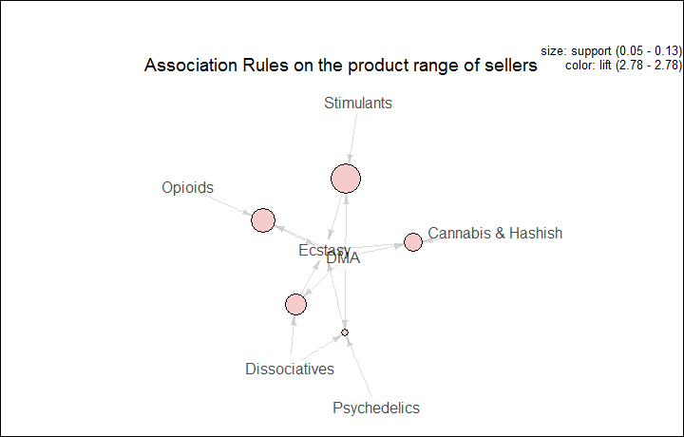

Fig. 21 Cluster of drugs - Association rules 2

The algorithm succeeds in finding some rules in the data frame. That means that some drugs can effectively be clustered. The support is between 5% and 15% so it is frequent to have these item sets. Moreover the confidence is more than 80%. In other words, if there is the item set on the left we are most likely to have the drug on the right.

These rules can be interpreted as follows: sellers often deal more than one product. And these products can be clustered by type.

## Prediction of ads origin

After trying to make predictions on sellers (cf. Sellers Predictions), Prognoses on the origin of the ads have been made using Decision Tree method and Association Rules.

### Decision tree

Looking at prices and categories, a Decision Tree has been created in order to predict the origin. In the same way the algorithm has been trained on one half of the data, and predictions made on the other half.

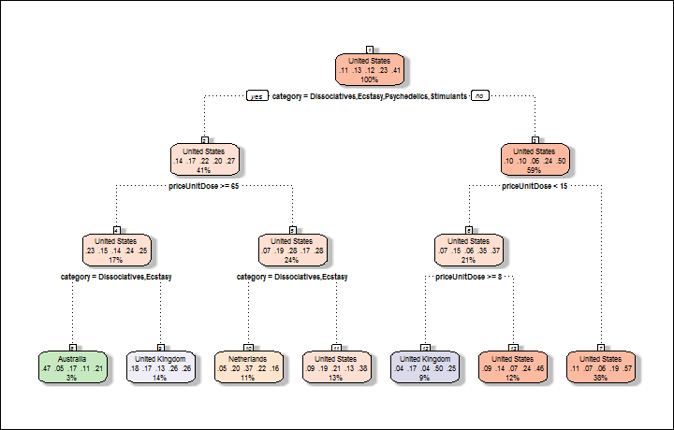

Fig. 22 Origins prediction - Decision tree

Results don’t seem to be very good, the accuracy is 45.33 % which is lower than previously. It turns out that without sellers, which give a lot of information on the origin, prognoses are not very reliable.

### Correlations between categories and origins

To do so, Association Rules Method has been run with 2 variables: category and origin. Thus, one may be able to make a link with predictions of above decision tree. One country has been fixed, here United States.

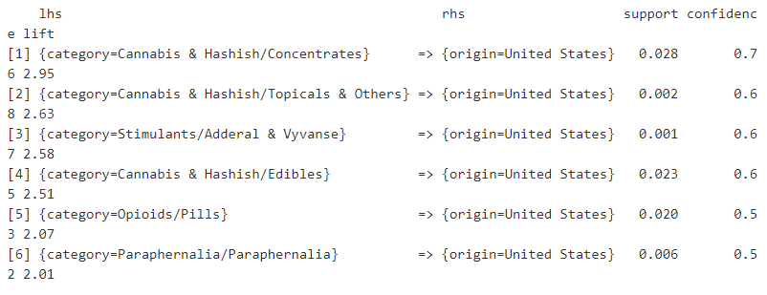

Fig. 23 Origin prediction - Association rules

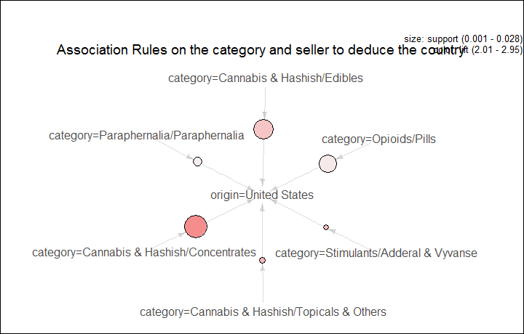

Fig. 24 Origin prediction - Association rules 2

The results show that when there is an ad of the category on the left, it is likely to come from United States with a confidence higher than 50%. Thus, ads from United States are often on Cannabis & Hashish, this can be easily confirmed by plotting a pie chart of United States exportations, as in the section before.

It is striking to see that Cannabis & Hashish seems to be the main rule. This can be explained by the legalization of Cannabis in some states. Thus, the sales of these products is easy in United States and may interest people from other countries where they are not legalized.

## Prediction of ads profitability

## File Naming

Figures (line artwork or photographs) should be named starting with the first 5 letters of the author’s last name. The next characters in the filename should be the number that represents the sequential location of this image in your article. For example, in author “Anderson’s” paper, the first three figures would be named ander1.tif, ander2.tif, and ander3.ps.

Tables should contain only the body of the table (not the caption) and should be named similarly to figures, except that ‘.t’ is inserted in-between the author’s name and the table number. For example, author Anderson’s first three tables would be named ander.t1.tif, ander.t2.ps, ander.t3.eps.

Author photographs should be named using the first five characters of the pictured author’s last name. For example, four author photographs for a paper may be named: oppen.ps, moshc.tif, chen.eps, and duran.pdf.

If two authors or more have the same last name, their first initial(s) can be substituted for the fifth, fourth, third... letters of their surname until the degree where there is differentiation. For example, two authors Michael and Monica Oppenheimer’s photos would be named oppmi.tif, and oppmo.eps.

## Referencing a Figure or Table Within Your Paper

When referencing your figures and tables within your paper, use the abbreviation “Fig.” even at the beginning of a sentence. Do not abbreviate “Table.” Tables should be numbered with Roman Numerals.

## Checking Your Figures: The IEEE Graphics Analyzer

The IEEE Graphics Analyzer enables authors to pre-screen their graphics for compliance with IEEE Transactions and Journals standards before submission. The online tool, located at <http://graphicsqc.ieee.org/>, allows authors to upload their graphics in order to check that each file is the correct file format, resolution, size and colorspace; that no fonts are missing or corrupt; that figures are not compiled in layers or have transparency, and that they are named according to the IEEE Transactions and Journals naming convention. At the end of this automated process, authors are provided with a detailed report on each graphic within the web applet, as well as by email.

For more information on using the Graphics Analyzer   
or any other graphics related topic, contact the IEEE Graphics Help Desk by e-mail at [graphics@ieee.org](mailto:graphics@ieee.org).

## Submitting Your Graphics

Because IEEE will do the final formatting of your paper,   
you do not need to position figures and tables at the top and bottom of each column. In fact, all figures, figure captions, and tables can be placed at the end of your paper. In addition to, or even in lieu of submitting figures within your final manuscript, figures should be submitted individually, separate from the manuscript in one of the file formats listed above in section VI-J. Place figure captions below the figures; place table titles above the tables. Please do not include captions as part of the figures, or put them in “text boxes” linked to the figures. Also, do not place borders around the outside of your figures.

## Color Processing / Printing in IEEE Journals

All IEEE Transactions, Journals, and Letters allow an author to publish color figures on IEEE *Xplore*® at no charge, and automatically convert them to grayscale for print versions. In most journals, figures and tables may alternatively be printed in color if an author chooses to do so. Please note that this service comes at an extra expense to the author. If you intend to have print color graphics, include a note with your final paper indicating which figures or tables you would like to be handled that way, and stating that you are willing to pay the additional fee.

# Conclusion

## A conclusion section is not required. Although a conclusion may review the main points of the paper, do not replicate the abstract as the conclusion. A conclusion might elaborate on the importance of the work or suggest applications and extensions.

Appendix

Appendixes, if needed, appear before the acknowledgment.

Acknowledgment

The preferred spelling of the word “acknowledgment” in American English is without an “e” after the “g.” Use the singular heading even if you have many acknowledgments. Avoid expressions such as “One of us (S.B.A.) would like to thank ... .” Instead, write “F. A. Author thanks ... .” In most cases, sponsor and financial support acknowledgments are placed in the unnumbered footnote on the first page, not here.

References and Footnotes

## References

References need not be cited in text. When they are, they appear on the line, in square brackets, inside the punctuation. Multiple references are each numbered with separate brackets. When citing a section in a book, please give the relevant page numbers. In text, refer simply to the reference number. Do not use “Ref.” or “reference” except at the beginning of a sentence: “Reference [3] shows ... .” Please do not use automatic endnotes in *Word*, rather, type the reference list at the end of the paper using the “References” style.

Reference numbers are set flush left and form a column of their own, hanging out beyond the body of the reference. The reference numbers are on the line, enclosed in square brackets. In all references, the given name of the author or editor is abbreviated to the initial only and precedes the last name. Use them all; use *et al*. only if names are not given. Use commas around Jr., Sr., and III in names. Abbreviate conference titles. When citing IEEE transactions, provide the issue number, page range, volume number, year, and/or month if available. When referencing a patent, provide the day and the month of issue, or application. References may not include all information; please obtain and include relevant information. Do not combine references. There must be only one reference with each number. If there is a URL included with the print reference, it can be included at the end of the reference.

Other than books, capitalize only the first word in a paper title, except for proper nouns and element symbols. For papers published in translation journals, please give the English citation first, followed by the original foreign-language citation See the end of this document for formats and examples of common references. For a complete discussion of references and their formats, see the IEEE style manual at [www.ieee.org/authortools](http://www.ieee.org/authortools).

## Footnotes

Number footnotes separately in superscripts (Insert | Footnote).[2] Place the actual footnote at the bottom of the column in which it is cited; do not put footnotes in the reference list (endnotes). Use letters for table footnotes (see Table I).

# Submitting Your Paper for Review

## Review Stage Using Word 6.0 or Higher

If you want to submit your file with one column electronically, please do the following:

--First, click on the View menu and choose Print Layout.

--Second, place your cursor in the first paragraph. Go to the Format menu, choose Columns, choose one column Layout, and choose “apply to whole document” from the dropdown menu.

--Third, click and drag the right margin bar to just over 4 inches in width.

The graphics will stay in the “second” column, but you can drag them to the first column. Make the graphic wider to push out any text that may try to fill in next to the graphic.

## Final Stage Using Word 6.0

When you submit your final version (after your paper has been accepted), print it in two-column format, including figures and tables. You must also send your final manuscript on a disk, via e-mail, or through a Web manuscript submission system as directed by the society contact. You may use *Zip* for large files, or compress files using *Compress, Pkzip, Stuffit,* or *Gzip.*

Also, send a sheet of paper or PDF with complete contact information for all authors. Include full mailing addresses, telephone numbers, fax numbers, and e-mail addresses. This information will be used to send each author a complimentary copy of the journal in which the paper appears. In addition, designate one author as the “corresponding author.” This is the author to whom proofs of the paper will be sent. Proofs are sent to the corresponding author only.

## Review Stage Using ScholarOne® Manuscripts

Contributions to the Transactions, Journals, and Letters may be submitted electronically on IEEE’s on-line manuscript submission and peer-review system, ScholarOne® Manuscripts. You can get a listing of the publications that participate in ScholarOneat

<http://www.ieee.org/publications_standards/publications/authors/authors_submission.html> First check if you have an existing account. If there is none, please create a new account. After logging in, go to your Author Center and click “Submit First Draft of a New Manuscript.”

Along with other information, you will be asked to select the subject from a pull-down list. Depending on the journal, there are various steps to the submission process; you must complete all steps for a complete submission. At the end of each step you must click “Save and Continue”; just uploading the paper is not sufficient. After the last step, you should see a confirmation that the submission is complete. You should also receive an e-mail confirmation. For inquiries regarding the submission of your paper on ScholarOne Manuscripts, please contact oprs-support@ieee.org or call +1 732 465 5861.

ScholarOne Manuscripts will accept files for review in various formats. Please check the guidelines of the specific journal for which you plan to submit.

You will be asked to file an electronic copyright form immediately upon completing the submission process (authors are responsible for obtaining any security clearances). Failure to submit the electronic copyright could result in publishing delays later. You will also have the opportunity to designate your article as “open access” if you agree to pay the IEEE open access fee.

## Final Stage Using ScholarOne Manuscripts

Upon acceptance, you will receive an email with specific instructions regarding the submission of your final files. To avoid any delays in publication, please be sure to follow these instructions. Most journals require that final submissions be uploaded through ScholarOne Manuscripts, although some may still accept final submissions via email. Final submissions should include source files of your accepted manuscript, high quality graphic files, and a formatted pdf file. If you have any questions regarding the final submission process, please contact the administrative contact for the journal.

In addition to this, upload a file with complete contact information for all authors. Include full mailing addresses, telephone numbers, fax numbers, and e-mail addresses. Designate the author who submitted the manuscript on ScholarOne Manuscripts as the “corresponding author.” This is the only author to whom proofs of the paper will be sent.

## Copyright Form

Authors must submit an electronic IEEE Copyright Form (eCF) upon submitting their final manuscript files.  You can access the eCF system through your manuscript submission system or through the Author Gateway. You are responsible for obtaining any necessary approvals and/or security clearances. For additional information on intellectual property rights, visit the IEEE Intellectual Property Rights department web page at

<http://www.ieee.org/publications_standards/publications/rights/index.html>.

# IEEE Publishing Policy

The general IEEE policy requires that authors should only submit original work that has neither appeared elsewhere for publication, nor is under review for another refereed publication. The submitting author must disclose all prior publication(s) and current submissions when submitting a manuscript. Do not publish “preliminary” data or results. The submitting author is responsible for obtaining agreement of all coauthors and any consent required from employers or sponsors before submitting an article. The IEEE Transactions and Journals Department strongly discourages courtesy authorship; it is the obligation of the authors to cite only relevant prior work.

The IEEE Transactions and Journals Department does not publish conference records or proceedings, but can publish articles related to conferences that have undergone rigorous peer review. Minimally, two reviews are required for every article submitted for peer review.

# Publication Principles

The two types of contents of that are published are; 1) peer-reviewed and 2) archival. The Transactions and Journals Department publishes scholarly articles of archival value as well as tutorial expositions and critical reviews of classical subjects and topics of current interest.

Authors should consider the following points:

1. Technical papers submitted for publication must advance the state of knowledge and must cite relevant prior work.
2. The length of a submitted paper should be commensurate with the importance, or appropriate to the complexity, of the work. For example, an obvious extension of previously published work might not be appropriate for publication or might be adequately treated in just a few pages.
3. Authors must convince both peer reviewers and the editors of the scientific and technical merit of a paper; the standards of proof are higher when extraordinary or unexpected results are reported.
4. Because replication is required for scientific progress, papers submitted for publication must provide sufficient information to allow readers to perform similar experiments or calculations and use the reported results. Although not everything need be disclosed, a paper must contain new, useable, and fully described information. For example, a specimen’s chemical composition need not be reported if the main purpose of a paper is to introduce a new measurement technique. Authors should expect to be challenged by reviewers if the results are not supported by adequate data and critical details.
5. Papers that describe ongoing work or announce the latest technical achievement, which are suitable for presentation at a professional conference, may not be appropriate for publication.

# References

|  |  |
| --- | --- |
| [1] | "Megaupload file-sharing Site Shut Down," BBC News, 08 03 2012. [Online]. Available: http://www.bbc.co.uk/news/technology-16642369. [Accessed 07 08 2017]. |
| [2] | Reuters, "Megaupload Reboot ? Founder kim dotcom plans a relaunch in 2017," The guardian, 11 07 2016. [Online]. Available: https://www.theguardian.com/technology/2016/jul/11/kim-dotcom-megaupload-founder-plans-reboot-2017. [Accessed 07 08 2017]. |
| [3] | "Dark Web & Deep Web market list with up & down daily updated market status," DarkWebNews, [Online]. Available: https://darkwebnews.com/dark-web-market-list/. [Accessed 07 08 2017]. |
| [4] | C. Baraniuk, "Alphabay and Hansa Dark Web Markets shut down," BBC news, 20 07 2017. [Online]. Available: http://www.bbc.co.uk/news/technology-40670010. [Accessed 24 07 2017]. |
| [5] | T. Kopan, "Doj announces takedown of dark web market Alphabay," CNN, 07 20 2017. [Online]. Available: http://edition.cnn.com/2017/07/20/politics/doj-takes-down-dark-web-marketplace-alphabay/index.html. [Accessed 24 07 2017]. |
| [6] | "2017 SAS, R, or Python flash survey results," Burtch works, 19 06 2017. [Online]. Available: http://www.burtchworks.com/2017/06/19/2017-sas-r-python-flash-survey-results/. [Accessed 08 07 2017]. |
| [7] | "R Markdown tutorial," R Markdown from RStudio, [Online]. Available: http://rmarkdown.rstudio.com/lesson-1.html. [Accessed 29 06 2017]. |
| [8] | "Explore: AlphaBay, Dream Market," Google trends, [Online]. Available: https://trends.google.co.uk/trends/explore?date=2015-01-01%202017-07-01&q=alphabay,Dream%20Market. [Accessed 22 07 2017]. |
| [9] | "Forget silk road, cops just scored their biggest victory against the dark web drug trade," Forbes, 20 07 2017. [Online]. Available: https://www.forbes.com/sites/thomasbrewster/2017/07/20/alphabay-hansa-dark-web-markets-taken-down-in-massive-drug-bust-operation/#480a3cb05b4b. [Accessed 07 08 2017]. |
| [10] | "Explore: AlphaBay," Google trends, [Online]. Available: https://trends.google.co.uk/trends/explore?date=2014-12-01%202017-07-01&q=alphabay. [Accessed 22 07 2017]. |
| [11] | "Cocaine – Trafficking and supply," EU drug markets report, [Online]. Available: http://www.emcdda.europa.eu/publications/eu-drug-markets/2016/online/cocaine/trafficking-and-supply. [Accessed 24 07 2017]. |
| [12] | "How much do drugs cost?," DrugWise, [Online]. Available: http://www.drugwise.org.uk/how-much-do-drugs-cost/. [Accessed 12 07 2017]. |
| [13] | "The cost of street drugs in britain," The Telegraph, [Online]. Available: http://www.telegraph.co.uk/news/uknews/crime/11346133/The-cost-of-street-drugs-in-Britain.html. [Accessed 12 07 2017]. |
| [14] | "The average cost of illegal street drugs," RehabCenters.net, [Online]. Available: http://www.rehabcenter.net/the-average-cost-of-illegal-drugs-on-the-street/. [Accessed 12 07 2017]. |
| [15] | "What illegal drugs cost on the street around the world," Canada.com, [Online]. Available: http://o.canada.com/business/interactive-what-illegal-drugs-cost-on-the-street-around-the-world. [Accessed 12 07 2017]. |
| [16] | "Facts about drugs," The student pocket guide, [Online]. Available: http://www.thestudentpocketguide.com/2012/01/student-life/health-and-relationships/facts-about-drugs/. [Accessed 12 07 2017]. |

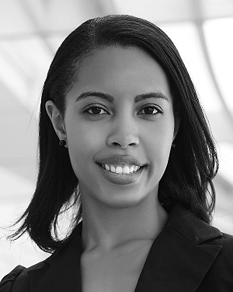**First A. Author** (M’76–SM’81–F’87) and all authors may include biographies. Biographies are often not included in conference-related papers. This author became a Member (M) of IEEE in 1976, a Senior Member (SM) in 1981, and a Fellow (F) in 1987. The first paragraph may contain a place and/or date of birth (list place, then date). Next, the author’s educational background is listed. The degrees should be listed with type of degree in what field, which institution, city, state, and country, and year the degree was earned. The author’s major field of study should be lower-cased.

The second paragraph uses the pronoun of the person (he or she) and not the author’s last name. It lists military and work experience, including summer and fellowship jobs. Job titles are capitalized. The current job must have a location; previous positions may be listed without one. Information concerning previous publications may be included. Try not to list more than three books or published articles. The format for listing publishers of a book within the biography is: title of book (publisher name, year) similar to a reference. Current and previous research interests end the paragraph.

The third paragraph begins with the author’s title and last name (e.g., Dr. Smith, Prof. Jones, Mr. Kajor, Ms. Hunter). List any memberships in professional societies other than the IEEE. Finally, list any awards and work for IEEE committees and publications. If a photograph is provided, it should be of good quality, and professional-looking. Following are two examples of an author’s biography.

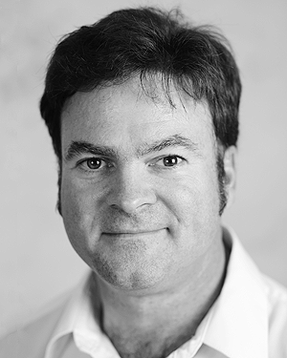**Second B. Author** was born in Greenwich Village, New York, NY, USA in 1977. He received the B.S. and M.S. degrees in aerospace engineering from the University of Virginia, Charlottesville, in 2001 and the Ph.D. degree in mechanical engineering from Drexel University, Philadelphia, PA, in 2008.

From 2001 to 2004, he was a Research Assistant with the Princeton Plasma Physics Laboratory. Since 2009, he has been an Assistant Professor with the Mechanical Engineering Department, Texas A&M University, College Station. He is the author of three books, more than 150 articles, and more than 70 inventions. His research interests include high-pressure and high-density nonthermal plasma discharge processes and applications, microscale plasma discharges, discharges in liquids, spectroscopic diagnostics, plasma propulsion, and innovation plasma applications. He is an Associate Editor of the journal *Earth*, *Moon*, *Planets*, and holds two patents.

Dr. Author was a recipient of the International Association of Geomagnetism and Aeronomy Young Scientist Award for Excellence in 2008, and the IEEE Electromagnetic Compatibility Society Best Symposium Paper Award in 2011.

1. This paragraph of the first footnote will contain the date on which you submitted your paper for review. It will also contain support information, including sponsor and financial support acknowledgment. For example, “This work was supported in part by the U.S. Depart­ment of Com­merce under Grant BS123456.”

   The next few paragraphs should contain the authors’ current affiliations, including current address and e-mail. For example, F. A. Author is with the National Institute of Standards and Technology, Boulder, CO 80305 USA (e-mail: author@ boulder.nist.gov).

   S. B. Author, Jr., was with Rice University, Houston, TX 77005 USA. He is now with the Department of Physics, Colorado State University, Fort Collins, CO 80523 USA (e-mail: author@lamar.colostate.edu).

   T. C. Author is with the Electrical Engineering Department, University of Colorado, Boulder, CO 80309 USA, on leave from the National Research Institute for Metals, Tsukuba, Japan (e-mail: author@nrim.go.jp).
2. It is recommended that footnotes be avoided (except for the unnumbered footnote with the receipt date on the first page). Instead, try to integrate the footnote information into the text.