|  |  |
| --- | --- |
| **Soal Tugas Mandiri**  *Assignment Case* |  |
| ISYS6197  Business Application Development |
| **Teknik Informatika**  *Computer Science* | **E3-ISYS6197-DV01** |
| **Periode Berlaku** Semester Genap 2015/2016  ***Valid on*** *Even Semester Year 2015/2016* | **Revisi 00**  *Revision00* |

## Soal

*Case*

**Phone Creator**

**Phone Creator** is a simple application to register handphone’s list. You, as a programmer are asked to create program **using object oriented programming concept such as encapsulation** and **inheritance** with the descriptions below:

* There are **4 main menus**:

1. **Create HandPhone**
2. **Delete HandPhone**
3. **View HandPhone**
4. **Exit**

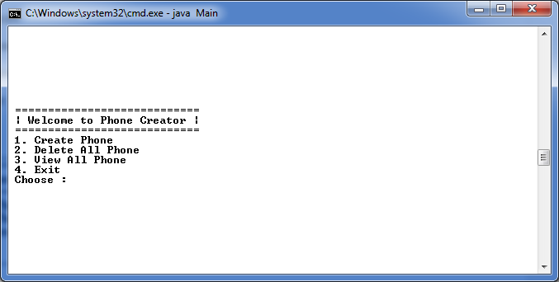

* If the user choose **Menu 1** (‘**Create Phone**), then show **Submenu**: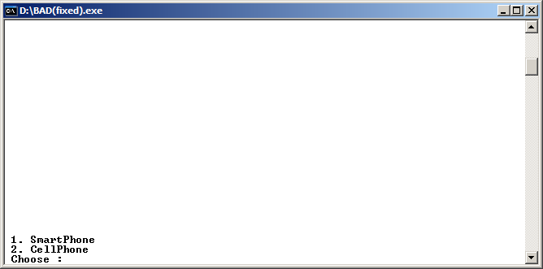
* If the user choose **Submenu 1** (‘**SmartPhone**’), then:
* Ask user to input **SmartPhone Name**. Validate the **length of Smartphone Name** must be **between 5** and **20 characters**.
* Ask user to input **SmartPhone Operating System**. Validate the input must be “**IOS**”, “**Android**” or “**WindowsPhone**” (**Case sensitive**).
* Ask user to input **SmartPhone Memory**. Validate the input must be “**8**”, “**16**”, “**32**” or “**64**”.
* Ask user to input if the **SmartPhone** supports **TouchScreen** technology. Validate the input must be “**Y**” or “**N**”(**Case Sensitive**).
* The program will calculate **Total price** with the following formula:

|  |  |
| --- | --- |
| Operating System | Base Price |
| IOS | Rp. 2000000 |
| Android | Rp. 1500000 |
| WindowsPhone | Rp. 1000000 |

**Total Price** = **Base Price + (Memory * 1000)**

* After **SmartPhone** successfully created, then **add** the data into **Array/Vector/ArrayList**.

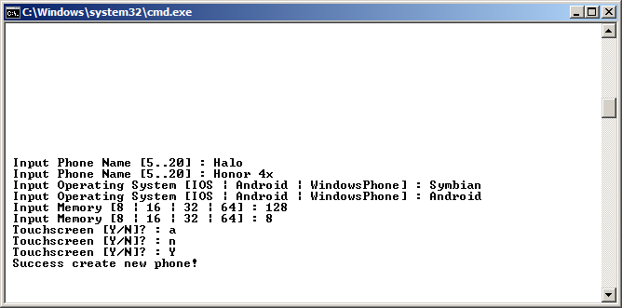

* If user choose **Submenu 2** (‘**CellPhone**’),then:
* Ask user to input **CellPhone Name**. Validate the **length of CellPhone Name** must be **between 5** and **20 characters**.
* Ask user to input **CellPhone Operating System**. Validate the input must be “**Symbian**” or “**Bada**” (**Case sensitive**).
* Ask user to input **CellPhone Memory**. Validate the input must be “**8**”, “**16**”, “**32**” or “**64**”.
* The program will calculate **Total price** with the following formula:

|  |  |
| --- | --- |
| Operating System | BasePrice |
| Symbian | Rp. 800000 |
| Bada | Rp. 650000 |

**Total Price** = **Base Price + (Memory * 1000)**

* After **CellPhone** successfully created, then **add** the data into **Array / Vector / ArrayList**.

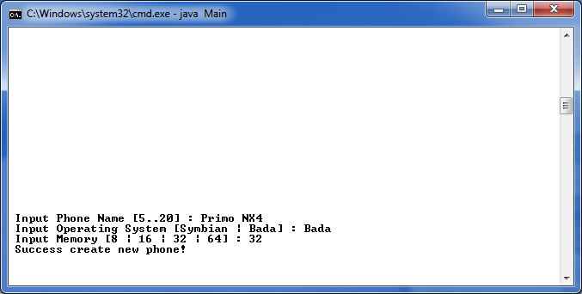

* If user choose **Menu 2** (‘**Delete All Phone**’), then:
* If **all phone data is empty,** then show message “**No phone(s) to be deleted**”.
* Otherwise, **delete all phone data** and show message “**All Phones(s) has been successfully deleted**”.
* If user choose **Menu 3** (‘**View All Phone**’), then:
* If **all phone data is empty**, then show message “**No phone(s) to be shown**”.
* Otherwise, show **all phone data**.

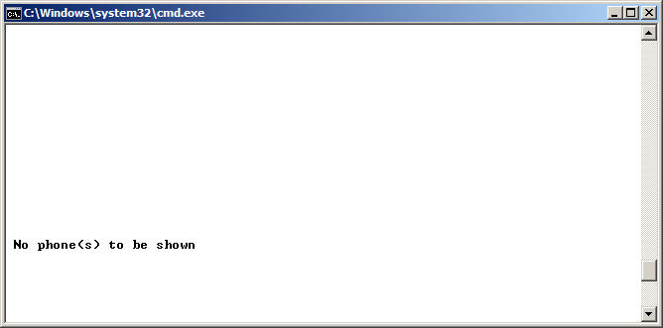

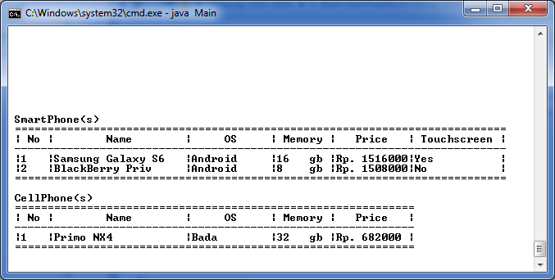

* If user choose **Menu 4** (‘**Exit**’), the program will be **closed**.

**Please run the EXE file to see the sample program.**