MUHAMMAD ALI NASIK AWAN

OBJECTIVES:

1. Understanding and using access modifiers.
2. Understanding control statements and using them in programs.
3. Understanding textbox, button, label, form controls and using them in programs.
4. Understanding event handler methods.
5. Practice Activities.

**OBJECTIVE 1:** Understanding and using access modifiers.

# Access Modifier

Specifies the declared accessibility of types and type members.

Publico No restrictions on type and type members

Privateo Only for type members and limitation up to class level.

Protectedo Only for type members and limitation is up to same class or within derived classes in same or different projects.o Not accessible within other classes even in same project.

Internalo Applicable for type and type memberso Type members accessible within same projecto Types accessible within same project

Protected internalo Application for type members onlyo Type members accessible within same projecto Type members accessible within derived classes in other projects.

**OBJECTIVE 2:** Understanding control statements and using them in programs.

# Control statements

Statements that control the flow of program.

Selection statements o If else, switch case statement

Iteration statements o Do, For, For each in, while

Branch or Jump statements o Break, continue, default, go to, return

Exception handling statements o Throw

**OBJECTIVE 3:** Understanding form, textbox, button, label controls and using them in programs.

Form

It is object of a class that inherits Form class.

It is also known as control b/c it also inherits control class.

It is rectangular area on which controls are placed and is used for interacting with user.

It is container for other controls.

Textbox

It is control/graphical component that is object of TextBox class.

It is used to get user input.

Its output is text.

It is also used to display some values to user.

Button

It is object of Button class.

It is used to trigger events like click, double click and so on.

On the basis of events, a particular method is called in which desired code is placed.

Label

It is control that is used to display information to user and is passive control.

It is object of Label class.

**OBJECTIVE 4:** Event handler methods.

Method

A block of code containing sequence of instructions that should be executed when method is called.

Event handler method

Method that is called when specific situation occurs.

For example: method call when button is clicked.

**ACTIVITIES SECTION**

# ACTIVITY 1: STEPS

Create console application named consoleapplication1.

Create second console application named consoleapplication2 within same solution by right clicking on solution and adding a new project.

Create a class in consoleapplication1 with default modifier.

* Create a static variable in that class with public modifier.

Access variable in Main method of second project and observe the results.

* For launching second project that you have created select second project as default project from properties of solution.o For that right click solution, go to properties, and select consoleapplication2 as default project for solution from drop down list given for **single startup project**

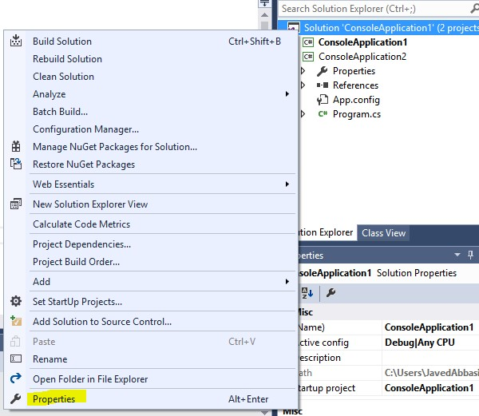

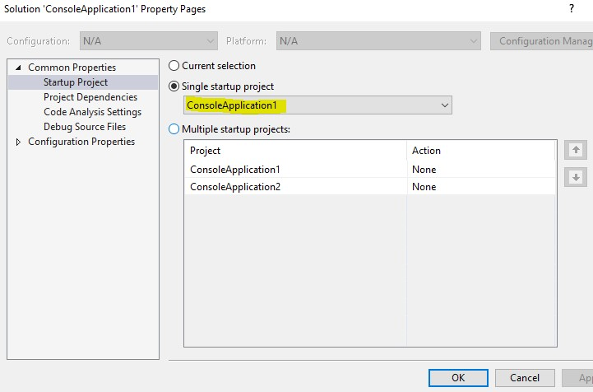

Change modifier of class from default to public in consoleapplication1 and observe the results.

Change modifier of class from public to default and observe the results.

Set modifier of class public and set modifier of variable as protected, access variable in Main method of other class and observe the results.

Extend Program class of consoleapplication2 from class created in consoleapplication1 then access protected variable and check the results.

Access protected variable of class in consoleapplication1 in other class which is note derived from that class and check the results.

Change access modifier of variable in class from protected to protected internal, now access variable in external class which is not child class of class containing variable and check the results.

Access protected internal variable of a class in derive class of other project and check the results.

# ACTIVITY 2: STEPS

Extending Activity 9 of LAB-2.

Instead of Three textboxes for calculator place single textbox on form named txtCalculator.

Now in step 1 get first value from text box

In step 2 get operator from textbox

In step 3 get another value from textbox

In step 4 perform operation on both values based on operator obtained after pressing the equal button added on form.

Display result in the same txtCalculator textbox.

Add controls on form.

Assign names to controls related to their function just as btnZero for button having text 0 and so on.

btnClear = Button for clearing value of textbox.

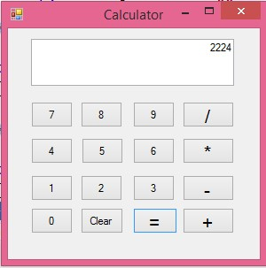

**Code :**

using System;

using System.Collections.Generic;

using System.ComponentModel;

using System.Data;

using System.Drawing;

using System.Linq;

using System.Text;

using System.Threading.Tasks;

using System.Windows.Forms;

namespace Calculator

{

public partial class Form1 : Form

{

public float first_value = 0;

public float second_value = 0;

public string op = "";

public Form1()

{

InitializeComponent();

}

private void button1_Click(object sender, EventArgs e)

{

textBox1.Text += "1";

}

private void button3_Click(object sender, EventArgs e)

{

textBox1.Text += "2";

}

private void button2_Click(object sender, EventArgs e)

{

textBox1.Text += "3";

}

private void button6_Click(object sender, EventArgs e)

{

textBox1.Text += "4";

}

private void button5_Click(object sender, EventArgs e)

{

textBox1.Text += "5";

}

private void button4_Click(object sender, EventArgs e)

{

textBox1.Text += "6";

}

private void button9_Click(object sender, EventArgs e)

{

textBox1.Text += "7";

}

private void button8_Click(object sender, EventArgs e)

{

textBox1.Text += "8";

}

private void button7_Click(object sender, EventArgs e)

{

textBox1.Text += "9";

}

private void button10_Click(object sender, EventArgs e)

{

textBox1.Text += "0";

}

private void button12_Click(object sender, EventArgs e)

{

textBox1.Text = " ";

}

private void button11_Click(object sender, EventArgs e)

{

first_value = Convert.ToInt32(textBox1.Text);

op = "+";

textBox1.Text = " ";

}

private void button16_Click(object sender, EventArgs e)

{

second_value = Convert.ToInt32(textBox1.Text);

if (op == "+")

{

textBox1.Text = " " + (first_value + second_value);

}

else if (op == "-")

{

textBox1.Text = " " + (first_value - second_value);

}

else if (op == "*")

{

textBox1.Text = " " + (first_value * second_value);

}

else if (op == "/")

{

textBox1.Text = " " + (first_value / second_value);

}

}

private void button15_Click(object sender, EventArgs e)

{

first_value = Convert.ToInt32(textBox1.Text);

op = "-";

textBox1.Text = " ";

}

private void button14_Click(object sender, EventArgs e)

{

first_value = Convert.ToInt32(textBox1.Text);

op = "*";

textBox1.Text = " ";

}

private void button13_Click(object sender, EventArgs e)

{

first_value = Convert.ToInt32(textBox1.Text);

op = "/";

textBox1.Text = " ";

}

}

}

OUTPUT:

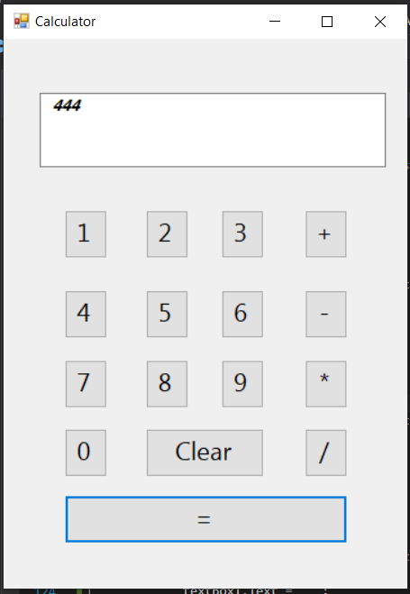

# ACTIVITY 3: STEPS

Extending Activity 2.

Instead of getting separate values from textbox, get all values at the same time.

Now separate values by using operator after pressing the equal button and perform operations based on the operator.

Note: you can use **TextAlign** property of textbox for text to be displayed right aligned.

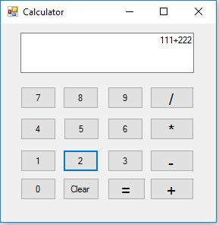

**Code :**

using System;

using System.Collections.Generic;

using System.ComponentModel;

using System.Data;

using System.Drawing;

using System.Linq;

using System.Text;

using System.Threading.Tasks;

using System.Windows.Forms;

using System.Collections;

namespace Calculator

{

public partial class Form1 : Form

{

public float first_value = 0;

public float second_value = 0;

public string op = "";

public string[] list= new string[20];

public Form1()

{

InitializeComponent();

}

private void button1_Click(object sender, EventArgs e)

{

textBox1.Text += "1";

}

private void button3_Click(object sender, EventArgs e)

{

textBox1.Text += "2";

}

private void button2_Click(object sender, EventArgs e)

{

textBox1.Text += "3";

}

private void button6_Click(object sender, EventArgs e)

{

textBox1.Text += "4";

}

private void button5_Click(object sender, EventArgs e)

{

textBox1.Text += "5";

}

private void button4_Click(object sender, EventArgs e)

{

textBox1.Text += "6";

}

private void button9_Click(object sender, EventArgs e)

{

textBox1.Text += "7";

}

private void button8_Click(object sender, EventArgs e)

{

textBox1.Text += "8";

}

private void button7_Click(object sender, EventArgs e)

{

textBox1.Text += "9";

}

private void button10_Click(object sender, EventArgs e)

{

textBox1.Text += "0";

}

private void button12_Click(object sender, EventArgs e)

{

textBox1.Text = " ";

}

private void button11_Click(object sender, EventArgs e)

{

first_value = Convert.ToInt32(textBox1.Text);

op = "+";

textBox1.Text += " + ";

}

private void button16_Click(object sender, EventArgs e)

{

Console.WriteLine("HELOO");

String sample = textBox1.Text;

String second = "";

int index = -1;

char[] array = { '*', '+', '-', '/' };

for (int i = 0; i < array.Length; i++)

{

if (sample.IndexOf(array[i]) > 0)

{

index = sample.IndexOf(array[i]);

break;

}

}

second = sample.Substring(index+1);

second_value = Convert.ToInt32(second);

if (op == "+")

{

textBox1.Text = " " + (first_value + second_value);

}

else if (op == "-")

{

textBox1.Text = " " + (first_value - second_value);

}

else if (op == "*")

{

textBox1.Text = " " + (first_value * second_value);

}

else if (op == "/")

{

textBox1.Text = " " + (first_value / second_value);

}

}

private void button15_Click(object sender, EventArgs e)

{

first_value = Convert.ToInt32(textBox1.Text);

op = "-";

textBox1.Text += " - ";

}

private void button14_Click(object sender, EventArgs e)

{

first_value = Convert.ToInt32(textBox1.Text);

op = "*";

textBox1.Text += " * ";

}

private void button13_Click(object sender, EventArgs e)

{

first_value = Convert.ToInt32(textBox1.Text);

op = "/";

textBox1.Text += " / ";

}

}

}

Output:

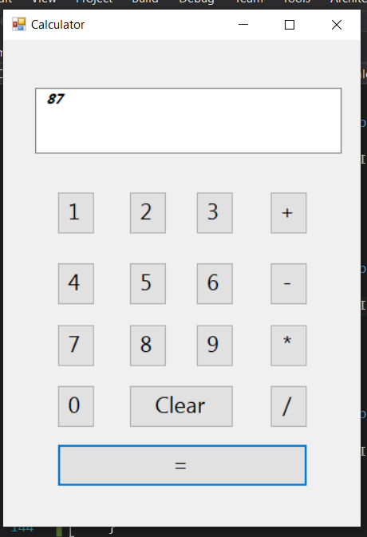

# ACTIVITY 4: STEPS

Create a form named frmTicTacToe.

Add 9 buttons on a form named btnOne up to btnNine with Text property set to “”.

Add new class named classTicTacToe.

* Create a variable named toogleValue of bool type, with value True.
* Create a variable userOne of string type, with value “O”. o Create a variable userTwo of string type, with value “X”. o Create setter and getter methods for ToogleValue variable. o Create getter method for userOne variable. o Create getter method for userTwo variable.
* Add following code in event handler method of btnOne.

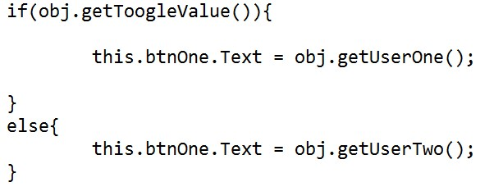

* Similarly write same code for event handlers of all buttons but with following conditions.

Text of button with every click should not be similar, it should display “O” or “X” alternatively.

One should not be able to click the same button twice.

• For this reason use **Enabled** property of button and set it to false.

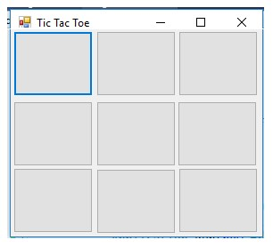

Code:

using System;

using System.Collections.Generic;

using System.ComponentModel;

using System.Data;

using System.Drawing;

using System.Linq;

using System.Text;

using System.Threading.Tasks;

using System.Windows.Forms;

namespace TicTacToe

{

public partial class Form1 : Form

{

bool player = false;

string userone = "X";

string usertwo = "O";

public Form1()

{

InitializeComponent();

}

private void button1_Click(object sender, EventArgs e)

{

}

private void tictactoe_Click(object sender, EventArgs e)

{

Button btn = (Button)sender;

if (player)

{

btn.Text = usertwo;

}

else

{

btn.Text = userone;

}

player = !player;

btn.Click -= new EventHandler(tictactoe_Click);

}

}

}

Output:

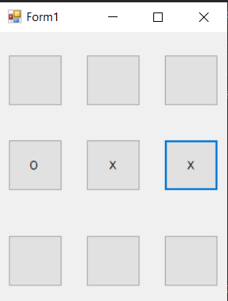

# ACTIVITY 5: STEPS

Extending activity 3.

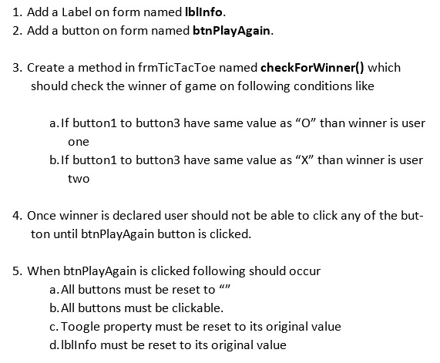

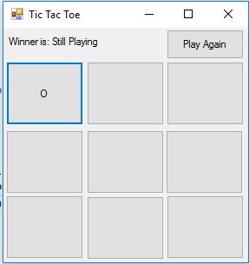

Code:

using System;

using System.Collections.Generic;

using System.ComponentModel;

using System.Data;

using System.Drawing;

using System.Linq;

using System.Text;

using System.Threading.Tasks;

using System.Windows.Forms;

namespace TicTacToe

{

public partial class Form1 : Form

{

bool player = false;

string userone = "X";

string usertwo = "O";

string winner = "";

public Form1()

{

InitializeComponent();

}

private void button1_Click(object sender, EventArgs e)

{

}

private void tictactoe_Click(object sender, EventArgs e)

{

Button btn = (Button)sender;

if (player)

{

btn.Text = usertwo;

}

else

{

btn.Text = userone;

}

player = !player;

btn.Click -= new EventHandler(tictactoe_Click);

checkforwinner();

}

private void button10_Click(object sender, EventArgs e)

{

reset();

button1.Click += new EventHandler(tictactoe_Click);

button2.Click += new EventHandler(tictactoe_Click);

button3.Click += new EventHandler(tictactoe_Click);

button4.Click += new EventHandler(tictactoe_Click);

button5.Click += new EventHandler(tictactoe_Click);

button6.Click += new EventHandler(tictactoe_Click);

button7.Click += new EventHandler(tictactoe_Click);

button8.Click += new EventHandler(tictactoe_Click);

button9.Click += new EventHandler(tictactoe_Click);

label1.Text="Winner:" + winner;

}

public void reset()

{

button1.Text = " ";

button2.Text = " ";

button3.Text = " ";

button4.Text = " ";

button5.Text = " ";

button6.Text = " ";

button7.Text = " ";

button8.Text = " ";

button9.Text = " ";

}

public void stop()

{

button1.Click -= new EventHandler(tictactoe_Click);

button2.Click -= new EventHandler(tictactoe_Click);

button3.Click -= new EventHandler(tictactoe_Click);

button4.Click -= new EventHandler(tictactoe_Click);

button5.Click -= new EventHandler(tictactoe_Click);

button6.Click -= new EventHandler(tictactoe_Click);

button7.Click -= new EventHandler(tictactoe_Click);

button8.Click -= new EventHandler(tictactoe_Click);

button9.Click -= new EventHandler(tictactoe_Click);

}

public void checkforwinner()

{

if(button1.Text.Equals(button2.Text) && button2.Text.Equals(button3.Text))

{

if(button1.Text == "X")

{

MessageBoxButtons buttons = MessageBoxButtons.OK;

//MessageBox.Show("Player one wins", "Winner");

DialogResult result = MessageBox.Show("Player one wins", "Winner", buttons);

if (result == DialogResult.OK)

{

//this.Close();

//reset();

stop();

winner = "player one";

}

}

else if(button1.Text=="O")

{

MessageBoxButtons buttons = MessageBoxButtons.OK;

// MessageBox.Show("Player one wins", "Winner");

DialogResult result = MessageBox.Show("Player Two wins", "Winner", buttons);

if (result == DialogResult.OK)

{

//this.Close();

//reset();

stop();

winner = "player two";

}

}

}

else if (button4.Text.Equals(button5.Text) && button5.Text.Equals(button6.Text))

{

if (button4.Text == "X")

{

MessageBoxButtons buttons = MessageBoxButtons.OK;

//MessageBox.Show("Player one wins", "Winner");

DialogResult result = MessageBox.Show("Player one wins", "Winner", buttons);

if (result == DialogResult.OK)

{

//this.Close();

// reset();

stop();

winner = "player one";

}

}

else if (button4.Text == "O")

{

MessageBoxButtons buttons = MessageBoxButtons.OK;

// MessageBox.Show("Player one wins", "Winner");

DialogResult result = MessageBox.Show("Player Two wins", "Winner", buttons);

if (result == DialogResult.OK)

{

//this.Close();

// reset();

stop();

winner = "player two";

}

}

}

else if (button7.Text.Equals(button8.Text) && button8.Text.Equals(button9.Text))

{

if (button7.Text == "X")

{

MessageBoxButtons buttons = MessageBoxButtons.OK;

//MessageBox.Show("Player one wins", "Winner");

DialogResult result = MessageBox.Show("Player one wins", "Winner", buttons);

if (result == DialogResult.OK)

{

//this.Close();

//reset();

stop();

winner = "player one";

}

}

else if (button7.Text == "O")

{

MessageBoxButtons buttons = MessageBoxButtons.OK;

// MessageBox.Show("Player one wins", "Winner");

DialogResult result = MessageBox.Show("Player Two wins", "Winner", buttons);

if (result == DialogResult.OK)

{

//this.Close();

//reset();

stop();

winner = "player two";

}

}

}

else if (button1.Text.Equals(button4.Text) && button4.Text.Equals(button7.Text))

{

if (button1.Text == "X")

{

MessageBoxButtons buttons = MessageBoxButtons.OK;

//MessageBox.Show("Player one wins", "Winner");

DialogResult result = MessageBox.Show("Player one wins", "Winner", buttons);

if (result == DialogResult.OK)

{

//this.Close();

// reset();

stop();

winner = "player one";

}

}

else if (button1.Text == "O")

{

MessageBoxButtons buttons = MessageBoxButtons.OK;

// MessageBox.Show("Player one wins", "Winner");

DialogResult result = MessageBox.Show("Player Two wins", "Winner", buttons);

if (result == DialogResult.OK)

{

//this.Close();

// reset();

stop();

winner = "player two";

}

}

}

else if (button2.Text.Equals(button5.Text) && button5.Text.Equals(button8.Text))

{

if (button2.Text == "X")

{

MessageBoxButtons buttons = MessageBoxButtons.OK;

//MessageBox.Show("Player one wins", "Winner");

DialogResult result = MessageBox.Show("Player one wins", "Winner", buttons);

if (result == DialogResult.OK)

{

//this.Close();

// reset();

stop();

winner = "player one";

}

}

else if (button2.Text == "O")

{

MessageBoxButtons buttons = MessageBoxButtons.OK;

// MessageBox.Show("Player one wins", "Winner");

DialogResult result = MessageBox.Show("Player Two wins", "Winner", buttons);

if (result == DialogResult.OK)

{

//this.Close();

//reset();

stop();

winner = "player two";

}

}

}

else if (button3.Text.Equals(button6.Text) && button6.Text.Equals(button9.Text))

{

if (button3.Text == "X")

{

MessageBoxButtons buttons = MessageBoxButtons.OK;

//MessageBox.Show("Player one wins", "Winner");

DialogResult result = MessageBox.Show("Player one wins", "Winner", buttons);

if (result == DialogResult.OK)

{

//this.Close();

// reset();

stop();

winner = "player one";

}

}

else if (button3.Text == "O")

{

MessageBoxButtons buttons = MessageBoxButtons.OK;

// MessageBox.Show("Player one wins", "Winner");

DialogResult result = MessageBox.Show("Player Two wins", "Winner", buttons);

if (result == DialogResult.OK)

{

//this.Close();

// reset();

stop();

winner = "player two";

}

}

}

else if (button1.Text.Equals(button5.Text) && button5.Text.Equals(button9.Text))

{

if (button1.Text == "X")

{

MessageBoxButtons buttons = MessageBoxButtons.OK;

//MessageBox.Show("Player one wins", "Winner");

DialogResult result = MessageBox.Show("Player one wins", "Winner", buttons);

if (result == DialogResult.OK)

{

//this.Close();

//reset();

stop();

winner = "player one";

}

}

else if (button1.Text == "O")

{

MessageBoxButtons buttons = MessageBoxButtons.OK;

// MessageBox.Show("Player one wins", "Winner");

DialogResult result = MessageBox.Show("Player Two wins", "Winner", buttons);

if (result == DialogResult.OK)

{

//this.Close();

//reset();

stop();

winner = "player two";

}

}

}

if (button3.Text.Equals(button5.Text) && button5.Text.Equals(button7.Text))

{

if (button3.Text == "X")

{

MessageBoxButtons buttons = MessageBoxButtons.OK;

//MessageBox.Show("Player one wins", "Winner");

DialogResult result = MessageBox.Show("Player one wins", "Winner", buttons);

if (result == DialogResult.OK)

{

//this.Close();

// reset();

stop();

winner = "player one";

}

}

else if (button3.Text == "O")

{

MessageBoxButtons buttons = MessageBoxButtons.OK;

// MessageBox.Show("Player one wins", "Winner");

DialogResult result = MessageBox.Show("Player Two wins", "Winner", buttons);

if (result == DialogResult.OK)

{

//this.Close();

// reset();

stop();

winner = "player two";

}

}

}

}

private void backgroundWorker1_DoWork(object sender, DoWorkEventArgs e)

{

}

private void label1_Click(object sender, EventArgs e)

{

}

}

}

Output:

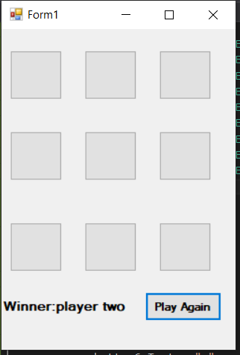

MUHAMMAD ALI NASIK AWAN