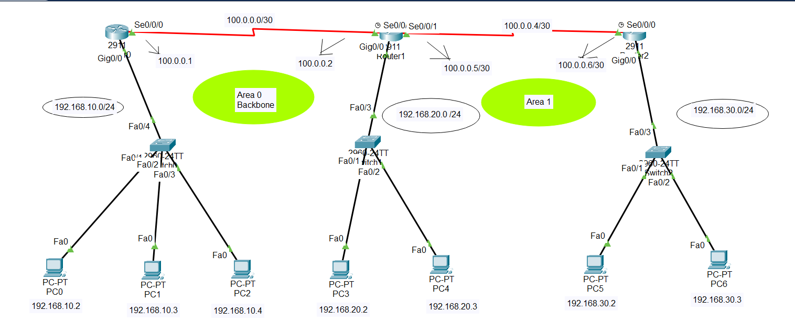

**In router 0:**

**Step1:**

Router>enable

Router#configure terminal

**Step2:**

Router(config)#int gig0/0

Router(config-if)#no shutdown

Router(config-if)#ip address 192.168.10.1 255.255.255.0

Router(config-if)#exit

**Step3:**

Router(config)#int se0/0/0

Router(config-if)#no shutdown

Router(config-if)#ip address 100.0.0.1 255.255.255.252

Router(config-if)#exit

**Step4: (DHCP IP assign)**

Router(config)#ip dhcp pool mypool

Router(dhcp-config)#network 192.168.10.0 255.255.255.0

Router(dhcp-config)#default-router 192.168.10.1

Router(dhcp-config)#dns-server 0.0.0.0

Router(dhcp-config)#exit

**Step5 : ( OSPF routing command)**

**Router(config)#router ospf 1**

**Router(config-router)#router-id 1.1.1.1**

**Router(config-router)#network 192.168.10.0 0.0.0.255 area 0**

**Router(config-router)#network 100.0.0.0 0.0.0.3 area 0**

**Router(config-router)# exit**

**In router 1:**

**Step1:**

Router>enable

Router#configure terminal

**Step2:**

Router(config)#int gig0/0

Router(config-if)#no shutdown

Router(config-if)#ip address 192.168.20.1 255.255.255.0

Router(config-if)#exit

**Step3:**

**{a}**

Router(config)#int se0/0/0

Router(config-if)#no shutdown

Router(config-if)#ip address 100.0.0.2 255.255.255.252

Router(config-if)#exit

{b}

Router(config)#int se0/0/1

Router(config-if)#no shutdown

Router(config-if)#ip address 100.0.0.5 255.255.255.252

Router(config-if)#exit

**Step4: (DHCP ip assign)**

Router(config)#ip dhcp pool mypool

Router(dhcp-config)#network 192.168.20.0 255.255.255.0

Router(dhcp-config)#default-router 192.168.20.1

Router(dhcp-config)#dns-server 0.0.0.0

Router(dhcp-config)#exit

**Step5 : ( OSPF routing command)**

**Router(config)#router ospf 1**

**Router(config-router)#router-id 1.1.1.1**

**Router(config-router)#network 192.168.20.0 0.0.0.255 area 0**

**Router(config-router)#network 100.0.0.0 0.0.0.3 area 0**

**Router(config-router)#network 100.0.0.4 0.0.0.3 area 1**

**In router 2:**

**Step1:**

Router>enable

Router#configure terminal

**Step2:**

Router(config)#int gig0/0

Router(config-if)#no shutdown

Router(config-if)#ip address 192.168.30.1 255.255.255.0

Router(config-if)#exit

**Step3:**

Router(config)#int se0/0/0

Router(config-if)#no shutdown

Router(config-if)#ip address 100.0.0.6 255.255.255.252

Router(config-if)#exit

**Step4: (DHCP IP assign):**

Router(config)#ip dhcp pool mypool

Router(dhcp-config)#network 192.168.30.0 255.255.255.0

Router(dhcp-config)#default-router 192.168.30.1

Router(dhcp-config)#dns-server 0.0.0.0

Router(dhcp-config)#exit

**Step5 : ( OSPF routing command)**

**Router(config)#router ospf 1**

**Router(config-router)#router-id 1.1.1.1**

**Router(config-router)#network 100.0.0.4 0.0.0.3 area 1**

**Router(config-router)#network 192.168.30.0 0.0.0.255 area 1**

**Router(config-router)#exit**

## if I want to undo the OSPF routing then command:

For router 0:

**if I want to remove full ospf routing

**Router(config)# no router ospf 1**

**\*\* if I want to remove some specific network**

**Router(config)# router ospf 1 { first I have to tell which routing }**

**Router(config-router)# no network 192.168.10.0 0.0.0.255 area 0**

**Router(config-router)# no network 100.0.0.0 0.0.0.3 area** 0

For router 1:

**if I want to remove full eigrp routing

**Router(config)# no router ospf 1**

**\*\* if I want to remove some specific network**

**Router(config)# router ospf 1 { first I have to tell which routing }**

**Router(config-router)# no network 192.168.20.0 0.0.0.255 area 0**

**Router(config-router)# no network 100.0.0.4 0.0.0.3 area 1**

**Router(config-router)# no network 100.0.0.0 0.0.0.3 area 0**

For router 2:

**if I want to remove full eigrp routing

**Router(config)# no router ospf 1**

**\*\* if I want to remove some specific network**

**Router(config)# router ospf 1 { first I have to tell which routing }**

**Router(config-router)# no network 192.168.30.0 0.0.0.255 area 1**

**Router(config-router)# no network 100.0.0.4 0.0.0.3 area 1**

**VERIFY:  
Router#show ip protocols**