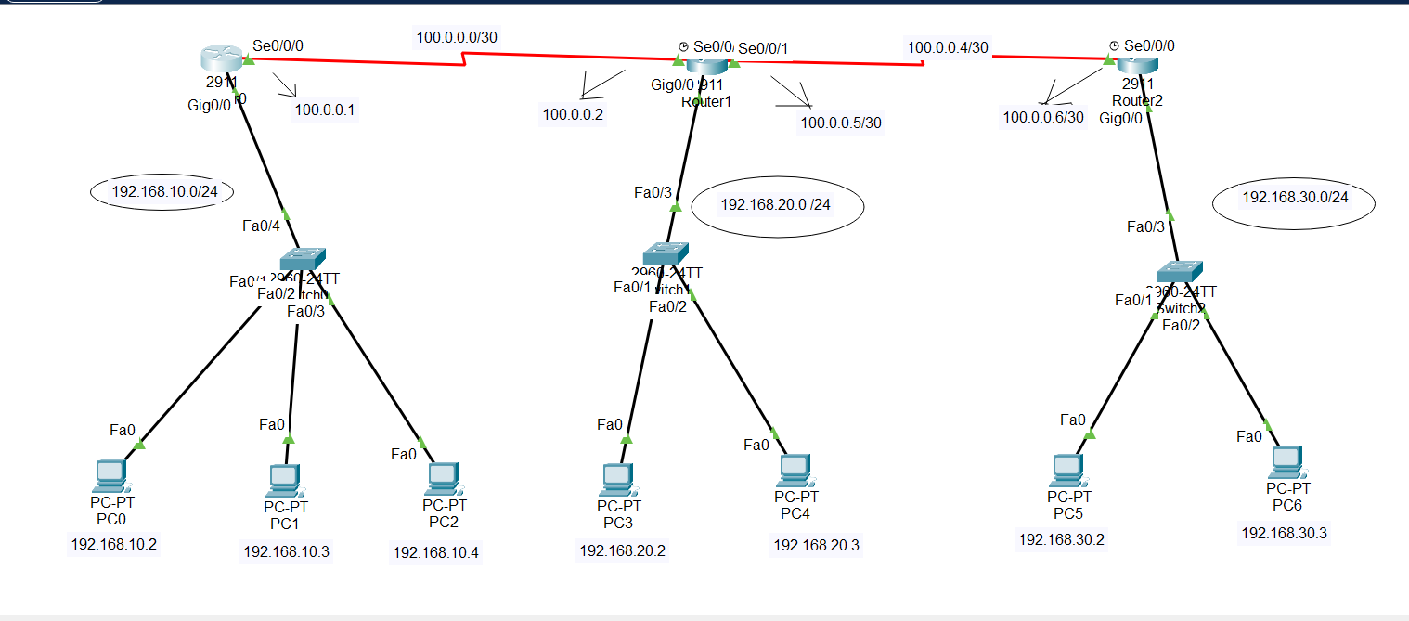

**In router 0:**

**Step1:**

Router>enable

Router#configure terminal

**Step2:**

Router(config)#int gig0/0

Router(config-if)#no shutdown

Router(config-if)#ip address 192.168.10.1 255.255.255.0

Router(config-if)#exit

**Step3:**

Router(config)#int se0/0/0

Router(config-if)#no shutdown

Router(config-if)#ip address 100.0.0.1 255.255.255.252

Router(config-if)#exit

**Step4: (DHCP IP assign)**

Router(config)#ip dhcp pool mypool

Router(dhcp-config)#network 192.168.10.0 255.255.255.0

Router(dhcp-config)#default-router 192.168.10.1

Router(dhcp-config)#dns-server 0.0.0.0

Router(dhcp-config)#exit

**Step5 : ( RIP routing command)**

Router(config)# router rip

Router(config-router)# version 2

Router(config-router)# network 100.0.0.0

Router(config-router)# network 192.168.10.0

Router(config-router)# exit

**In router 1:**

**Step1:**

Router>enable

Router#configure terminal

**Step2:**

Router(config)#int gig0/0

Router(config-if)#no shutdown

Router(config-if)#ip address 192.168.20.1 255.255.255.0

Router(config-if)#exit

**Step3:**

**{a}**

Router(config)#int se0/0/0

Router(config-if)#no shutdown

Router(config-if)#ip address 100.0.0.2 255.255.255.252

Router(config-if)#exit

{b}

Router(config)#int se0/0/1

Router(config-if)#no shutdown

Router(config-if)#ip address 100.0.0.5 255.255.255.252

Router(config-if)#exit

**Step4: (DHCP ip assign)**

Router(config)#ip dhcp pool mypool

Router(dhcp-config)#network 192.168.20.0 255.255.255.0

Router(dhcp-config)#default-router 192.168.20.1

Router(dhcp-config)#dns-server 0.0.0.0

Router(dhcp-config)#exit

**Step5 : ( RIP routing command)**

Router(config)# router rip

Router(config-router)# version 2

Router(config-router)# network 192.168.20.0

Router(config-router)# network 100.0.0.0

Router(config-router)# network 100.0.0.4

Router(config-router)# exit

**In router 2:**

**Step1:**

Router>enable

Router#configure terminal

**Step2:**

Router(config)#int gig0/0

Router(config-if)#no shutdown

Router(config-if)#ip address 192.168.30.1 255.255.255.0

Router(config-if)#exit

**Step3:**

Router(config)#int se0/0/0

Router(config-if)#no shutdown

Router(config-if)#ip address 100.0.0.6 255.255.255.252

Router(config-if)#exit

**Step4: (DHCP IP assign):**

Router(config)#ip dhcp pool mypool

Router(dhcp-config)#network 192.168.30.0 255.255.255.0

Router(dhcp-config)#default-router 192.168.30.1

Router(dhcp-config)#dns-server 0.0.0.0

Router(dhcp-config)#exit

**Step5 : ( RIP routing command)**

Router(config)#router rip

Router(config-router)#version 2

Router(config-router)#network 192.168.30.0

Router(config-router)#network 100.0.0.4

Router(config-router)#exit

## if I want to undo the RIP routing then command:

For router 0:  
**Router(config-router)#no network 100.0.0.0**

**Router(config-router)#no network 192.168.10.0**

For router 1:

**Router(config-router)#no network 100.0.0.0**

**Router(config-router)#no network 192.168.20.0**

For router 2:

**Router(config-router)#no network 100.0.0.0**

**Router(config-router)#no network 192.168.30.0**