**Inter-vlan**

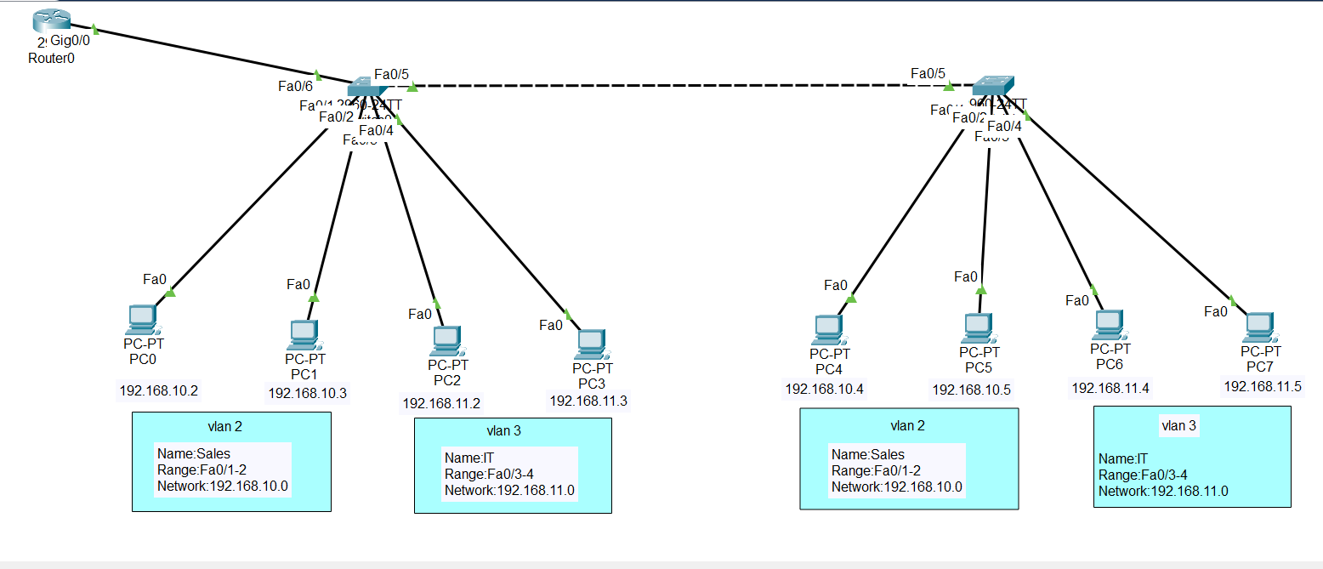

**Switch 0 Command:**

Switch>en

Switch#configure terminal

Switch(config)#vlan 2

Switch(config-vlan)# name Sales

Switch(config-vlan)#exit

Switch(config)#int range fa0/1-2

Switch(config-if-range)#switchport mode access

Switch(config-if-range)#switchport access vlan 2

Switch(config-if-range)#exit

Switch(config)#vlan 3

Switch(config-vlan)#name IT

Switch(config-vlan)#exit

Switch(config)#int range fa0/3-4

Switch(config-if-range)#switchport mode access

Switch(config-if-range)#switchport access vlan 3

Switch(config-if-range)#end

**Switch 1 Command:**

Switch>en

Switch#configure terminal

Switch(config)#vlan 2

Switch(config-vlan)# name Sales

Switch(config-vlan)#exit

Switch(config)#int range fa0/1-2

Switch(config-if-range)#switchport mode access

Switch(config-if-range)#switchport access vlan 2

Switch(config-if-range)#exit

Switch(config)#vlan 3

Switch(config-vlan)#name IT

Switch(config-vlan)#exit

Switch(config)#int range fa0/3-4

Switch(config-if-range)#switchport mode access

Switch(config-if-range)#switchport access vlan 3

Switch(config-if-range)#end

**Trunk command in switch 1 or switch 2:**

Switch(config)#int fa0/5

Switch(config-if)#switchport mode trunk

**Configuration commands (Inter-VLAN):**

Router>enable

Router#configure terminal

Router(config)#int gig0/0

Router(config-if)#no shutdown

Router(config-if)#exit

Router(config)#int gig0/0.1

Router(config-subif)#no shutdown

Router(config-subif)#encapsulation dot1q 2

Router(config-subif)#ip address 192.168.10.1 255.255.255.0

Router(config-subif)#exit

Router(config)#int gig0/0.2

Router(config-subif)#no shutdown

Router(config-subif)#encapsulation dot1q 3

Router(config-subif)#ip address 192.168.11.1 255.255.255.0

Router(config-subif)#exit

**Now again trunking command in router to switch:**  
Switch(config)#int fa0/6

Switch(config-if)#switchport mode trunk

**Verify in priviledge mode:**

Switch#show vlan brief

**MUST CHECK : in every pc -> all default gateway should be filled up must for inter-vlan**

