**NAME : MALIHA SHAHID**

**ROLL NO:SU92-BSSEM-S24-071**

**LAB 2**

#include <iostream>

using namespace std;

int getMaxElement(int arr[], int size) {

int highest = arr[0];

for (int i = 1; i < size; i++) {

if (arr[i] > highest) {

highest = arr[i];

}

}

return highest;

}

int main() {

int size;

cout << "Enter the number of elements in the array: ";

cin >> size;

int* array = new int[size];

cout << "Provide " << size << " values: " << endl;

for (int i = 0; i < size; i++) {

cin >> array[i];

}

int maxElement = getMaxElement(array, size);

cout << "The largest element in the array is: " << maxElement << endl;

delete[] array;

return 0;

}

**OUTPUT**

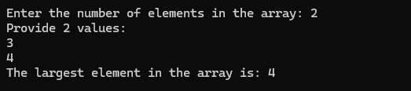

**EXPLANATION**

* The program asks the user for the number of elements.
* It dynamically creates an array of that size.
* The user enters the values into the array.
* The function returns the maximum value.
* The program prints the largest element.
* Finally, the allocated memory is freed using delete[].