**NAME : MALIHA SHAHID**

**ROLL NO:SU92-BSSEM-S24-071**

**LAB 3**

#include <iostream>

using namespace std;

class ListNode {

public:

int data;

ListNode* nextNode;

ListNode(int val) {

data = val;

nextNode = NULL;

}

};

class LinkedList {

public:

ListNode* first;

LinkedList() {

first = NULL;

}

void addToBeginning(int val) {

ListNode* newNode = new ListNode(val);

newNode->nextNode = first;

first = newNode;

}

void addToEnd(int val) {

ListNode* newNode = new ListNode(val);

if (first == NULL) {

first = newNode;

return;

}

ListNode* temp = first;

while (temp->nextNode != NULL) {

temp = temp->nextNode;

}

temp->nextNode = newNode;

}

void printList() {

if (first == NULL) {

cout << "The list is currently empty!" << endl;

return;

}

ListNode* temp = first;

while (temp != NULL) {

cout << temp->data << " -> ";

temp = temp->nextNode;

}

cout << "NULL" << endl;

}

};

int main() {

LinkedList list;

list.addToBeginning(1);

list.printList();

list.addToEnd(4);

list.printList();

return 0;

**}**

**OUTPUT**

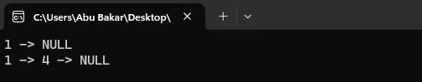

**EXPLANATION**

* ListNode Class – Defines a node with data and a pointer nextNode
* LinkedList Class – Manages the list with a pointer first.
* addToBeginning(int val) – Inserts a new node at the start.
* addToEnd(int val) – Adds a new node at the end.
* printList() – Prints the linked list.
* main() Function – Demonstrates adding and printing nodes.