**PROJECT TEAM LEAD:** PAKEEZA NASIR

**TEAM MEMBER 02:** ABDUL AHAD

**TEAM MEMBER 03:** SIBGHA AQEEL

**DATE:** MAR 03, 2025

SUPERVISED BY: DR. ONAIZA MAQBOOL

DEPARTMENT OF COMPUTER SCIENCE

Quaid-I-Azam University, Islamabad

ANALYSIS PHASE

**LABORATORY MANAGEMENT SYSTEM**

**PAKEEZA NASIR (TEAM LEAD)**

**Use Case: Generate Hardware Reports**

**1. Actors:**

* **Primary Actor:** Lab Coordinator
* **Secondary Actor:** External Reporting System (if applicable, for exporting reports)

**2. Pre-Conditions:**

* The Lab Coordinator must be logged into the system.
* The system must have existing hardware details stored in the database.

**3. Post-Conditions:**

* The report is generated successfully with accurate and up-to-date hardware details.
* The report can be downloaded, viewed, or printed.

**4. Inputs & Outputs:**

**Inputs:**

* Report type selection (Summary or Detailed Report)
* Lab selection (Select a specific lab or all labs)
* Filter criteria (e.g., processor type, RAM size, storage capacity)

**Outputs:**

* A detailed hardware report containing the following information:
  + **Computer ID**
  + **Lab Number**
  + **Processor Type & Speed**
  + **RAM Size & Type** (DDR3, DDR4, etc.)
  + **Storage Type & Capacity** (HDD, SSD, NVMe – 256GB, 512GB, etc.)
  + **GPU Details** (if applicable)
  + **Current System Status** (Active, Under Maintenance, Decommissioned)
* Report format: Downloadable PDF, Excel, or Web View

**5. Main Success Scenario:**

1. The Lab Coordinator navigates to the “Generate Hardware Reports” section.
2. The system displays available report options (Summary Report or Detailed Report).
3. The Lab Coordinator selects the report type and specifies any filters (e.g., by lab, by hardware type).
4. The system retrieves the relevant hardware details from the database.
5. The system generates the report based on the selected criteria.
6. The system presents the report in a downloadable/viewable format.
7. The Lab Coordinator downloads, prints, or exports the report.
8. The Lab Coordinator logs out or continues using the system.

**6. Alternative Scenarios:**

**6.1 No Hardware Data Available:**

* If no data is found for the selected filters, the system displays: "No hardware records found for the selected criteria."

**6.2 Report Generation Failure:**

* If the report generation fails due to a system issue, the system displays: "Error: Unable to generate the report. Please try again later."

**6.3 External System Export Failure (if applicable):**

* If the Lab Coordinator chooses to export the report to an external system (e.g., university-wide database) and the connection fails, the system displays: "Error: Unable to send report to external system. Check connection and try again."

**SYSTEM SEQUENCE DIAGRAM**

**Use Case: Generate Hardware Reports**

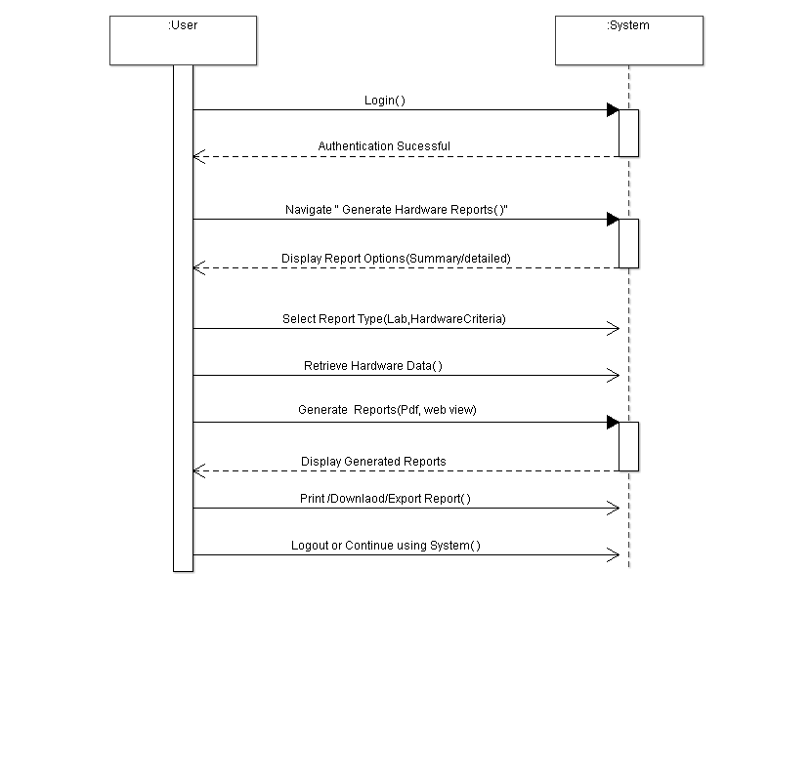

**ABDUL AHAD**

**Use Case: Request Software Installation**

**1. Actors:**

* **Primary Actor:** Student / Teacher
* **Secondary Actor:** Lab Coordinator

**2. Pre-Conditions:**

* The user (Student/Teacher) must be logged into the system.
* The system must have a list of available software and a mechanism to handle installation requests.

**3. Post-Conditions:**

* The software installation request is successfully recorded in the system.
* The Lab Coordinator is notified about the request for further action.

**4. Inputs & Outputs:**

**Inputs:**

* Software Name
* Version (if applicable)
* **Request Type (Single Computer / Entire Lab)**
* **Computer ID (if for a specific computer)**
* **Lab Selection (if for an entire lab)**
* Justification for Installation (optional but recommended)

**Outputs:**

* Confirmation message that the request has been submitted
* Notification sent to the Lab Coordinator
* Error message if the request submission fails

**5. Main Success Scenario:**

1. User (Student/Teacher) navigates to the **"Request Software Installation"** section.
2. The system prompts them to select whether the request is for a **single computer** or an **entire lab**.
3. If **single computer** is selected, they must enter the **Computer ID**.
4. If **entire lab** is selected, they must choose the **Lab Name/ID**.
5. The user provides the **Software Name, Version, and Justification**.
6. The user submits the request.
7. The system validates the request and stores it in the database.
8. The system displays a confirmation message: **"Software installation request submitted successfully."**
9. The Lab Coordinator is notified about the request.
10. The Student/Teacher logs out or continues using the system.

**6. Alternative Scenarios:**

**6.1 Software Already Installed:**

* If the requested software is already installed on the **selected computer or lab**, the system displays:  
  **"This software is already available on the selected computer/lab."**

**6.2 Invalid or Incomplete Input:**

* If the user submits the request with missing or invalid details, the system displays:  
  **"Please fill in all required fields before submitting your request."**

**6.3 Request Submission Failure:**

* If there is a system error preventing the request from being submitted, the system displays:  
  **"Error: Unable to process your request. Please try again later."**

**SYSTEM SEQUENCE DIAGRAM**

**Use Case: Request Software Installation**

**SIBGHA AQEEL**

**Use Case: Register Complaint**

**1. Actors:**

* **Primary Actor:** Student / Teacher
* **Secondary Actor:** Lab Coordinator

**2. Pre-Conditions:**

* The user (Student/Teacher) must be logged into the system.
* The system must have a list of registered labs and computers.
* The computer for which the complaint is being registered must exist in the system database.

**3. Post-Conditions:**

* The complaint is successfully recorded in the system.
* The Lab Coordinator is notified about the complaint for further action.
* A unique Complaint ID is generated for tracking purposes.

**4. Inputs & Outputs:**

**Inputs:**

* Computer ID
* Lab Name/ID
* Complaint Category (e.g., Hardware Issue, Software Issue, Network Issue)
* Complaint Description (details of the problem)
* Optional Attachment (e.g., screenshot of the error)

**Outputs:**

* Confirmation message that the complaint has been registered
* Notification sent to the Lab Coordinator
* Complaint ID for future reference
* Error message if the complaint submission fails

**5. Main Success Scenario:**

1. The user navigates to the "**Register Complaint**" section.
2. The system prompts the user to select the **Lab Name/ID and Computer ID** from a list.
3. The user selects the **Complaint Category** (e.g., Hardware Issue).
4. The user provides a detailed Complaint Description and optionally attaches a file (e.g., error screenshot).
5. The user submits the complaint.
6. The system validates the input fields.
7. The system saves the complaint details into the database.
8. A unique Complaint ID is generated by the system.
9. The system displays a confirmation message: "**Complaint registered successfully. Your Complaint ID is [Complaint ID].**"
10. The Lab Coordinator is notified of the new complaint via email or dashboard alert.
11. The user logs out or continues using the system.

**6. Alternative Scenarios:**

**6.1 Incomplete Information:**

* If the user submits the complaint without selecting a Lab Name/ID or Computer ID, or leaves required fields empty:
  + The system displays:  
    "**Please fill in all required fields before submitting your complaint.**"
* The system highlights the missing/incorrect fields.

**6.2 Invalid Computer Selection:**

* If the selected Computer ID does not exist or is not linked to the selected Lab Name/ID:
  + The system displays:  
    "**The selected computer does not exist in the chosen lab. Please verify your selection.**"

**6.3 Complaint Submission Failure (System Error):**

* If there is a system error preventing the complaint from being recorded:
  + The system displays:  
    "**Error: Unable to register your complaint at this time. Please try again later.**"

**6.4 Duplicate Complaint Detected:**

* If the same issue has already been reported for the computer and is unresolved:
  + The system displays:  
    "**A similar complaint for this computer is already registered and pending. You can track its progress using Complaint ID [Existing Complaint ID].**"

**SYSTEM SEQUENCE DIAGRAM**

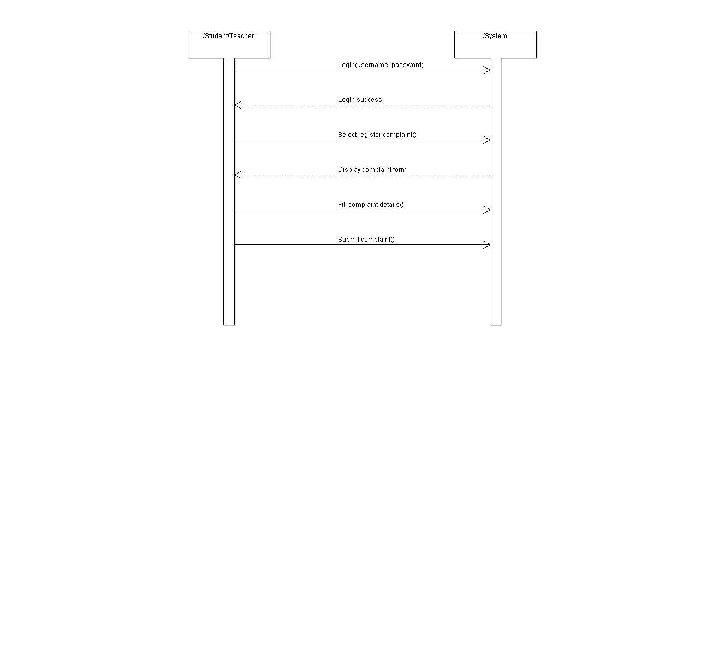**Use Case: Register Complaint**

**DOMAIN MODEL**



