Design and Analysis of Algorithms

Final Project

Dijkstra’s Algorithm:
Dijkstra’s algorithm is a way to find out the single-source shortest path. Problem in graph theory:
- It can be either directed or undirected.
- It contains all the weighted edges.
- It is a connected graph.

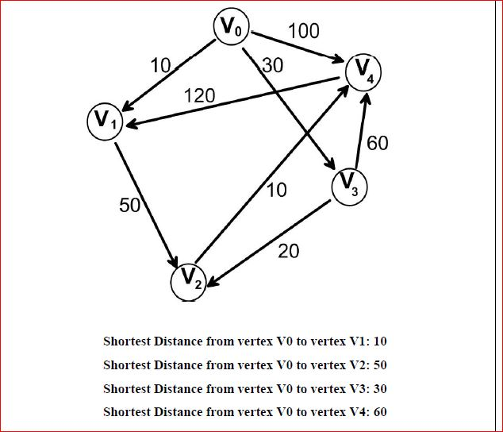

Abstract:
The main aim of this project is using Dijkstra’s Algorithm to find the shortest distance between nodes and respond to requests and allotting emergency vehicles for which they requested.
There are 3 different types of emergency vehicles:
1 (Ambulance),
2 (Fire Truck),
3 (Police car)
We assumed that only one vehicle of each type is available at each node.

Emergency Vehicle dispatch system:
- We provide the vehicle type as an input along with the location (zip code) of origin. To process multiple requests we provided in a JSON.
- Implemented an algorithm that processes requests one by one. For each request, the algorithm will try to find the closest available emergency vehicle. Then it makes that vehicle unavailable for next use unless otherwise made available

Visualization:
- Visualization of the output data was implemented using the Bootstrap with conversion of JSON data into HTML tables to access the data and the output vehicles for the better user interface
Input: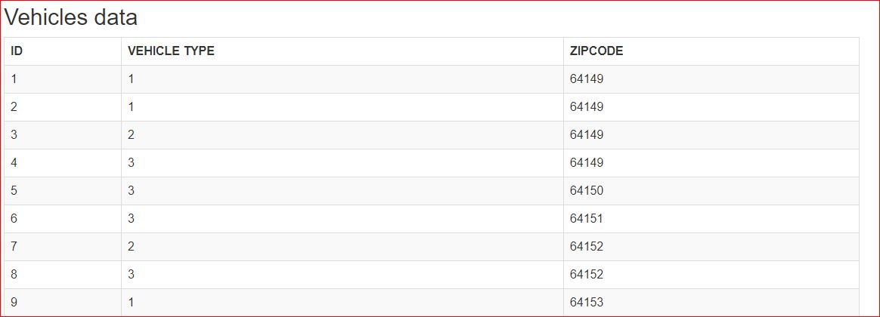

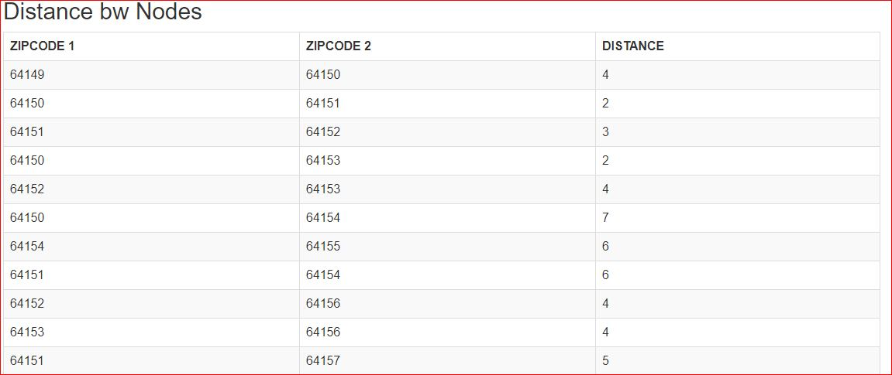

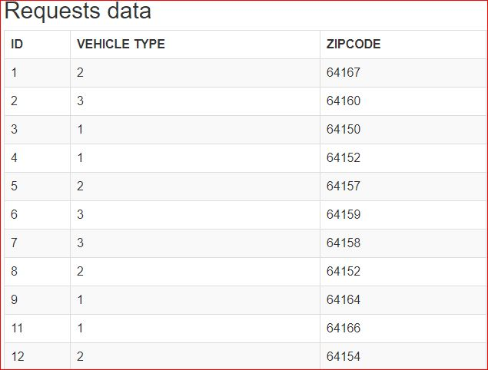

Output:

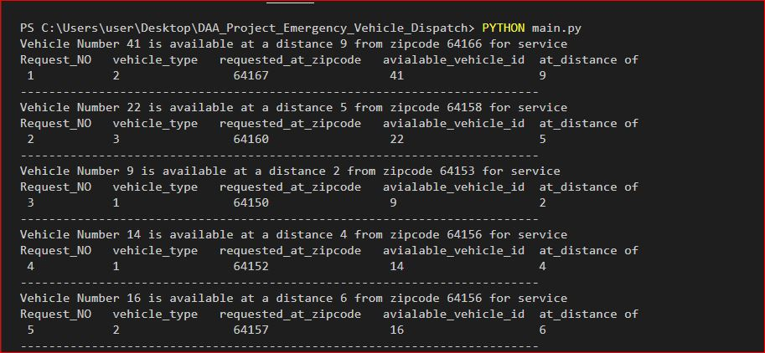

Time complexity:
Time Complexity of Dijkstra’s is reduced from O (V^2) to O (E log V) by using adjacency list instead of using Adjacency Matrix along with binary heaps.
Time complexity of operations like extract-min and decrease-key value is O (Log V) for Min Heap.
Following are the detailed steps.
1) Create a Min Heap of size V where V is the number of vertices in the given graph. Every node of min heap contains vertex number and distance value of the vertex.
2) Initialize Min Heap with source vertex as root (the distance value assigned to source vertex is 0). The distance value assigned to all other vertices is INF (infinite).
3) While Min Heap is not empty, do following
a) Extract the vertex with minimum distance value node from Min Heap. Let the extracted vertex be u.
b) For every adjacent vertex v of u, check if v is in Min Heap. If v is in Min Heap and distance value is more than weight of u-v plus distance value of u, then update the distance value of v.

Future Work:
We can make it a program which receives call from user for a minute .We can detect keyword using python speech recognition module to detect specific keywords like “area 51” “ambulance” “police” then dispatch the require vehicle to that area. Further we could add exchange locations of user to our system and then the dispatched vehicle will know the exact location it needs to go to.
References:
YouTube
Medium
berkeleyUniversityPdf
MIT-Paper

